Q1 Create a web form which allows the teacher to enter the student details like name,
date of birth, address, contact number, email id and marks of English, Physics and
Chemistry. After filling all the information and on clicking submit button, details
should be added to a textarea displayed on the same page. Display the total
percentage of marks obtained in a label.
Html file

{% load static %}
<!DOCTYPE html>
<html lang="en">
<head>
<meta charset="UTF-8">
<meta name="viewport" content="width=device-width, initial-scale=1.0">
<title>Student Details Form</title>
<link rel="stylesheet" href="{% static 'student_form/style.css' %}">
<script src="{% static 'student_form/script.js' %}" defer></script>
</head>
<body>
<div class="form-container">
<h2>Enter Student Details</h2>
<form id="student-form">
<label for="name">Name:</label>
<input type="text" id="name" name="name" required><br>

<label for="dob">Date of Birth:</label>
<input type="date" id="dob" name="dob" required><br>

<label for="address">Address:</label>
<textarea id="address" name="address" required></textarea><br>

<label for="contact">Contact Number:</label>
<input type="tel" id="contact" name="contact" pattern="\d{10}" required><br>

<label for="email">Email ID:</label>
<input type="email" id="email" name="email" required><br>

<label for="english">English Marks:</label>
<input type="number" id="english" name="english" required><br>

<label for="physics">Physics Marks:</label>
<input type="number" id="physics" name="physics" required><br>

<label for="chemistry">Chemistry Marks:</label>
<input type="number" id="chemistry" name="chemistry" required><br>

<button type="submit">Submit</button>
</form>

<div id="result">
<h3>Details:</h3>
<textarea id="details-output" rows="10" cols="50" readonly></textarea><br>
<label for="percentage">Total Percentage: </label>
<span id="percentage"></span>
</div>
</div>
</body>
</html>

views.py

from django.shortcuts import render

def student_form_view(request):
return render(request, 'student_form/student_form.html')

settings.py

"""
Django settings for student_details project.

Generated by 'django-admin startproject' using Django 5.1.6.

For more information on this file, see
https://docs.djangoproject.com/en/5.1/topics/settings/

For the full list of settings and their values, see
https://docs.djangoproject.com/en/5.1/ref/settings/
"""

from pathlib import Path

# Build paths inside the project like this: BASE_DIR / 'subdir'.
BASE_DIR = Path(__file__).resolve().parent.parent

# Quick-start development settings - unsuitable for production
# See https://docs.djangoproject.com/en/5.1/howto/deployment/checklist/

# SECURITY WARNING: keep the secret key used in production secret!
SECRET_KEY = 'django-insecure-lh*d0nygx!z@c%---0y6)txegdmzj$_q*h=)+7_x36ltp@ox3w'

# SECURITY WARNING: don't run with debug turned on in production!
DEBUG = True

ALLOWED_HOSTS = []

# Application definition

INSTALLED_APPS = [
'django.contrib.admin',
'django.contrib.auth',
'django.contrib.contenttypes',
'django.contrib.sessions',
'django.contrib.messages',
'django.contrib.staticfiles',
'student_form',
]

MIDDLEWARE = [
'django.middleware.security.SecurityMiddleware',
'django.contrib.sessions.middleware.SessionMiddleware',
'django.middleware.common.CommonMiddleware',
'django.middleware.csrf.CsrfViewMiddleware',
'django.contrib.auth.middleware.AuthenticationMiddleware',
'django.contrib.messages.middleware.MessageMiddleware',
'django.middleware.clickjacking.XFrameOptionsMiddleware',
]

ROOT_URLCONF = 'student_details.urls'

TEMPLATES = [
{
'BACKEND': 'django.template.backends.django.DjangoTemplates',
'DIRS': [],
'APP_DIRS': True,
'OPTIONS': {
'context_processors': [
'django.template.context_processors.debug',
'django.template.context_processors.request',
'django.contrib.auth.context_processors.auth',
'django.contrib.messages.context_processors.messages',
],
},
},
]

WSGI_APPLICATION = 'student_details.wsgi.application'

# Database
# https://docs.djangoproject.com/en/5.1/ref/settings/#databases

DATABASES = {
'default': {
'ENGINE': 'django.db.backends.sqlite3',
'NAME': BASE_DIR / 'db.sqlite3',
}
}

# Password validation
# https://docs.djangoproject.com/en/5.1/ref/settings/#auth-password-validators

AUTH_PASSWORD_VALIDATORS = [
{
'NAME': 'django.contrib.auth.password_validation.UserAttributeSimilarityValidator',
},
{
'NAME': 'django.contrib.auth.password_validation.MinimumLengthValidator',
},
{
'NAME': 'django.contrib.auth.password_validation.CommonPasswordValidator',
},
{
'NAME': 'django.contrib.auth.password_validation.NumericPasswordValidator',
},
]

# Internationalization
# https://docs.djangoproject.com/en/5.1/topics/i18n/

LANGUAGE_CODE = 'en-us'

TIME_ZONE = 'UTC'

USE_I18N = True

USE_TZ = True

# Static files (CSS, JavaScript, Images)
# https://docs.djangoproject.com/en/5.1/howto/static-files/

STATIC_URL = '/static/'

# Default primary key field type
# https://docs.djangoproject.com/en/5.1/ref/settings/#default-auto-field

DEFAULT_AUTO_FIELD = 'django.db.models.BigAutoField'

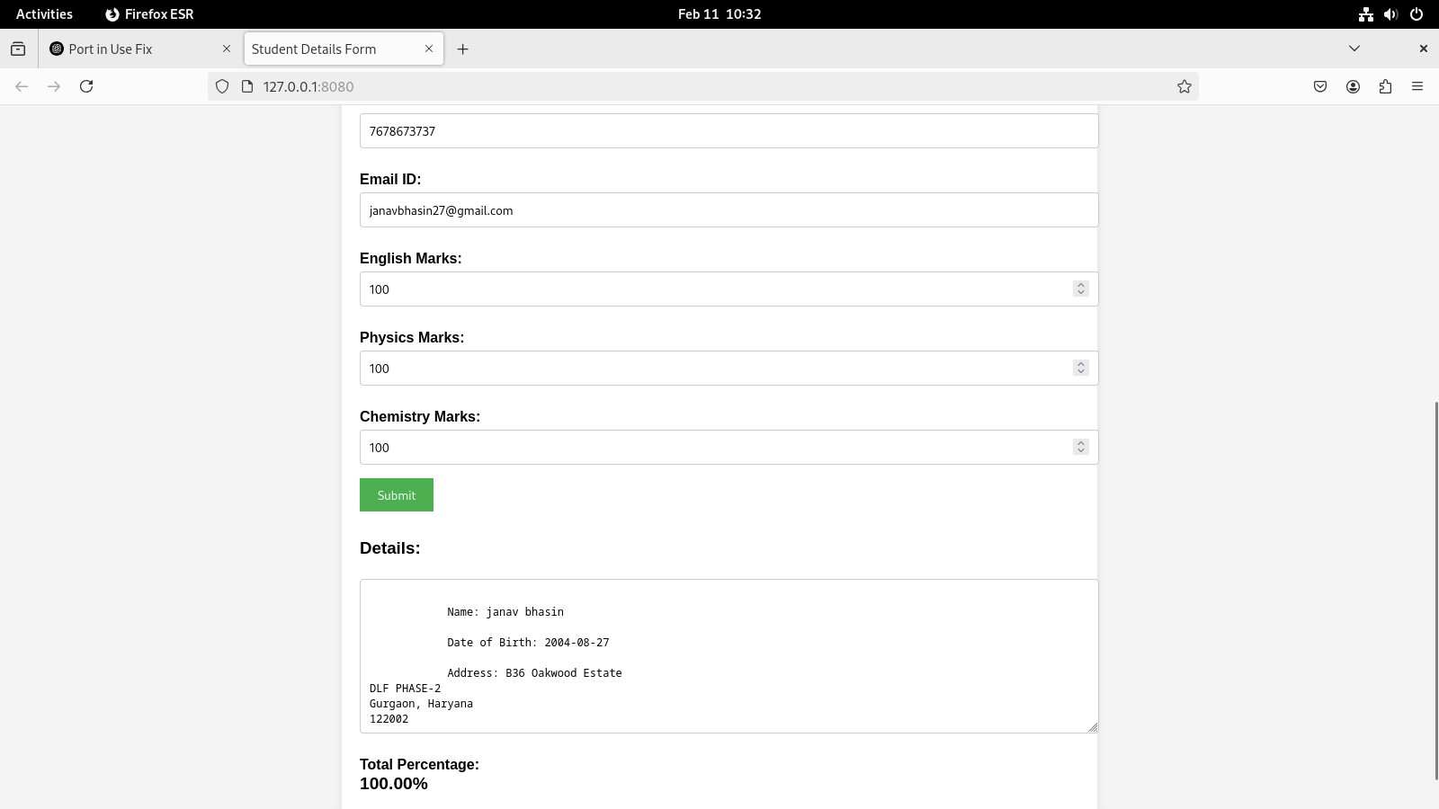
Q2Create a web form with employee ids in dropdown list. Use a textbox for accepting
date of joining. Add a button named “Am I Eligible for Promotion”. On clicking
the button, if he has more than 5 years of experience, then display “YES” else
“NO” in the label control.

Html file
{% load static %}
<!DOCTYPE html>
<html lang="en">
<head>
<meta charset="UTF-8">
<meta name="viewport" content="width=device-width, initial-scale=1.0">
<title>Promotion Eligibility</title>
<link rel="stylesheet" href="{% static 'styles.css' %}">
</head>
<body>
<div class="form-container">
<h1>Employee Promotion Eligibility</h1>
<form method="POST">
{% csrf_token %}
<label for="employee_id">Employee ID:</label>
<select name="employee_id" id="employee_id">
<option value="101">101</option>
<option value="102">102</option>
<option value="103">103</option>
<option value="104">104</option>
</select>
<br><br>
<label for="date_of_joining">Date of Joining:</label>
<input type="date" id="date_of_joining" name="date_of_joining" required>
<br><br>
<button type="submit">Am I Eligible for Promotion</button>
</form>

{% if eligible is not None %}
<div class="result">
<p>Eligibility: <span>{{ eligible }}</span></p>
</div>
{% endif %}
</div>

<script src="{% static 'script.js' %}"></script>
</body>
</html>

views.py

from django.shortcuts import render
from datetime import datetime

# View to display the employee promotion form
def promotion_eligibility(request):
if request.method == 'POST':
# Get the employee id and the date of joining from the form
employee_id = request.POST.get('employee_id')
date_of_joining = request.POST.get('date_of_joining')
# Convert the date of joining to datetime object
try:
doj = datetime.strptime(date_of_joining, '%Y-%m-%d')
# Calculate years of experience
years_of_experience = (datetime.now() - doj).days // 365
# Check eligibility for promotion
if years_of_experience > 5:
eligible = "YES"
else:
eligible = "NO"
except ValueError:
eligible = "Invalid date format"

return render(request, 'promotion_form.html', {'eligible': eligible})

return render(request, 'promotion_form.html', {'eligible': None})

settings.py

"""
Django settings for employee_project project.

Generated by 'django-admin startproject' using Django 5.1.6.

For more information on this file, see
https://docs.djangoproject.com/en/5.1/topics/settings/

For the full list of settings and their values, see
https://docs.djangoproject.com/en/5.1/ref/settings/
"""

from pathlib import Path

# Build paths inside the project like this: BASE_DIR / 'subdir'.
BASE_DIR = Path(__file__).resolve().parent.parent

# Quick-start development settings - unsuitable for production
# See https://docs.djangoproject.com/en/5.1/howto/deployment/checklist/

# SECURITY WARNING: keep the secret key used in production secret!
SECRET_KEY = 'django-insecure-upjl_)5uuwyvq27*etpnl%ka_5$c3776_wyxo&bpsq)3at_rce'

# SECURITY WARNING: don't run with debug turned on in production!
DEBUG = True

ALLOWED_HOSTS = []

# Application definition

INSTALLED_APPS = [
'django.contrib.admin',
'django.contrib.auth',
'django.contrib.contenttypes',
'django.contrib.sessions',
'django.contrib.messages',
'django.contrib.staticfiles',
'employee',
]

MIDDLEWARE = [
'django.middleware.security.SecurityMiddleware',
'django.contrib.sessions.middleware.SessionMiddleware',
'django.middleware.common.CommonMiddleware',
'django.middleware.csrf.CsrfViewMiddleware',
'django.contrib.auth.middleware.AuthenticationMiddleware',
'django.contrib.messages.middleware.MessageMiddleware',
'django.middleware.clickjacking.XFrameOptionsMiddleware',
]

ROOT_URLCONF = 'employee_project.urls'

TEMPLATES = [
{
'BACKEND': 'django.template.backends.django.DjangoTemplates',
'DIRS': [],
'APP_DIRS': True,
'OPTIONS': {
'context_processors': [
'django.template.context_processors.debug',
'django.template.context_processors.request',
'django.contrib.auth.context_processors.auth',
'django.contrib.messages.context_processors.messages',
],
},
},
]

WSGI_APPLICATION = 'employee_project.wsgi.application'

# Database
# https://docs.djangoproject.com/en/5.1/ref/settings/#databases

DATABASES = {
'default': {
'ENGINE': 'django.db.backends.sqlite3',
'NAME': BASE_DIR / 'db.sqlite3',
}
}

# Password validation
# https://docs.djangoproject.com/en/5.1/ref/settings/#auth-password-validators

AUTH_PASSWORD_VALIDATORS = [
{
'NAME': 'django.contrib.auth.password_validation.UserAttributeSimilarityValidator',
},
{
'NAME': 'django.contrib.auth.password_validation.MinimumLengthValidator',
},
{
'NAME': 'django.contrib.auth.password_validation.CommonPasswordValidator',
},
{
'NAME': 'django.contrib.auth.password_validation.NumericPasswordValidator',
},
]

# Internationalization
# https://docs.djangoproject.com/en/5.1/topics/i18n/

LANGUAGE_CODE = 'en-us'

TIME_ZONE = 'UTC'

USE_I18N = True

USE_TZ = True

# Static files (CSS, JavaScript, Images)
# https://docs.djangoproject.com/en/5.1/howto/static-files/
# settings.py

import os

STATIC_URL = '/static/'

# Directory where static files will be collected
STATIC_ROOT = os.path.join(BASE_DIR, 'staticfiles')

# Directories where Django will look for static files in addition to each app's 'static' folder
STATICFILES_DIRS = [
os.path.join(BASE_DIR, 'static'),
]

# Default primary key field type
# https://docs.djangoproject.com/en/5.1/ref/settings/#default-auto-field

DEFAULT_AUTO_FIELD = 'django.db.models.BigAutoField'

