Janav Bhasin
220962049
WP Lab
Week-10
1st April 2025

PROJECT FILES

settings.py

"""
Django settings for myProj project.

Generated by 'django-admin startproject' using Django 5.1.6.

For more information on this file, see
https://docs.djangoproject.com/en/5.1/topics/settings/

For the full list of settings and their values, see
https://docs.djangoproject.com/en/5.1/ref/settings/
"""

from pathlib import Path
import os

# Build paths inside the project like this: BASE_DIR / 'subdir'.
BASE_DIR = Path(__file__).resolve().parent.parent

# Quick-start development settings - unsuitable for production
# See https://docs.djangoproject.com/en/5.1/howto/deployment/checklist/

# SECURITY WARNING: keep the secret key used in production secret!
SECRET_KEY = 'django-insecure-o5nkkkd85o6o%&$0z6w3x5#5fcroz*t7!2!qec8snc1xvl!4t0'

# SECURITY WARNING: don't run with debug turned on in production!
DEBUG = True

ALLOWED_HOSTS = []

# Application definition

INSTALLED_APPS = [
'django.contrib.admin',
'django.contrib.auth',
'django.contrib.contenttypes',
'django.contrib.sessions',
'django.contrib.messages',
'django.contrib.staticfiles',
'bookApp'
]

MIDDLEWARE = [
'django.middleware.security.SecurityMiddleware',
'django.contrib.sessions.middleware.SessionMiddleware',
'django.middleware.common.CommonMiddleware',
'django.middleware.csrf.CsrfViewMiddleware',
'django.contrib.auth.middleware.AuthenticationMiddleware',
'django.contrib.messages.middleware.MessageMiddleware',
'django.middleware.clickjacking.XFrameOptionsMiddleware',
]

ROOT_URLCONF = 'myProj.urls'

TEMPLATES = [
{
'BACKEND': 'django.template.backends.django.DjangoTemplates',
'DIRS': [
os.path.join(BASE_DIR, "bookApp/templates")
],
'APP_DIRS': True,
'OPTIONS': {
'context_processors': [
'django.template.context_processors.debug',
'django.template.context_processors.request',
'django.contrib.auth.context_processors.auth',
'django.contrib.messages.context_processors.messages',
],
},
},
]

WSGI_APPLICATION = 'myProj.wsgi.application'

# Database
# https://docs.djangoproject.com/en/5.1/ref/settings/#databases

DATABASES = {
'default': {
'ENGINE': 'django.db.backends.sqlite3',
'NAME': BASE_DIR / 'db.sqlite3',
}
}

# Password validation
# https://docs.djangoproject.com/en/5.1/ref/settings/#auth-password-validators

AUTH_PASSWORD_VALIDATORS = [
{
'NAME': 'django.contrib.auth.password_validation.UserAttributeSimilarityValidator',
},
{
'NAME': 'django.contrib.auth.password_validation.MinimumLengthValidator',
},
{
'NAME': 'django.contrib.auth.password_validation.CommonPasswordValidator',
},
{
'NAME': 'django.contrib.auth.password_validation.NumericPasswordValidator',
},
]

# Internationalization
# https://docs.djangoproject.com/en/5.1/topics/i18n/

LANGUAGE_CODE = 'en-us'

TIME_ZONE = 'UTC'

USE_I18N = True

USE_TZ = True

# Static files (CSS, JavaScript, Images)
# https://docs.djangoproject.com/en/5.1/howto/static-files/

STATIC_URL = 'static/'

# Default primary key field type
# https://docs.djangoproject.com/en/5.1/ref/settings/#default-auto-field

DEFAULT_AUTO_FIELD = 'django.db.models.BigAutoField'

urls.py

from django.contrib import admin
from django.urls import path, re_path, include

urlpatterns = [
path('admin/', admin.site.urls),
re_path('bookApp/', include('bookApp.urls'))
]

Question – 1

urls.py

from django.urls import path
from . import views

urlpatterns = [
path('', views.index, name="index"),
path('addAuthor/', views.authorIndex, name="Add Author"),
path('addPublisher/', views.publisherIndex, name="Add Publisher"),
path('addBook/', views.bookIndex, name="Add Book"),
path('retrieve/', views.retrieve, name="RetrieveRecords")
]

models.py

from django.db import models

class Author(models.Model):
first_name = models.CharField(max_length=100)
last_name = models.CharField(max_length=100)
email = models.EmailField()

def __str__(self):
return f"{self.first_name} {self.last_name}"

class Publisher(models.Model):
name = models.CharField(max_length=200)
street_address = models.CharField(max_length=255)
city = models.CharField(max_length=100)
state_province = models.CharField(max_length=100)
country = models.CharField(max_length=100)
website = models.URLField()

def __str__(self):
return self.name

class Book(models.Model):
title = models.CharField(max_length=200)
publication_date = models.DateField()
authors = models.ManyToManyField(Author)
publisher = models.ForeignKey(Publisher, on_delete=models.CASCADE)

def __str__(self):
return self.title

forms.py

from django import forms
from .models import Author, Publisher, Book

class AuthorForm(forms.Form):
first_name = forms.CharField(max_length=100)
last_name = forms.CharField(max_length=100)
email = forms.EmailField()

class PublisherForm(forms.Form):
name = forms.CharField(max_length=100)
street_address = forms.CharField(max_length=255)
city = forms.CharField(max_length=100)
state_province = forms.CharField(max_length=100)
country = forms.CharField(max_length=100)
website = forms.URLField()

class BookForm(forms.Form):
title = forms.CharField(max_length=100)
publication_date = forms.DateField()
authors = forms.CharField(max_length=300)
publisher = forms.CharField(max_length=100)

class SearchForm(forms.Form):
name = forms.CharField(max_length=100)

views.py

from django.shortcuts import render, redirect
from .forms import BookForm, AuthorForm, PublisherForm, SearchForm
from .models import Book, Author, Publisher

def index(request):
bookForm, authorForm, publisherForm = BookForm(), AuthorForm(), PublisherForm()
return render(request, "populate.html", {
"bookForm": bookForm,
"authorForm": authorForm,
"publisherForm": publisherForm
})

def bookIndex(request):
if request.method == "POST":
form = BookForm(request.POST)
if form.is_valid():
print("Valid")
data = form.cleaned_data
book = Book.objects.create(
title = data["title"],
publication_date = data["publication_date"],
publisher = Publisher.objects.get(name=data["publisher"])
)
author_names = data["authors"].split()
for author_name in author_names:
author = Author.objects.filter(first_name=author_name)[0]
book.authors.add(author)

return redirect("index")
print("Not Valid")

def authorIndex(request):
if request.method == "POST":
form = AuthorForm(request.POST)
if form.is_valid():
data = form.cleaned_data
author = Author.objects.create(
first_name = data["first_name"],
last_name = data["last_name"],
email = data["email"]
)
return redirect("index")

def publisherIndex(request):
if request.method == "POST":
form = PublisherForm(request.POST)
if form.is_valid():
data = form.cleaned_data
publisher = Publisher.objects.create(
name = data["name"],
street_address = data["street_address"],
city = data["city"],
state_province = data["state_province"],
country = data["country"],
website = data["website"]
)
return redirect("index")

def retrieve(request):
if request.method == "POST":
form = SearchForm(request.POST)
if form.is_valid():
name = form.cleaned_data["name"]
book = Book.objects.filter(title=name)[0]
bookName = book.title
bookDate = book.publication_date
authors = book.authors
print([i for i in authors.all()])
author = None
for a in authors.all():
author = a
break
if author is not None:
authorName = author.first_name
authorEmail = author.email
else:
authorName = None
authorEmail = None

publisher = book.publisher
publisherName = publisher.name
publisherWebsite = publisher.website

context = {"authorName": authorName,
"authorEmail": authorEmail,
"publisherName": publisherName,
"publisherWebsite": publisherWebsite,
"bookName": bookName,
"bookDate": bookDate}
print(context)

return render(request, "retrieve.html", context)
else:
form = SearchForm()
return render(request, "retrieve.html", {"form": form})

tempates: populate.html

<!DOCTYPE html>
<html>
<head>
<title>Insert Data into Tables</title>
</head>
<body>
<h1>Insert Data</h1>
<form method="POST" action="./addAuthor/">
{% csrf_token %}
{{ authorForm.as_p }}
<button type="submit">Insert</button>
</form>

<form method="POST" action="./addPublisher/">
{% csrf_token %}
{{ publisherForm.as_p }}
<button type="submit">Insert</button>
</form>

<form method="POST" action="./addBook/">
{% csrf_token %}
{{ bookForm.as_p }}
<button type="submit">Insert</button>
</form>

<a href="{% url 'RetrieveRecords' %}">Go to Search</a>
</body>
</html>

templates: retrieve.html

<!DOCTYPE html>
<html>
<head>
<title>Retrieve</title>
</head>
<body>
<h1>Retrieve Data</h1>
<form method="POST" action="./">
{% csrf_token %}
{{ form.as_p }}
<button type="submit">Search</button>
</form>

<a href="{% url 'index' %}">Go to Populate</a>

<ul>{{ bookName }}</ul>
<ul>{{ bookDate }}</ul>
<ul>{{ authorName }}</ul>
<ul>{{ authorEmail }}</ul>
<ul>{{ publisherName }}</ul>
<ul>{{ publisherWebsite }}</ul>
</body>
</html>

OUTPUT

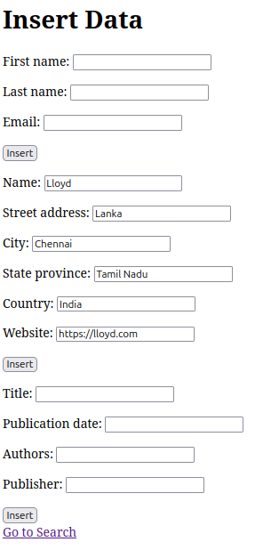

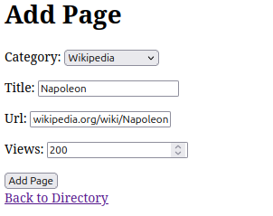

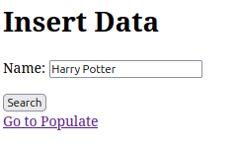

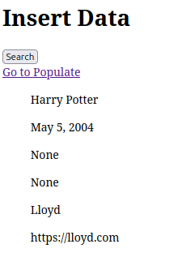

Question - 2

urls.py

from django.urls import path
from .views import create_product, product_list

urlpatterns = [
path('', product_list, name='product_list'),
path('create/', create_product, name='create_product'),
]

models.py

from django.db import models

class Product(models.Model):
title = models.CharField(max_length=200)
price = models.DecimalField(max_digits=8, decimal_places=2)
description = models.TextField()

def __str__(self):
return self.title

forms.py

from django import forms
from .models import Product

class ProductForm(forms.ModelForm):
class Meta:
model = Product
fields = ('title', 'price', 'description')

admin.py

from django.contrib import admin
from .models import Product

admin.site.register(Product)

views.py

from django.shortcuts import render, redirect
from .forms import ProductForm
from .models import Product

def create_product(request):
if request.method == 'POST':
form = ProductForm(request.POST)
if form.is_valid():
form.save()
return redirect('product_list')
else:
form = ProductForm()
return render(request, 'create_product.html', {'form': form})

def product_list(request):
products = Product.objects.all()
return render(request, 'product_list.html', {'products': products})

templates: base.html

<!DOCTYPE html>
<html lang="en">
<head>
<meta charset="UTF-8">
<meta name="viewport" content="width=device-width, initial-scale=1.0">
<title>Product App</title>
<link href="https://cdn.jsdelivr.net/npm/bootstrap@5.1.3/dist/css/bootstrap.min.css" rel="stylesheet" integrity="sha384-1BmE4kWBq78iYhFldvKuhfTAU6auU8tT94WrHftjDbrCEXSU1oBoqyl2QvZ6jIW3" crossorigin="anonymous">
</head>
<body>
<div class="container mt-5">
{% block content %}{% endblock %}
</div>

<script src="https://cdn.jsdelivr.net/npm/bootstrap@5.1.3/dist/js/bootstrap.bundle.min.js" integrity="sha384-ka7Sk0Gln4gmtz2MlQnikT1wXgYsOg+OMhuP+IlRH9sENBO0LRn5q+8nbTov4+1p" crossorigin="anonymous"></script>
</body>
</html>

templates: create_product.html

{% extends 'base.html' %}

{% block content %}
<h1 class="mb-3">Create Product</h1>
<form method="post">
{% csrf_token %}
<div class="mb-3">
{{ form.title.label_tag }} {{ form.title }}
</div>
<div class="mb-3">
{{ form.price.label_tag }} {{ form.price }}
</div>
<div class="mb-3">
{{ form.description.label_tag }} {{ form.description }}
</div>
<button type="submit" class="btn btn-primary">Create</button>
</form>
{% endblock %}

templates: product_list.html

{% extends 'base.html' %}

{% block content %}
<h1 class="mb-3">Product List</h1>
<ul class="list-group">
{% for product in products %}
<li class="list-group-item">
<span>{{ product.title }} ({{ product.price }})</span>
<br>
{{ product.description }}
</li>
{% endfor %}
</ul>

<p><a href="{% url 'create_product' %}" class="btn btn-secondary mt-3">Create a new product</a></p>
{% endblock %}

OUTPUT

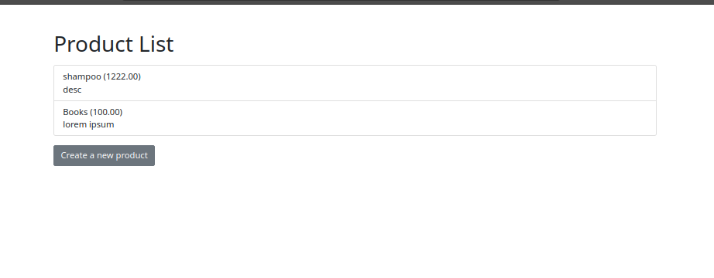

Question – 3

views.py

from django.shortcuts import render, redirect
from .models import Human
from django.http import JsonResponse

def human_list(request):
humans = Human.objects.all()
first_names = [h.first_name for h in humans]
return render(request, 'human_list.html', {'first_names': first_names})

def get_human_details(request, first_name):
try:
human = Human.objects.get(first_name=first_name)
return JsonResponse({
'first_name': human.first_name,
'last_name': human.last_name,
'phone': human.phone,
'address': human.address,
'city': human.city,
})
except Human.DoesNotExist:
return JsonResponse({})

def update_human(request, first_name):
human = Human.objects.get(first_name=first_name)
if request.method == 'POST':
human.last_name = request.POST.get('last_name')
human.phone = request.POST.get('phone')
human.address = request.POST.get('address')
human.city = request.POST.get('city')
human.save()
return redirect('human_list')

def delete_human(request, first_name):
human = Human.objects.get(first_name=first_name)
human.delete()
return redirect('human_list')

forms.py

from django import forms
from .models import Human

class HumanForm(forms.ModelForm):
class Meta:
model = Human
fields = ('first_name', 'last_name', 'phone', 'address', 'city')

urls.py
from django.urls import path
from .views import human_list, get_human_details, update_human, delete_human

urlpatterns = [
path('', human_list, name='human_list'),
path('get_details/<str:first_name>/', get_human_details, name='get_human_details'),
path('update/<str:first_name>/', update_human, name='update_human'),
path('delete/<str:first_name>/', delete_human, name='delete_human'),
]

models.py

from django.db import models

class Human(models.Model):
first_name = models.CharField(max_length=100)
last_name = models.CharField(max_length=100)
phone = models.CharField(max_length=20)
address = models.CharField(max_length=200)
city = models.CharField(max_length=50)

def __str__(self):
return f"{self.first_name} {self.last_name}"

templates: human_list.html

<!DOCTYPE html>
<html lang="en">
<head>
<meta charset="UTF-8">
<meta name="viewport" content="width=device-width, initial-scale=1.0">
<title>Human Details</title>
<link href="https://cdn.jsdelivr.net/npm/bootstrap@5.1.3/dist/css/bootstrap.min.css" rel="stylesheet" integrity="sha384-1BmE4kWBq78iYhFldvKuhfTAU6auU8tT94WrHftjDbrCEXSU1oBoqyl2QvZ6jIW3" crossorigin="anonymous">
</head>
<body>
<div class="container mt-5">
<h1>Human Details</h1>
<select id="humanSelect" class="form-select">
{% for name in first_names %}
<option value="{{ name }}">{{ name }}</option>
{% endfor %}
</select>

<form id="humanForm">
<div class="mb-3">
<label for="first_name" class="form-label">First Name</label>
<input type="text" class="form-control" id="first_name" disabled>
</div>
<div class="mb-3">
<label for="last_name" class="form-label">Last Name</label>
<input type="text" class="form-control" id="last_name" name="last_name">
</div>
<div class="mb-3">
<label for="phone" class="form-label">Phone</label>
<input type="text" class="form-control" id="phone" name="phone">
</div>
<div class="mb-3">
<label for="address" class="form-label">Address</label>
<input type="text" class="form-control" id="address" name="address">
</div>
<div class="mb-3">
<label for="city" class="form-label">City</label>
<input type="text" class="form-control" id="city" name="city">
</div>
<button type="submit" class="btn btn-primary" id="updateBtn">Update</button>
<button type="button" class="btn btn-danger" id="deleteBtn">Delete</button>
</form>
</div>

<script src="https://cdn.jsdelivr.net/npm/bootstrap@5.1.3/dist/js/bootstrap.bundle.min.js" integrity="sha384-ka7Sk0Gln4gmtz2MlQnikT1wXgYsOg+OMhuP+IlRH9sENBO0LRn5q+8nbTov4+1p" crossorigin="anonymous"></script>
<script src="https://code.jquery.com/jquery-3.6.0.min.js" integrity="sha256-/xUj+3OJU5yExlq6GSYGSHk7tPXikynS7ogEvDej/m4=" crossorigin="anonymous"></script>
<script>
document.addEventListener('DOMContentLoaded', function() {
const humanSelect = document.getElementById('humanSelect');
const humanForm = document.getElementById('humanForm');
humanSelect.addEventListener('change', function() {
const first_name = this.value;
fetch('/get_details/' + first_name)
.then(response => response.json())
.then(data => {
document.getElementById('first_name').value = data.first_name;
document.getElementById('last_name').value = data.last_name || '';
document.getElementById('phone').value = data.phone || '';
document.getElementById('address').value = data.address || '';
document.getElementById('city').value = data.city || '';
});
});

humanForm.addEventListener('submit', function(event) {
event.preventDefault();
const first_name = document.getElementById('first_name').value;
const last_name = document.getElementById('last_name').value;
const phone = document.getElementById('phone').value;
const address = document.getElementById('address').value;
const city = document.getElementById('city').value;

$.ajax({
type: 'POST',
url: '/update/' + first_name + '/',
data: {
'last_name': last_name,
'phone': phone,
'address': address,
'city': city,
'csrfmiddlewaretoken': '{{ csrf_token }}',
},
success: function() {
alert('Details updated successfully!');
},
error: function(xhr) {
alert('Error updating details: ' + xhr.statusText);
}
});
});

document.getElementById('deleteBtn').addEventListener('click', function() {
const first_name = document.getElementById('first_name').value;
if (confirm('Are you sure you want to delete this record?')) {
$.ajax({
type: 'GET',
url: '/delete/' + first_name + '/',
success: function() {
alert('Record deleted successfully!');
// Refresh dropdown
location.reload();
},
error: function(xhr) {
alert('Error deleting record: ' + xhr.statusText);
}
});
}
});
});
</script>
</body>
</html>

OUTPUT
