SAI VIDYA INSTITUTE OF TECHNOLOGY
(Affiliated to Visvesvaraya Technological University, Belagavi | Recognized by Govt. of Karnataka | Approved by AICTE, New Delhi)
Accredited by NBA, New Delhi (CSE, ISE, ECE), NAAC ‘A’ Grade
Rajanukunte, Bengaluru- 560064

DEPARTMENT OF INFORMATION SCIENCE AND ENGINEERING
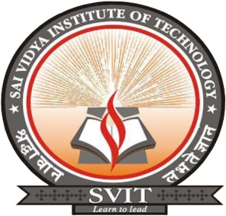

CERTIFICATE

This is to certify that the Project work (BIS786) entitled “Secret-phrase triggered SOS alert & Evidence recording system” carried out by Mr. Abhishek P (1VA22IS002), Ms. Busupalli Haritha (1VA22IS019), Ms. Janavi K (1VA22IS041), Ms. Keerthana C (1VA22IS044) bonafide students of SAI VIDYA INSTITUTE OF TECHNOLOGY, Bengaluru, in partial fulfillment for the award of Bachelor of Engineering in Information Science and Engineering of VISVESVARAYA TECHNOLOGICAL UNIVERSITY, Belagavi during the year 2025-26. It is certified that all corrections/suggestions indicated for Internal Assessment have been incorporated in the Report deposited in the departmental library. The Project report has been approved as it satisfies the academic requirements in respect of Project work prescribed for the said Degree.

Dr. Vijayashree Budyal  Associate Professor,  Dept. of ISE, SVIT | Dr. Vrinda Shetty  Professor & Head  Dept. of ISE, SVIT | Dr. Manjunath T N  Principal, SVIT

External Viva:

Name | Signature
- ___________________________ | __________________________
- ___________________________ | __________________________

