It’s Raining Men! Final Project Version
Game Design Document
Jocilyn Blocker

My current game is based off the theme where something falls from the sky, and you try to catch as many as you can before the time runs out. I am thinking of expanding upon this game I already have made to make it more fun and interesting. I have had many of my coworkers play my game already and they have given many far-fetched ideas of how I could make the game more enjoyable. Some ideas that I have thought about implementing based on their feedback is another sprite falling from the sky that adds time to the clock, a sprite that takes away points if hit, and a high score button. I have also thought it would be more interesting if I gave the game more time and added other features like the ability to jump up and down and maybe another sprite that gives the player the ability to fly temporarily, which would be on another timer that would pop up on the screen, similar to a Mario Kart upgrade that is grabbed in those types of games. The last few of these sprites I tried implementing but could not get to work properly. There are multiple versions of the game saved in my directory that I eventually had to give up on. I switched to a different title for the python code submissions after I scrapped a lot of ideas that weren’t working well in the coding.

This would require new sprites, labels, and variables:
- moreTime-
  - a sprite that has a 1/20 (per?) chance of appearing
    - could not figure out how to get the moreTime to work without always having at least one on screen
  - spawns at a random x point at top of screen
  - falls at a random speed between 3 and 8
  - disappears once player touches it or it touches ground
  - adds 5 seconds if player touches it
- badGuy-
  - a sprite that falls from the sky
  - spawns at random x point at top of screen
  - falls at random speed between 3 and 8
  - disappears once hits the ground
  - game ends if player touches it
- wings
  - a sprite that falls from the sky (1/10 chance of appearing?)
  - spawns at random x point at top of screen
  - falls at random speed between 3 and 8
  - disappears once hits the ground
  - player gets ability to fly if player touches it
- LblFlyTime
  - A label that is next to the time label
  - It reads the time left for flying
  - Only two decimal places
  - Disappears when fly time =< 0 (or when player isn’t flying?)
- flyTime-
  - the time that player has left to fly
  - fly is for 5 seconds
  - +5 fly time when player collides with wings
  - Automatically starts at 0
  - if flyTime = 0, then gravity is True
  - else gravity is False
- gravity-
  - this will make it so player can only travel x axis normally (no flying)
  - player is held down to the bottom of x axis
  - space bar == jump which will make player jump 10 (pixels?)
  - player will jump up when up arrow is pushed at speed of 5
  - once player reaches any y => (screen width -10) then player falls downward
  - ^(that will make them fall after fly as well)
  - Player will fall with speed of 5 (equal to jump speed)
- LblHighScore
  - Label that says the high score
  - Placed right above previous score on instruction screen
- highScore
  - variable that holds the highest score
  - save the high score to a file to keep it
  - Needs to update every time prevScore > highScore

When gravity is false:
- Game settings need to allow player to move up and down the y axis by using up and down buttons
- Should be same coding as move left and right coding
- Create bounce boundaries for all 4 corners

Player turning/moving-
- Player needs to be able to turn his face based on if he is going left or right
- Maybe inverse his image
- Image I have is a gif- use different images to show moving
- ^when left key pressed import correct image
- ^when right key pushed import correct image

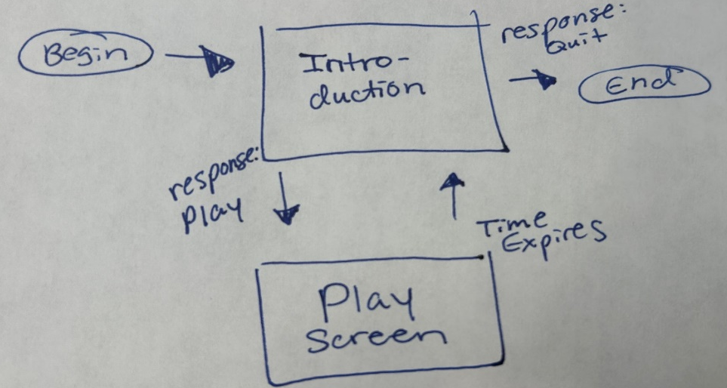
State Transition Diagram
Instruction Scene/Screen

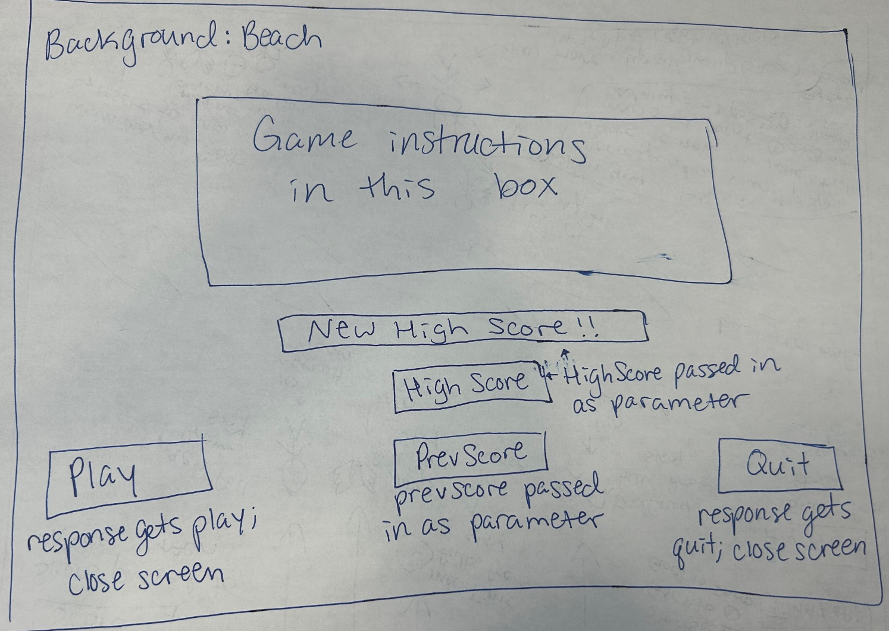

Four visual elements:
- Instructions- simpleGE multiLabel that has instructions how to play game
- prevScore- label showing previous score
- btnPlay- button that says “Play
- btnQuit- button that says “Quit”
- lblHighScore- label that shows the highest score
- lblNewHighScore- label that is visible when high score is new (did not get to this)

Attributes:
- prevScore- integer that is the last score, passed to initalizer, displayed on prevScore label
- response- string that is what user wants to do, “Play” or “Quit” from buttons
- highScore- integer that holds the highest score, passed to initializer, displayed on lblHighScore

Methods:
- initializer- init()
  - creates attributes
  - sets up sprite list
- process meth0d- process()
  - event-handling

Game Class and Screen

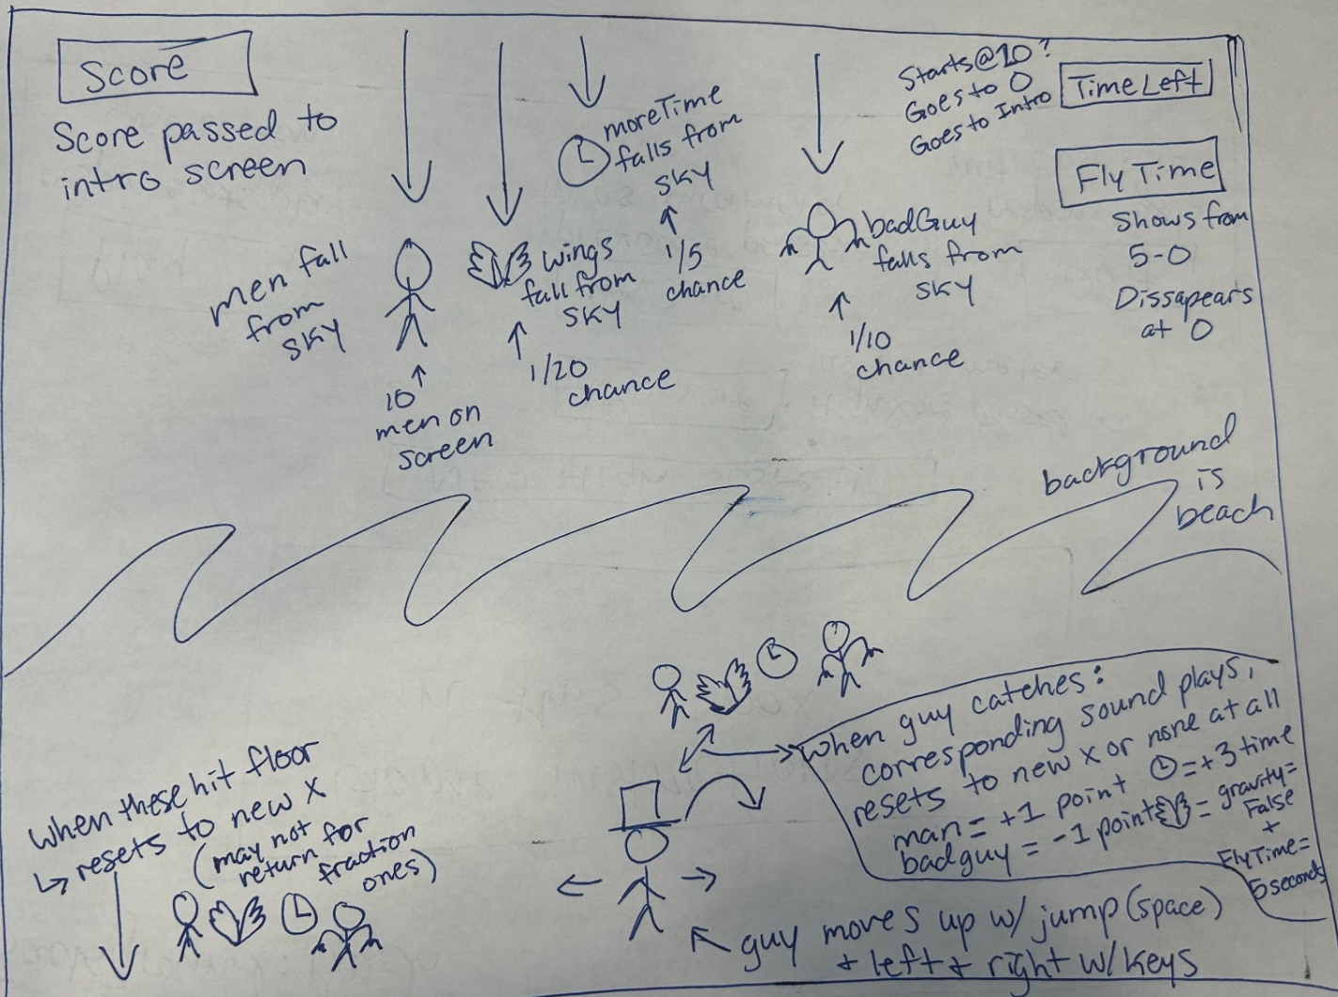
The Game class will have visual attributes:
- guy - an instance of the Guy class
- mens - a list of instances of the Men class
- lblScore- an instance of the LblScore class
- lblTime- an instance of the LblTime class
- bagGuy- an instance of the (bagGuy) class!!!! (need to make class)
- moreTime- an instance of the moreTime class (need to make class)
- wings- an instance of the wings class (need to make class)
- LblFlyTime- label that shows fly time

It will also contain some non-sprite assets:
- timer- a stock instance of the simpleGE.Timer class
- score- an integer containing the current score
- sndMen - a stock instance of the simpleGE.Sound class
- snd(badGuy)- a stock instance of the simpleGE.Sound class
- flyTime- a stock instance of the simpleGE.Timer class
- gravity- a Boolean containing True or False for game mechanics

Methods within Game Class:
- Initializer- init()
  - Will create needed components
  - Will add to sprite list
- Process method- process()
  - Will handle events

Components of Game Class
Guy-
Guy is a subClass of simpleGE.Sprite
The image is image of a guy (creative commons)
Size is 35 by 45
Transparent background
Initial position center bottom of screen
moveSpeed is an integer starts at 5
Guy has two methods
- init() - standard initialization
  - set images- left and right different
  - set size
  - set position
  - set speed
- process(gravity) - method to set moving up down left right
  - if gravity true- just left, right, and jump
    - up key- gets jump (will require much coding from information provided at beginning of document)
  - if gravity false- up, down, left, right buttons
  - auto image is right
  - if going left- left image
  - if going right- right image

Men-
Men is a subclass of simpleGE.Sprite
The image is image of hero, girl, and half man thing (creative commons)
transparent background
Reset method sets men to top of screen, random x
Fall speed is random within limit (3 to 8 ppf)
Men falls down screen
If men leaves bottom of screen, reset
Men has three methods
- init() - standard initialization
  - image- changed to be 3 different images
  - size
  - reset
- reset() - custom method to set speed and position- pick sound
- checkBounds() - overwrite existing checkBounds to handle bottom-of screen

LblScore-
Subclass of simpleGE.Label
One method:
Initilazer-
- Set text
- Set center

LblScore-
Subclass of simpleGE.Label
One method:
Initilazer-
- Set text
- Set center

LblTime-
Subclass of simpleGE.Label
One method:
Initilazer-
- Set text
- Set center

badGuy-
badGuy is a subclass of simpleGE.Sprite
The image is image of Creepy man (creative commons)
transparent background
Reset method sets badGuy to top of screen, random x
Fall speed is random within limit (3 to 8 ppf)
badGuy falls down screen
If badGuy leaves bottom of screen, reset
Men has three methods
- init() - standard initialization
  - set image
  - set size
  - reset
- reset() - custom method to set speed and position
- checkBounds() - overwrite existing checkBounds to handle bottom-of screen

moreTime-
moreTime is a subclass of simpleGE.Sprite
The image is image of a clock (creative commons)
transparent background
Reset method sets moreTime back to top or gone
Fall speed is random within limit (3 to 8 ppf)
moreTime falls down screen
If moreTime leaves bottom of screen, reset
moreTime has three methods
- init() - standard initialization
  - set image
  - set size
  - reset
- reset() - custom method to set speed and position
- checkBounds() - overwrite existing checkBounds to handle bottom-of screen

wings-
wings is a subclass of simpleGE.Sprite
The image is image of a clock (creative commons)
transparent background
Reset method sets wings back to top or gone
Fall speed is random within limit (3 to 8 ppf)
wings falls down screen
If wings leaves bottom of screen, reset
wings has three methods
- init() - standard initialization
- reset() - custom method to set speed and position
- checkBounds() - overwrite existing checkBounds to handle bottom-of screen

lblFlyTime-
Subclass of simpleGE.Label
One method:
Initilazer-
- Set text
- Set center

The main() function
This plays the game
- instructions- instance of the Instructions class
- game - an instance of the Game class
- keepGoing – Boolean sentry
- score – the current score
- highScore- the highest score

Milestone Plan
- Create the Documentation plan
- Create the pseudocode for each sprite/scene/class/variable
- Introduce gravity and jumping
- Introduce badGuy, sndBadGuy, and bounce boundaries
- Introduce wings and flyTime
- Introduce highScore, LblHighScore, and LblNewHighScore
- Check everything runs smoothly

Asset Plan

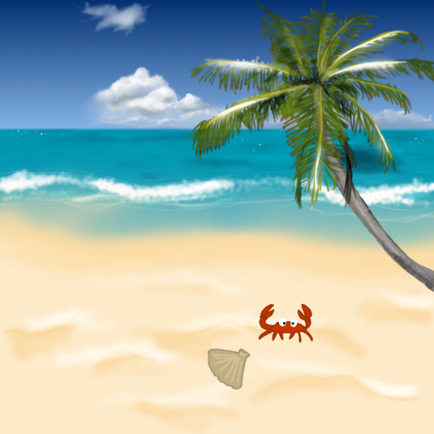
Beach background | OpenGameArt.org
Creative commons

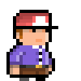
Man walking animation | OpenGameArt.org
Creative commons

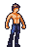
Hero spritesheets (Ars Notoria) | OpenGameArt.org
Creative commons

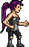
Pixie | OpenGameArt.org
Creative commons

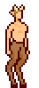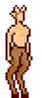
MV Platformer Satyr (32x64) | OpenGameArt.org
Creative commons

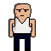
bald man | OpenGameArt.org
Creative commons

Doh sound for men
Doh! | OpenGameArt.org
Creative commons

Alarm for clock
Short alarm | OpenGameArt.org
Creative commons

Rock Breaking sound for bad guy
rock_breaking | OpenGameArt.org
creative commons

Gotcha sound
Gotcha! | OpenGameArt.org
Creative commons

Oh Yeah sound
Oh Yeah | OpenGameArt.org
Creative commons

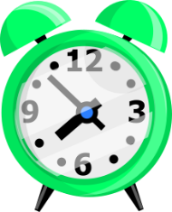
clock | OpenGameArt.org
creative commons

Content License Summary from Pixabay:

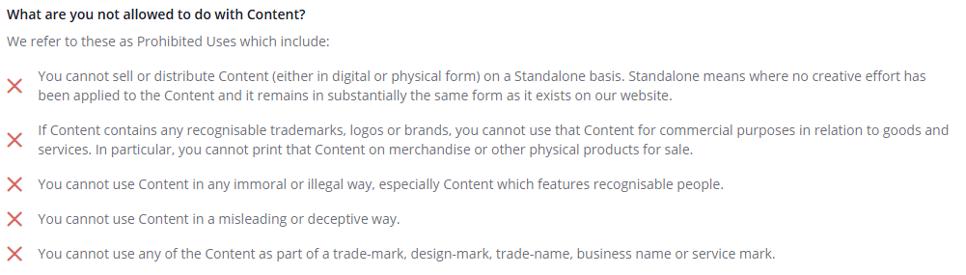
freesound_community on pixabay.com is creator of this sound
name of sound is cartoon kiss
Cartoon Kiss_cjohnstone | Royalty-free Music - Pixabay-link to page where found

- A description of your process -
  - What did you learn?
  - Where did you get stuck?
  - What would you like to improve?
  - How would you do things differently next time?
  - How far did you stray from the game design document?
  - How did you stay on track?

I learned that many things I wanted to do to this game were much harder than I had anticipated. Figuring out how to keep track of instances of objects and how to manipulate them into doing what I want considering the scopes they need to be transitioned into and out of, was difficult to say the least. There were multiple things I could not figure out after hours of trying different ways, watching class videos, reading example coding, etc. It is hard to get an idea from where it is into your head into the pseudocode that will turn into code that works. The high score I could not get to save after the game had been closed. I worked on this for at least half a day, I can’t quite remember how long exactly. I tried different forms of saving files, looked through many notes I have taken from class lectures, and spent a lot of time thinking about what could be causing each mistake. I definitely spent way more time looking through the simpleGE coding than I thought I would! Trying to implement gravity and jumping was by far the worst turn out. There were multiple steps along the way where my game was flashing from the normal screen to a black screen and the main character was falling off the screen, unless you jumped, then he would fly straight up…? There were many other wrecked versions as well. I think I worked on that for two days and eventually realized that my game was too far gone. I had to scrap that version and go back to the previous saved version. I would like to improve upon my understanding of the instances of objects and how to transfer objects and variables between classes in different ways. I know how to in theory but in practice it gets messier. I am not sure if it is some sort of confusion or if it is because I don’t quite understand every move that needs to be done in order to implement the things that I think I know how to implement. There were also many things I know are possible to do but just couldn’t figure out what to do. I created a key photo that I wanted to put onto the instructions screen beside one of the labels that shows a clear picture of the badGuy. This was to help differentiate between all the different characters I introduced. However, I could not figure out if the center coding works for a photo or what way to put a photo in the spot want. This was a last-minute decision I thought of so maybe I would’ve been able to if I had thought of it sooner! My final game is not what I thought it would be. I had to scrap a few concepts and add other ones instead. I am disappointed that I was not able to figure out gravity or the high score saving after closing the game because I was sure that if I just focused, I would be able to. However, it seems I need more practice. I think next time maybe I need to do a lot more planning before starting the game. I might need to make smaller goals so that large goals don’t take up so much of my time, at least while I am still a beginner. I got frustrated over and over with this game, but I think I did a good job of continuing to come back to it and make changes and find new ways to develop an advanced version of my last game.

