Bergen/Jan Brøgger/2016-11-16

How to get started with the ScorePipeline project

# 1. Install Matlab 2016

# 2. Setup ODBC connection

## Using the command line

This only works on Windows 8 or later, or recent Windows Server Versions. Not tested

Start Powershell. Enter the following commands:

Import-Module Wdac

Add-OdbcDsn "SCOREAnon2" -DriverName "Microsoft SQL Server Native Client Version 11.00.6020" -DsnType System -Platform 64-bit -SetPropertyValue @("Database=nativedb") -PassThru -SetPropertyValue @("Server=.", "Trusted_Connection=Yes", "Database=HolbergAnon")

## Using the graphical user interface

Open the Control Panel and search for ODBC.

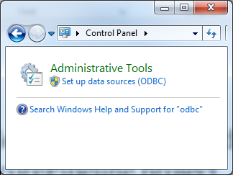

Click on ODBC.

Go to “System DSN”, click Add

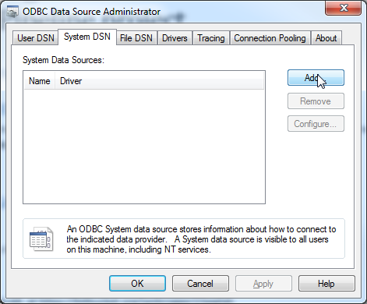

Choose the most recent SQL Client version

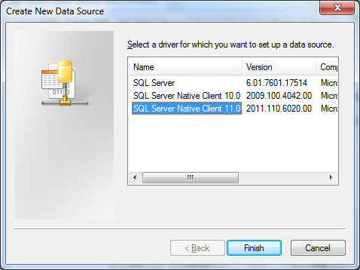

Click Finish.

Fill out the following information. Click Next.

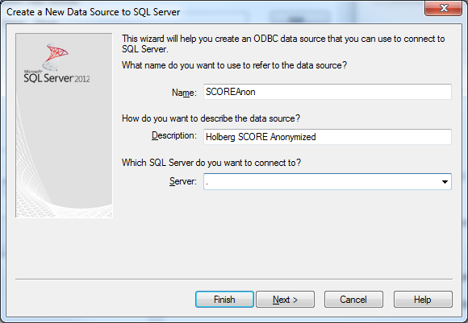

Click Next on this screen:

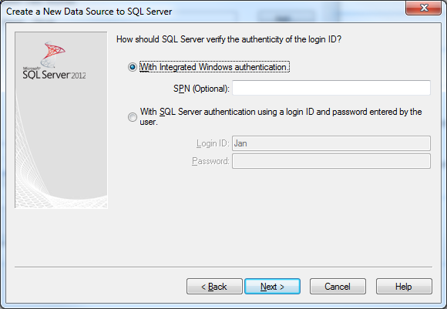

On this next screen, enter the name of the anonymized SCORE research database (e.g. HolbergAnon).

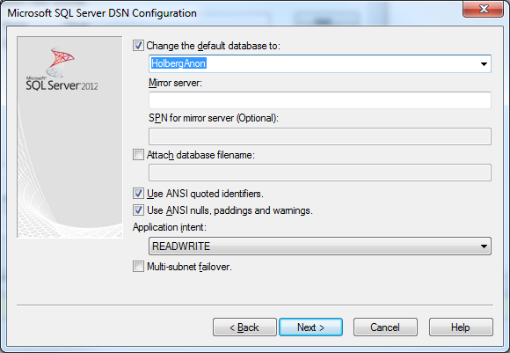

Click Next here, too:

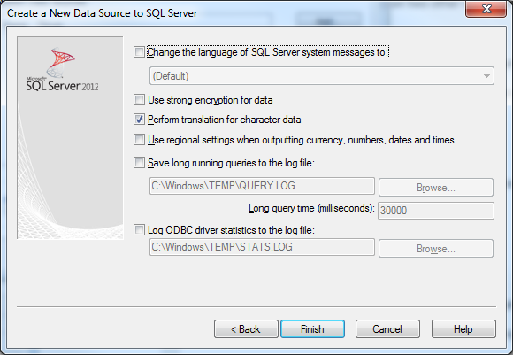

Then click “Test” on this screen:

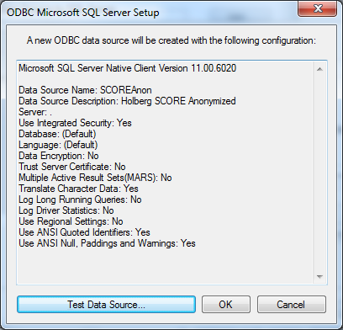

Verify that the test completed successfully:

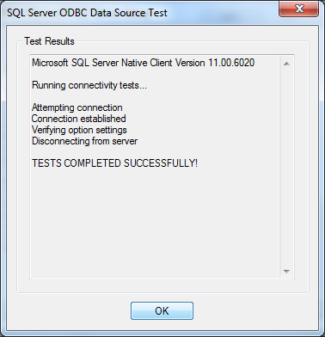

Then click OK to close the ODBC panel:

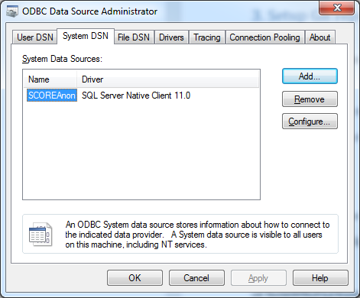

# 3. Setup Git repo dependencies

This repository depends on two other repositories:

1. A fork of EEGLAB, at https://bitbucket.org/janbrogger2/eeglab

2. A fork of FieldTrip at https://github.com/janbrogger/fieldtrip

How to clone the repos to use with ScorePipeline:

cd /d %USERPROFILE%\Documents\

mkdir GitHub

cd %USERPROFILE%\Documents\GitHub

git clone https://janbrogger2@bitbucket.org/janbrogger2/eeglab.git eeglab

git clone https://github.com/janbrogger/fieldtrip fieldtrip