1 Discuss advantages of computer graphics?

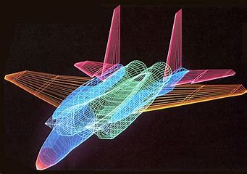

The ability of computers to store complex drawings and display them whenever needed was one of the main attraction for using computers in the graphic mode and The use of sound cards to make computers produce sound effect led to other uses of graphics.

Advantage of computer graphics

1design

2 time

3usability

4reasearch and product development …etc

**Design**

Advertising is an important aspect in the business world. Customers respond to product or service depending on how it is presented to them. Graphical techniques are applied to produce attractive adverts and billboards. Applications like CorelDraw and Photoshop are used to produce magnificent images used in the adverts. Graphics make adverts lively and make them more appealing to potential customers.

### Time

In product development, the traditional method is to produce samples and carry out tests on them, a process that is time consuming. Dorsey and McMillan point that, the availability of such technology “frees humans from tedious and mundane tasks” (Para. 4).

Computer aided design on the other hand involves designing of a graphical presentation of a virtual model. Tests are then done on the model using special software. This saves not only time, but also other resources that would have been used in testing the real structure, hence the cost of production.

### Research and Product Development

Graphical representation software contributes much in research. Models can be presented in three dimensions giving researchers a broader picture of how natural phenomena operate. In engineering, presentation of models in three-dimensional manner enables engineers to identify weaknesses in structures and areas of possible improvement. Computer aided molecular modeling is used in computational chemistry to investigate molecular structures and properties using graphical visualization techniques.

### Usability

Graphical techniques offer more flexible and options compared to other traditional methods in design. One can make changes and undo them without tampering with the whole design. It is also possible to view a model from different angles by rotating it along various axes. One can also perfect on minute details of a design by magnifying it to see them clearly.

Presenting images in three dimensions enables designers to illustrate inner parts of structures they design, bringing clarity on the structures they intend to build. Some graphical applications like Photoshop and illustrator come with tutorials, which help inexperienced users to solve any difficulties. They have a user-friendly interface, usually designed with diversified functions for simplicity.

4 List down and briefly explain about the application areas of computer graphics.



[Computer graphics](https://www.geeksforgeeks.org/computer-graphics-2/) deals with creation, manipulation and storage of different type of images and objects.

Some of the applications of computer graphics are:

1. **Computer Art:**  
   Using computer graphics we can create fine and commercial art which include animation packages, paint packages. These packages provide facilities for designing object shapes and specifying object motion.Cartoon drawing, paintings, logo design can also be done.
2. **Computer Aided Drawing:**  
   Designing of buildings, automobile, aircraft is done with the help of computer aided drawing, this helps in providing minute details to the drawing and producing more accurate and sharp drawings with better specifications.

**3 Presentation Graphics:**  
For the preparation of reports or summarising the financial, statistical, mathematical, scientific, economic data for research reports, managerial reports, moreover creation of bar graphs, pie charts, time chart, can be done using the tools present in computer graphics.

**4Entertainment:**  
Computer graphics finds a major part of its utility in the movie industry and game industry. Used for creating motion pictures , music video, television shows, cartoon animation films. In the game industry where focus and interactivity are the key players, computer graphics helps in providing such features in the efficient way.

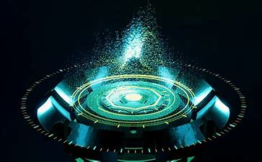

**5Education:**  
Computer generated models are extremely useful for teaching huge number of concepts and fundamentals in an easy to understand and learn manner. Using computer graphics many educational models can be created through which more interest can be generated among the students regarding the subject.

**6Training**  
Specialised system for training like simulators can be used for training the candidates in a way that can be grasped in a short span of time with better understanding. Creation of training modules using computer graphics is simple and very useful.

**7Visualisation:**  
Today the need of visualise things have increased drastically, the need of visualisation can be seen in many advance technologies , data visualisation helps in finding insights of the data , to check and study the behaviour of processes around us we need appropriate visualisation which can be achieved through proper usage of computer graphics

**8Education:**  
Computer generated models are extremely useful for teaching huge number of concepts and fundamentals in an easy to understand and learn manner. Using computer graphics many educational models can be created through which more interest can be generated among the students regarding the subject.

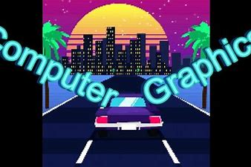

**9Training:**  
Specialised system for training like simulators can be used for training the candidates in a way that can be grasped in a short span of time with better understanding. Creation of training modules using computer graphics is simple and very useful.

**10Visualisation:**  
Today the need of visualise things have increased drastically, the need of visualisation can be seen in many advance technologies , data visualisation helps in finding insights of the data , to check and study the behaviour of processes around us we need appropriate visualisation which can be achieved through proper usage of computer graphics

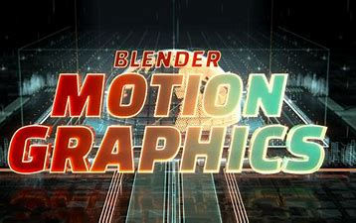

**11Image Processing:**  
Various kinds of photographs or images require editing in order to be used in different places. Processing of existing images into refined ones for better interpretation is one of the many applications of computer graphics.

1. **Machine Drawing:**  
   Computer graphics is very frequently used for designing, modifying and creation of various parts of machine and the whole machine itself, the main reason behind using computer graphics for this purpose is the precision and clarity we get from such drawing is ultimate and extremely desired for the safe manufacturing of machine using these drawings.
2. **Graphical User Interface:**  
   The use of pictures, images, icons, pop-up menus, graphical objects helps in creating a user friendly environment where working is easy and pleasant, using computer graphics we can create such an atmosphere where everything can be automated and anyone can get the desired action performed in an easy fashion.

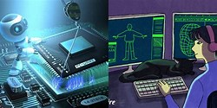

11 a animation

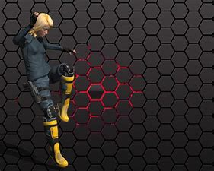

**Animation** is a method in which [figures](https://en.wikipedia.org/wiki/Image) are manipulated to appear as [moving images](https://en.wikipedia.org/wiki/Motion_picture). In [traditional animation](https://en.wikipedia.org/wiki/Traditional_animation), images are drawn or painted by hand on transparent [celluloid sheets](https://en.wikipedia.org/wiki/Cel) to be photographed and exhibited on [film](https://en.wikipedia.org/wiki/Film). Today, most animations are made with [computer-generated imagery](https://en.wikipedia.org/wiki/Computer-generated_imagery) (CGI). [Computer animation](https://en.wikipedia.org/wiki/Computer_animation) can be very detailed [3D animation](https://en.wikipedia.org/wiki/Computer_animation#Animation_methods), while [2D computer animation](https://en.wikipedia.org/wiki/Traditional_animation#Computers_and_traditional_animation) (which may have the look of traditional animation) can be used for stylistic reasons, low bandwidth, or faster [real-time renderings](https://en.wikipedia.org/wiki/Real-time_rendering). Other common animation methods apply a [stop motion](https://en.wikipedia.org/wiki/Stop_motion) technique to two- and three-dimensional objects like [paper cutouts](https://en.wikipedia.org/wiki/Cutout_animation), [puppets](https://en.wikipedia.org/wiki/Puppet), or [clay figures](https://en.wikipedia.org/wiki/Clay_animation).

**Advantages**

* Using interactive animations improve the skills of students as well as teachers. It engages the students in the entire learning process. It helps their imagination and learn concepts with ease. Instructors can use a different method of teaching to the traditional classroom lecture. Emphasis is on learning is less time and effort.
* Interactive animation holds the audience's attention. The use of audio, graphics, and video interactive animation makes it interesting, engaging.
* Real-life experiments hazardous in nature can be sorted using animation. It provides flexibility and safety in re-attempting the experiment.
* Computer animation is made for a flexible interactive way of learning. This builds interest in students wanting to learn more and motivates them. Animation allows one to assess their skills and abilities and attempt risk-free experiments in a safe environment.
* It helps build practical skills. Animation provides real to life scenarios faced in daily life during learning. This learning uses methods of learning by viewing, doing and coaching.  This helps in practical skill development and better knowledge retention.
* Animation adds fun to learning and motivates one to look for more information to learn.

**Disadvantages**

* Animation requires a lot of effort and time to create. It works well from a technical perspective. But educators may find it difficult to place it in their curriculum.
* It cannot judge the level of every student in a class. It becomes difficult to adapt to individual IQ levels. It becomes easy for teachers to handle it with some technical knowledge know-how. It might not fit in well for all.
* The animation technology is created to interact with the students. It cannot recognize the creative factor in the batch of students. Some might be able to use it while others may not.
* Animation technology uses more storage and memory space. It uses more bandwidth and requires high speed and uninterrupted internet connection.

Application area of animation



* 1. **Education and Training:** Animation is used in school, colleges and training centers for education purpose. Flight simulators for aircraft are also animation based.

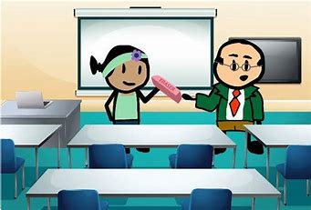

* 1. **Entertainment:** Animation methods are now commonly used in making motion pictures, music videos and television shows, etc.



**3. Computer Aided Design (CAD):** One of the best applications of computer animation is Computer Aided Design and is generally referred to as CAD. One of the earlier applications of CAD was automobile designing. But now almost all types of designing are done by using CAD application, and without animation, all these work can't be possible.

**4. Advertising:** This is one of the significant applications of computer animation. The most important advantage of an animated advertisement is that it takes very less space and capture people attention.



**5. Presentation:** Animated Presentation is the most effective way to represent an idea. It is used to describe financial, statistical, mathematical, scientific & economic data.