Clone project from Gitea (git clone ...)

run commands after cloning:
npm init -y this creates “package.json” etc config files (try to run it, maybe need to
also run 'npm install' before and install node.js)
npm install express socket.io -this one to get socket module

check that node.js installed (‘node -v’)
in case of install or compatibility issues ‘npm audit fix’ can help

to start server, enter command -
npm start
(or 'node server.js')

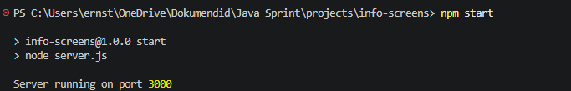

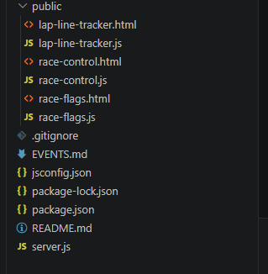
Check in “public” folder sample html and .js files for interfaces, and server.js file for server:

E.g. in race-control.js it is set up that race-control emits such events as “race start”, “flag change” and “race end” (event names must be same on server side), it is done with this socket.emit method

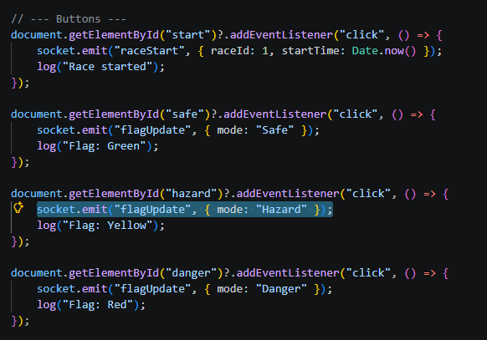

Server gets these events (check server.js) by ‘socket.on’ method, and then with ‘io.emit’ sends info to all other screens

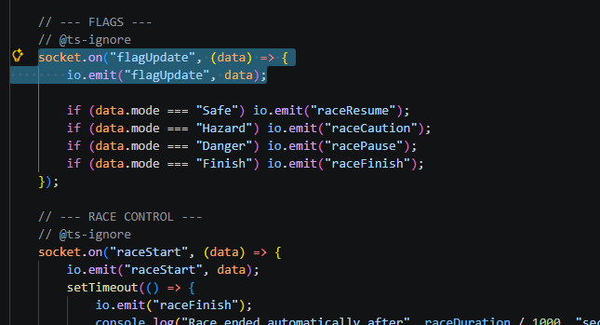

For example, race-control.js ends race
socket.emit("raceEnd", { raceId: 1 });

now server.js has ‘socket.on’ listening to “raceEnd” and with io.emit it sends it over to all others
socket.on("raceEnd", (data) => {
io.emit("raceEnd", data);
});

now lap-line-tracker.js gets this event too
socket.on("raceEnd", () => {
log("Race ended. Lap submission disabled.");
raceEnded = true;
});

So further logic and functions about what to do with that piece of data, is all implemented in .js files of each interface (display)

