Peer assesment 1_reproducible research

Marijan Mihaldinec

2nd November 2017

Table of Contents

Introduction 1

Assignment 2

set working directory 2

Included packages 2

Loading and preprocessing the data 2

Process/transform the data => format suitable for analysis 3

What is mean total number of steps taken per day? 4

What is the average daily activity pattern? 5

Which 5-minute interval, on average across all the days in the dataset, contains the maximum number of steps? 6

Calculate and report the total number of missing values in the dataset (i.e. the total number of rows with NAs) 6

Devise a strategy 7

## Introduction

It is now possible to collect a large amount of data about personal movement using activity monitoring devices such as a Fitbit, Nike Fuelband, or Jawbone Up. These type of devices are part of the “quantified self” movement – a group of enthusiasts who take measurements about themselves regularly to improve their health, to find patterns in their behavior, or because they are tech geeks. But these data remain under-utilized both because the raw data are hard to obtain and there is a lack of statistical methods and software for processing and interpreting the data.

This assignment makes use of data from a personal activity monitoring device. This device collects data at 5 minute intervals through out the day. The data consists of two months of data from an anonymous individual collected during the months of October and November, 2012 and include the number of steps taken in 5 minute intervals each day.

The data for this assignment can be downloaded from the course web site:

Dataset: Activity monitoring data [52K] The variables included in this dataset are:

steps: Number of steps taking in a 5-minute interval (missing values are coded as NA) date: The date on which the measurement was taken in YYYY-MM-DD format interval: Identifier for the 5-minute interval in which measurement was taken The dataset is stored in a comma-separated-value (CSV) file and there are a total of 17,568 observations in this dataset.

## Assignment

When writing code chunks in the R markdown document, always use echo = TRUE

# set working directory

setwd("C:/Users/mihaldma/Documents/coursera/REPRODUCIBLE_RESEARCH/REPRODUCIBLE_RESEARCH_PEER ASSESSMENT1")

# Included packages

library(knitr)  
library(dplyr)

##   
## Attaching package: 'dplyr'

## The following objects are masked from 'package:stats':  
##   
## filter, lag

## The following objects are masked from 'package:base':  
##   
## intersect, setdiff, setequal, union

library(ggplot2)  
library(lattice)  
library(reshape2)  
library(lubridate)

##   
## Attaching package: 'lubridate'

## The following object is masked from 'package:base':  
##   
## date

# Loading and preprocessing the data

data <- read.csv("activity.csv")  
head(data)

## steps date interval  
## 1 NA 2012-10-01 0  
## 2 NA 2012-10-01 5  
## 3 NA 2012-10-01 10  
## 4 NA 2012-10-01 15  
## 5 NA 2012-10-01 20  
## 6 NA 2012-10-01 25

tail(data)

## steps date interval  
## 17563 NA 2012-11-30 2330  
## 17564 NA 2012-11-30 2335  
## 17565 NA 2012-11-30 2340  
## 17566 NA 2012-11-30 2345  
## 17567 NA 2012-11-30 2350  
## 17568 NA 2012-11-30 2355

summary(data)

## steps date interval   
## Min. : 0.00 2012-10-01: 288 Min. : 0.0   
## 1st Qu.: 0.00 2012-10-02: 288 1st Qu.: 588.8   
## Median : 0.00 2012-10-03: 288 Median :1177.5   
## Mean : 37.38 2012-10-04: 288 Mean :1177.5   
## 3rd Qu.: 12.00 2012-10-05: 288 3rd Qu.:1766.2   
## Max. :806.00 2012-10-06: 288 Max. :2355.0   
## NA's :2304 (Other) :15840

str(data)

## 'data.frame': 17568 obs. of 3 variables:  
## $ steps : int NA NA NA NA NA NA NA NA NA NA ...  
## $ date : Factor w/ 61 levels "2012-10-01","2012-10-02",..: 1 1 1 1 1 1 1 1 1 1 ...  
## $ interval: int 0 5 10 15 20 25 30 35 40 45 ...

# Process/transform the data => format suitable for analysis

dt = Sys.time()  
  
date <- format(dt,"%d-%b-%Y")  
  
time <- format(dt,"%H:%M:%S")  
  
str(data)

## 'data.frame': 17568 obs. of 3 variables:  
## $ steps : int NA NA NA NA NA NA NA NA NA NA ...  
## $ date : Factor w/ 61 levels "2012-10-01","2012-10-02",..: 1 1 1 1 1 1 1 1 1 1 ...  
## $ interval: int 0 5 10 15 20 25 30 35 40 45 ...

head(data)

## steps date interval  
## 1 NA 2012-10-01 0  
## 2 NA 2012-10-01 5  
## 3 NA 2012-10-01 10  
## 4 NA 2012-10-01 15  
## 5 NA 2012-10-01 20  
## 6 NA 2012-10-01 25

summary(data)

## steps date interval   
## Min. : 0.00 2012-10-01: 288 Min. : 0.0   
## 1st Qu.: 0.00 2012-10-02: 288 1st Qu.: 588.8   
## Median : 0.00 2012-10-03: 288 Median :1177.5   
## Mean : 37.38 2012-10-04: 288 Mean :1177.5   
## 3rd Qu.: 12.00 2012-10-05: 288 3rd Qu.:1766.2   
## Max. :806.00 2012-10-06: 288 Max. :2355.0   
## NA's :2304 (Other) :15840

datatransform <- na.omit(data)  
  
head(datatransform)

## steps date interval  
## 289 0 2012-10-02 0  
## 290 0 2012-10-02 5  
## 291 0 2012-10-02 10  
## 292 0 2012-10-02 15  
## 293 0 2012-10-02 20  
## 294 0 2012-10-02 25

summary(datatransform)

## steps date interval   
## Min. : 0.00 2012-10-02: 288 Min. : 0.0   
## 1st Qu.: 0.00 2012-10-03: 288 1st Qu.: 588.8   
## Median : 0.00 2012-10-04: 288 Median :1177.5   
## Mean : 37.38 2012-10-05: 288 Mean :1177.5   
## 3rd Qu.: 12.00 2012-10-06: 288 3rd Qu.:1766.2   
## Max. :806.00 2012-10-07: 288 Max. :2355.0   
## (Other) :13536

# What is mean total number of steps taken per day?

sumsteps<- aggregate(steps ~ date, datatransform, FUN=sum)  
  
hist(sumsteps$steps, main= "Total Steps per Day", xlab="Steps")  
  
abline(v=median(sumsteps$steps), lty=4, col="red")

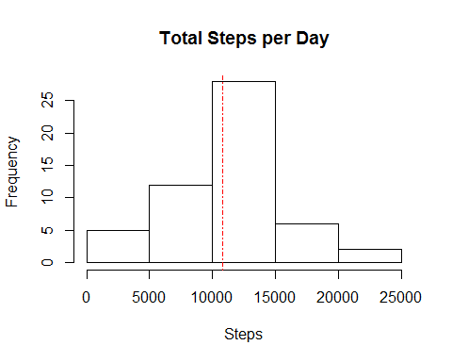

summary(sumsteps$steps)

## Min. 1st Qu. Median Mean 3rd Qu. Max.   
## 41 8841 10765 10766 13294 21194

# What is the average daily activity pattern?

stepsinterval<- aggregate(steps ~ interval, datatransform, mean, na.rm = TRUE)  
  
plot (stepsinterval$interval, stepsinterval$steps, type = "l", lwd = 2,   
 xlab = "Interval",   
 ylab = "Total Steps",   
 main = "Average daily activity pattern")

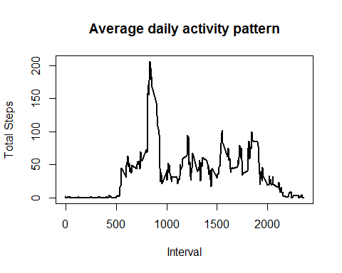

# Which 5-minute interval, on average across all the days in the dataset, contains the maximum number of steps?

summary(stepsinterval)

## interval steps   
## Min. : 0.0 Min. : 0.000   
## 1st Qu.: 588.8 1st Qu.: 2.486   
## Median :1177.5 Median : 34.113   
## Mean :1177.5 Mean : 37.383   
## 3rd Qu.:1766.2 3rd Qu.: 52.835   
## Max. :2355.0 Max. :206.170

stepsinterval[which.max(stepsinterval$steps),]

## interval steps  
## 104 835 206.1698

# Calculate and report the total number of missing values in the dataset (i.e. the total number of rows with NAs)

missingvalues <- is.na(data)  
  
totalmissingvalues <- sum(as.numeric(missingvalues))

# Devise a strategy

Devise a strategy for filling in all of the missing values in the dataset. The strategy does not need to be sophisticated. For example, you could use the mean/median for that day, or the mean for that 5-minute interval, etc.

Median for 5-minute interval as the strategy to fill the missing values

nd <- data  
for (i in stepsinterval) {  
 nd[nd$interval == i & is.na(nd$steps), ]$steps <-   
 stepsinterval$steps[stepsinterval$interval == i]  
}  
  
head(nd)

## steps date interval  
## 1 1.7169811 2012-10-01 0  
## 2 0.3396226 2012-10-01 5  
## 3 0.1320755 2012-10-01 10  
## 4 0.1509434 2012-10-01 15  
## 5 0.0754717 2012-10-01 20  
## 6 2.0943396 2012-10-01 25

sum(is.na(nd))

## [1] 0

Make a histogram of the total number of steps taken each day and Calculate and report the mean and median total number of steps taken per day.

Do these values differ from the estimates from the first part of the assignment? What is the impact of imputing missing data on the estimates of the total daily number of steps?

daily_no_steps <- aggregate(steps ~ date, data = nd, sum, na.rm = TRUE)  
  
hist(daily_no_steps$steps, main = "Daily total number of steps", xlab = "Step", breaks = 60)  
abline(v=median(daily_no_steps$steps), lty = 5, col = "red", main = "Median")

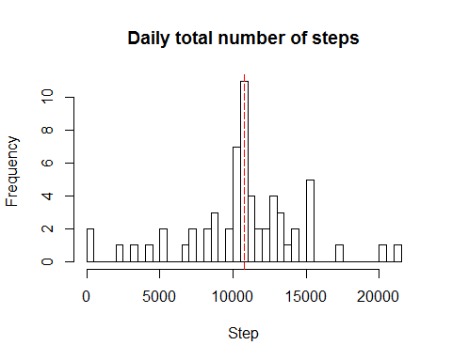

median(daily_no_steps$steps)

## [1] 10766.19

mean(daily_no_steps$steps)

## [1] 10766.19

median(sumsteps$steps)

## [1] 10765

mean(sumsteps$steps)

## [1] 10766.19

Are there differences in activity patterns between weekdays and weekends?

Create a new factor variable in the dataset with two levels – “weekday” and “weekend” indicating whether a given date is a weekday or weekend day.

nd <-nd %>%   
   
 mutate(day=as.factor(ifelse(wday(date) %in% c(1,7),"weekend","weekday")))

Make a panel plot containing a time series plot (i.e. type = "l") of the 5-minute interval (x-axis) and the average number of steps taken, averaged across all weekday days or weekend days (y-axis).

nd <- nd %>%   
   
 group_by(day,interval) %>%  
   
 summarise(meansteps=mean(steps))  
  
ggplot(nd , aes(x = interval , y = meansteps)) + geom_line() + labs(title = "weekday vs weekend", x = "Interval", y = "Number of Steps") + facet_wrap(~`day` , ncol = 2, nrow=1)

