1.INTRODUCTION

1.1 overview:

**A tour is a journey during which several places are visited, especially on a holiday. Travel is movement for any purpose, business or pleasure. Touring often but not always means a vacation trip to see a different place. A trip is the process of travelling from one place to A journey is the distance covered when travelling from one place to another. 'Journey' can refer to a long distance another, staying there, usually for a short time, and coming back again. A journey is the distance covered when travelling from one place to another. 'Journey' can refer to a long distance or a short regular one. The journey was long ...**

**1.2 purpose:**

This business **employs individuals that are dedicated towards their respective roles** and put in a lot of effort to achieve the common vision and larger goals of .. Travel is **the movement of people between distant geographical locations**. Travel can be done by foot, bicycle, automobile, train, boat, bus, airplane, ship or ... **Tourism is travel for pleasure or business**, and the commercial activity of providing and supporting such travel. The World Tourism Organization defines .

**2.Problem Defining & Design Thinking:**

**2.1Empthy Map**

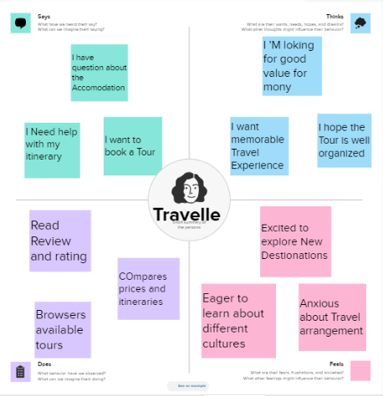

**2.2Ideation & Brainstorming**

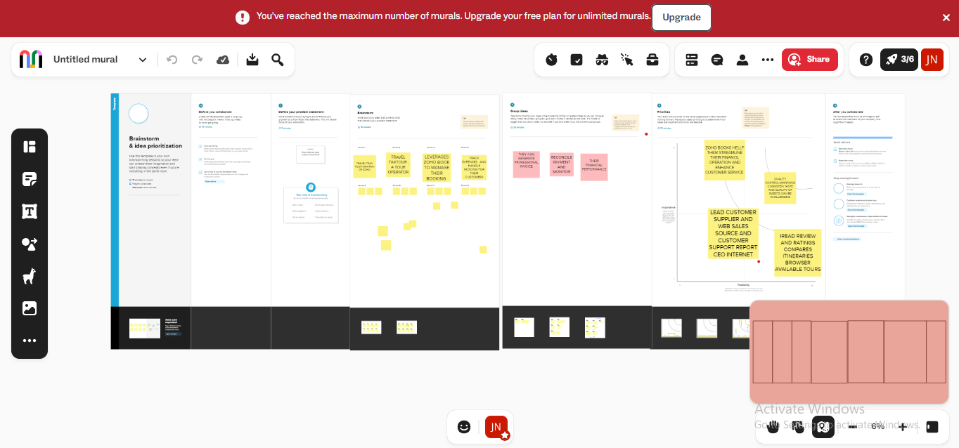

**3 Result:**

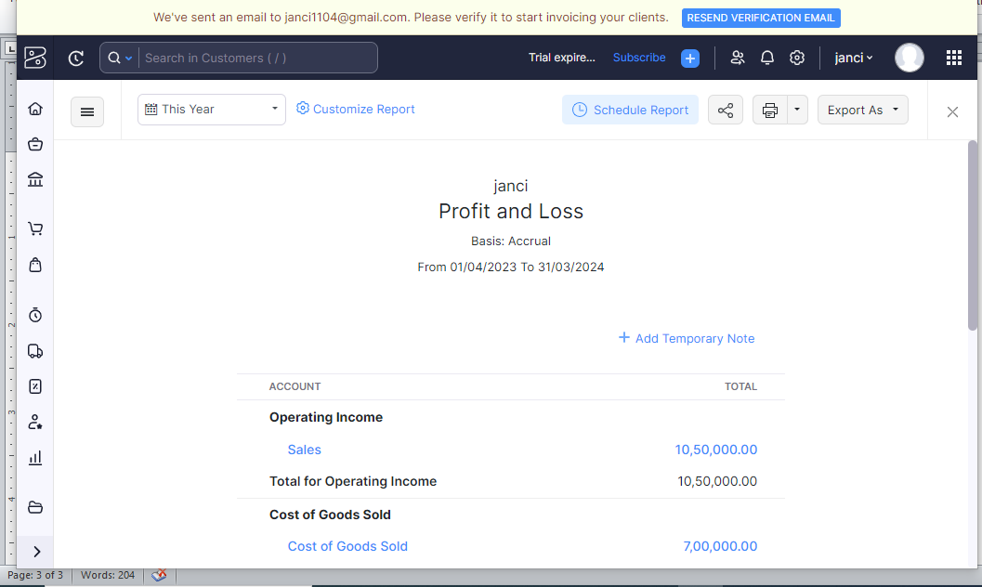

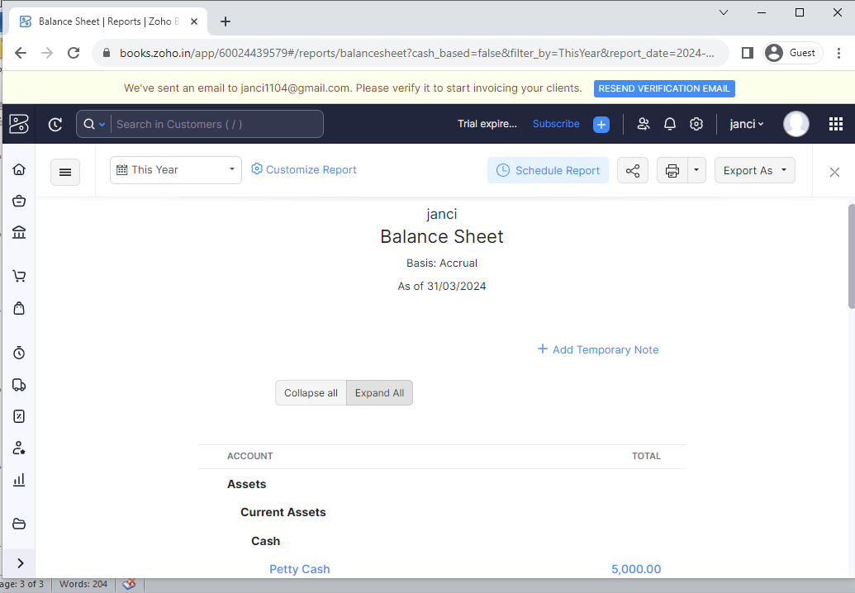

**4 ADVANTAGES & DISADVANTAGES:**

* Tour packages can be a great option when you are looking to plan a **honeymoon or travel with your family**. A poorly planned trip can be quite You will have an expert Tour Director to guide you. ...
* Local guides will ensure you never miss a thing.
* Enjoy a perfect balance of touring and free time.
* Make friends for life.
* Exceptional value for money.
* Curated experiences just for you.
* Another advantage of package tours is that they also provide access to some popular attractions which are not easy to book for a single person.

6. Conclusion:

In conclusion, we can say that tourism is a very productive activity both for the tourist and the government. As they support each other simultaneously. Also, the government should consider improving the conditions of the country as more and more number of tourist visit their country. Despite the effects of adventure tourism and lack of benefits to the surrounding community, the people still support tourism development. Some local communities accept adventure tourism if only they shall benefit directly, whereas, others believe that the positive impacts are more than the negative impacts

7 FUTURE SCOPE:

The tourism sector is projected to contribute to the country's GDP by 2030, generating an employment for 137 Mn individuals, and accrueing $56 Bn in foreign exchange earnings (FEE). The Indian Tourism sector ranks among the fastest-growing economic sectors in the country.