**Results from validation under training setting TS1** (nod detection models trained on each dataset separately)

* comparing various model architectures (4, 8, 16, and 32 GRU units)
* number of features is fixed to 12
* window size is fixed to 32 frames
* the results were generated using the script deep-virtual-rapport-agent/head_gesture_detector/show_training_history.ipynb

**4 GRU**

Loading: hatice2010_nod_32ws_12f_4u.pkl

[last] Max train bacc: 0.9041 @epoch 33

[last] Max val bacc: 0.8798 @epoch 26

[majority] Max train bacc: 0.8950 @epoch 33

[majority] Max val bacc: 0.8205 @epoch 33

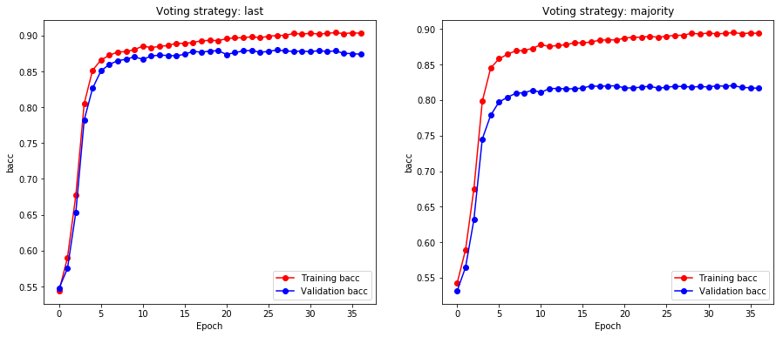

Loading: nvb_nod_32ws_12f_4u.pkl

[last] Max train bacc: 0.8217 @epoch 29

[last] Max val bacc: 0.8209 @epoch 21

[majority] Max train bacc: 0.8217 @epoch 31

[majority] Max val bacc: 0.8272 @epoch 21

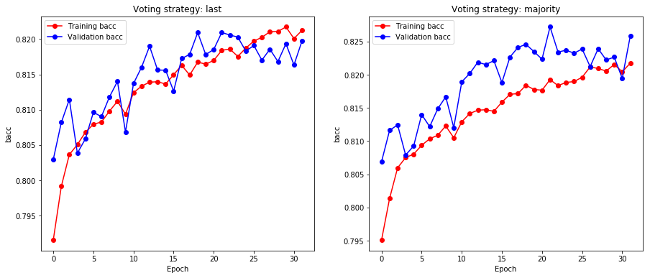

Loading: sewa_nod_32ws_12f_4u.pkl

[last] Max train bacc: 0.8043 @epoch 36

[last] Max val bacc: 0.7784 @epoch 27

[majority] Max train bacc: 0.7881 @epoch 33

[majority] Max val bacc: 0.7701 @epoch 25

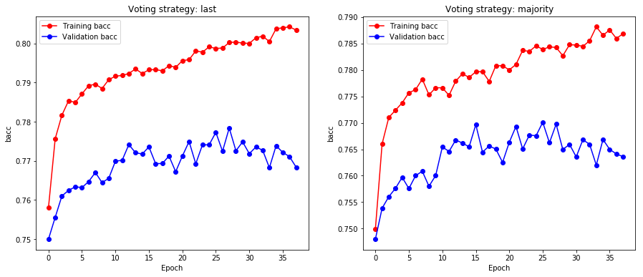

Loading: vra1_nod_32ws_12f_4u.pkl

[last] Max train bacc: 0.8752 @epoch 36

[last] Max val bacc: 0.8595 @epoch 27

[majority] Max train bacc: 0.8706 @epoch 36

[majority] Max val bacc: 0.8588 @epoch 27

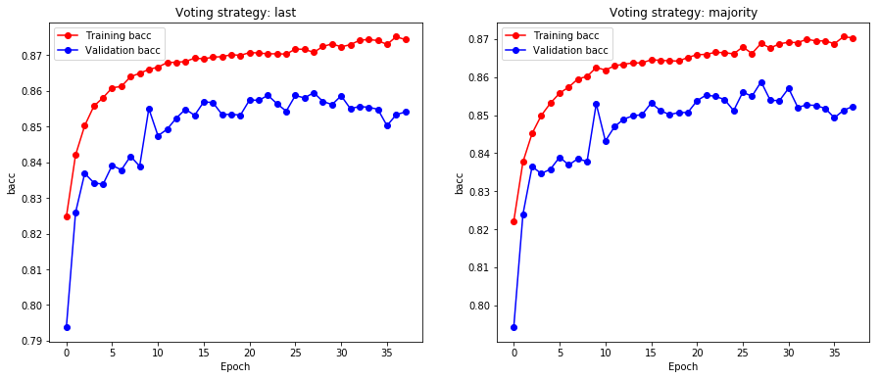

**8 GRU**

Loading: hatice2010_nod_32ws_12f_8u.pkl

[last] Max train bacc: 0.9260 @epoch 63

[last] Max val bacc: 0.8940 @epoch 53

[majority] Max train bacc: 0.9155 @epoch 63

[majority] Max val bacc: 0.8301 @epoch 53

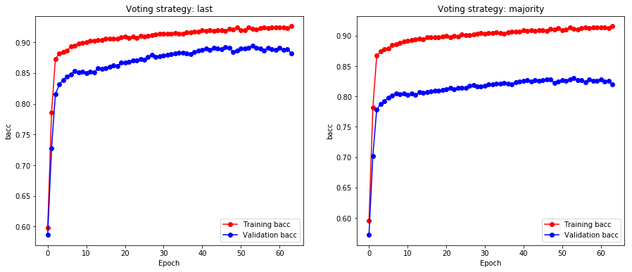

Loading: nvb_nod_32ws_12f_8u.pkl

[last] Max train bacc: 0.8350 @epoch 14

[last] Max val bacc: 0.8263 @epoch 4

[majority] Max train bacc: 0.8337 @epoch 14

[majority] Max val bacc: 0.8317 @epoch 4

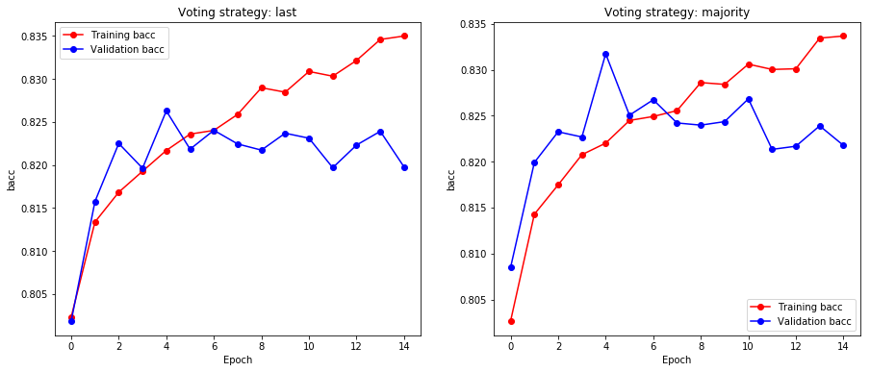

Loading: sewa_nod_32ws_12f_8u.pkl

[last] Max train bacc: 0.8378 @epoch 52

[last] Max val bacc: 0.7886 @epoch 44

[majority] Max train bacc: 0.8200 @epoch 51

[majority] Max val bacc: 0.7795 @epoch 42

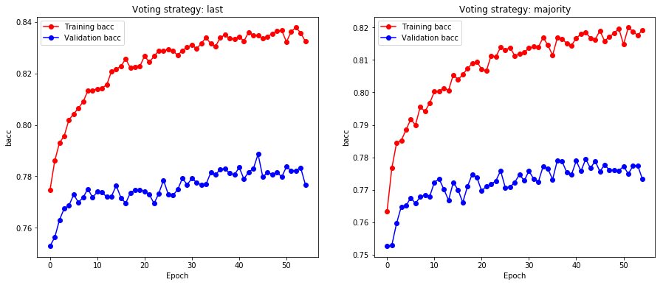

Loading: vra1_nod_32ws_12f_8u.pkl

[last] Max train bacc: 0.8905 @epoch 17

[last] Max val bacc: 0.8475 @epoch 9

[majority] Max train bacc: 0.8867 @epoch 17

[majority] Max val bacc: 0.8484 @epoch 7

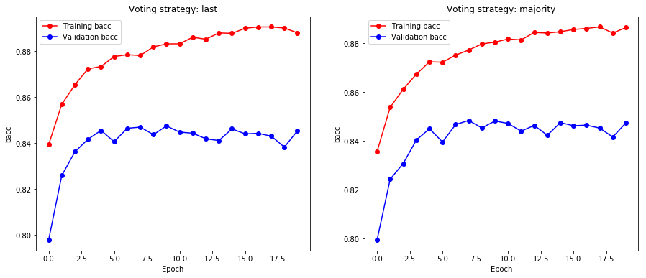

**16 GRU**

Loading: hatice2010_nod_32ws_12f_16u.pkl

[last] Max train bacc: 0.9323 @epoch 41

[last] Max val bacc: 0.8796 @epoch 32

[majority] Max train bacc: 0.9222 @epoch 41

[majority] Max val bacc: 0.8231 @epoch 18

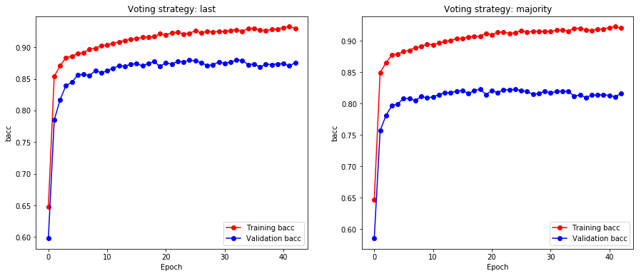

Loading: nvb_nod_32ws_12f_16u.pkl

[last] Max train bacc: 0.8663 @epoch 12

[last] Max val bacc: 0.8200 @epoch 2

[majority] Max train bacc: 0.8622 @epoch 12

[majority] Max val bacc: 0.8242 @epoch 9

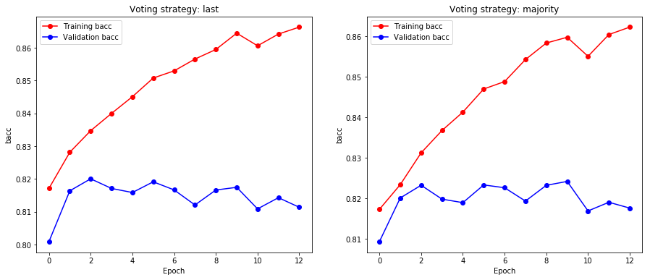

Loading: sewa_nod_32ws_12f_16u.pkl

[last] Max train bacc: 0.8656 @epoch 17

[last] Max val bacc: 0.7884 @epoch 8

[majority] Max train bacc: 0.8447 @epoch 18

[majority] Max val bacc: 0.7850 @epoch 14

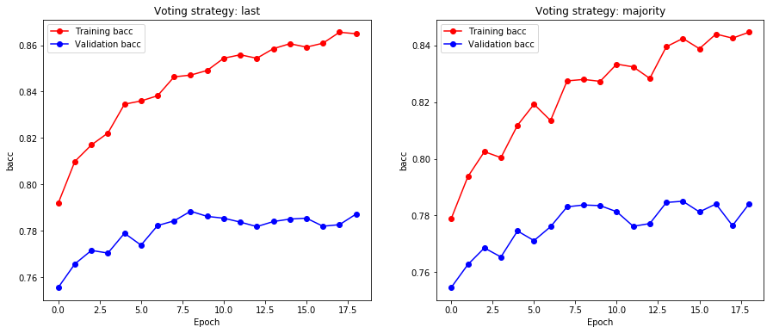

Loading: vra1_nod_32ws_12f_16u.pkl

[last] Max train bacc: 0.9223 @epoch 27

[last] Max val bacc: 0.8679 @epoch 17

[majority] Max train bacc: 0.9152 @epoch 26

[majority] Max val bacc: 0.8648 @epoch 17

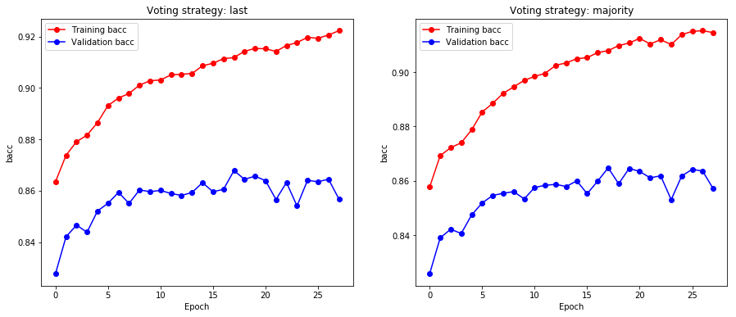

**32 GRU**

Loading: hatice2010_nod_32ws_12f_32u.pkl

[last] Max train bacc: 0.9444 @epoch 48

[last] Max val bacc: 0.8913 @epoch 39

[majority] Max train bacc: 0.9342 @epoch 48

[majority] Max val bacc: 0.8262 @epoch 22

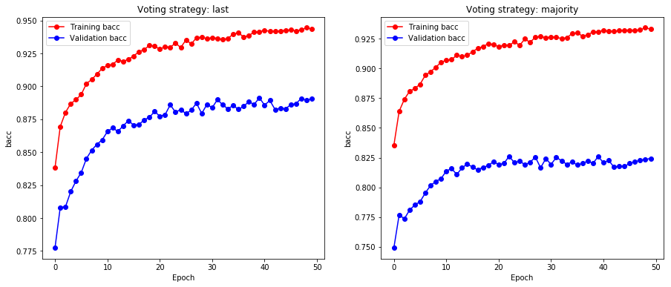

Loading: nvb_nod_32ws_12f_32u.pkl

[last] Max train bacc: 0.9155 @epoch 11

[last] Max val bacc: 0.8207 @epoch 1

[majority] Max train bacc: 0.9059 @epoch 11

[majority] Max val bacc: 0.8259 @epoch 1

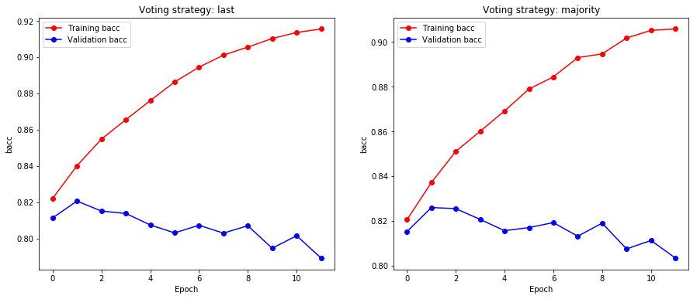

Loading: sewa_nod_32ws_12f_32u.pkl

[last] Max train bacc: 0.9204 @epoch 14

[last] Max val bacc: 0.7943 @epoch 4

[majority] Max train bacc: 0.8966 @epoch 13

[majority] Max val bacc: 0.7909 @epoch 7

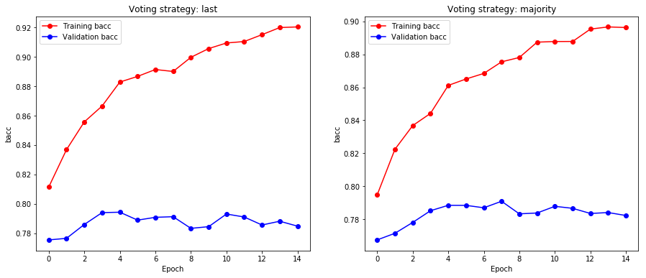

Loading: vra1_nod_32ws_12f_32u.pkl

[last] Max train bacc: 0.9611 @epoch 29

[last] Max val bacc: 0.8635 @epoch 19

[majority] Max train bacc: 0.9489 @epoch 29

[majority] Max val bacc: 0.8671 @epoch 19

