**Results from validation and testing under training setting TS2** (models trained on the 4comb dataset and tested on the 4comb dataset) **for nod head gesture**

* during validation, comparing various model architectures (8, 16, 32, 64, and 128 GRU units)
* testing using non-smoothed and smoothed predictions with the best model architecture
* number of features is fixed to 12
* window size is fixed to 32 frames
* the results were generated using the scripts deep-virtual-rapport-agent/head_gesture_detector/show_training_history.ipynb (validation) and deep-virtual-rapport-agent/head_gesture_detector/evaluate_4comb_hgd.py (testing)

**TESTING - NON-SMOOTHED [for best model 16 GRU units]**

Loading model:

4comb_nod_32ws_12f_16u.hdf5 #params: 1409

Testing on 4comb

[last] bacc: 0.8346

[last] f1: 0.4916

[last] precision: 0.3514

[last] recall: 0.8180

[majority] bacc: 0.8384

[majority] f1: 0.5013

[majority] precision: 0.3610

[majority] recall: 0.8198

Total time taken: 5.688638687133789 s

Saved to ./test_results_4comb_nonS/test_results_4comb_nonS_nod_32ws_12f_16u.pkl

**TESTING - SMOOTHED [for best model 16 GRU units]**

Loading model:

4comb_nod_32ws_12f_16u.hdf5 #params: 1409

Testing on 4comb

[last] bacc: 0.8422

[last] f1: 0.5045

[last] precision: 0.3628

[last] recall: 0.8278

[majority] bacc: 0.8494

[majority] f1: 0.5195

[majority] precision: 0.3771

[majority] recall: 0.8347

Total time taken: 5.047616958618164 s

Saved to ./test_results_4comb_S/test_results_4comb_S_nod_32ws_12f_16u.pkl

**VALIDATION [to find the best model architecture]**

Loading: 4comb_nod_32ws_12f_8u.pkl

[last] Max train bacc: 0.8236 @epoch 13

[last] Max val bacc: 0.8190 @epoch 3

[majority] Max train bacc: 0.8187 @epoch 13

[majority] Max val bacc: 0.8123 @epoch 11

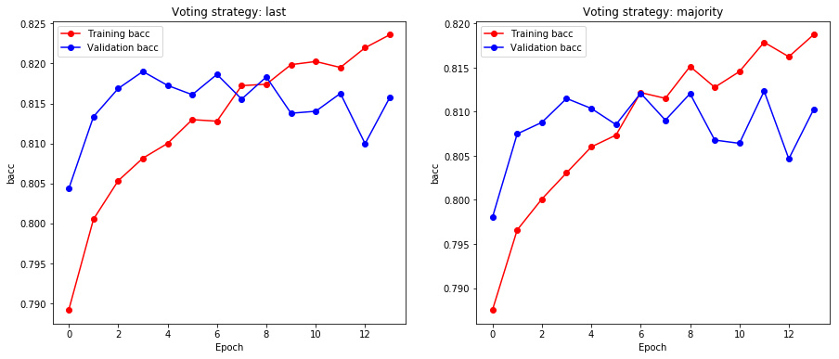

Loading: 4comb_nod_32ws_12f_16u.pkl

[last] Max train bacc: 0.8567 @epoch 14

[last] Max val bacc: 0.8323 @epoch 5

[majority] Max train bacc: 0.8467 @epoch 12

[majority] Max val bacc: 0.8280 @epoch 13

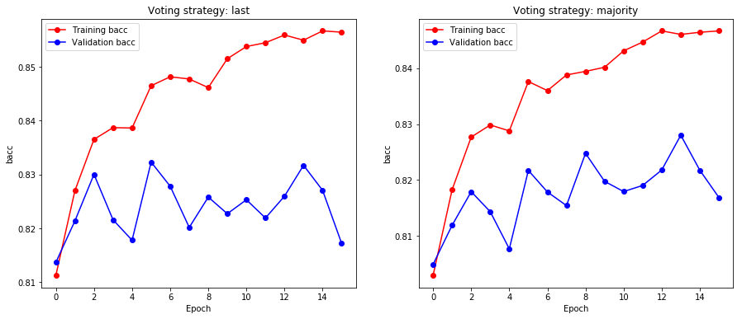

Loading: 4comb_nod_32ws_12f_32u.pkl

[last] Max train bacc: 0.8944 @epoch 10

[last] Max val bacc: 0.8398 @epoch 0

[majority] Max train bacc: 0.8814 @epoch 9

[majority] Max val bacc: 0.8316 @epoch 0

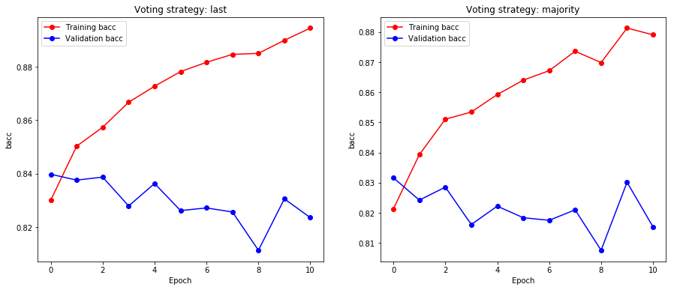

Loading: 4comb_nod_32ws_12f_64u.pkl

[last] Max train bacc: 0.9521 @epoch 12

[last] Max val bacc: 0.8192 @epoch 2

[majority] Max train bacc: 0.9402 @epoch 12

[majority] Max val bacc: 0.8214 @epoch 2

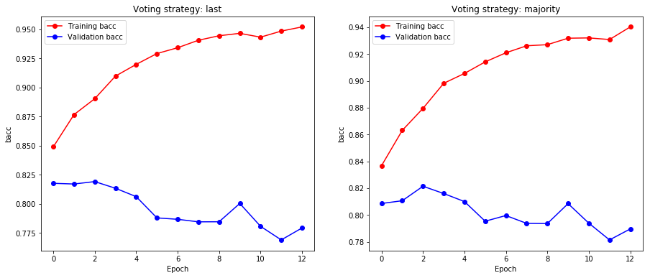

Loading: 4comb_nod_32ws_12f_128u.pkl

[last] Max train bacc: 0.9798 @epoch 10

[last] Max val bacc: 0.8046 @epoch 0

[majority] Max train bacc: 0.9757 @epoch 10

[majority] Max val bacc: 0.8022 @epoch 0

