**Results from validation and testing under training setting TS2** (models trained on the 4comb dataset and tested on the 4comb dataset) **for shake head gesture**

* during validation, comparing various model architectures (4, 8, 16, and 32 GRU units)
* testing using non-smoothed and smoothed predictions with the best model architecture
* number of features is fixed to 12
* window size is fixed to 32 frames
* the results were generated using the scripts deep-virtual-rapport-agent/head_gesture_detector/show_training_history.ipynb (validation) and deep-virtual-rapport-agent/head_gesture_detector/evaluate_4comb_hgd.py (testing)

**TESTING - NON-SMOOTHED [for best model 8 GRU units]**

Loading model:

4comb_shake_32ws_12f_8u.hdf5 #params: 513

Testing on 4comb

[last] bacc: 0.8506

[last] f1: 0.4860

[last] precision: 0.3447

[last] recall: 0.8239

[majority] bacc: 0.8303

[majority] f1: 0.4761

[majority] precision: 0.3432

[majority] recall: 0.7770

Total time taken: 3.9955103397369385 s

Saved to ./test_results_4comb_nonS/test_results_4comb_nonS_shake_32ws_12f_8u.pkl

**TESTING - SMOOTHED [for best model 8 GRU units]**

Loading model:

4comb_shake_32ws_12f_8u.hdf5 #params: 513

Testing on 4comb

[last] bacc: 0.8558

[last] f1: 0.5003

[last] precision: 0.3586

[last] recall: 0.8275

[majority] bacc: 0.8371

[majority] f1: 0.4944

[majority] precision: 0.3613

[majority] recall: 0.7826

Total time taken: 3.169133424758911 s

Saved to ./test_results_4comb_S/test_results_4comb_S_shake_32ws_12f_8u.pkl

**VALIDATION [to find the best model architecture]**

Loading: 4comb_shake_32ws_12f_4u.pkl

[last] Max train bacc: 0.8406 @epoch 17

[last] Max val bacc: 0.8540 @epoch 15

[majority] Max train bacc: 0.8295 @epoch 22

[majority] Max val bacc: 0.8323 @epoch 25

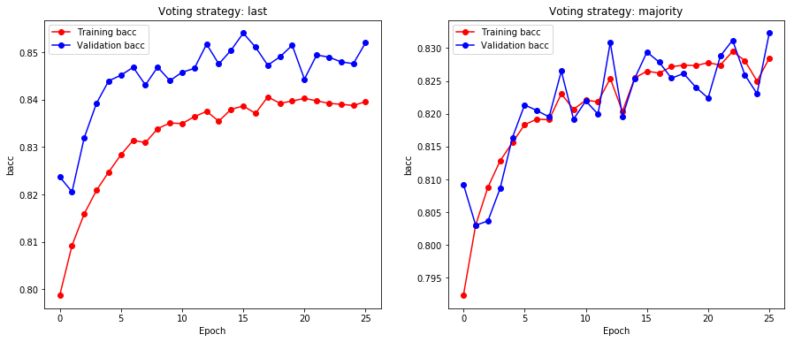

Loading: 4comb_shake_32ws_12f_8u.pkl

[last] Max train bacc: 0.8671 @epoch 45

[last] Max val bacc: 0.8602 @epoch 39

[majority] Max train bacc: 0.8557 @epoch 45

[majority] Max val bacc: 0.8438 @epoch 39

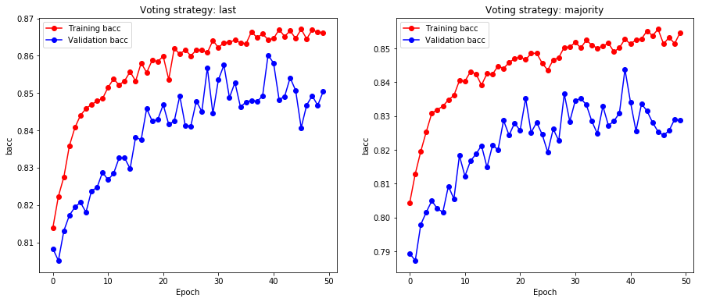

Loading: 4comb_shake_32ws_12f_16u.pkl

[last] Max train bacc: 0.8922 @epoch 19

[last] Max val bacc: 0.8588 @epoch 10

[majority] Max train bacc: 0.8779 @epoch 19

[majority] Max val bacc: 0.8335 @epoch 13

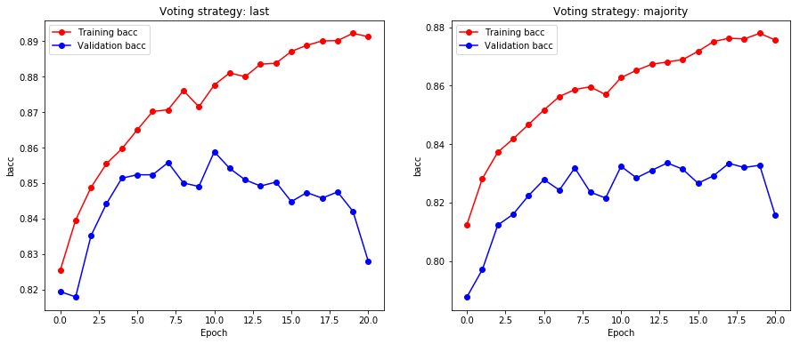

Loading: 4comb_shake_32ws_12f_32u.pkl

[last] Max train bacc: 0.9337 @epoch 14

[last] Max val bacc: 0.8276 @epoch 5

[majority] Max train bacc: 0.9189 @epoch 14

[majority] Max val bacc: 0.8166 @epoch 5

