**Results from validation and testing under training setting TS2** (models trained on the 4comb dataset and tested on the 4comb dataset) **for tilt head gesture**

* during validation, comparing various model architectures (4, 8, 16, and 32 GRU units)
* testing using non-smoothed and smoothed predictions with the best model architecture
* number of features is fixed to 12
* window size is fixed to 32 frames
* the results were generated using the scripts deep-virtual-rapport-agent/head_gesture_detector/show_training_history.ipynb (validation) and deep-virtual-rapport-agent/head_gesture_detector/evaluate_4comb_hgd.py (testing)

**TESTING - NON-SMOOTHED [for best model 16 GRU units]**

Loading model:

4comb_tilt_32ws_12f_16u.hdf5 #params: 1409

Testing on 4comb

[last] bacc: 0.7358

[last] f1: 0.2379

[last] precision: 0.1470

[last] recall: 0.6238

[majority] bacc: 0.7472

[majority] f1: 0.2469

[majority] precision: 0.1526

[majority] recall: 0.6451

Total time taken: 1.8992550373077393 s

Saved to ./test_results_4comb_nonS/test_results_4comb_nonS_tilt_32ws_12f_16u.pkl

**TESTING - SMOOTHED [for best model 16 GRU units]**

Loading model:

4comb_tilt_32ws_12f_16u.hdf5 #params: 1409

Testing on 4comb

[last] bacc: 0.7409

[last] f1: 0.2470

[last] precision: 0.1538

[last] recall: 0.6267

[majority] bacc: 0.7537

[majority] f1: 0.2580

[majority] precision: 0.1609

[majority] recall: 0.6499

Total time taken: 2.9409849643707275 s

Saved to ./test_results_4comb_S/test_results_4comb_S_tilt_32ws_12f_16u.pkl

**VALIDATION [to find the best model architecture]**

Loading: 4comb_tilt_32ws_12f_4u.pkl

[last] Max train bacc: 0.7800 @epoch 57

[last] Max val bacc: 0.8216 @epoch 47

[majority] Max train bacc: 0.7802 @epoch 57

[majority] Max val bacc: 0.8291 @epoch 38

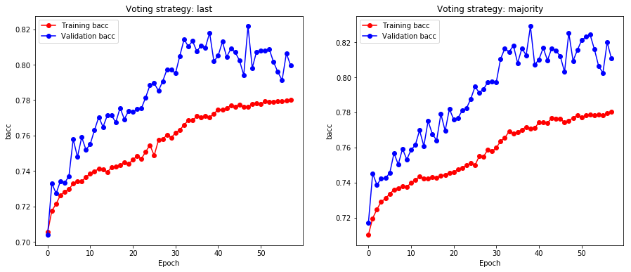

Loading: 4comb_tilt_32ws_12f_8u.pkl

[last] Max train bacc: 0.8147 @epoch 64

[last] Max val bacc: 0.8215 @epoch 54

[majority] Max train bacc: 0.8145 @epoch 64

[majority] Max val bacc: 0.8296 @epoch 40

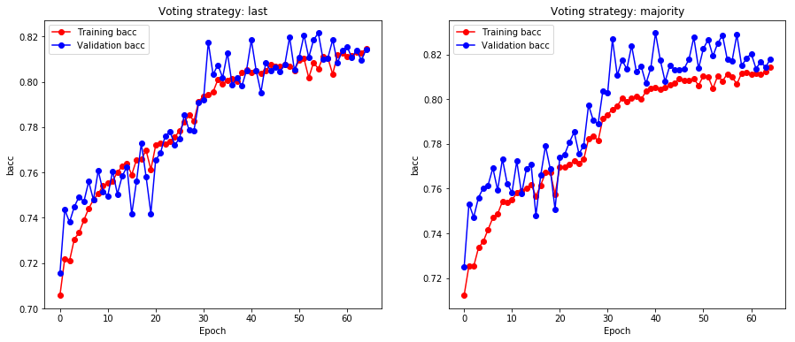

Loading: 4comb_tilt_32ws_12f_16u.pkl

[last] Max train bacc: 0.8627 @epoch 34

[last] Max val bacc: 0.8236 @epoch 24

[majority] Max train bacc: 0.8528 @epoch 34

[majority] Max val bacc: 0.8246 @epoch 31

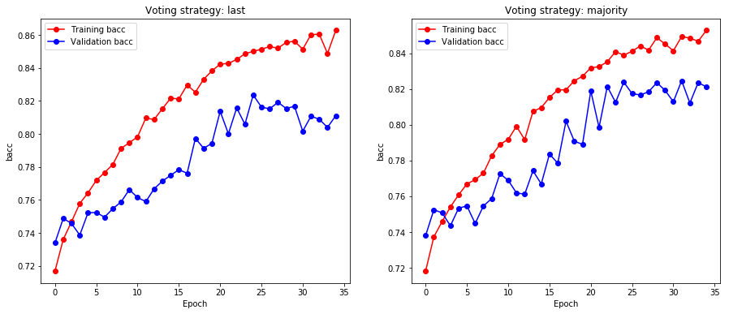

Loading: 4comb_tilt_32ws_12f_32u.pkl

[last] Max train bacc: 0.8947 @epoch 13

[last] Max val bacc: 0.7813 @epoch 3

[majority] Max train bacc: 0.8809 @epoch 12

[majority] Max val bacc: 0.7777 @epoch 3

