**Results from validation under training setting TS3** (models trained on the **whole**  4comb dataset and then tested on another dataset)

* comparing the training with and without data augmentation (A1)
* number of features is fixed to 12
* window size is fixed to 32 frames
* uses the best model architectures found in TS2 during validation
* the results were generated using the scripts deep-virtual-rapport-agent/head_gesture_detector/show_training_history.ipynb

**NO AUGMENTATION**

**NOD**

Loading: final_200epochs_4comb_nod_32ws_12f_16u.pkl 200 epochs [not much better]

[last] Max train bacc: 0.8745 @epoch 178

**[last] Max val bacc: 0.8366 @epoch 172**

[majority] Max train bacc: 0.8651 @epoch 185

[majority] Max val bacc: 0.8307 @epoch 155

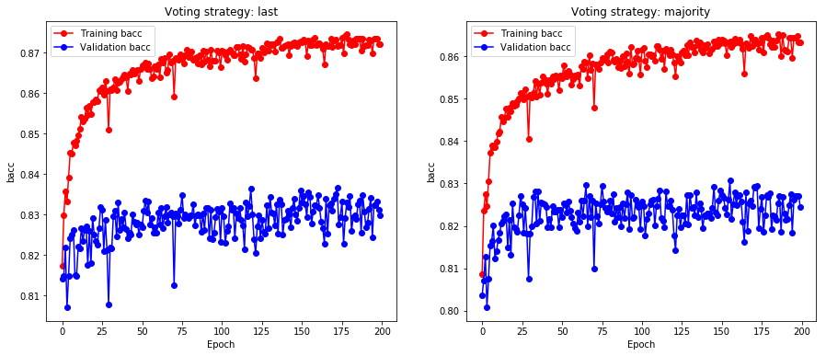

Loading: final_4comb_nod_32ws_12f_16u.pkl 100 epochs

[last] Max train bacc: 0.8706 @epoch 97

**[last] Max val bacc: 0.8363 @epoch 90**

[majority] Max train bacc: 0.8614 @epoch 93

[majority] Max val bacc: 0.8295 @epoch 93

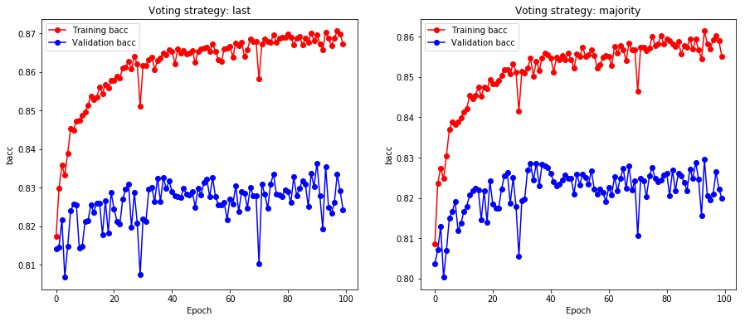

**SHAKE**

Loading: final_4comb_shake_32ws_12f_8u.pkl

[last] Max train bacc: 0.8747 @epoch 93

**[last] Max val bacc: 0.8673 @epoch 63**

[majority] Max train bacc: 0.8627 @epoch 93

[majority] Max val bacc: 0.8467 @epoch 67

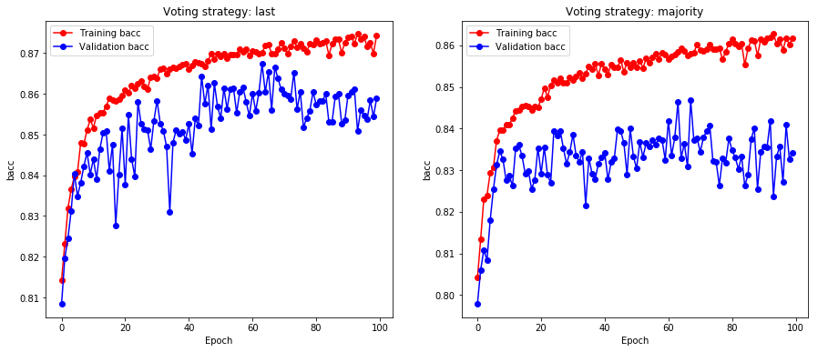

**TILT**

Loading: final_4comb_tilt_32ws_12f_16u.pkl

[last] Max train bacc: 0.8925 @epoch 95

**[last] Max val bacc: 0.8302 @epoch 42**

[majority] Max train bacc: 0.8811 @epoch 98

[majority] Max val bacc: 0.8367 @epoch 75

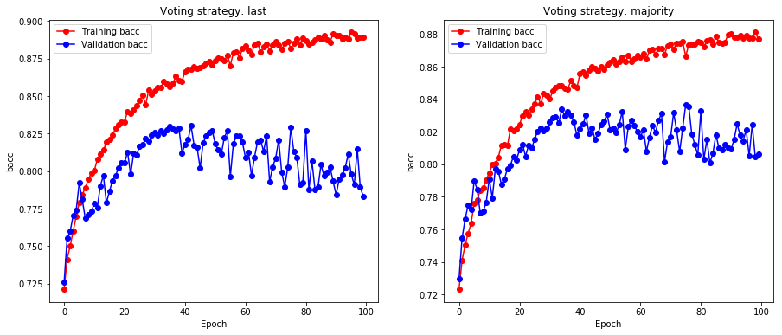

**AUGMENTATION A1 [not better!]**

**NOD**

Loading: final_4comb_nod_32ws_12f_A1_16u.pkl

[last] Max train bacc: 0.8696 @epoch 41

**[last] Max val bacc: 0.8274 @epoch 38**

[majority] Max train bacc: 0.8590 @epoch 97

[majority] Max val bacc: 0.8239 @epoch 38

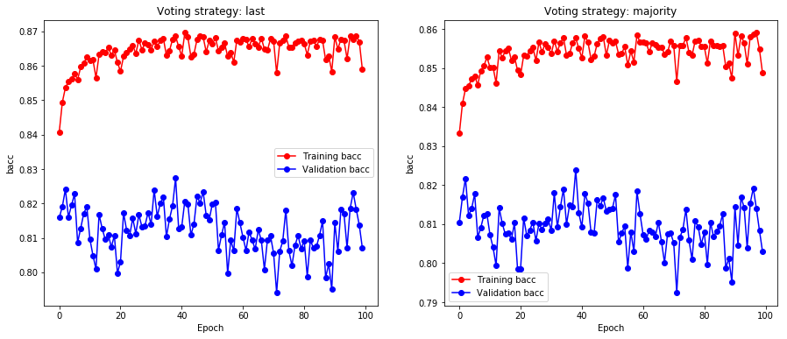

**SHAKE**

Loading: final_4comb_shake_32ws_12f_A1_8u.pkl

[last] Max train bacc: 0.8551 @epoch 38

**[last] Max val bacc: 0.8323 @epoch 96**

[majority] Max train bacc: 0.8431 @epoch 38

[majority] Max val bacc: 0.8187 @epoch 93

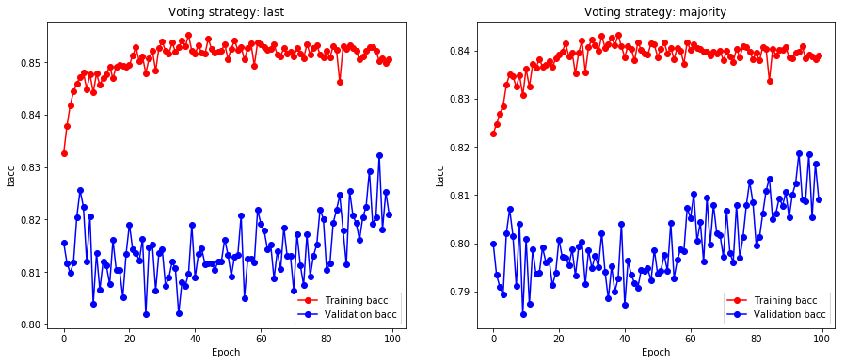

**TILT**

Loading: final_4comb_tilt_32ws_12f_A1_16u.pkl

[last] Max train bacc: 0.8856 @epoch 71

**[last] Max val bacc: 0.7459 @epoch 90**

[majority] Max train bacc: 0.8720 @epoch 97

[majority] Max val bacc: 0.7714 @epoch 97