**Testing results without smoothing (non-cleaned)**

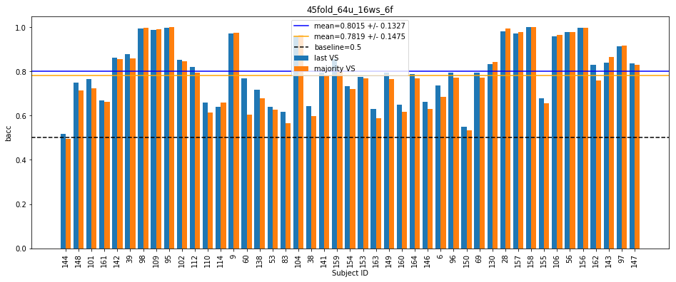

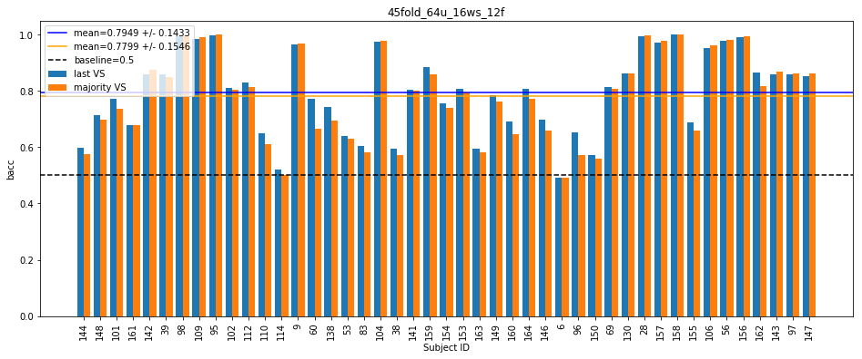

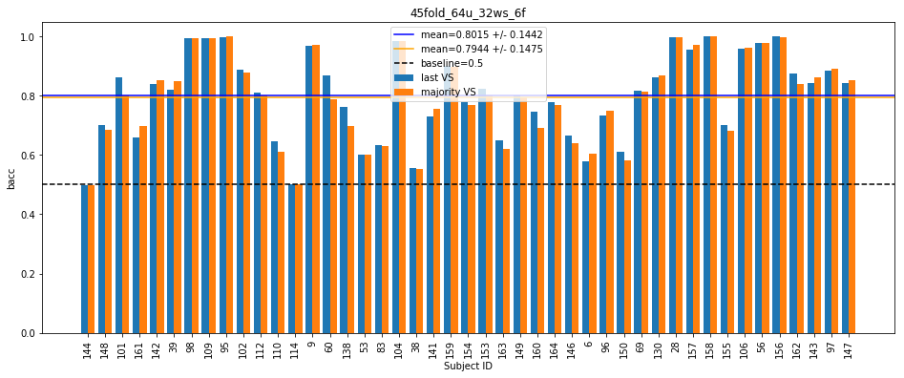

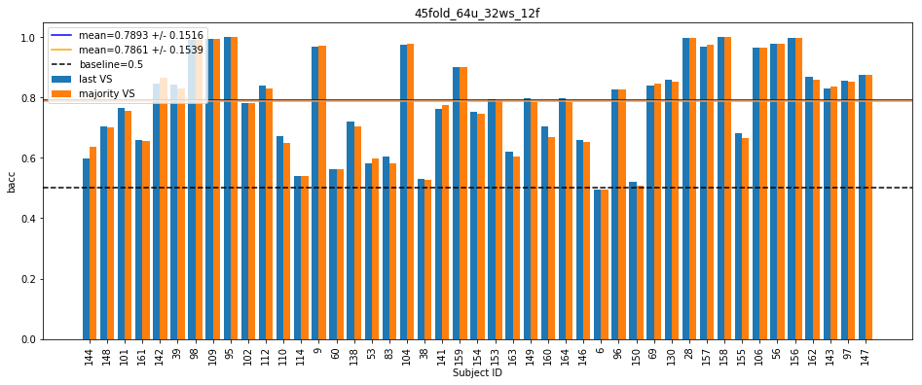

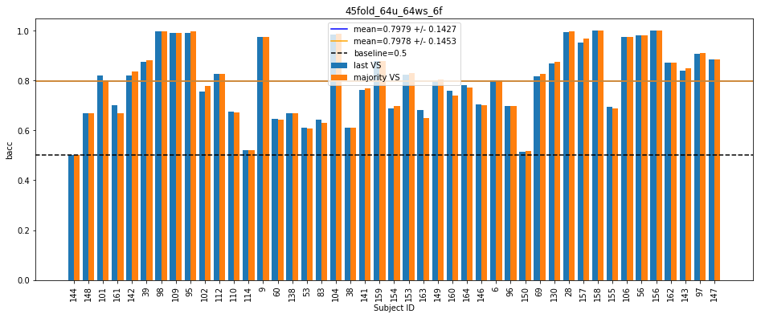

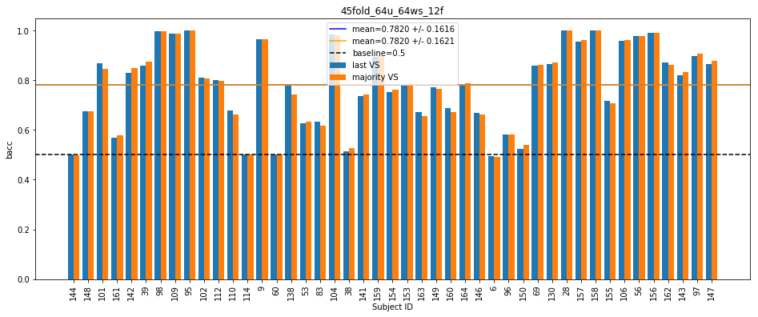

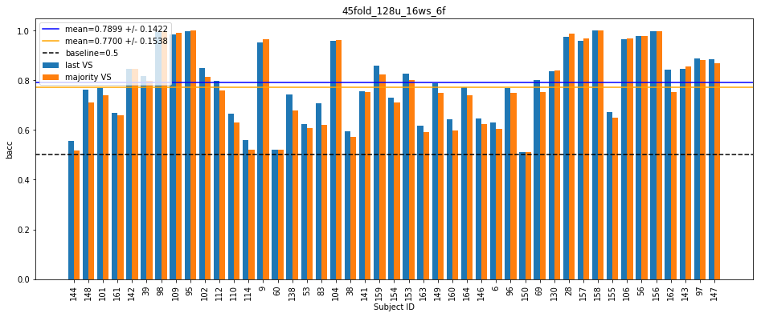

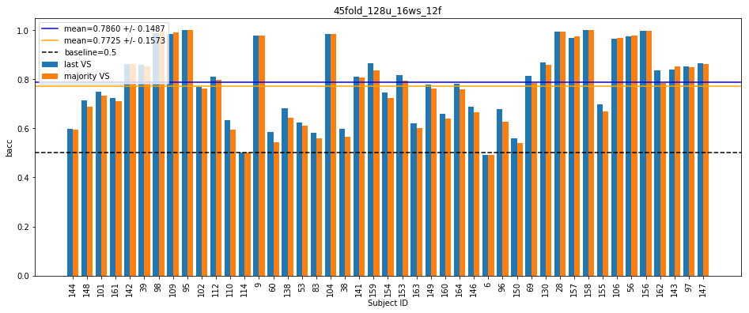

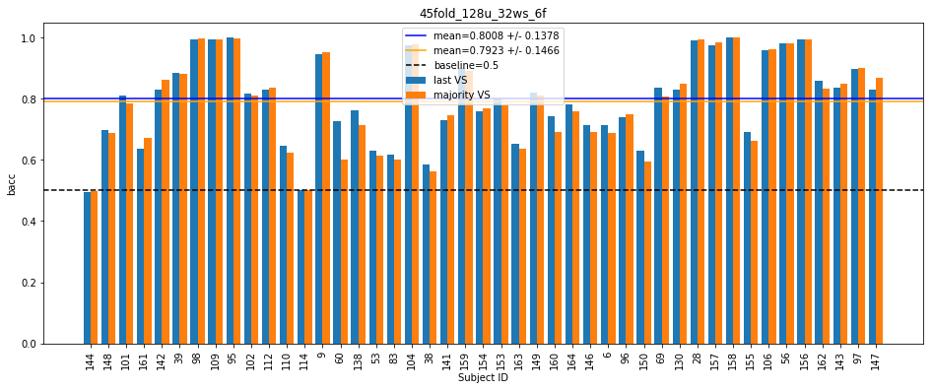

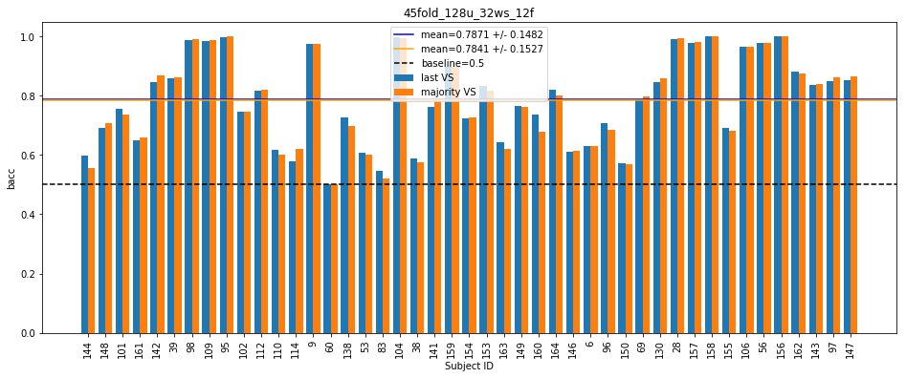

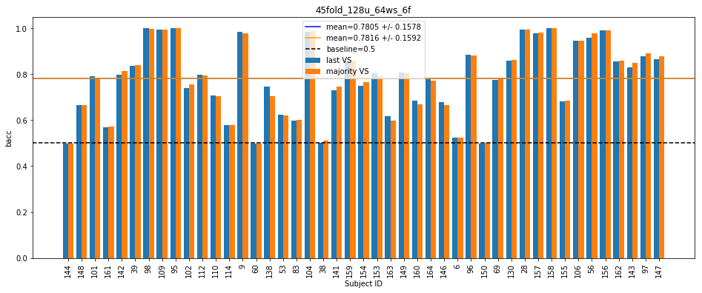

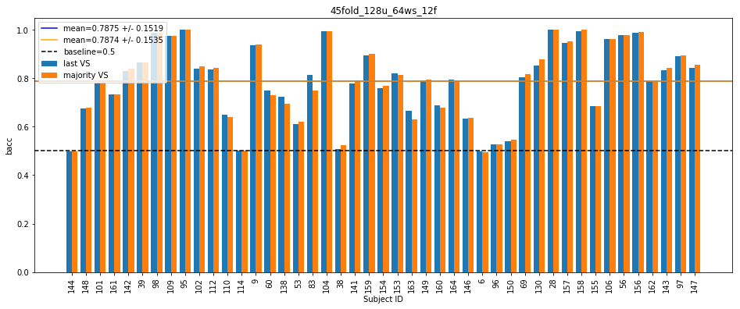

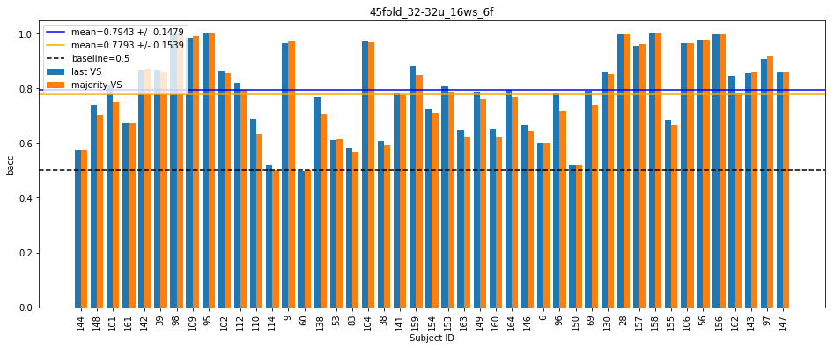

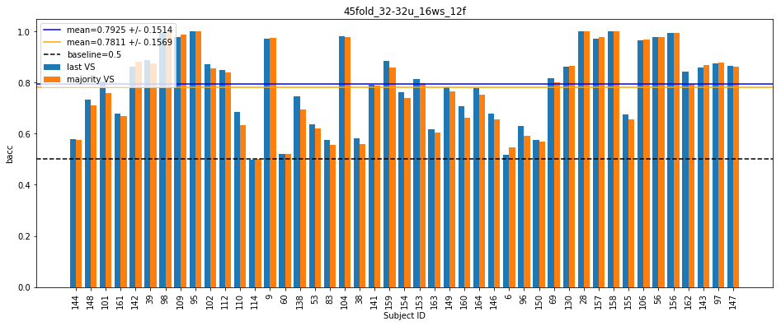

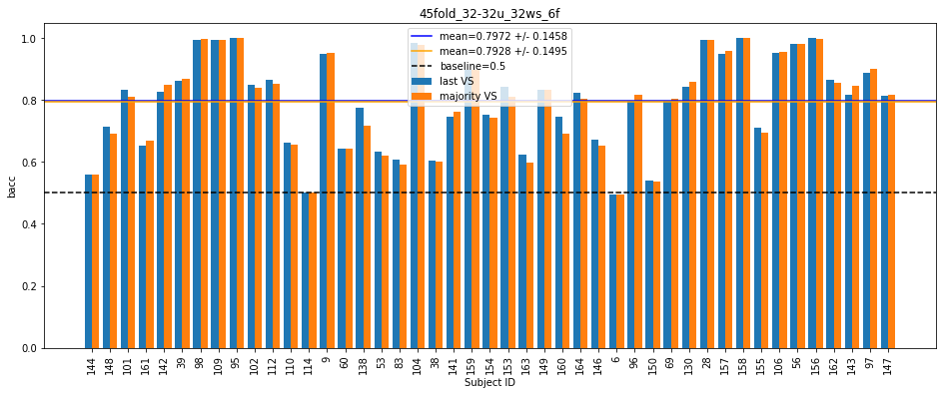

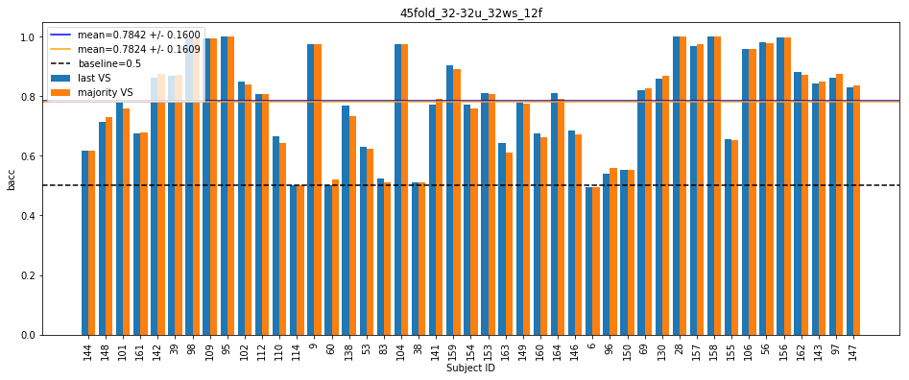

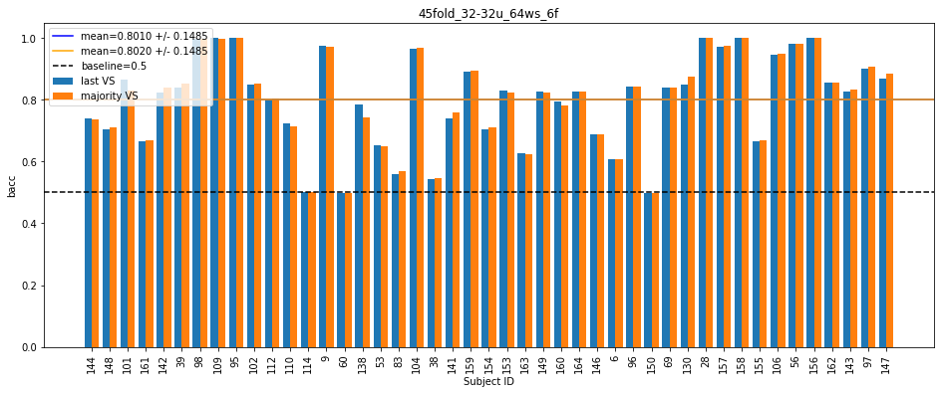

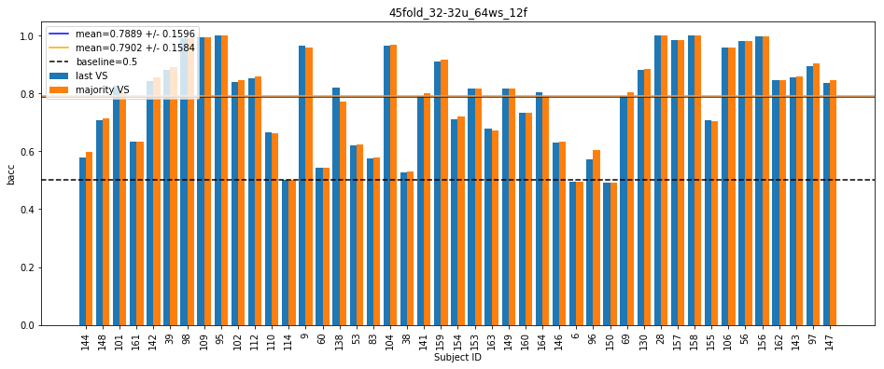

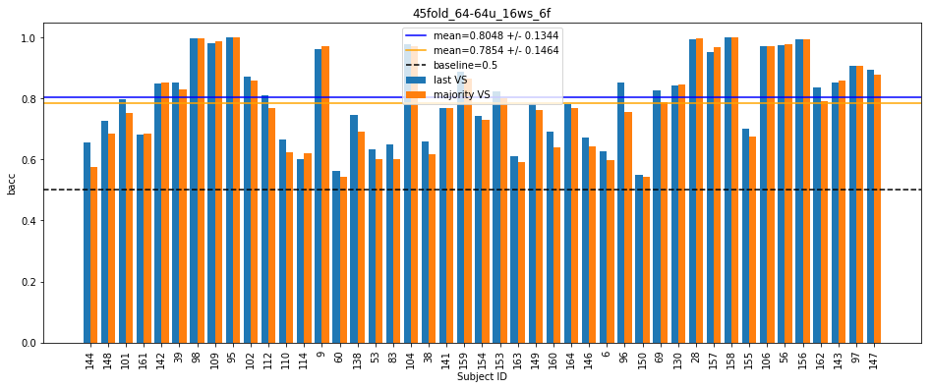

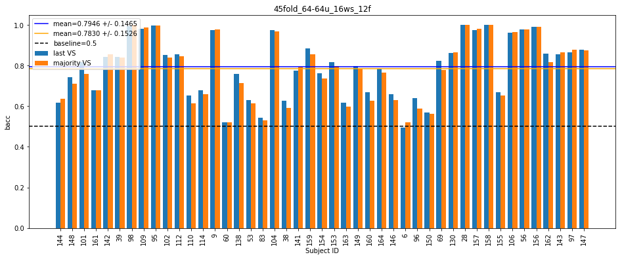

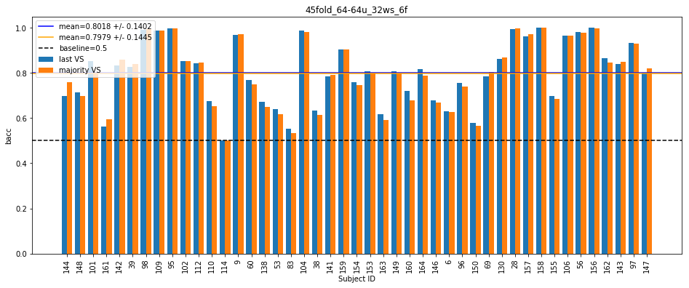

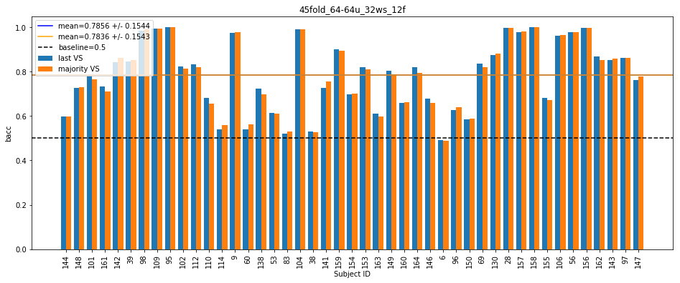

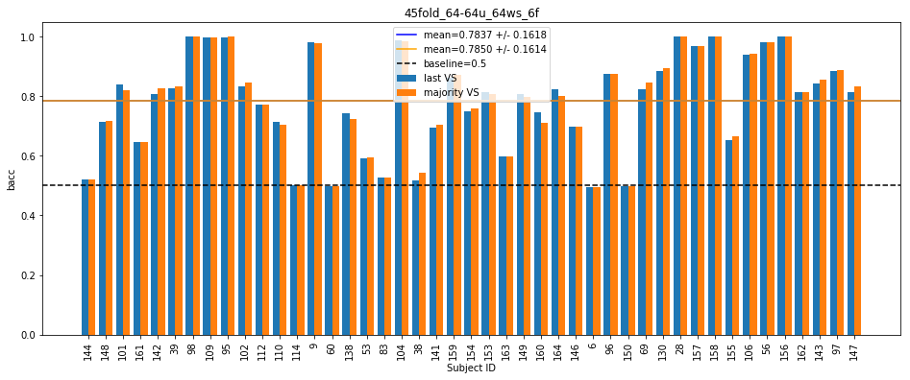

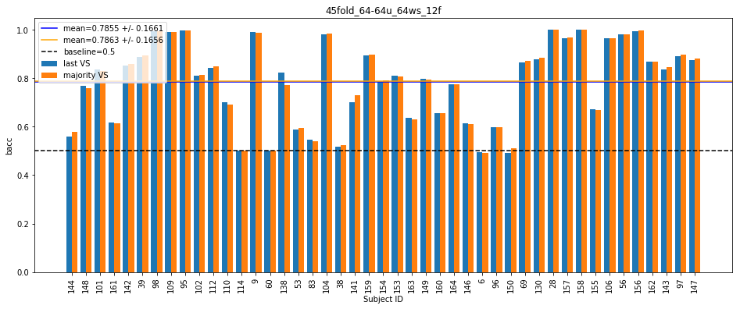

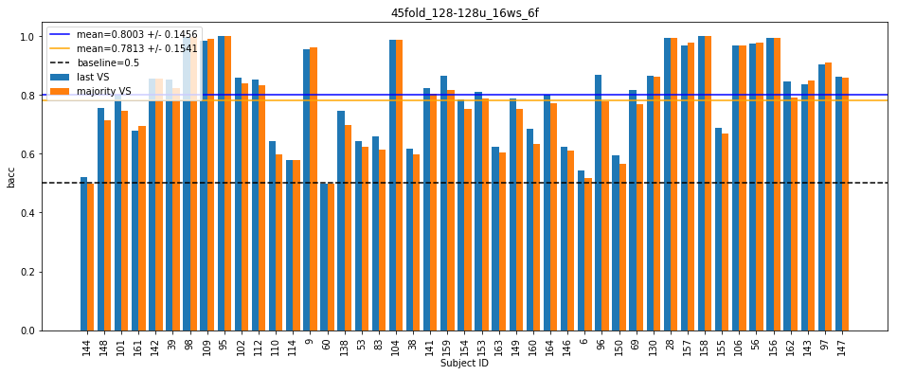

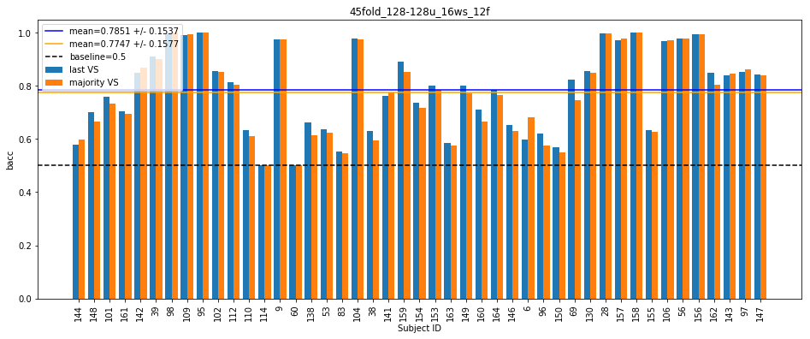

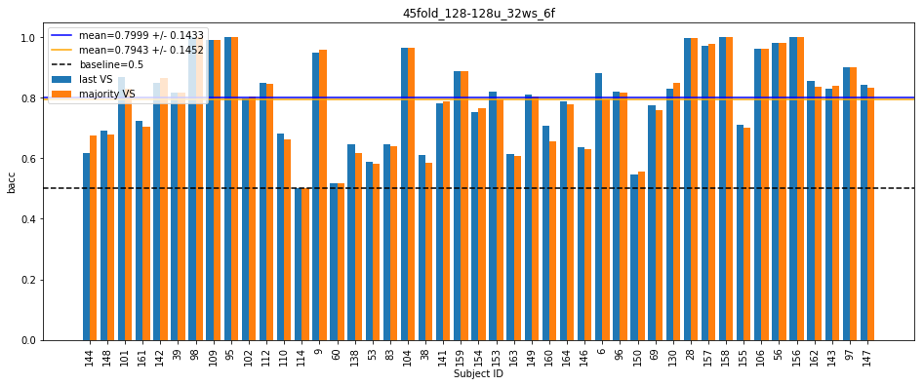

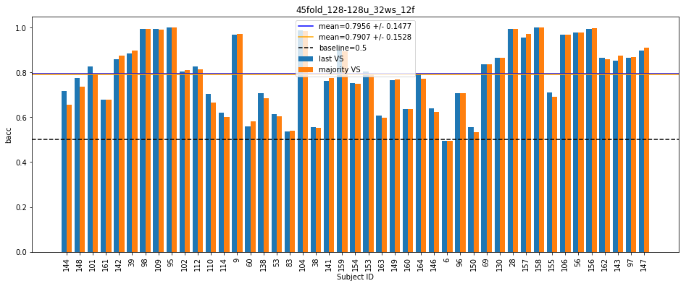

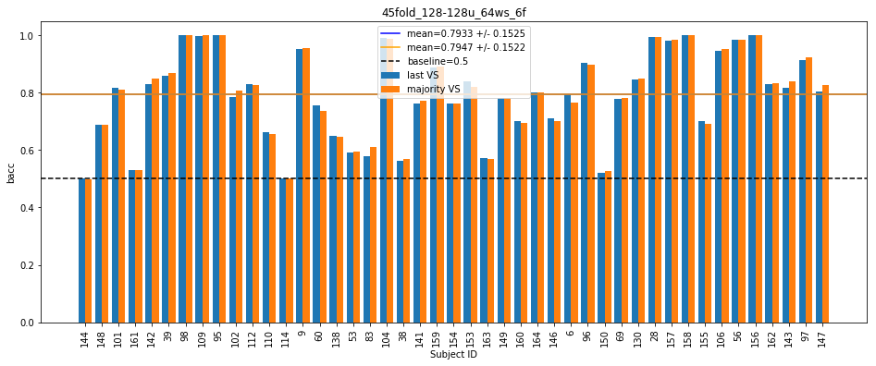

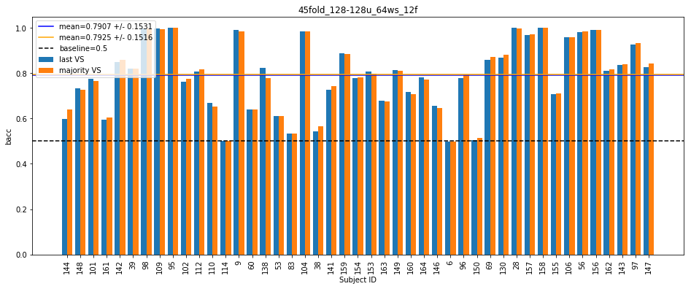

**Testing results without smoothing**

45fold_64u_16ws_6f #params: 13697

[last] Mean bacc: 0.8015 +/- 0.1327

[last] Mean f1: 0.4351 +/- 0.3078

[last] Mean precision: 0.5387 +/- 0.3708

[last] Mean recall: 0.3941 +/- 0.2889

[majority] Mean bacc: 0.7819 +/- 0.1475

[majority] Mean f1: 0.4069 +/- 0.3037

[majority] Mean precision: 0.5733 +/- 0.3891

[majority] Mean recall: 0.3442 +/- 0.2754

Total time taken: 160.00959610939026 s

45fold_64u_16ws_12f #params: 14849

[last] Mean bacc: 0.7949 +/- 0.1433

[last] Mean f1: 0.4283 +/- 0.3114

[last] Mean precision: 0.5428 +/- 0.3673

[last] Mean recall: 0.3814 +/- 0.3012

[majority] Mean bacc: 0.7799 +/- 0.1546

[majority] Mean f1: 0.4014 +/- 0.3095

[majority] Mean precision: 0.5538 +/- 0.3892

[majority] Mean recall: 0.3421 +/- 0.2908

Total time taken: 316.4030590057373 s

45fold_64u_32ws_6f #params: 13697

[last] Mean bacc: 0.8015 +/- 0.1442

[last] Mean f1: 0.4272 +/- 0.3190

[last] Mean precision: 0.5153 +/- 0.3678

[last] Mean recall: 0.3940 +/- 0.3103

[majority] Mean bacc: 0.7944 +/- 0.1475

[majority] Mean f1: 0.4207 +/- 0.3196

[majority] Mean precision: 0.5455 +/- 0.3876

[majority] Mean recall: 0.3712 +/- 0.2979

Total time taken: 481.626590013504 s

45fold_64u_32ws_12f #params: 14849

[last] Mean bacc: 0.7893 +/- 0.1516

[last] Mean f1: 0.4199 +/- 0.3186

[last] Mean precision: 0.5590 +/- 0.3722

[last] Mean recall: 0.3672 +/- 0.3051

[majority] Mean bacc: 0.7861 +/- 0.1539

[majority] Mean f1: 0.4141 +/- 0.3186

[majority] Mean precision: 0.5829 +/- 0.3894

[majority] Mean recall: 0.3548 +/- 0.2988

Total time taken: 650.4020836353302 s

45fold_64u_64ws_6f #params: 13697

[last] Mean bacc: 0.7979 +/- 0.1427

[last] Mean f1: 0.4257 +/- 0.3111

[last] Mean precision: 0.5406 +/- 0.3683

[last] Mean recall: 0.3894 +/- 0.3027

[majority] Mean bacc: 0.7978 +/- 0.1453

[majority] Mean f1: 0.4248 +/- 0.3146

[majority] Mean precision: 0.5556 +/- 0.3781

[majority] Mean recall: 0.3822 +/- 0.3013

Total time taken: 832.7958836555481 s

45fold_64u_64ws_12f #params: 14849

[last] Mean bacc: 0.7820 +/- 0.1616

[last] Mean f1: 0.3956 +/- 0.3296

[last] Mean precision: 0.5039 +/- 0.3867

[last] Mean recall: 0.3580 +/- 0.3181

[majority] Mean bacc: 0.7820 +/- 0.1621

[majority] Mean f1: 0.3984 +/- 0.3299

[majority] Mean precision: 0.5174 +/- 0.3927

[majority] Mean recall: 0.3536 +/- 0.3155

Total time taken: 1026.9666526317596 s

45fold_128u_16ws_6f #params: 51969

[last] Mean bacc: 0.7899 +/- 0.1422

[last] Mean f1: 0.4196 +/- 0.3120

[last] Mean precision: 0.5421 +/- 0.3701

[last] Mean recall: 0.3716 +/- 0.2935

[majority] Mean bacc: 0.7700 +/- 0.1538

[majority] Mean f1: 0.3859 +/- 0.3039

[majority] Mean precision: 0.5783 +/- 0.3868

[majority] Mean recall: 0.3220 +/- 0.2742

Total time taken: 1183.7367670536041 s

45fold_128u_16ws_12f #params: 54273

[last] Mean bacc: 0.7860 +/- 0.1487

[last] Mean f1: 0.4129 +/- 0.3087

[last] Mean precision: 0.5476 +/- 0.3891

[last] Mean recall: 0.3595 +/- 0.2940

[majority] Mean bacc: 0.7725 +/- 0.1573

[majority] Mean f1: 0.3875 +/- 0.3051

[majority] Mean precision: 0.5670 +/- 0.3997

[majority] Mean recall: 0.3249 +/- 0.2825

Total time taken: 1342.1732203960419 s

45fold_128u_32ws_6f #params: 51969

[last] Mean bacc: 0.8008 +/- 0.1378

[last] Mean f1: 0.4312 +/- 0.3155

[last] Mean precision: 0.5242 +/- 0.3747

[last] Mean recall: 0.3960 +/- 0.3019

[majority] Mean bacc: 0.7923 +/- 0.1466

[majority] Mean f1: 0.4195 +/- 0.3176

[majority] Mean precision: 0.5452 +/- 0.3886

[majority] Mean recall: 0.3698 +/- 0.2972

Total time taken: 1507.2650127410889 s

45fold_128u_32ws_12f #params: 54273

[last] Mean bacc: 0.7871 +/- 0.1482

[last] Mean f1: 0.4070 +/- 0.3068

[last] Mean precision: 0.5236 +/- 0.3688

[last] Mean recall: 0.3670 +/- 0.2995

[majority] Mean bacc: 0.7841 +/- 0.1527

[majority] Mean f1: 0.4031 +/- 0.3114

[majority] Mean precision: 0.5457 +/- 0.3847

[majority] Mean recall: 0.3538 +/- 0.2970

Total time taken: 1677.9485585689545 s

45fold_128u_64ws_6f #params: 51969

[last] Mean bacc: 0.7805 +/- 0.1578

[last] Mean f1: 0.3969 +/- 0.3242

[last] Mean precision: 0.5189 +/- 0.3883

[last] Mean recall: 0.3497 +/- 0.3024

[majority] Mean bacc: 0.7816 +/- 0.1592

[majority] Mean f1: 0.4003 +/- 0.3263

[majority] Mean precision: 0.5442 +/- 0.3973

[majority] Mean recall: 0.3470 +/- 0.3025

Total time taken: 1864.2244255542755 s

45fold_128u_64ws_12f #params: 54273

[last] Mean bacc: 0.7875 +/- 0.1519

[last] Mean f1: 0.4119 +/- 0.3268

[last] Mean precision: 0.5225 +/- 0.3801

[last] Mean recall: 0.3700 +/- 0.3124

[majority] Mean bacc: 0.7874 +/- 0.1535

[majority] Mean f1: 0.4119 +/- 0.3264

[majority] Mean precision: 0.5389 +/- 0.3885

[majority] Mean recall: 0.3652 +/- 0.3112

Total time taken: 2060.5689840316772 s

45fold_32-32u_16ws_6f #params: 10017

[last] Mean bacc: 0.7943 +/- 0.1479

[last] Mean f1: 0.4222 +/- 0.3259

[last] Mean precision: 0.5346 +/- 0.3817

[last] Mean recall: 0.3791 +/- 0.3065

[majority] Mean bacc: 0.7793 +/- 0.1539

[majority] Mean f1: 0.3985 +/- 0.3155

[majority] Mean precision: 0.5383 +/- 0.3954

[majority] Mean recall: 0.3403 +/- 0.2871

Total time taken: 2323.1664566993713 s

45fold_32-32u_16ws_12f #params: 10593

[last] Mean bacc: 0.7925 +/- 0.1514

[last] Mean f1: 0.4164 +/- 0.3221

[last] Mean precision: 0.5175 +/- 0.3793

[last] Mean recall: 0.3767 +/- 0.3127

[majority] Mean bacc: 0.7811 +/- 0.1569

[majority] Mean f1: 0.3983 +/- 0.3163

[majority] Mean precision: 0.5562 +/- 0.3938

[majority] Mean recall: 0.3452 +/- 0.2986

Total time taken: 2589.819005250931 s

45fold_32-32u_32ws_6f #params: 10017

[last] Mean bacc: 0.7972 +/- 0.1458

[last] Mean f1: 0.4336 +/- 0.3242

[last] Mean precision: 0.5330 +/- 0.3714

[last] Mean recall: 0.3875 +/- 0.3115

[majority] Mean bacc: 0.7928 +/- 0.1495

[majority] Mean f1: 0.4279 +/- 0.3246

[majority] Mean precision: 0.5507 +/- 0.3825

[majority] Mean recall: 0.3714 +/- 0.3054

Total time taken: 2865.891002893448 s

45fold_32-32u_32ws_12f #params: 10593

[last] Mean bacc: 0.7842 +/- 0.1600

[last] Mean f1: 0.3984 +/- 0.3288

[last] Mean precision: 0.5018 +/- 0.3731

[last] Mean recall: 0.3597 +/- 0.3184

[majority] Mean bacc: 0.7824 +/- 0.1609

[majority] Mean f1: 0.3986 +/- 0.3279

[majority] Mean precision: 0.5430 +/- 0.3863

[majority] Mean recall: 0.3501 +/- 0.3119

Total time taken: 3148.3490765094757 s

45fold_32-32u_64ws_6f #params: 10017

[last] Mean bacc: 0.8010 +/- 0.1485

[last] Mean f1: 0.4288 +/- 0.3321

[last] Mean precision: 0.5210 +/- 0.3844

[last] Mean recall: 0.3975 +/- 0.3210

[majority] Mean bacc: 0.8020 +/- 0.1485

[majority] Mean f1: 0.4311 +/- 0.3336

[majority] Mean precision: 0.5313 +/- 0.3917

[majority] Mean recall: 0.3944 +/- 0.3188

Total time taken: 3445.3557047843933 s

45fold_32-32u_64ws_12f #params: 10593

[last] Mean bacc: 0.7889 +/- 0.1596

[last] Mean f1: 0.4125 +/- 0.3310

[last] Mean precision: 0.5464 +/- 0.3857

[last] Mean recall: 0.3685 +/- 0.3204

[majority] Mean bacc: 0.7902 +/- 0.1584

[majority] Mean f1: 0.4173 +/- 0.3313

[majority] Mean precision: 0.5565 +/- 0.3918

[majority] Mean recall: 0.3675 +/- 0.3175

Total time taken: 3754.349651813507 s

45fold_64-64u_16ws_6f #params: 38465

[last] Mean bacc: 0.8048 +/- 0.1344

[last] Mean f1: 0.4465 +/- 0.3124

[last] Mean precision: 0.5660 +/- 0.3663

[last] Mean recall: 0.3995 +/- 0.2960

[majority] Mean bacc: 0.7854 +/- 0.1464

[majority] Mean f1: 0.4149 +/- 0.3040

[majority] Mean precision: 0.5946 +/- 0.3859

[majority] Mean recall: 0.3524 +/- 0.2803

Total time taken: 4023.1258330345154 s

45fold_64-64u_16ws_12f #params: 39617

[last] Mean bacc: 0.7946 +/- 0.1465

[last] Mean f1: 0.4283 +/- 0.3160

[last] Mean precision: 0.5560 +/- 0.3755

[last] Mean recall: 0.3786 +/- 0.3047

[majority] Mean bacc: 0.7830 +/- 0.1526

[majority] Mean f1: 0.4076 +/- 0.3101

[majority] Mean precision: 0.5824 +/- 0.3859

[majority] Mean recall: 0.3478 +/- 0.2921

Total time taken: 4298.007304191589 s

45fold_64-64u_32ws_6f #params: 38465

[last] Mean bacc: 0.8018 +/- 0.1402

[last] Mean f1: 0.4326 +/- 0.3159

[last] Mean precision: 0.5405 +/- 0.3680

[last] Mean recall: 0.3935 +/- 0.3036

[majority] Mean bacc: 0.7979 +/- 0.1445

[majority] Mean f1: 0.4312 +/- 0.3190

[majority] Mean precision: 0.5747 +/- 0.3842

[majority] Mean recall: 0.3785 +/- 0.2991

Total time taken: 4578.694331407547 s

45fold_64-64u_32ws_12f #params: 39617

[last] Mean bacc: 0.7856 +/- 0.1544

[last] Mean f1: 0.4128 +/- 0.3209

[last] Mean precision: 0.5476 +/- 0.3691

[last] Mean recall: 0.3574 +/- 0.3018

[majority] Mean bacc: 0.7836 +/- 0.1543

[majority] Mean f1: 0.4126 +/- 0.3172

[majority] Mean precision: 0.5735 +/- 0.3817

[majority] Mean recall: 0.3478 +/- 0.2922

Total time taken: 4864.811518907547 s

45fold_64-64u_64ws_6f #params: 38465

[last] Mean bacc: 0.7837 +/- 0.1618

[last] Mean f1: 0.4020 +/- 0.3397

[last] Mean precision: 0.5219 +/- 0.3914

[last] Mean recall: 0.3552 +/- 0.3140

[majority] Mean bacc: 0.7850 +/- 0.1614

[majority] Mean f1: 0.4065 +/- 0.3397

[majority] Mean precision: 0.5315 +/- 0.3971

[majority] Mean recall: 0.3542 +/- 0.3127

Total time taken: 5161.76053404808 s

45fold_64-64u_64ws_12f #params: 39617

[last] Mean bacc: 0.7855 +/- 0.1661

[last] Mean f1: 0.3970 +/- 0.3355

[last] Mean precision: 0.5112 +/- 0.3845

[last] Mean recall: 0.3601 +/- 0.3291

[majority] Mean bacc: 0.7863 +/- 0.1656

[majority] Mean f1: 0.3996 +/- 0.3355

[majority] Mean precision: 0.5164 +/- 0.3855

[majority] Mean recall: 0.3587 +/- 0.3267

Total time taken: 5472.84716963768 s

45fold_128-128u_16ws_6f #params: 150657

[last] Mean bacc: 0.8003 +/- 0.1456

[last] Mean f1: 0.4365 +/- 0.3256

[last] Mean precision: 0.5467 +/- 0.3838

[last] Mean recall: 0.3892 +/- 0.3088

[majority] Mean bacc: 0.7813 +/- 0.1541

[majority] Mean f1: 0.4070 +/- 0.3138

[majority] Mean precision: 0.5660 +/- 0.3987

[majority] Mean recall: 0.3429 +/- 0.2884

Total time taken: 5741.947146892548 s

45fold_128-128u_16ws_12f #params: 152961

[last] Mean bacc: 0.7851 +/- 0.1537

[last] Mean f1: 0.4052 +/- 0.3184

[last] Mean precision: 0.5320 +/- 0.3902

[last] Mean recall: 0.3558 +/- 0.2992

[majority] Mean bacc: 0.7747 +/- 0.1577

[majority] Mean f1: 0.3834 +/- 0.3107

[majority] Mean precision: 0.5489 +/- 0.3974

[majority] Mean recall: 0.3292 +/- 0.2858

Total time taken: 6015.335110425949 s

45fold_128-128u_32ws_6f #params: 150657

[last] Mean bacc: 0.7999 +/- 0.1433

[last] Mean f1: 0.4223 +/- 0.3161

[last] Mean precision: 0.5323 +/- 0.3788

[last] Mean recall: 0.3913 +/- 0.3086

[majority] Mean bacc: 0.7943 +/- 0.1452

[majority] Mean f1: 0.4166 +/- 0.3155

[majority] Mean precision: 0.5538 +/- 0.3902

[majority] Mean recall: 0.3730 +/- 0.2970

Total time taken: 6297.468487501144 s

45fold_128-128u_32ws_12f #params: 152961

[last] Mean bacc: 0.7956 +/- 0.1477

[last] Mean f1: 0.4253 +/- 0.3149

[last] Mean precision: 0.5548 +/- 0.3741

[last] Mean recall: 0.3793 +/- 0.3078

[majority] Mean bacc: 0.7907 +/- 0.1528

[majority] Mean f1: 0.4178 +/- 0.3165

[majority] Mean precision: 0.5732 +/- 0.3883

[majority] Mean recall: 0.3633 +/- 0.3046

Total time taken: 6587.005630493164 s

45fold_128-128u_64ws_6f #params: 150657

[last] Mean bacc: 0.7933 +/- 0.1525

[last] Mean f1: 0.4038 +/- 0.3292

[last] Mean precision: 0.5517 +/- 0.3971

[last] Mean recall: 0.3763 +/- 0.3132

[majority] Mean bacc: 0.7947 +/- 0.1522

[majority] Mean f1: 0.4097 +/- 0.3315

[majority] Mean precision: 0.5667 +/- 0.4063

[majority] Mean recall: 0.3749 +/- 0.3110

Total time taken: 6892.981014728546 s

45fold_128-128u_64ws_12f #params: 152961

[last] Mean bacc: 0.7907 +/- 0.1531

[last] Mean f1: 0.4110 +/- 0.3271

[last] Mean precision: 0.5216 +/- 0.3848

[last] Mean recall: 0.3704 +/- 0.3070

[majority] Mean bacc: 0.7925 +/- 0.1516

[majority] Mean f1: 0.4178 +/- 0.3273

[majority] Mean precision: 0.5369 +/- 0.3900

[majority] Mean recall: 0.3709 +/- 0.3047

Total time taken: 7210.695964097977 s