**Testing results with smoothing (non-cleaned)**

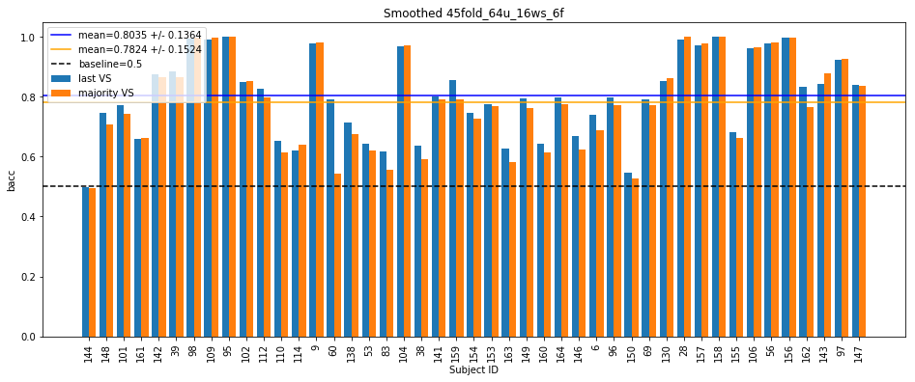

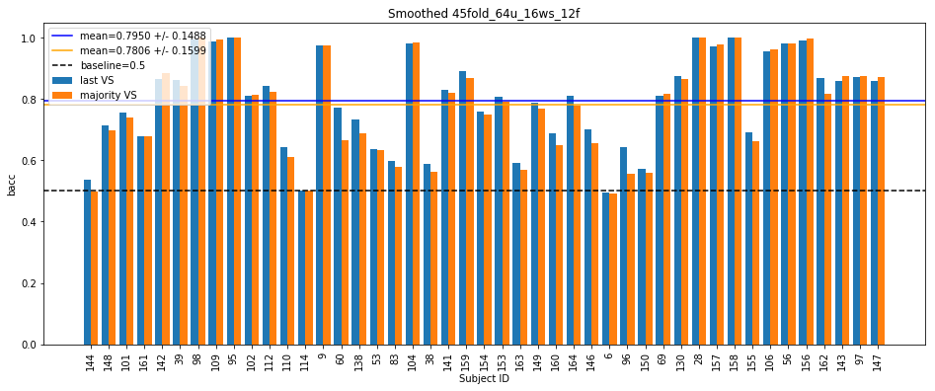

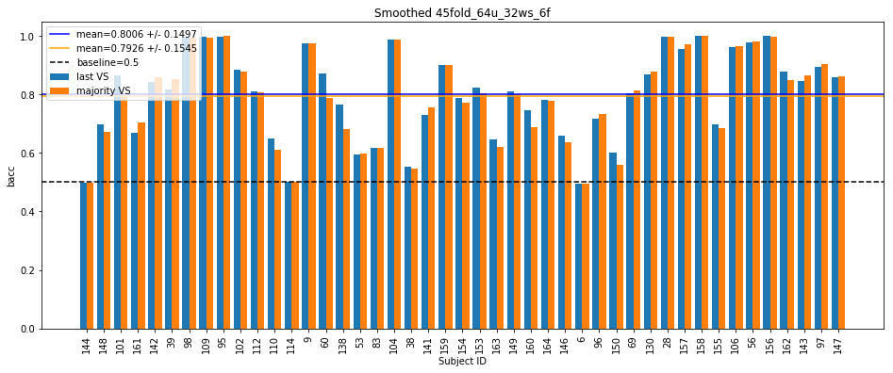

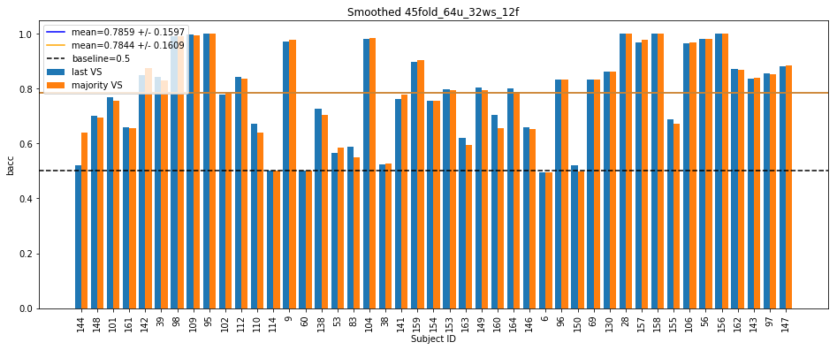

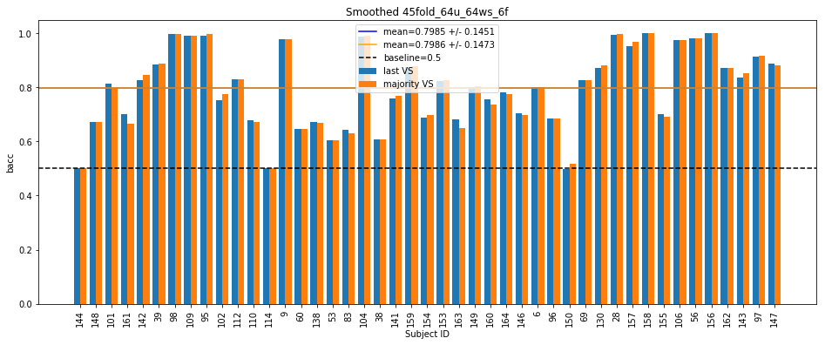

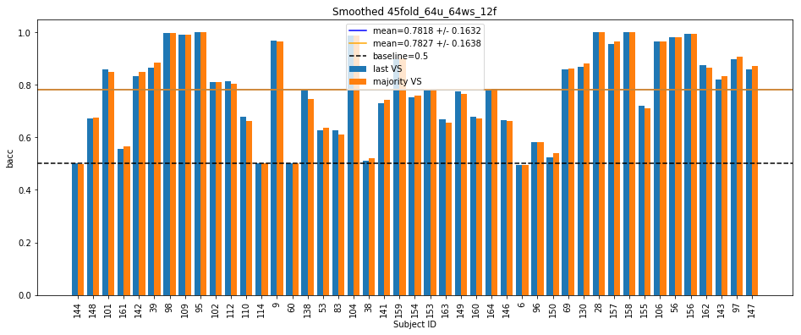

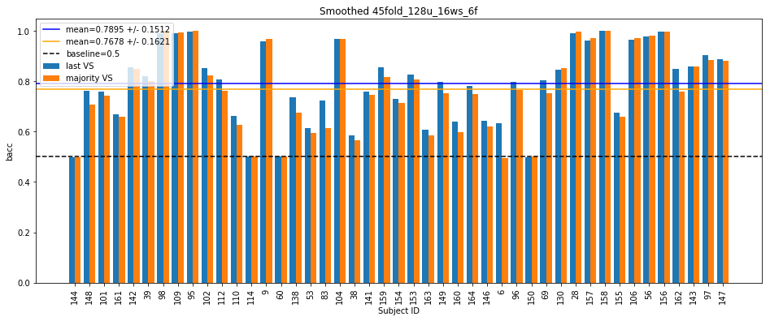

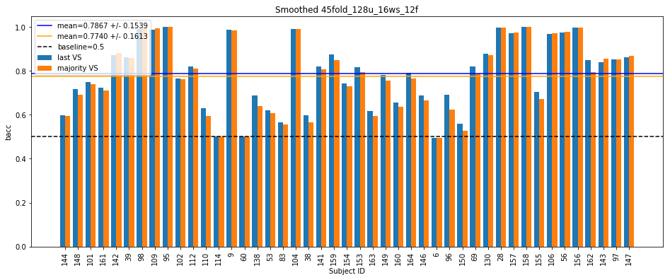

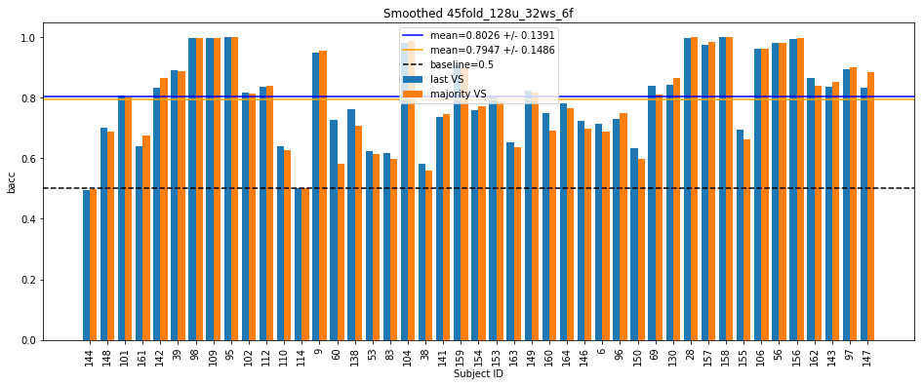

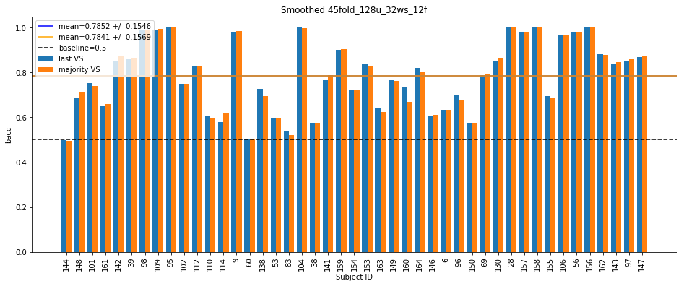

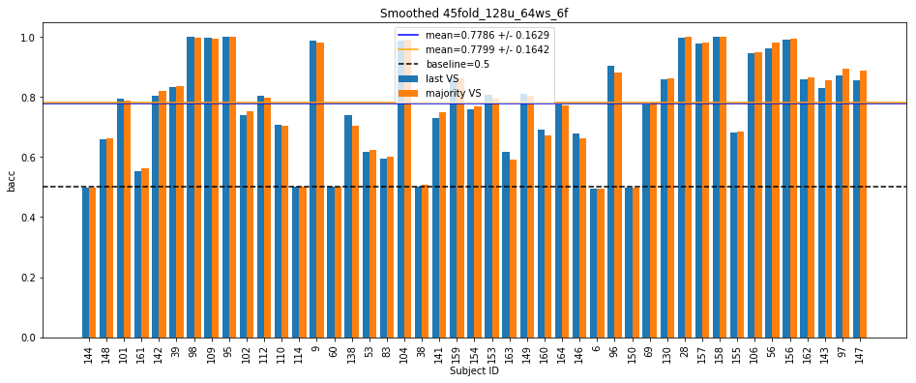

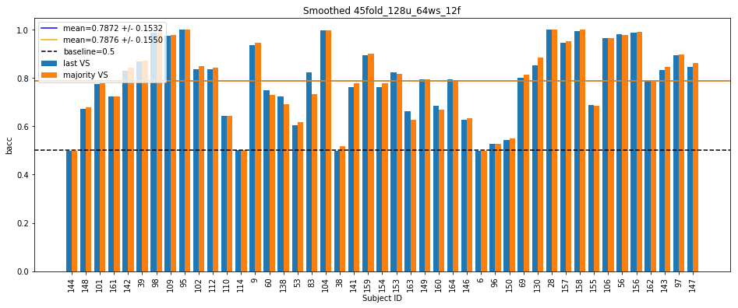

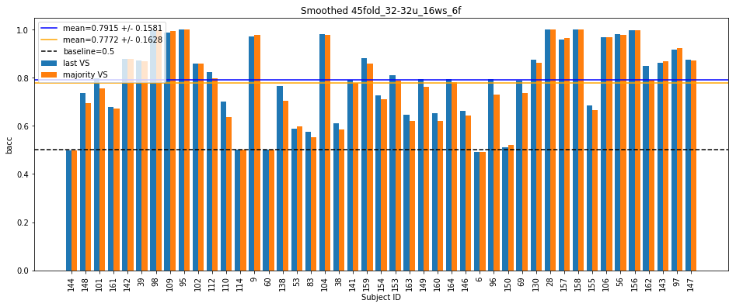

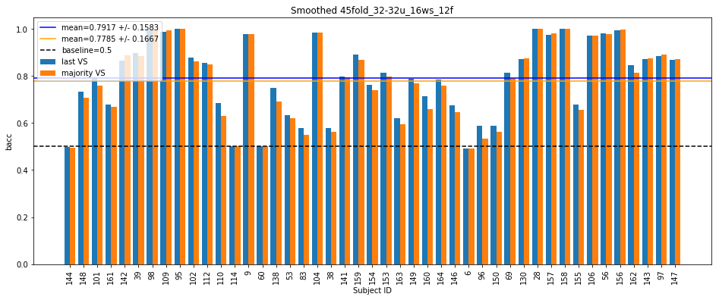



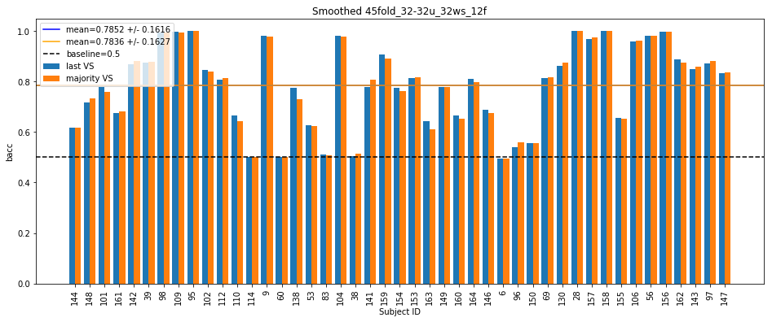

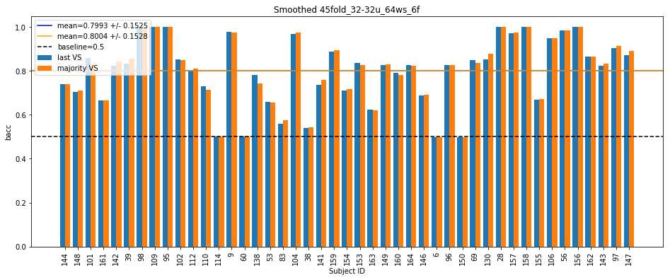

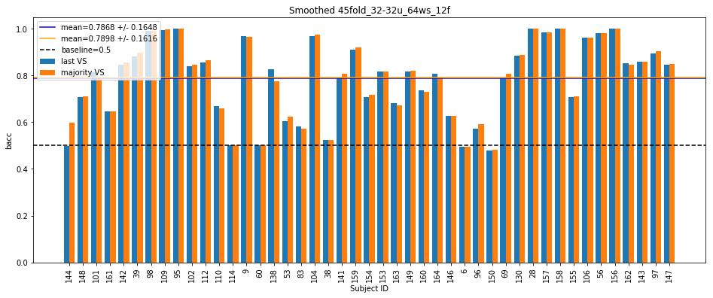

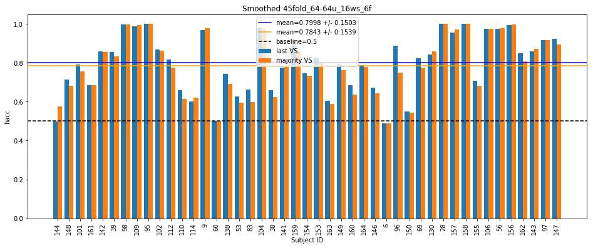

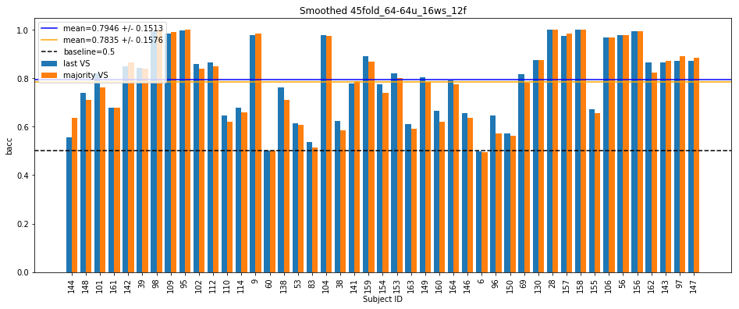

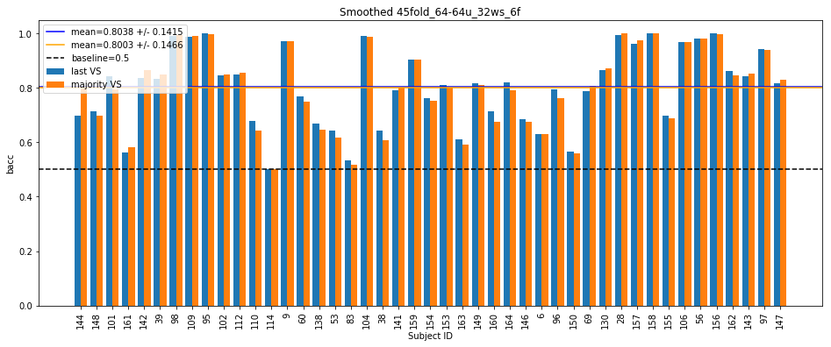

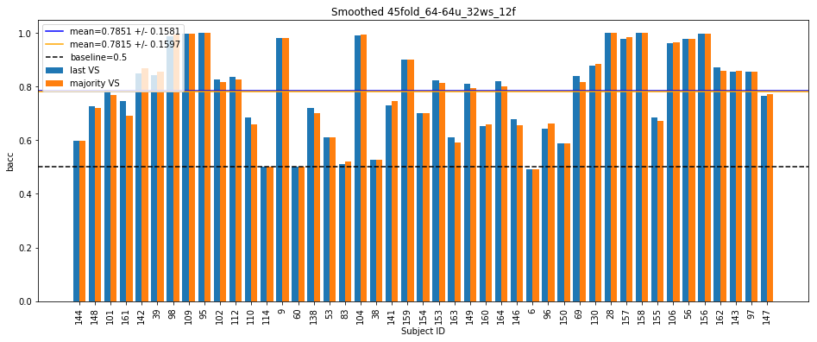

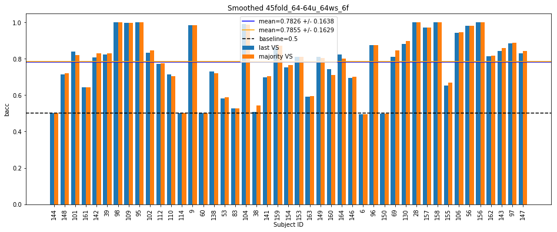

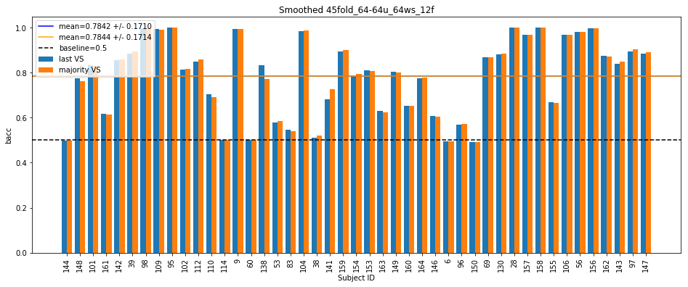

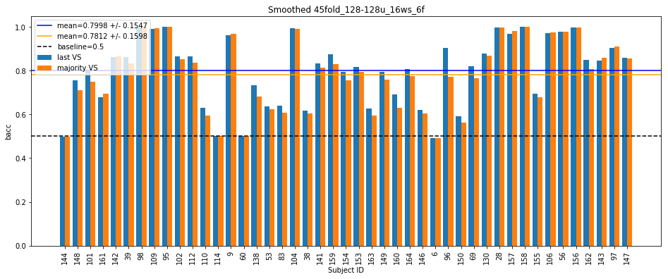

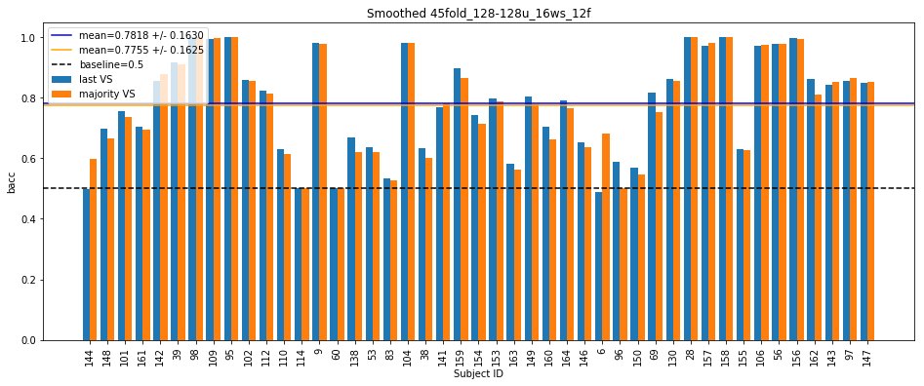

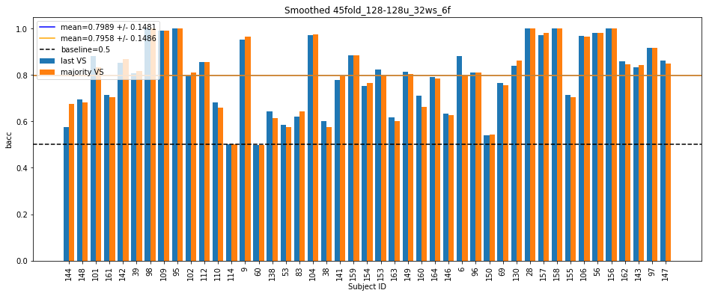

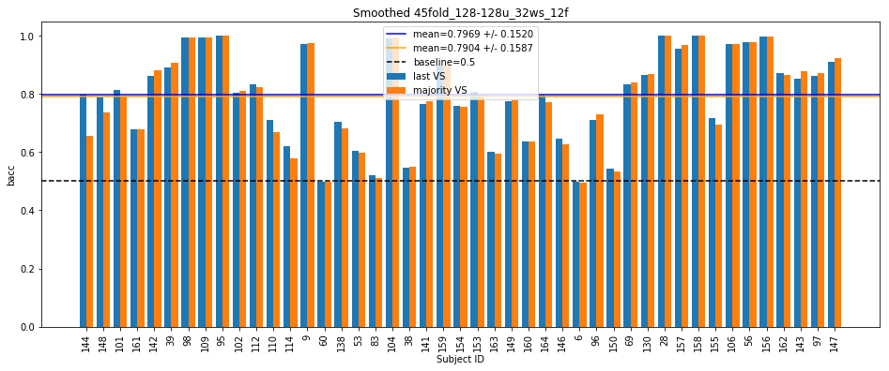

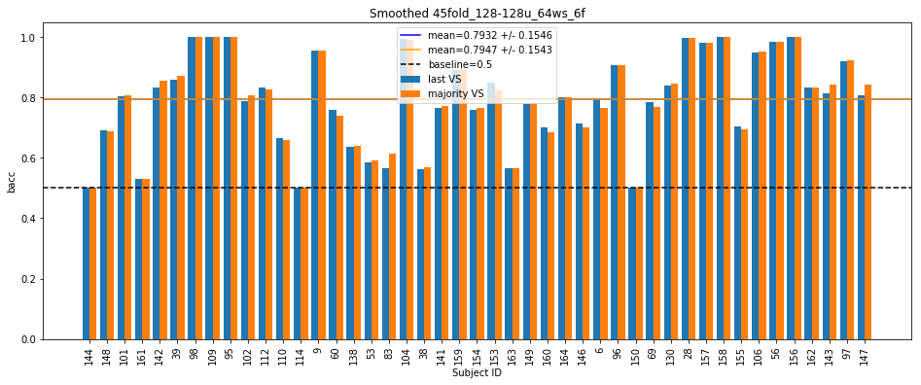

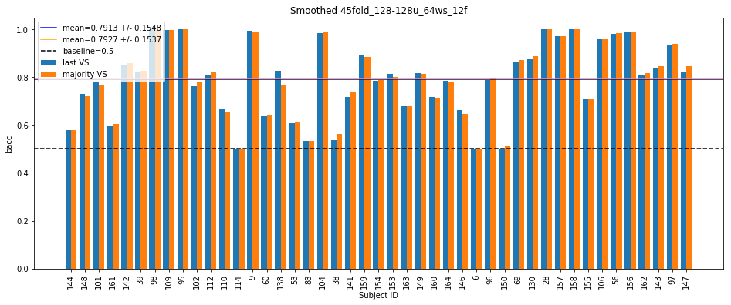

**Testing results with smoothing**

45fold_64u_16ws_6f #params: 13697

[last] Mean bacc: 0.8035 +/- 0.1364

[last] Mean f1: 0.4415 +/- 0.3141

[last] Mean precision: 0.5599 +/- 0.3786

[last] Mean recall: 0.3927 +/- 0.2937

[majority] Mean bacc: 0.7824 +/- 0.1524

[majority] Mean f1: 0.4075 +/- 0.3116

[majority] Mean precision: 0.6176 +/- 0.4035

[majority] Mean recall: 0.3406 +/- 0.2824

Total time taken: 93.65223503112793 s

45fold_64u_16ws_12f #params: 14849

[last] Mean bacc: 0.7950 +/- 0.1488

[last] Mean f1: 0.4287 +/- 0.3214

[last] Mean precision: 0.5497 +/- 0.3913

[last] Mean recall: 0.3771 +/- 0.3080

[majority] Mean bacc: 0.7806 +/- 0.1599

[majority] Mean f1: 0.4034 +/- 0.3210

[majority] Mean precision: 0.5769 +/- 0.4072

[majority] Mean recall: 0.3395 +/- 0.2992

Total time taken: 188.39780974388123 s

45fold_64u_32ws_6f #params: 13697

[last] Mean bacc: 0.8006 +/- 0.1497

[last] Mean f1: 0.4318 +/- 0.3248

[last] Mean precision: 0.5321 +/- 0.3759

[last] Mean recall: 0.3891 +/- 0.3164

[majority] Mean bacc: 0.7926 +/- 0.1545

[majority] Mean f1: 0.4231 +/- 0.3271

[majority] Mean precision: 0.5626 +/- 0.3961

[majority] Mean recall: 0.3643 +/- 0.3061

Total time taken: 290.00797986984253 s

45fold_64u_32ws_12f #params: 14849

[last] Mean bacc: 0.7859 +/- 0.1597

[last] Mean f1: 0.4095 +/- 0.3331

[last] Mean precision: 0.5584 +/- 0.4027

[last] Mean recall: 0.3577 +/- 0.3144

[majority] Mean bacc: 0.7844 +/- 0.1609

[majority] Mean f1: 0.4067 +/- 0.3329

[majority] Mean precision: 0.5557 +/- 0.4145

[majority] Mean recall: 0.3483 +/- 0.3078

Total time taken: 395.4786009788513 s

45fold_64u_64ws_6f #params: 13697

[last] Mean bacc: 0.7985 +/- 0.1451

[last] Mean f1: 0.4279 +/- 0.3165

[last] Mean precision: 0.5342 +/- 0.3837

[last] Mean recall: 0.3883 +/- 0.3065

[majority] Mean bacc: 0.7986 +/- 0.1473

[majority] Mean f1: 0.4279 +/- 0.3182

[majority] Mean precision: 0.5554 +/- 0.3872

[majority] Mean recall: 0.3812 +/- 0.3041

Total time taken: 508.60591101646423 s

45fold_64u_64ws_12f #params: 14849

[last] Mean bacc: 0.7818 +/- 0.1632

[last] Mean f1: 0.3953 +/- 0.3317

[last] Mean precision: 0.5214 +/- 0.3999

[last] Mean recall: 0.3551 +/- 0.3186

[majority] Mean bacc: 0.7827 +/- 0.1638

[majority] Mean f1: 0.3995 +/- 0.3334

[majority] Mean precision: 0.5336 +/- 0.4044

[majority] Mean recall: 0.3530 +/- 0.3178

Total time taken: 627.5399582386017 s

45fold_128u_16ws_6f #params: 51969

[last] Mean bacc: 0.7895 +/- 0.1512

[last] Mean f1: 0.4150 +/- 0.3290

[last] Mean precision: 0.5288 +/- 0.4005

[last] Mean recall: 0.3658 +/- 0.3054

[majority] Mean bacc: 0.7678 +/- 0.1621

[majority] Mean f1: 0.3824 +/- 0.3173

[majority] Mean precision: 0.5554 +/- 0.4231

[majority] Mean recall: 0.3134 +/- 0.2843

Total time taken: 725.4614055156708 s

45fold_128u_16ws_12f #params: 54273

[last] Mean bacc: 0.7867 +/- 0.1539

[last] Mean f1: 0.4114 +/- 0.3202

[last] Mean precision: 0.5391 +/- 0.3994

[last] Mean recall: 0.3566 +/- 0.3005

[majority] Mean bacc: 0.7740 +/- 0.1613

[majority] Mean f1: 0.3890 +/- 0.3161

[majority] Mean precision: 0.5693 +/- 0.4165

[majority] Mean recall: 0.3240 +/- 0.2893

Total time taken: 819.9851312637329 s

45fold_128u_32ws_6f #params: 51969

[last] Mean bacc: 0.8026 +/- 0.1391

[last] Mean f1: 0.4371 +/- 0.3187

[last] Mean precision: 0.5408 +/- 0.3802

[last] Mean recall: 0.3961 +/- 0.3037

[majority] Mean bacc: 0.7947 +/- 0.1486

[majority] Mean f1: 0.4265 +/- 0.3219

[majority] Mean precision: 0.5719 +/- 0.3955

[majority] Mean recall: 0.3708 +/- 0.3014

Total time taken: 917.1804394721985 s

45fold_128u_32ws_12f #params: 54273

[last] Mean bacc: 0.7852 +/- 0.1546

[last] Mean f1: 0.4020 +/- 0.3135

[last] Mean precision: 0.5294 +/- 0.3785

[last] Mean recall: 0.3597 +/- 0.3059

[majority] Mean bacc: 0.7841 +/- 0.1569

[majority] Mean f1: 0.4031 +/- 0.3169

[majority] Mean precision: 0.5651 +/- 0.3999

[majority] Mean recall: 0.3505 +/- 0.3021

Total time taken: 1014.5051381587982 s

45fold_128u_64ws_6f #params: 51969

[last] Mean bacc: 0.7786 +/- 0.1629

[last] Mean f1: 0.3907 +/- 0.3329

[last] Mean precision: 0.4896 +/- 0.4007

[last] Mean recall: 0.3437 +/- 0.3079

[majority] Mean bacc: 0.7799 +/- 0.1642

[majority] Mean f1: 0.3942 +/- 0.3347

[majority] Mean precision: 0.5300 +/- 0.4098

[majority] Mean recall: 0.3412 +/- 0.3087

Total time taken: 1117.764996290207 s

45fold_128u_64ws_12f #params: 54273

[last] Mean bacc: 0.7872 +/- 0.1532

[last] Mean f1: 0.4135 +/- 0.3300

[last] Mean precision: 0.5234 +/- 0.3960

[last] Mean recall: 0.3677 +/- 0.3130

[majority] Mean bacc: 0.7876 +/- 0.1550

[majority] Mean f1: 0.4145 +/- 0.3299

[majority] Mean precision: 0.5542 +/- 0.3978

[majority] Mean recall: 0.3631 +/- 0.3121

Total time taken: 1233.8687043190002 s

45fold_32-32u_16ws_6f #params: 10017

[last] Mean bacc: 0.7915 +/- 0.1581

[last] Mean f1: 0.4194 +/- 0.3383

[last] Mean precision: 0.5228 +/- 0.3967

[last] Mean recall: 0.3688 +/- 0.3186

[majority] Mean bacc: 0.7772 +/- 0.1628

[majority] Mean f1: 0.3972 +/- 0.3268

[majority] Mean precision: 0.5521 +/- 0.4085

[majority] Mean recall: 0.3322 +/- 0.2990

Total time taken: 1396.448923587799 s

45fold_32-32u_16ws_12f #params: 10593

[last] Mean bacc: 0.7917 +/- 0.1583

[last] Mean f1: 0.4145 +/- 0.3325

[last] Mean precision: 0.5259 +/- 0.3955

[last] Mean recall: 0.3705 +/- 0.3211

[majority] Mean bacc: 0.7785 +/- 0.1667

[majority] Mean f1: 0.3922 +/- 0.3304

[majority] Mean precision: 0.5458 +/- 0.4089

[majority] Mean recall: 0.3365 +/- 0.3119

Total time taken: 1560.5693576335907 s

45fold_32-32u_32ws_6f #params: 10017

[last] Mean bacc: 0.7967 +/- 0.1503

[last] Mean f1: 0.4314 +/- 0.3306

[last] Mean precision: 0.5332 +/- 0.3823

[last] Mean recall: 0.3840 +/- 0.3169

[majority] Mean bacc: 0.7922 +/- 0.1540

[majority] Mean f1: 0.4273 +/- 0.3310

[majority] Mean precision: 0.5657 +/- 0.3941

[majority] Mean recall: 0.3674 +/- 0.3112

Total time taken: 1732.9938650131226 s

45fold_32-32u_32ws_12f #params: 10593

[last] Mean bacc: 0.7852 +/- 0.1616

[last] Mean f1: 0.4002 +/- 0.3325

[last] Mean precision: 0.5098 +/- 0.3812

[last] Mean recall: 0.3592 +/- 0.3207

[majority] Mean bacc: 0.7836 +/- 0.1627

[majority] Mean f1: 0.4004 +/- 0.3334

[majority] Mean precision: 0.5420 +/- 0.4018

[majority] Mean recall: 0.3497 +/- 0.3151

Total time taken: 1907.7516646385193 s

45fold_32-32u_64ws_6f #params: 10017

[last] Mean bacc: 0.7993 +/- 0.1525

[last] Mean f1: 0.4281 +/- 0.3358

[last] Mean precision: 0.5279 +/- 0.3926

[last] Mean recall: 0.3923 +/- 0.3255

[majority] Mean bacc: 0.8004 +/- 0.1528

[majority] Mean f1: 0.4313 +/- 0.3374

[majority] Mean precision: 0.5394 +/- 0.3992

[majority] Mean recall: 0.3892 +/- 0.3233

Total time taken: 2086.1395637989044 s

45fold_32-32u_64ws_12f #params: 10593

[last] Mean bacc: 0.7868 +/- 0.1648

[last] Mean f1: 0.4058 +/- 0.3413

[last] Mean precision: 0.5220 +/- 0.4015

[last] Mean recall: 0.3626 +/- 0.3264

[majority] Mean bacc: 0.7898 +/- 0.1616

[majority] Mean f1: 0.4144 +/- 0.3378

[majority] Mean precision: 0.5421 +/- 0.4011

[majority] Mean recall: 0.3650 +/- 0.3214

Total time taken: 2266.6614027023315 s

45fold_64-64u_16ws_6f #params: 38465

[last] Mean bacc: 0.7998 +/- 0.1503

[last] Mean f1: 0.4394 +/- 0.3300

[last] Mean precision: 0.5580 +/- 0.3852

[last] Mean recall: 0.3854 +/- 0.3145

[majority] Mean bacc: 0.7843 +/- 0.1539

[majority] Mean f1: 0.4150 +/- 0.3142

[majority] Mean precision: 0.5920 +/- 0.4030

[majority] Mean recall: 0.3464 +/- 0.2903

Total time taken: 2436.426069498062 s

45fold_64-64u_16ws_12f #params: 39617

[last] Mean bacc: 0.7946 +/- 0.1513

[last] Mean f1: 0.4274 +/- 0.3248

[last] Mean precision: 0.5452 +/- 0.3868

[last] Mean recall: 0.3749 +/- 0.3106

[majority] Mean bacc: 0.7835 +/- 0.1576

[majority] Mean f1: 0.4078 +/- 0.3198

[majority] Mean precision: 0.5812 +/- 0.4042

[majority] Mean recall: 0.3450 +/- 0.2993

Total time taken: 2613.136741876602 s

45fold_64-64u_32ws_6f #params: 38465

[last] Mean bacc: 0.8038 +/- 0.1415

[last] Mean f1: 0.4375 +/- 0.3213

[last] Mean precision: 0.5509 +/- 0.3712

[last] Mean recall: 0.3954 +/- 0.3073

[majority] Mean bacc: 0.8003 +/- 0.1466

[majority] Mean f1: 0.4376 +/- 0.3271

[majority] Mean precision: 0.5909 +/- 0.3948

[majority] Mean recall: 0.3810 +/- 0.3046

Total time taken: 2785.8511850833893 s

45fold_64-64u_32ws_12f #params: 39617

[last] Mean bacc: 0.7851 +/- 0.1581

[last] Mean f1: 0.4097 +/- 0.3305

[last] Mean precision: 0.5585 +/- 0.3977

[last] Mean recall: 0.3538 +/- 0.3068

[majority] Mean bacc: 0.7815 +/- 0.1597

[majority] Mean f1: 0.4055 +/- 0.3275

[majority] Mean precision: 0.5717 +/- 0.4090

[majority] Mean recall: 0.3410 +/- 0.2982

Total time taken: 2960.9988911151886 s

45fold_64-64u_64ws_6f #params: 38465

[last] Mean bacc: 0.7826 +/- 0.1638

[last] Mean f1: 0.3987 +/- 0.3424

[last] Mean precision: 0.5193 +/- 0.4006

[last] Mean recall: 0.3515 +/- 0.3147

[majority] Mean bacc: 0.7855 +/- 0.1629

[majority] Mean f1: 0.4064 +/- 0.3431

[majority] Mean precision: 0.5331 +/- 0.4095

[majority] Mean recall: 0.3535 +/- 0.3148

Total time taken: 3142.093982934952 s

45fold_64-64u_64ws_12f #params: 39617

[last] Mean bacc: 0.7842 +/- 0.1710

[last] Mean f1: 0.3916 +/- 0.3426

[last] Mean precision: 0.5085 +/- 0.3923

[last] Mean recall: 0.3554 +/- 0.3352

[majority] Mean bacc: 0.7844 +/- 0.1714

[majority] Mean f1: 0.3937 +/- 0.3438

[majority] Mean precision: 0.5200 +/- 0.3994

[majority] Mean recall: 0.3526 +/- 0.3335

Total time taken: 3323.6192548274994 s

45fold_128-128u_16ws_6f #params: 150657

[last] Mean bacc: 0.7998 +/- 0.1547

[last] Mean f1: 0.4339 +/- 0.3391

[last] Mean precision: 0.5375 +/- 0.3955

[last] Mean recall: 0.3838 +/- 0.3219

[majority] Mean bacc: 0.7812 +/- 0.1598

[majority] Mean f1: 0.4051 +/- 0.3247

[majority] Mean precision: 0.5671 +/- 0.4122

[majority] Mean recall: 0.3383 +/- 0.2962

Total time taken: 3492.6568698883057 s

45fold_128-128u_16ws_12f #params: 152961

[last] Mean bacc: 0.7818 +/- 0.1630

[last] Mean f1: 0.4013 +/- 0.3285

[last] Mean precision: 0.5420 +/- 0.4026

[last] Mean recall: 0.3457 +/- 0.3102

[majority] Mean bacc: 0.7755 +/- 0.1625

[majority] Mean f1: 0.3815 +/- 0.3225

[majority] Mean precision: 0.5442 +/- 0.4088

[majority] Mean recall: 0.3276 +/- 0.2942

Total time taken: 3661.4167580604553 s

45fold_128-128u_32ws_6f #params: 150657

[last] Mean bacc: 0.7989 +/- 0.1481

[last] Mean f1: 0.4205 +/- 0.3204

[last] Mean precision: 0.5453 +/- 0.3899

[last] Mean recall: 0.3863 +/- 0.3138

[majority] Mean bacc: 0.7958 +/- 0.1486

[majority] Mean f1: 0.4180 +/- 0.3212

[majority] Mean precision: 0.5698 +/- 0.4026

[majority] Mean recall: 0.3726 +/- 0.3028

Total time taken: 3836.287207365036 s

45fold_128-128u_32ws_12f #params: 152961

[last] Mean bacc: 0.7969 +/- 0.1520

[last] Mean f1: 0.4254 +/- 0.3241

[last] Mean precision: 0.5593 +/- 0.3825

[last] Mean recall: 0.3793 +/- 0.3155

[majority] Mean bacc: 0.7904 +/- 0.1587

[majority] Mean f1: 0.4145 +/- 0.3283

[majority] Mean precision: 0.5746 +/- 0.4020

[majority] Mean recall: 0.3601 +/- 0.3137

Total time taken: 4018.80886054039 s

45fold_128-128u_64ws_6f #params: 150657

[last] Mean bacc: 0.7932 +/- 0.1546

[last] Mean f1: 0.4021 +/- 0.3327

[last] Mean precision: 0.5334 +/- 0.4017

[last] Mean recall: 0.3749 +/- 0.3164

[majority] Mean bacc: 0.7947 +/- 0.1543

[majority] Mean f1: 0.4088 +/- 0.3350

[majority] Mean precision: 0.5511 +/- 0.4127

[majority] Mean recall: 0.3735 +/- 0.3143

Total time taken: 4206.753963708878 s

45fold_128-128u_64ws_12f #params: 152961

[last] Mean bacc: 0.7913 +/- 0.1548

[last] Mean f1: 0.4118 +/- 0.3307

[last] Mean precision: 0.5276 +/- 0.3891

[last] Mean recall: 0.3699 +/- 0.3100

[majority] Mean bacc: 0.7927 +/- 0.1537

[majority] Mean f1: 0.4179 +/- 0.3312

[majority] Mean precision: 0.5397 +/- 0.3932

[majority] Mean recall: 0.3695 +/- 0.3076

Total time taken: 4395.41800403595 s