**Comparing models with vs without head translation features**

[using NON-cleaned data: the beginnings of the recordings, prior to the beep, were not skipped]

**On validation set:**

n_folds = 45

WINDOW_SIZE = 32

GRU_ARCH = [32, 32]

(T = translation features)

|  |  |  |  |  |
| --- | --- | --- | --- | --- |
|  | 6 f [with T] | 12 f [with T] | 3 f [without T] | 6 f [without T] |
| val_loss | 0.2049 +/- 0.0207 | 0.2025 +/- 0.0249 | 0.2682 +/- 0.0319 | 0.2740 +/- 0.0307 |
| val_bacc_last | 0.8061 +/- 0.0248 | 0.8114 +/- 0.0205 | 0.7090 +/- 0.0273 | 0.6999 +/- 0.0270 |
| val_bacc_major | 0.7927 +/- 0.0235 | 0.7977 +/- 0.0225 | 0.6868 +/- 0.0245 | 0.6801 +/- 0.0256 |
| test_bacc_last | 0.7972 +/- 0.1458 | 0.7842 +/- 0.1600 | 0.7299 +/- 0.1750 | 0.7350 +/- 0.1705 |
| test_bacc_major | 0.7928 +/- 0.1495 | 0.7824 +/- 0.1609 | 0.7166 +/- 0.1798 | 0.7224 +/- 0.1772 |

=> **translation features are informative** (performance drop by ~6-10% when excluded).

[with]

ALL_45fold_32-32u_32ws_**6f**

Mean val_loss: 0.2049 +/- 0.0207

[last] Mean bacc:  **0.8061 +/- 0.0248**

[majority] Mean bacc:  **0.7927 +/- 0.0235**

ALL_45fold_32-32u_32ws_**12f**

Mean val_loss: 0.2025 +/- 0.0249

[last] Mean bacc: **0.8114 +/- 0.0205**

[majority] Mean bacc:  **0.7977 +/- 0.0225**

[without]

ALL_45fold_32-32u_R_32ws_3f

Mean val_loss: 0.2682 +/- 0.0319

[last] Mean bacc:  **0.7090 +/- 0.0273**

[last] Mean f1: 0.5474 +/- 0.0494

[last] Mean precision: 0.7283 +/- 0.0482

[last] Mean recall: 0.4409 +/- 0.0555

[majority] Mean bacc: **0.6868 +/- 0.0245**

[majority] Mean f1: 0.5161 +/- 0.0496

[majority] Mean precision: 0.7700 +/- 0.0535

[majority] Mean recall: 0.3898 +/- 0.0492

ALL_45fold_32-32u_R_32ws_6f

Mean val_loss: 0.2740 +/- 0.0307

[last] Mean bacc:  **0.6999 +/- 0.0270**

[last] Mean f1: 0.5338 +/- 0.0511

[last] Mean precision: 0.7340 +/- 0.0472

[last] Mean recall: 0.4221 +/- 0.0551

[majority] Mean bacc:  **0.6801 +/- 0.0256**

[majority] Mean f1: 0.5050 +/- 0.0529

[majority] Mean precision: 0.7798 +/- 0.0518

[majority] Mean recall: 0.3755 +/- 0.0516

**On test set:**

[WITH]

45fold_32-32u_32ws_6f #params: 10017

[last] Mean bacc: **0.7972 +/- 0.1458**

[last] Mean f1: 0.4336 +/- 0.3242

[last] Mean precision: 0.5330 +/- 0.3714

[last] Mean recall: 0.3875 +/- 0.3115

[majority] Mean bacc: **0.7928 +/- 0.1495**

[majority] Mean f1: 0.4279 +/- 0.3246

[majority] Mean precision: 0.5507 +/- 0.3825

[majority] Mean recall: 0.3714 +/- 0.3054

Total time taken: 2865.891002893448 s

45fold_32-32u_32ws_12f #params: 10593

[last] Mean bacc:  **0.7842 +/- 0.1600**

[last] Mean f1: 0.3984 +/- 0.3288

[last] Mean precision: 0.5018 +/- 0.3731

[last] Mean recall: 0.3597 +/- 0.3184

[majority] Mean bacc: **0.7824 +/- 0.1609**

[majority] Mean f1: 0.3986 +/- 0.3279

[majority] Mean precision: 0.5430 +/- 0.3863

[majority] Mean recall: 0.3501 +/- 0.3119

Total time taken: 3148.3490765094757 s

[WITHOUT]

45fold_32-32u_R_32ws_3f #params: 9729

[last] Mean bacc: **0.7299 +/- 0.1750**

[last] Mean f1: 0.3073 +/- 0.2883

[last] Mean precision: 0.4738 +/- 0.4026

[last] Mean recall: 0.2453 +/- 0.2506

[majority] Mean bacc:  **0.7166 +/- 0.1798**

[majority] Mean f1: 0.2777 +/- 0.2734

[majority] Mean precision: 0.4893 +/- 0.4152

[majority] Mean recall: 0.2107 +/- 0.2278

Total time taken: 127.67240285873413 s

45fold_32-32u_R_32ws_6f #params: 10017

[last] Mean bacc:  **0.7350 +/- 0.1705**

[last] Mean f1: 0.3142 +/- 0.2882

[last] Mean precision: 0.4689 +/- 0.3855

[last] Mean recall: 0.2590 +/- 0.2565

[majority] Mean bacc: **0.7224 +/- 0.1772**

[majority] Mean f1: 0.2888 +/- 0.2787

[majority] Mean precision: 0.4872 +/- 0.4062

[majority] Mean recall: 0.2238 +/- 0.2383

Total time taken: 252.18373131752014 s

[WITH] by subjects 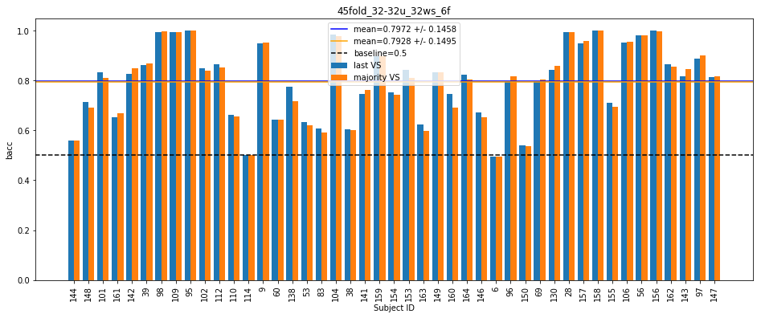

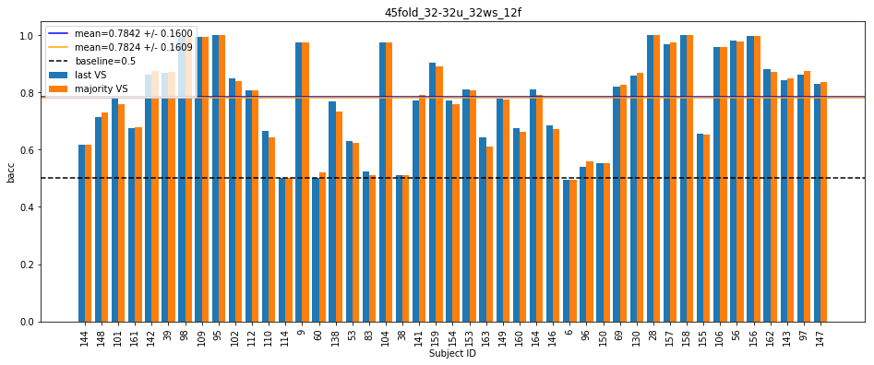

[WITHOUT] by subjects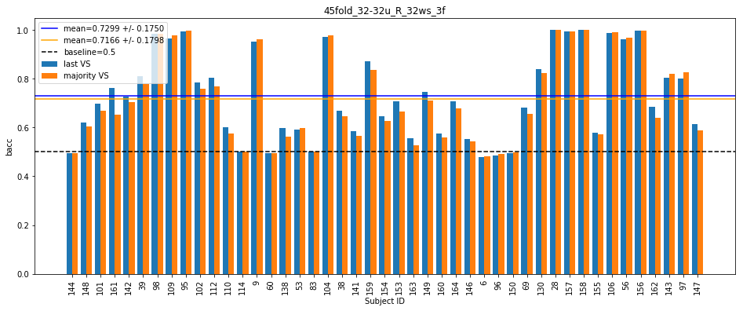

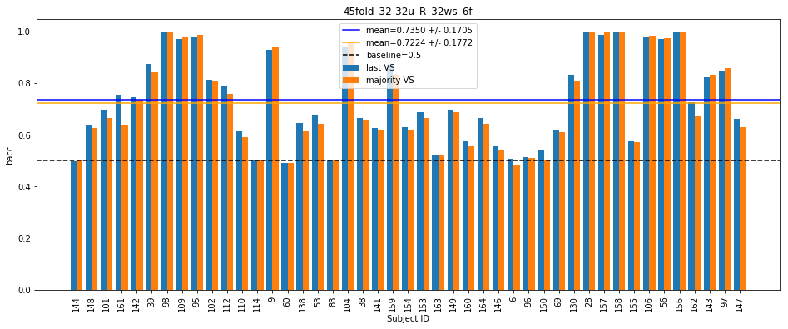

=> **translation features are informative!** [performance drop by ~6-10% when excluded]