Methods & Results

Feature extraction
- Resample signal to common frame rate 30 Hz.
- Take first order differences.
- Apply median filter (kernel size=9 samples) => filt_diff_angles.
  - We applied the median filter with kernel size of 9 frames (333ms), as it is commonly used to remove noise from head motion data \cite{gurbuz2012model}.
- Find peaks in filt_diff_angles.
- Find peaks in -filt_diff_angles (i.e. valleys).
- Iterate over peak and valley locations, always considering one peak and one valley (+ - or - +).
- Get nod/shake height (h) as difference between the peak and valley.
- Get nod/shake width (w) by calculating the number of samples from a previous peak/valley to a next peak/valley (- + - + or + - + -).
- If no peak can be found, use the left/right-most sample as an endpoint of nod/shake.
- Extract average (w, h) for each recording.
- Based on script [pos_neg_peaks_diff1_extended.ipynb]

Training and cross-validation
- Extract average peak parameters (w, h).
- Z-normalization [helped!]
- Random oversampling of minority classes (helps), then we can also use simple accuracy for evaluation.
- Shuffle the data.
- 2 binary classifications (Other vs Nod and Other vs Shake) with 5-fold cross-validation
  - OvsN:
    - feature vector [xw, xh]; label [{0,1}]
    - data from S used as negative examples (as they were from class O)
    - original # examples per class (including those from shake): 117 other, 146 nod
      - balanced to 146 per class
  - OvsS:
    - feature vector [yw, yh]; label [{0,1}]
    - data from N used as negative examples (as they were from class O)
    - original # examples per class (including those from nod): 174 other, 86 shake
      - balanced to 174 per class
  - Fusion:
if p(N) <= 0.5 and p(S) <= 0.5: # Assign other class
ann = 0
elif p(N) <= 0.5: # Assign shake class
ann = 2
elif p(S) <= 0.5: # Assign nod class
ann = 1
else: # Assign higher-probability nod/shake class
ann = 1 if p(N) >= p(S) else 2
  - Draw decision boundaries
  - Prediction:
    - Get probabilistic annotation from each classifier, then fuse as above.

- Ternary classification
  - feature vector [xw, xh, yw, yh]; label [{0,1,2}]
  - Prediction:
    - get per-frame annotations using features (w,h) for x angle and y angle, then stack next to each other, then feed (?x4) matrix to classifier
  - # examples per class, other/nod/shake:
    - Original: 25, 154, 104
    - After removing NaN entries 25, 143, 81
    - After oversampling 143, 143, 143
- Models:
  - kNN
    - 5-fold cross-validation
    - 1-25 neighbors
  - SVM
    - RBF kernel
    - C in range (), gamma in range ()
- Files
  - [binary_*, ternary_*]
- Finally, we used binary classifiers independently to count number of nods and number of shakes per recording.

Results

- Binary
  - 5-fold cross-validation
  - nod: {'n_neighbors': 21} acc = 0.8013698630136986
  - Best mean train accuracy: 1.0 +/- 0.0
  - Best mean test accuracy: 0.8013698630136986 +/- 0.08210694067746732
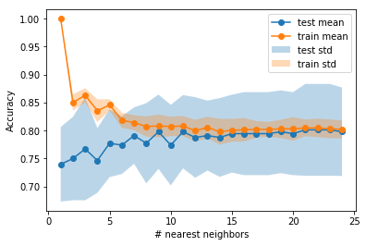

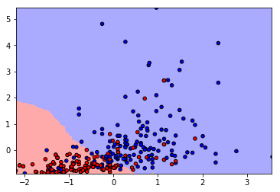

  - shake: {'n_neighbors': 15} acc = 0.8908045977011494
  - Best mean train accuracy: 1.0 +/- 0.0
  - Best mean test accuracy: 0.8908045977011494 +/- 0.038322546495471295

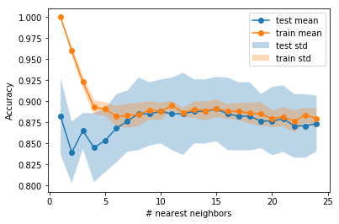

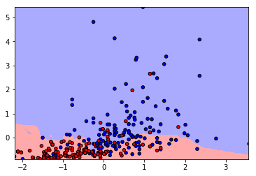

  - fused:
precision recall f1-score support

other 0.79 1.00 0.88 143
nod 0.94 0.79 0.86 143
shake 0.95 0.85 0.90 143

micro avg 0.88 0.88 0.88 429
macro avg 0.89 0.88 0.88 429
weighted avg 0.89 0.88 0.88 429

Accuracy score: 0.8811188811188811
- Ternary:
  - {'n_neighbors': 1} acc=0.9277389277389277
Best mean train accuracy: 1.0 +/- 0.0
Best mean test accuracy: 0.9277389277389277 +/- 0.027859846010352865
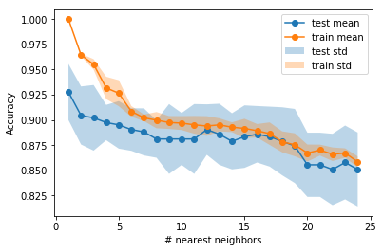

Other things I tried:
- Use of raw signal, detect peaks directly in it.
  - Gives worse separation of classes. Derivative gives normalization for free.
  - [find_peaks_thresholds_nod_raw_signal.ipynb]
  - [find_peaks_thresholds_nod_raw_signal_top1.ipynb] taking only the largest peak, based on height
  - see [analyze_peaks_*] for visualizations and comparisons
- Use of second derivative.
  - Does not seem to be better than the first, and probably hurts.
  - see [analyze_peaks_*] for visualizations and comparisons
- Visually inspected other kernel sizes for median filter.
  - But 9 seems to be the best. Potentially 7, but gives slightly worse accuracy.
- Tried to apply filtering before the derivative
  - Worse results
- Optimize F1 score to find thresholds for (w, h).
  - Maximize F1, since the classes were unbalanced (154 nod, 104 shake, and 25 other examples).
  - Tried to optimize w and h independently, and also jointly.
    - Joint optimization [jointly_optimize_peaks_thresholds.ipynb] gave worse results.
  - Resulted in unrealistic thresholds (too small).

- Width and height independently
F1 measures when no filt or median filter with specific kernel size
Nod | No filt | 7 | 9 | 11 | 13 | 15 | 17 | 19 | 21 | 23 | 25
width | 0.595 | 0.800 | 0.794 | 0.811 | 0.801 | 0.806 | 0.815 | 0.826 | 0.817 | 0.824 | 0.824
height | 0.670 | 0.835 | 0.831 | 0.832 | 0.840 | 0.833 | 0.849 | 0.853 | 0.852 | 0.850 | 0.853
Final F1 measure: 0.8516377649325626
best params (w, h) = (2.18, 0.0032) = (, rad)
(positive class / NOD <=> peakH > thrH and peakW > thrW)
- Width and height jointly
F1 around 0.3 only …
For shake
PEAK WIDTHS:
Best threshold: 3.22
F1: 0.6436781609195402 P: 0.49122807017543857 R: 0.9333333333333333
PEAK HEIGHTS:
Best threshold: 0.008
F1: 0.7596153846153846 P: 0.6694915254237288 R: 0.8777777777777778
Joint F1 measure: 0.7475728155339806
- Use all (w, h) parameters, not average.
  - Did not perform well, see .
- Use (w, h) of the largest peak, based on height
  - [find_peaks_thresholds_nod_raw_signal_top1.ipynb]
- Use (h/w, w) parameters
  - resembles 2nd derivative
  - not better
  - [pos_neg_peaks_diff1_ratio.ipynb]
- First, I took w to be the distance between adjacent peak and valley [first pos_neg_peaks_* files], but then I extended w to start from earlier extreme point on the left and end at later extreme point on the right. => [all pos_neg_peaks_*_extended]
- I also tried to use zero-crossings as start and end points [all pos_neg_peaks_*_extended]
  - Not better, too wide peaks, since the signal did not pass through zero
- Also looked at tilt angle, made histograms of angles [tilt_histograms_and_peaks].

Files
- analyze_peaks_*
  - 2D scatter plots of peaks clusters: nod, shake; raw, 1st and 2nd derivative; all, average, top1 peak
- find_peaks_* / jointly_optimize_ ...
  - first trials, optimizing F1
- pos_neg_peaks_ …
  - final attempts, best, detecting peaks and valleys
  - with +/- peak visualizations and 2D scatter plots of peaks clusters
- annotate_nod
  - visualizations of peaks in raw, filtered, derivative signals
  - demo to annotate data, perform detection based on thresholds

To try:
- Compare the final approach when low-pass filter is used (cutoff at 3/4/5 Hz).
- Compare with SVMs
- What to do with recordings where no peak was found?
  - e.g. if it is labeled as other/nod/shake and no peak is found, ignore this example? (currently implemented)
  - alternative, put into other class, but what (w,h) to use? w=0, h=0 ?

References

@article{gurbuz2012model,
title={Model free head pose estimation using stereovision},
author={Gurbuz, Sabri and Oztop, Erhan and Inoue, Naomi},
journal={Pattern Recognition},
volume={45},
number={1},
pages={33--42},
year={2012},
publisher={Elsevier}
}

