Introduction to Threat Hunting (ITH)
Phishing Campaigns Targeting Kazakhstan
Weeks 1–3 · individual project

Galimzhan Zhandos · CS-2427
GitHub: https://github.com/jand06s/Threat_hunting_Galimzhan_Zhandos

Summary
Here is what I did in the first three weeks of the project, following the tasks in section 3.3 of the syllabus. My topic is phishing campaigns aimed at users of Kazakhstan services: Kaspi, eGov, Halyk (Homebank), OLX.kz, Kazpost and others.
Week | Syllabus task | What was delivered
1 | Create a glossary of key CTI terms.  Classify threats and their sources. | Glossary of 35 terms with topic examples. Classification along 4 axes (vector, target, actor, intelligence source) with ATT&CK IDs. 2 diagrams.
2 | OSINT collection with Shodan, VirusTotal, Maltego.  Data source mapping. | Collector for an open phishing feed (806,622 hosts), dnstwist lookalike check, Shodan and VirusTotal scripts, Maltego import file, mapping of 10 sources, 5 charts.
3 | Deploy MISP and import IOCs.  Filter and normalize the data. | 9-step normalization pipeline, correlation into campaigns, MISP event (312 attributes), deployment guide, 2 Sigma rules converted to Elastic and tested.

Key findings
- Out of 806,622 hosts in a global phishing feed, 204 are related to Kazakhstan and only 6 really impersonate a Kazakh brand. Global feeds barely cover local brands.
- Attackers do not register typo domains inside .kz: 0 of 20,443 generated lookalikes appear in the feed. Instead they put the brand name as a keyword on a cheap foreign TLD (kaspibank.auth-telegramm.ru, halykbankres.xyz, post-kz.lol).
- The .kz zone is used mostly as infrastructure for foreign campaigns: hacked WordPress/Bitrix sites, free platforms (jcloud.kz, mylp.kz), and registered lookalikes of Apple and OpenSea under .com.kz.
- When I compared URL paths, it turned out that 5 Apple lookalike domains belong to one operator (same phishing kit path /m/sing/).
- Final output: 195 clean indicators, a MISP event and two Sigma detection rules. The DNS rule detects 5 of 6 KZ-brand domains with 0 false positives on the test set.

1. Introduction and methodology

1.1 Why this topic
Phishing is one of the most common ways attackers get in, according to both ENISA and vendor reports. In Kazakhstan, most adults use the same few digital services (Kaspi.kz, eGov.kz, Halyk Homebank, OLX.kz). One fake login page for such a brand can reach millions of people, which makes these brands an attractive lure. It is also practical: a bank SOC or KZ-CERT could use the results (indicators and detection rules) directly.

1.2 Priority Intelligence Requirements (PIR)
Threat intelligence always starts with a question. A PIR is the question the work has to answer; without one, you just end up collecting random data. I set three PIRs:
PIR-1: Which Kazakhstan brands are impersonated in currently active phishing infrastructure?
PIR-2: Where is this infrastructure hosted (TLDs, hosting platforms, IP/ASN)?
PIR-3: Which indicators can be safely shared with defenders (MISP, blocklists, detection rules)?

1.3 Methodology: the intelligence lifecycle
I follow the standard CTI lifecycle: Direction → Collection → Processing → Analysis → Dissemination → Feedback. Weeks 1–3 cover the first three stages. The later course weeks (Kill Chain, ATT&CK, hunting) cover analysis and dissemination.
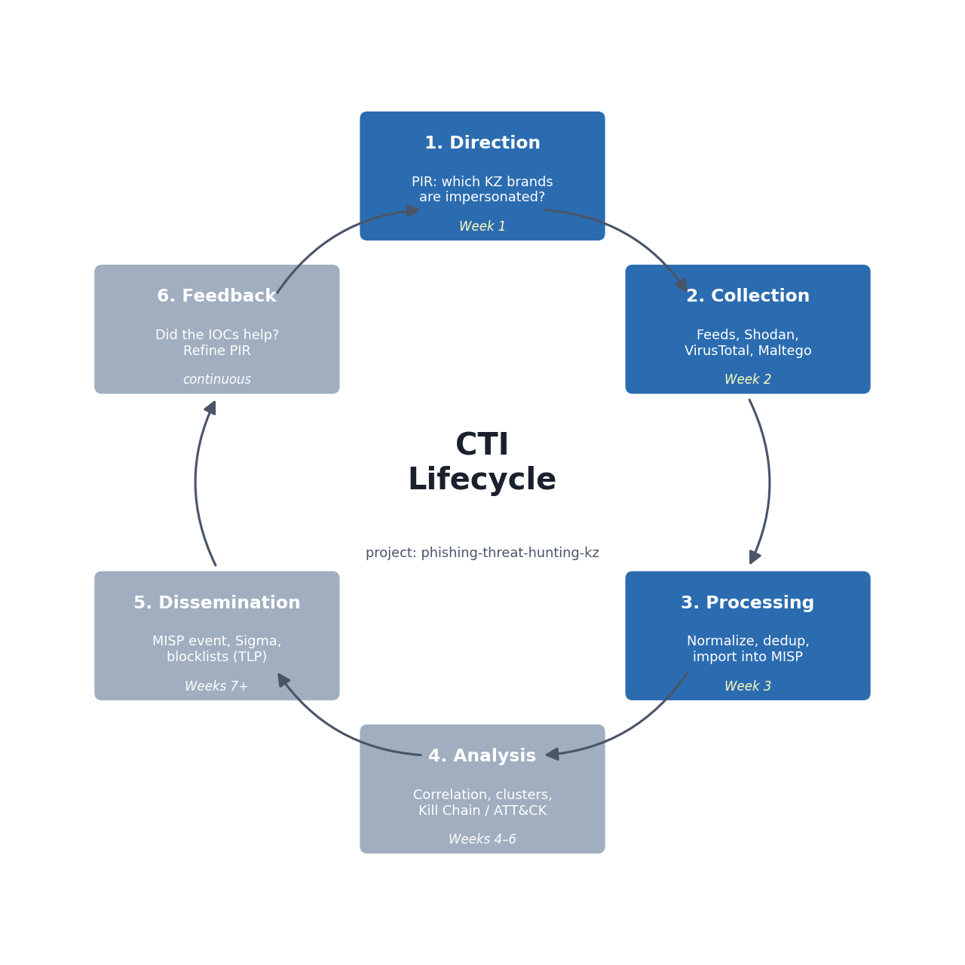
Figure 1. CTI lifecycle, with the stages covered in weeks 1–3 highlighted

1.4 Tools and repository
Everything is in my GitHub repository, with one commit per week. Tools: Python 3 (pandas, matplotlib, networkx, dnstwist, PyMISP, shodan, requests), MISP (Docker), Maltego CE, Sigma (sigma-cli with the Elasticsearch backend).
phishing-threat-hunting-kz/
├── week1-cti-fundamentals/ glossary, classification, images
├── week2-data-collection/ scripts, data, images, maltego
├── week3-data-processing/ scripts, data, images, misp, sigma
└── presentation/ defense notes

2. Week 1: Cyber Threat Intelligence Fundamentals
Tasks: (1) create a glossary of key CTI terms; (2) classify different types of threats and their sources. Recommended reading: ENISA Threat Landscape Report.

2.1 Glossary of key CTI terms
My glossary has 35 terms in four groups: core concepts (1–7), intelligence types (8–11), indicators and TTPs (12–18), process and frameworks (19–35). Every term has an example from the project topic, which shows how the term is applied and not only what it means.
# | Term | Definition | Example in this project
1 | Cyber Threat Intelligence (CTI) | Evidence-based knowledge about existing or emerging threats (context, mechanisms, indicators, implications) that helps defenders make decisions. | Knowing that a group mass-registers kaspi-* lookalike domains on cheap TLDs and hosts them on free platforms.
2 | Threat | Any circumstance or actor with the potential to harm an asset. | A phishing kit that steals Kaspi login + SMS code.
3 | Vulnerability | A weakness that a threat can exploit. | Users trusting any page that shows the Kaspi logo.
4 | Risk | Threat × vulnerability × impact. | High: stolen banking creds give direct financial loss.
5 | Threat actor | Person or group behind malicious activity. | "Classiscam"-style scam teams working through Telegram bots.
6 | Intent / Capability / Opportunity | The three conditions that make an actor a real threat. | Intent: money. Capability: ready-made phishing kit. Opportunity: OLX.kz sellers waiting for a buyer.
7 | Attack surface | All points where an attacker can interact with the target. | Brand name, public domains, SMS sender IDs, social media pages.
8 | Strategic intelligence | High-level trends for executives: who, why, and business impact. | "ENISA's Threat Landscape lists phishing among the most common initial access vectors in the EU."
9 | Operational intelligence | Information about specific campaigns and how they run. | A campaign sending "your parcel is on hold, pay 350 ₸" SMS on behalf of Kazpost.
10 | Tactical intelligence | TTPs: how attackers operate. | Use of URL shorteners + Cloudflare to hide the real phishing host.
11 | Technical intelligence | Machine-readable indicators with a short lifetime. | kaspibank.auth-telegramm.ru
12 | IOC (Indicator of Compromise) | An observable artifact that indicates malicious activity. | Domain, URL, IP, file hash, email sender.
13 | IOA (Indicator of Attack) | An indicator of attacker behaviour, independent of specific artifacts. | A newly registered domain containing a bank brand + "login"/"verify".
14 | TTP (Tactics, Techniques, Procedures) | Describes attacker behaviour at three levels of detail. | Tactic: Initial Access → Technique: T1566 Phishing → Procedure: SMS with a link to a fake Kaspi page.
15 | Pyramid of Pain | A model (David Bianco) that ranks indicators by how costly they are for the attacker to change: hashes < IPs < domains < artifacts < tools < TTPs. | Blocking one domain costs the attacker ~$1; detecting the kit's HTML structure costs much more.
16 | Observable | Any measurable event or property; it becomes an IOC once it's linked to malicious activity. | A DNS query to egov-kz.site.
17 | Typosquatting / lookalike domain | A domain that imitates a legitimate one through typos, homoglyphs or extra words. | kaspii.kz, egov-kz.online, halyk-bank.top
18 | Defanging | Making an IOC unclickable for safe sharing. | hxxps://kaspi-bonus[.]top
19 | Intelligence lifecycle | Direction → Collection → Processing → Analysis → Dissemination → Feedback. | Weeks 1–3 of this project follow the first three stages.
20 | PIR (Priority Intelligence Requirement) | A key question that intelligence must answer. | "Which KZ brands are impersonated in active phishing right now, and on what infrastructure?"
21 | OSINT | Intelligence from publicly available sources. | Phishing.Database, crt.sh, Shodan, VirusTotal.
22 | Threat feed | A continuously updated stream of indicators. | Phishing.Database phishing-domains-ACTIVE.txt
23 | Enrichment | Adding context to a raw indicator. | Domain → registrar, IP, ASN, country, VT detections.
24 | Correlation | Linking indicators that share attributes. | 10 phishing domains on the same IP → one campaign.
25 | TLP (Traffic Light Protocol) | Sharing labels: TLP:RED, AMBER(+STRICT), GREEN, CLEAR. | Our public report is TLP:CLEAR, raw victim data would be TLP:RED.
26 | STIX / TAXII | STIX is a JSON format for CTI objects. TAXII is the transport protocol used to share them. | Exporting our MISP event as STIX 2.1.
27 | MISP | Open-source threat intelligence platform for storing, correlating and sharing IOCs. | Week 3: we import our phishing IOCs into MISP.
28 | MITRE ATT&CK | A knowledge base of adversary tactics and techniques. | T1566.002 Spearphishing Link, T1583.001 Acquire Infrastructure: Domains.
29 | Cyber Kill Chain | Lockheed Martin's 7-stage attack model. | Recon → Weaponization (kit) → Delivery (SMS) → …
30 | Diamond Model | Describes an intrusion as Adversary – Capability – Infrastructure – Victim. | Scam team – phishing kit – *.top domains – Kaspi users.
31 | False positive | A benign item flagged as malicious. | kaspi.kz itself or krishna-*.github.io matched by a naive "krisha" filter.
32 | Confidence level | How sure the analyst is about an assessment (low / medium / high). | High: domain found in 2+ feeds and has a VT detection.
33 | Phishing kit | A packaged set of HTML/PHP files used to deploy phishing pages quickly. | A kit cloning the Kaspi login page with Telegram exfiltration.
34 | Phishing-as-a-Service (PhaaS) | Criminal service that rents kits, hosting and panels to operators. | Telegram bots that generate fake "OLX delivery" pages on demand.
35 | Smishing / Vishing / Quishing | Phishing via SMS / voice calls / QR codes. | Call from a "Kaspi security officer" asking for the SMS code.

How the key concepts connect
Three ideas from the glossary shape the rest of my project:
- Intelligence types. Strategic intel (trends) tells management *why* phishing matters. Operational intel describes *a specific campaign*. Tactical intel (TTPs) describes *how* attackers work. Technical intel is the list of IOCs. My project produces operational, tactical and technical intelligence.
- Pyramid of Pain. A phishing domain costs an attacker about $1 and minutes to replace, so blocking domains alone only causes them minimal pain. That is why in weeks 2–3 I look for patterns (brand keywords, hosting choices, kit paths), which are harder for the attacker to change.
- IOC vs IOA. An IOC is a concrete artifact (halykbankres.xyz). An IOA describes behaviour ("a new domain that contains a bank name but is not the bank"). The week 3 Sigma rule is built on the IOA idea, so it also catches domains that are not in any feed yet.

2.2 Classification of threats and their sources
I classified the threats along four independent axes. Together they answer: how the attack is delivered, what it steals, who is behind it, and where a defender can learn about it.
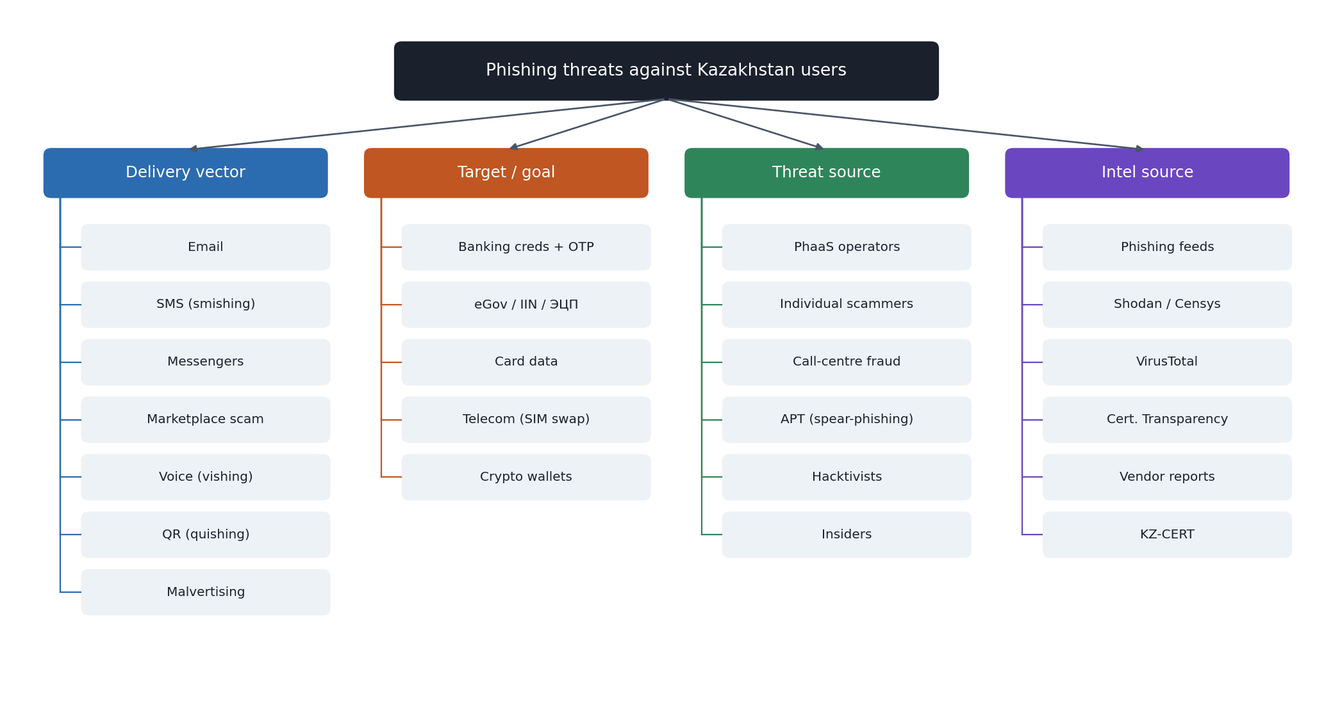
Figure 2. Taxonomy of phishing threats against Kazakhstan users

A. By delivery vector
Vector | Typical KZ scenario | MITRE ATT&CK
Email phishing | "eGov: your digital signature (ЭЦП) expires, renew here" | T1566.001 / T1566.002
Smishing (SMS) | "Kazpost: parcel on hold, pay customs fee" | T1566.002
Messenger phishing | Fake "Kaspi bonus" shared in Telegram/WhatsApp groups | T1566.003
Marketplace scam | OLX.kz seller gets a link to "receive payment" (fake 3-D Secure page) | T1566.003
Vishing (voice) | Call from a fake "Kaspi security service" asking for the SMS code | T1566.004
Quishing (QR) | Fake QR sticker on a payment terminal or parking meter | T1566
Malvertising / SEO | Search ad for "Homebank login" leads to a clone | T1583.008

B. By target and goal
Target | What is stolen | Brands | Impact
Banking / payments | Login, password, OTP, card data | Kaspi, Halyk, Jusan, Forte, BCC, Freedom | Direct financial loss
Government services | IIN, eGov credentials, ЭЦП | eGov.kz, Salyk, ENPF | Identity theft, loans in the victim's name
Marketplaces | Card data via fake delivery page | OLX.kz, Kolesa.kz, Krisha.kz | Card fraud
Logistics | Card data for a "customs fee" | Kazpost, CDEK | Card fraud
Telecom | Account takeover, SIM swap | Kcell, Beeline, Tele2/Altel | 2FA bypass
Crypto | Wallet seed phrase, deposits | Fake exchanges, OpenSea clones | Loss of funds

C. By threat source (actor)
Actor | Motivation | Capability | Relevance
Organised cybercriminals / PhaaS | Financial | Medium–High | Primary. Group-IB (2021) lists Kazakhstan among Classiscam targets and found a Kazakh version of the fake OLX page in Telegram bots.
Individual scammers ("workers") | Financial | Low (rent kits) | High volume, low skill
Call-centre fraud groups | Financial | Medium | Vishing combined with phishing links
APT / state-sponsored | Espionage | High | Spear-phishing of government bodies; low volume, high impact
Hacktivists | Ideological | Low–Medium | Defacement, credential dumps
Insiders | Financial / revenge | Varies | Leaked customer lists enable targeted phishing

D. By intelligence source
Source type | Examples | Open / closed | Intel type
Phishing feeds | Phishing.Database, OpenPhish, PhishTank, URLhaus | Open | Technical
Infrastructure search | Shodan, Censys, urlscan.io | Open (freemium) | Technical
Reputation services | VirusTotal, AbuseIPDB | Open (freemium) | Technical
Certificate Transparency | crt.sh | Open | Early warning
Vendor reports | Group-IB, Kaspersky, ESET, ENISA | Open | Strategic / operational
National CERT | KZ-CERT (cert.gov.kz) | Open | Operational
Sharing communities | MISP communities, ISACs | Closed | All levels
Internal telemetry | Mail gateway, DNS, proxy logs | Closed | Tactical / technical

2.3 Week 1 conclusions
- The main threat source for this topic is financially motivated criminals using ready-made phishing kits (PhaaS), not state-sponsored APT groups.
- Phishing domains sit at the bottom of the Pyramid of Pain, so I focus on patterns rather than single domains.
- Open sources (feeds, CT logs, Shodan, VirusTotal) are enough to start answering the PIRs, which is what week 2 does.

3. Week 2: Data Collection Process
Tasks: (1) perform OSINT data collection using Shodan, VirusTotal and Maltego; (2) develop a data source mapping for analysis. Recommended reading: M. Bazzell, *Open Source Intelligence Techniques*.

3.1 Collection plan
Collection runs from broad to narrow. I start with a big open feed and filter it down to Kazakhstan-related entries. Then I enrich each candidate with Shodan and VirusTotal, and draw the relationships in Maltego.
Step | Tool / source | Script | Output
1 | Open phishing feed (Phishing.Database) | collect_feeds.py | kz_phishing_candidates.csv
2 | Lookalike generator (dnstwist) | lookalike_check.py | lookalikes_offline.csv
3 | Shodan (hunting queries + host lookup) | enrich_shodan.py | shodan_*.csv
4 | VirusTotal (domain reputation) | enrich_virustotal.py | virustotal_enrichment.csv
5 | Maltego (link analysis) | maltego_import.csv | graph + screenshot
6 | Charts | make_charts.py | images/*.png

3.2 Step 1: open phishing feed
Source. Phishing.Database is an open GitHub project that publishes phishing domains and links and updates them every hour (it is also a data vendor for VirusTotal). I used three lists: active domains, active links and inactive links (historical).
How the script works. collect_feeds.py downloads the lists and extracts the hostname from every URL, giving 806,622 unique hosts. Each host is then checked two ways:
- Brand match. 20 regular expressions, one per Kazakh brand (Kaspi, Halyk, eGov, Kazpost, OLX.kz, Kolesa, Kcell…). For ambiguous words the script also requires "kz" in the name. "egov" alone would match Turkish turkiyegov sites, and "olx" would match OLX Poland, so these rules only fire when "kz" is also present.
- Zone match. Any host that ends in .kz.
For each match the script records the brand, the TLD, the hosting platform (by suffix, e.g. *.workers.dev = Cloudflare Workers), a hosting pattern and an example URL. Victim email addresses that sometimes appear inside phishing URLs are replaced with [redacted-email]. The script also checks results against an allowlist of legitimate brand domains.
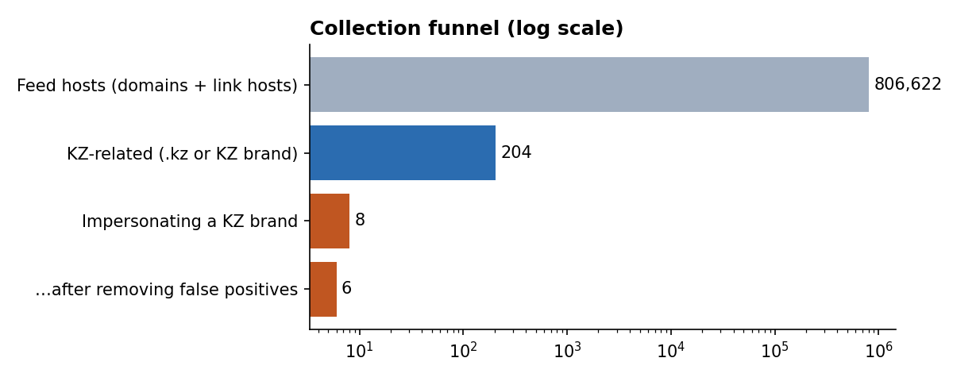
Figure 3. Collection funnel (logarithmic scale)

Result: domains impersonating Kazakh brands
Indicator (defanged) | Brand | Assessment
kaspibank[.]auth-telegramm[.]ru | Kaspi | Kaspi-themed Telegram account takeover page
kaspiy-delfin[.]tarho05[.]ru | Kaspi | Misspelled brand on a throwaway .ru domain
halykbankres[.]xyz | Halyk | Brand + suffix on a cheap .xyz TLD
olxkz[.]pay-sacure4ds[.]ru | OLX.kz | Fake "3-D Secure payment" page, the classic marketplace scam
post-kz[.]lol | Kazpost | Parcel / customs-fee lure
miss-kazakhstan[.]store | Generic | Low confidence, kept for review
usps[.]postkz[.]us | — | FALSE POSITIVE (keyword): actually a USPS lure
www[.]kazpost[.]kz | — | FALSE POSITIVE (feed): the real Kazpost site is on the list

Why indicators are written with [.]
Writing kaspi[.]kz instead of kaspi.kz is called defanging. It stops Word, email clients and chat apps from turning a malicious address into a clickable link. The scripts refang (convert back) automatically when needed.

What the .kz entries imitate and how they are hosted
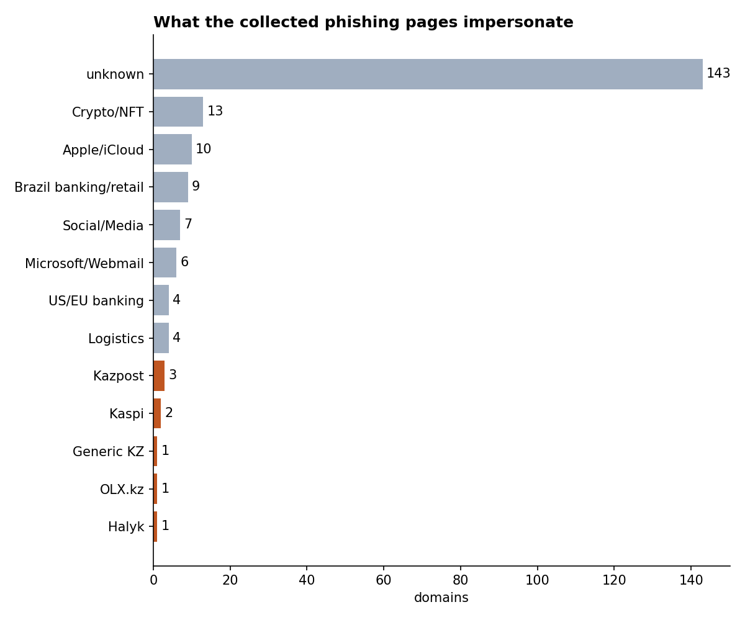
Figure 4. Brands imitated by the collected pages (orange = Kazakh brands)
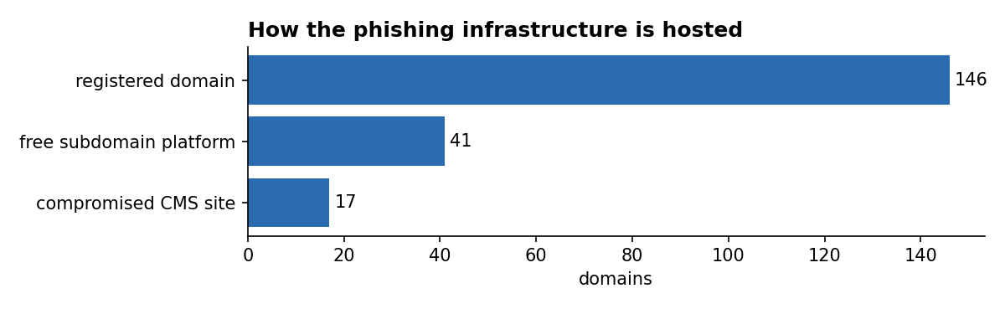
Figure 5. Hosting patterns
- Registered lookalikes under .com.kz / .org.kz: opensea[.]com[.]kz, uniswap[.]com[.]kz, appleid[.]com[.]kz, icloud[.]com[.]kz.
- Hacked Kazakh websites (WordPress, Bitrix) hosting foreign phishing kits for DHL, DocuSign, Chase, LinkedIn, Navy Federal. The URL gives it away: the kit is placed inside /wp-admin/, /wp-includes/ or /bitrix/.
- Free subdomain platforms: jcloud.kz (Brazilian banking and webmail phishing) and mylp.kz (landing-page builder).
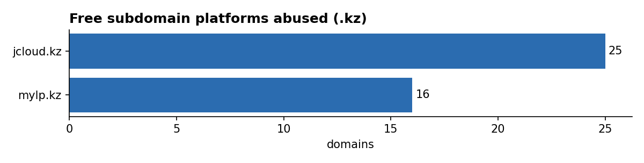
Figure 6. Abused free platforms

3.3 Step 2: lookalike domains with dnstwist
What dnstwist does. It takes a real domain and generates every plausible "mistake": missing letter (kasp.kz), swapped letters (kapsi.kz), look-alike characters (Cyrillic а instead of Latin a), extra hyphen, and so on. Defenders use it to find typosquatting domains before attackers use them.
Result. I generated 20,443 permutations for 10 brand domains (most are homoglyphs) and compared them with all 806,622 feed hosts. Not a single match.
What this means
Attackers targeting Kazakh brands do not register typos inside the .kz zone. Registration in .kz is controlled and more expensive. They use brandword-something.cheapTLD instead (.ru, .xyz, .lol).
Practical conclusion: for Kazakh brands, keyword monitoring (Certificate Transparency logs, feeds, DNS logs) is more useful than classic typo monitoring. This insight shaped the week 3 Sigma rule.

The same script with --resolve checks which lookalikes are actually registered (have DNS records). This list is a useful watch list even when the domains are not yet in any feed.

3.4 Step 3: Shodan
What Shodan is. A search engine that constantly scans the whole internet and stores what every server answers: open ports, web page title, TLS certificate, favicon. That means you can search for a phishing page by what it looks like, not just by its name.
Hunting query | Idea behind it
http.title:"Kaspi.kz" -hostname:kaspi.kz | Phishing kits copy the page title of the original site; exclude the real site.
http.favicon.hash:<hash> -hostname:kaspi.kz | Kits copy the original favicon byte for byte. Its hash (MurmurHash3 of the base64 file) finds clones on any domain.
ssl.cert.subject.cn:*kaspi* -ssl.cert.subject.cn:kaspi.kz | Attackers get free TLS certificates for names containing the brand.
http.title:"eGov.kz" -hostname:egov.kz | Clones of the government portal.

For every candidate domain, enrich_shodan.py also resolves the IP address and pulls the organisation, ASN, country and open ports. When several phishing domains share one IP or ASN, they most likely belong to one operator. I tested the script with simulated API responses and it produces the expected CSV. The real run needs an API key.
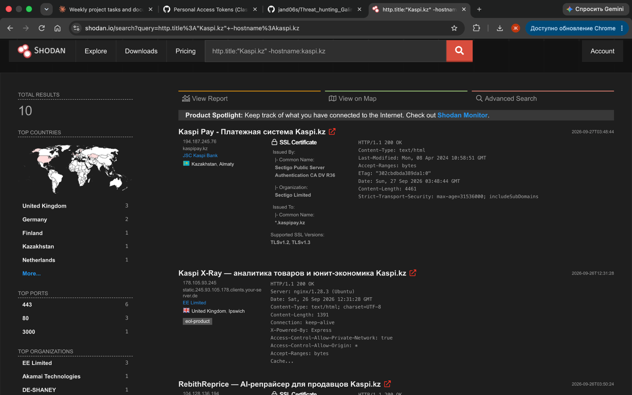

3.5 Step 4: VirusTotal
What VirusTotal gives. For a domain: how many of ~90 security vendors flag it as malicious, its reputation, registrar, creation date (a domain created a few days ago that contains a bank name is a strong signal), categories and IP addresses. enrich_virustotal.py uses API v3 and waits 15 seconds between requests, because the free tier allows 4 requests per minute.
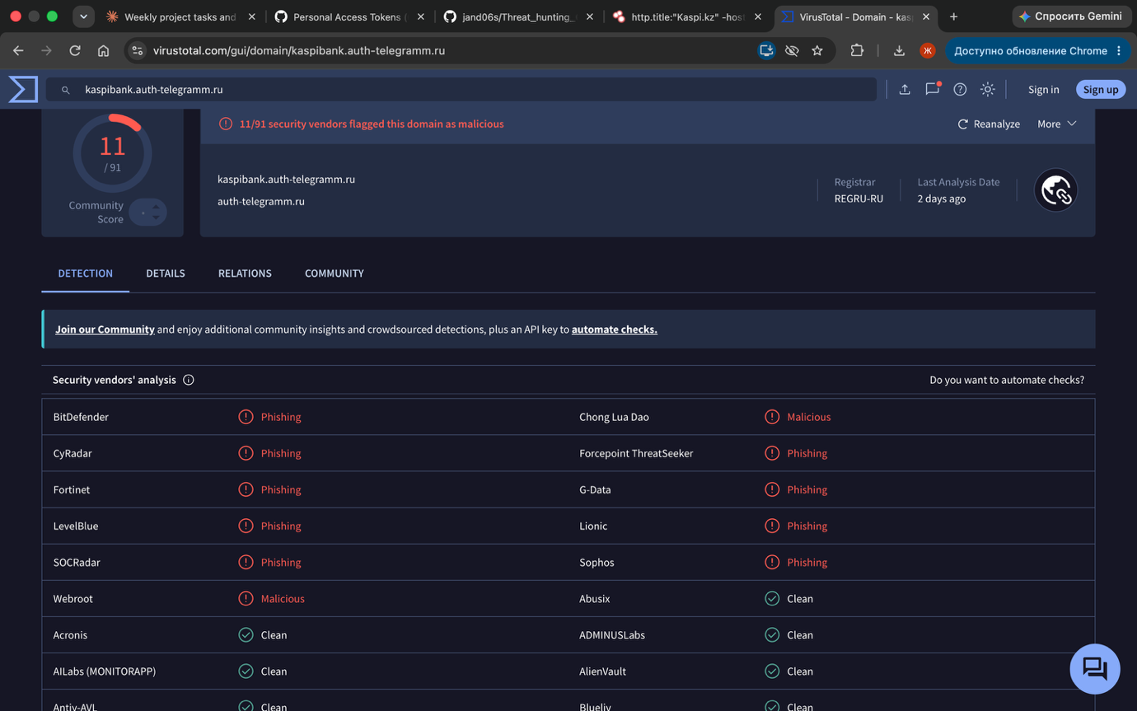

3.6 Step 5: Maltego
What Maltego does. It draws relationships as a graph: domain → IP → hosting provider → other domains on the same IP. "Transforms" automatically pull related data (DNS, WHOIS, name servers). I export the candidates as maltego_import.csv, import them with *Import → Import Graph from Table* and then run the DNS and WHOIS transforms.
Figure 7 is a preview of the same data built with Python (networkx), before the transforms. The clusters are already visible: .com.kz with Apple and crypto lures, jcloud.kz with Brazilian banks, and the Kazakh brands on foreign TLDs, separate from the rest.
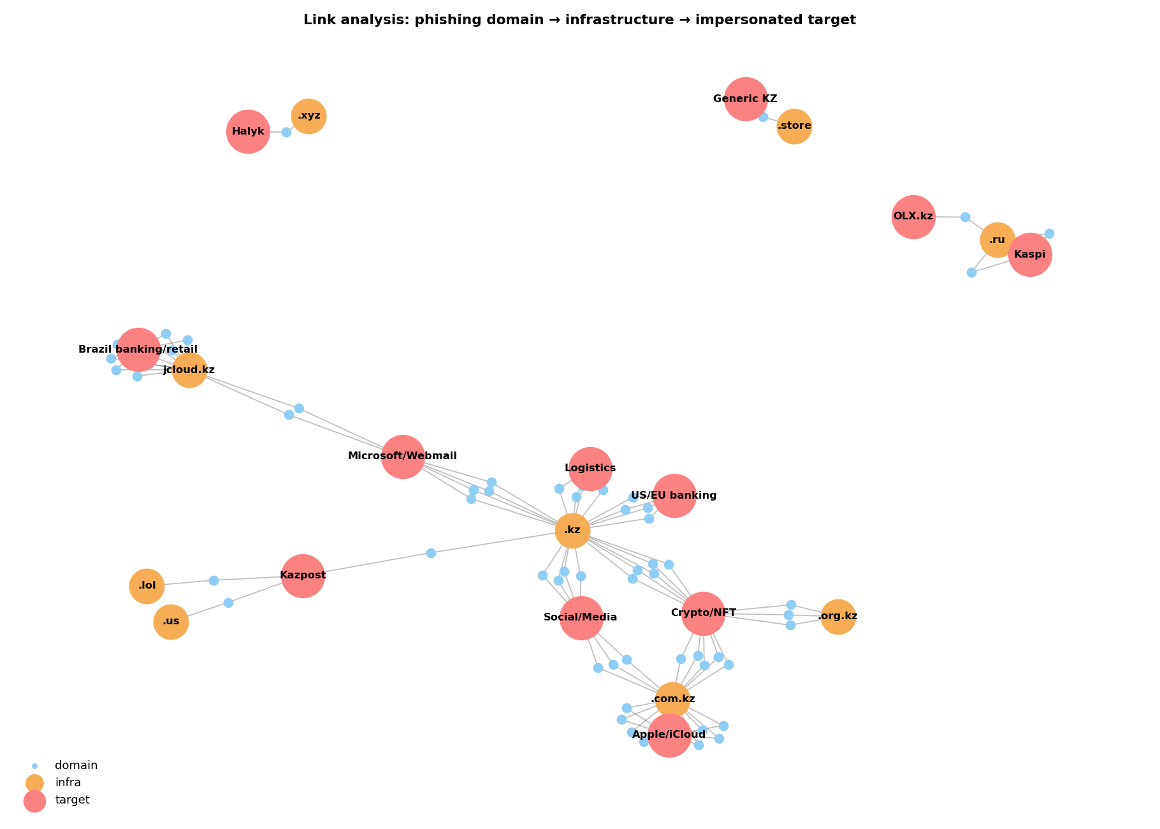
Figure 7. Link analysis: phishing domain → infrastructure → impersonated target

3.7 Data source mapping
The mapping records, for each source: what data it gives, which PIR it answers, how it is collected, and how reliable it is. Reliability uses the Admiralty Code: a letter for the source (A = completely reliable … F = cannot be judged) and a digit for the information (1 = confirmed … 6 = cannot be judged).
Source | Data | PIR | Method | Frequency | Rating
Phishing.Database | Domains, URLs | 1, 2 | collect_feeds.py | Daily | B2
dnstwist | Lookalike candidates | 1 | lookalike_check.py | On demand | n/a
Shodan | IP, ports, ASN, title, favicon, TLS | 2 | enrich_shodan.py | On demand | A2
VirusTotal | Detections, registrar, creation date | 1, 3 | enrich_virustotal.py | 4 req/min | B2
Maltego CE | Relationship graph | 2 | CSV import + transforms | Manual | varies
crt.sh (CT logs) | TLS certificates with brand names | 1 | Web / JSON | Daily | A1
urlscan.io | Page screenshots, DOM | 1 | Web / API | On demand | B2
KZ-CERT | Advisories, warnings | 1 | Manual | Weekly | A2
Vendor reports | Campaigns, TTPs | – | Manual | Monthly | B2
Internal logs (DNS, proxy, mail) | Observed traffic | – | SIEM | Real time | A1

Field mapping. All sources are converted to one common schema (indicator, type, first_seen, brand, hosting, confidence), which maps directly to MISP attribute fields. This makes the week 3 processing possible.

3.8 Week 2 findings (answering the PIRs)
- PIR-1: Kazakh brands are under-represented in global feeds (6 real hits among 806k hosts). The most impersonated are Kaspi, Halyk, OLX.kz and Kazpost. Better coverage needs local sources: KZ-CERT, CT logs, banks.
- PIR-2: Phishing aimed at Kazakh brands uses cheap foreign TLDs. The .kz zone itself mainly serves as infrastructure for foreign campaigns.
- PIR-3: 6 Kazakh-brand indicators and 196 .kz-hosted indicators go to week 3. Two kinds of false positives already appeared, which shows why normalization is needed.

4. Week 3: Data Processing and Exploitation
Tasks: (1) deploy MISP and import IOCs; (2) apply filtering and normalization techniques to the collected data. Lecture tools: MISP, Elastic Stack, Sigma rules. Recommended reading: MISP Training Documentation.

4.1 Why processing is needed
Raw data is messy. The same domain appears as www.x.kz and x.kz, some entries are legitimate sites listed by mistake, URLs contain tracking parameters or even victims' email addresses, and indicators from different sources use different formats. Sending that straight into a SIEM would create duplicate alerts and block legitimate sites. Processing turns raw data into clean, deduplicated, scored indicators that a machine can use.

4.2 Filtering and normalization pipeline
My normalize.py runs nine steps in order and logs what each step changed in processing_log.md.
# | Step | What it does | Effect on the data
1 | Refang | hxxp → http, [.] → . | Accepts defanged IOCs copied from reports
2 | Normalize | lowercase, remove www. and trailing dot, IDN → punycode | Same domain always has the same spelling
3 | Validate | hostname regex | 0 invalid values
4 | Deduplicate | same normalized value = one indicator | 7 duplicates merged
5 | Filter: allowlist | remove legitimate brand domains (like MISP warninglists) | kazpost.kz removed
6 | Filter: analyst review | remove confirmed false positives | usps.postkz.us removed
7 | URL normalization | drop utm_*/fbclid and fragments, redact emails | 117 clean example URLs
8 | Correlate | group by kit path, platform, brand family | 195 IOCs → a few campaigns
9 | Score | low / medium / high confidence | 29 medium, 166 low (before VirusTotal)

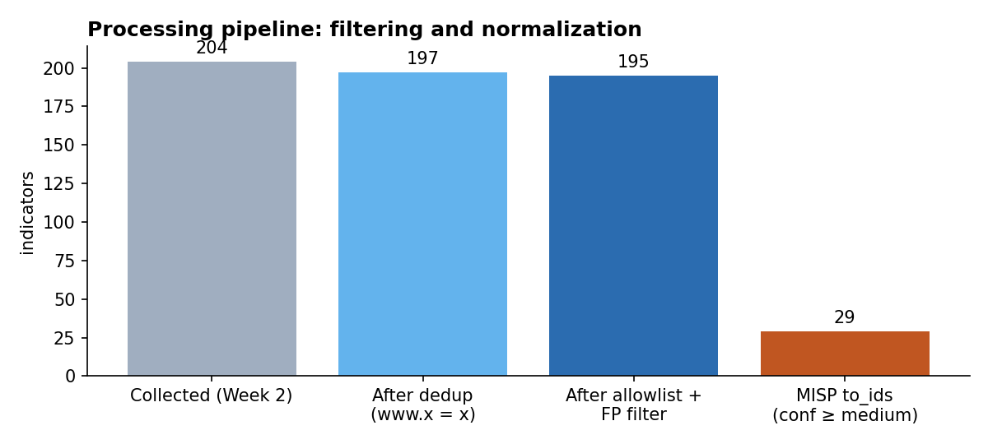
Figure 8. Indicators after each processing stage

Confidence scoring
One point each for: impersonates a Kazakh brand, still active, belongs to a correlated cluster, flagged as malicious by VirusTotal. 3–4 points = high, 2 = medium, 0–1 = low. Only medium and high indicators get to_ids = true in MISP, meaning they are safe to send to detection systems. A test with simulated VirusTotal data confirmed that a detection raises kaspibank.auth-telegramm.ru and appleid.com.kz to high.

4.3 Enrichment and correlation
Kit signature. A phishing kit is an archive of HTML/PHP files that the attacker uploads to every domain they use. So its folder structure repeats. The script takes the URL path and replaces random parts (tokens, hashes) with *. Domains with the same resulting "signature" were very likely set up by the same kit and operator.
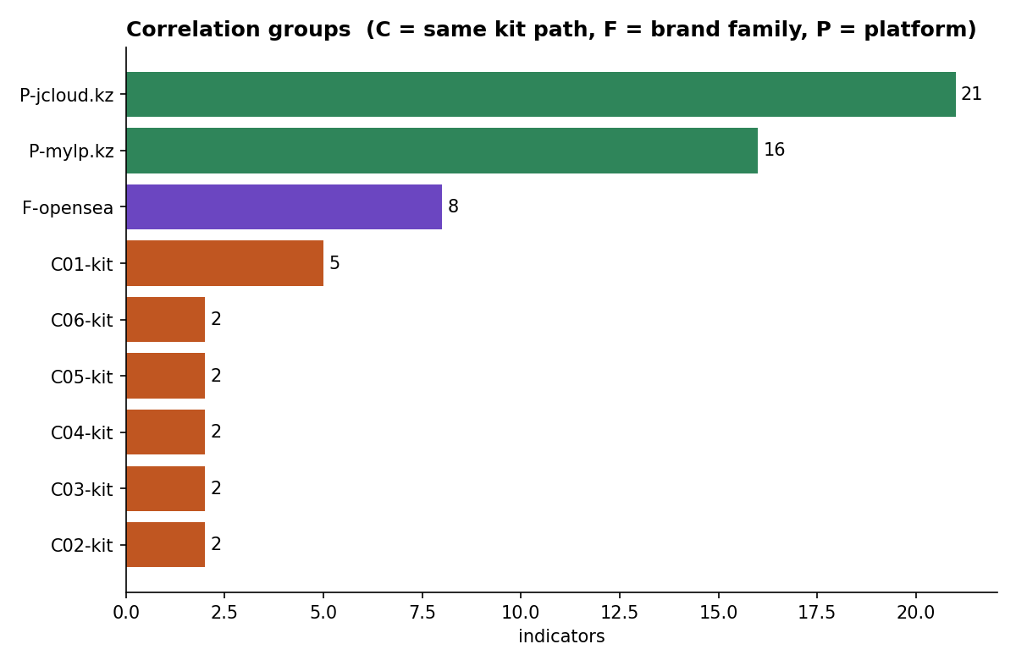
Figure 9. Correlation groups (C = same kit path, F = brand family, P = same platform)
Cluster | Signature | Members | Interpretation
C01 | /m/sing/* | appleid, appleoficial, idapple, miaccount, soporteapple (.com.kz) | One Apple ID phishing operator. Spanish words suggest a Latin American audience.
C02, C05 | /la/*, /m/* | applesoporte, supportapple, icloud, isupport (.com.kz) | Probably the same operator: same naming and TLD
C03, C06 | /acessomob/…, /acessodes/… | 4 × *.jcloud.kz | Brazilian (Portuguese) banking/webmail kit on a Kazakh free host
C04 | /wp-includes/sodium_compat/… | celinnaya.kz, joint.kz | Hacked WordPress sites, kit dropped in the same folder
F-opensea | brand family | 8 × opensea*/opersea* in .kz | NFT wallet-drainer campaign

This is the part I like most: instead of 195 separate domains I now know about a few tools (kits) and operators. Blocking a kit pattern hurts the attacker much more than blocking one domain.

4.4 MISP deployment and IOC import
What MISP is. MISP (Malware Information Sharing Platform) is an open-source threat intelligence platform. It stores indicators as events (one event = one incident or campaign) with attributes (the indicators). It finds overlaps with other events automatically (correlation), and it can share or export them (STIX, CSV, IDS rules).

Deployment
The official misp-docker project runs MISP as containers (MISP core, MISP modules, MariaDB, Redis):
git clone https://github.com/MISP/misp-docker.git && cd misp-docker
cp template.env .env # edit: BASE_URL, ADMIN_EMAIL, ADMIN_PASSWORD
docker compose pull && docker compose up -d
# open https://localhost and log in
📸 SCREENSHOT TO ADD
MISP dashboard after login, which proves the deployment (images/misp_login.png).

Building and importing the event
My misp_import.py builds the event from the normalized CSV with the official PyMISP library:
Element | Value
Event info | KZ-related phishing infrastructure (Phishing.Database), 2026-09-27
Attributes | 312: 195 domain + 117 url; 57 with to_ids = true (confidence ≥ medium)
Event tags | tlp:clear · type:OSINT · phishing:techniques="fake-website" · osint:source-type="block-or-filter-list" · workflow:state="incomplete"
ATT&CK galaxy | T1566 Phishing · T1566.002 Spearphishing Link · T1583.001 Acquire Infrastructure: Domains · T1584 Compromise Infrastructure
Attribute tags | confidence:low|medium|high · brand:<name> · cluster:<id>
Distribution | Your organisation only (lab)

Import options: (A) in the web UI, *Event Actions → Import from… → MISP JSON* and upload misp_event.json; (B) through the API with python3 misp_import.py --push (the script then also asks MISP which of the values already exist in other events). I checked the JSON by loading it back with PyMISP.

4.5 Sigma rules: from intelligence to detection
What Sigma is. A vendor-neutral format for detection rules written in YAML. One rule is converted automatically into queries for Elastic, Splunk, Microsoft Sentinel and others, which connects the Elastic Stack part of the lecture to my data.
Rule | Log source | Logic
dns_kz_brand_lookalike.yml | DNS | Query contains a brand keyword (kaspi, halyk, egov, kazpost…), AND is not the official domain (exact name or a real subdomain), AND does not contain a known false-positive word.
proxy_kz_phishing_kit_path.yml | Web proxy | URL path matches the kit signatures of clusters C01, C03, C06.

I converted the rules to Elastic (Lucene) with sigma convert -t lucene:
(query:(*kaspi* OR *halyk* OR *homebank* OR *egov* OR *kazpost* OR *post\-kz* OR *olxkz* OR *olx\-kz*))
AND (NOT ((query:(kaspi.kz OR ... OR olx.kz)) OR (query:(*.kaspi.kz OR ... OR *.olx.kz))
OR (query:(*kaspian* OR *turkiyegov*))))

Testing and tuning
I tested the DNS rule on the 6 Kazakh-brand IOCs, 11 legitimate queries and 2 evasion examples. It took three versions to get it right:
Version | Change | Detected | False positives
v1 | keyword AND NOT endswith official domain | 5 / 6 | 1 (kaspian-sea.org)
v2 | + filter of known false-positive words | 5 / 6 | 0
v3 | official = exact name or endswith ".kaspi.kz" (with the dot) | 5 / 6 + both evasion cases | 0

Why v3 was needed: in v2 the filter endswith: kaspi.kz also matched fakekaspi.kz, so an attacker could hide behind the "official" exception. The only missed domain, miss-kazakhstan.store, is a low-confidence generic entry and I left it out of the rule on purpose.

4.6 Week 3 conclusions
- Even a small dataset needs processing: 9 of 204 rows (4.4%) were duplicates or false positives, and one of them was the real Kazpost website.
- Correlation by kit signature turned 195 separate indicators into a few campaigns, which moves the work up the Pyramid of Pain.
- The .kz zone serves as infrastructure for foreign campaigns (Apple ID, OpenSea, Brazilian banks). This is useful for KZ-CERT and .kz registrars (takedowns).
- The data is now in MISP and in Sigma/Elastic format, ready for Week 4 (Kill Chain) and Week 5 (hunting in ELK).

5. Limitations, ethics and next steps

5.1 Limitations
- One main feed source. It is global and English-centric, so local campaigns are under-represented.
- Brand matching uses keywords, so homoglyph domains in other TLDs (Cyrillic letters) could be missed.
- Shodan and VirusTotal enrichment depend on API limits. Results are a snapshot of one day, since phishing domains live hours to days.
- Correlation by URL path is a heuristic, so clusters need confirmation with IP/ASN or WHOIS data.

5.2 Ethics and OPSEC
- Only passive collection. No phishing pages were opened, no forms were submitted.
- Indicators are defanged in the report, and victim email addresses in URLs are redacted automatically.
- All data comes from public sources, so the report is TLP:CLEAR.

5.3 Next steps
- Week 4: map the found campaigns (Classiscam-style OLX scam, Apple kit) to the Cyber Kill Chain and ATT&CK.
- Week 5: load the IOCs and DNS/proxy logs into ELK and run hypothesis-driven hunts with the Sigma rules.
- Add Certificate Transparency monitoring (crt.sh) for Kazakh brand keywords as an early-warning source.

5.4 Use of generative AI
I used an AI assistant (Claude, Anthropic) to help with script drafts and the report structure. I ran all the scripts and checked the results myself. I'm mentioning this because the course policy asks for it.

Appendix A. How to reproduce
git clone https://github.com/jand06s/Threat_hunting_Galimzhan
cd Threat_hunting_Galimzhan
pip install pandas matplotlib networkx dnstwist pymisp shodan mmh3 requests

# Week 1
python3 week1-cti-fundamentals/make_diagrams.py

# Week 2 (run inside week2-data-collection/scripts)
python3 collect_feeds.py
python3 lookalike_check.py
export SHODAN_API_KEY=...
python3 enrich_shodan.py --queries --hosts ../data/kz_phishing_candidates.csv
export VT_API_KEY=...
python3 enrich_virustotal.py ../data/kz_phishing_candidates.csv
python3 make_charts.py

# Week 3 (run inside week3-data-processing/scripts)
python3 normalize.py
python3 misp_import.py # add --push to send to MISP
python3 make_charts.py
python3 ../sigma/test_dns_rule.py

Appendix B. References
- Recorded Future — The Threat Intelligence Handbook
- ENISA Threat Landscape
- MITRE ATT&CK — T1566 Phishing
- Group-IB — Inside Classiscam (2021)
- Group-IB — Unmasking the Classiscam in Central Asia (2025)
- Phishing.Database (feed)
- dnstwist
- MISP Project & misp-docker
- MISP Training Documentation
- Sigma rules specification
- FIRST — Traffic Light Protocol 2.0
- KZ-CERT
Books (syllabus): V. Costa-Gazcón, *Practical Threat Intelligence and Data-Driven Threat Hunting*, 2021; M. Bazzell, *Open Source Intelligence Techniques*.

