**95482 webapp database description**

Name: Xuezhen Dai

Andrew ID: xuezhend

This is the document for describe the implementation of the database. The name of the database is called “finalproject”. For this project, there are total 6 charts: including: newsinfo, commentinfo, suggestionnews, taginfo, userinfo and userlike.

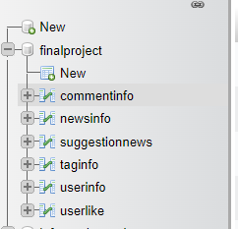

1. **Userinfo:**

This chart is for store the basic information for the users. The structure of the database is as below:

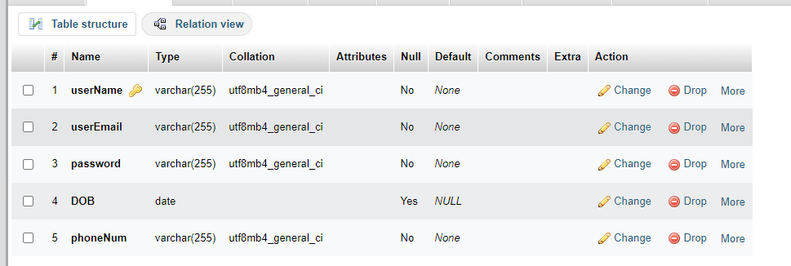

The primary key is username.

The example of the chart content is as below:

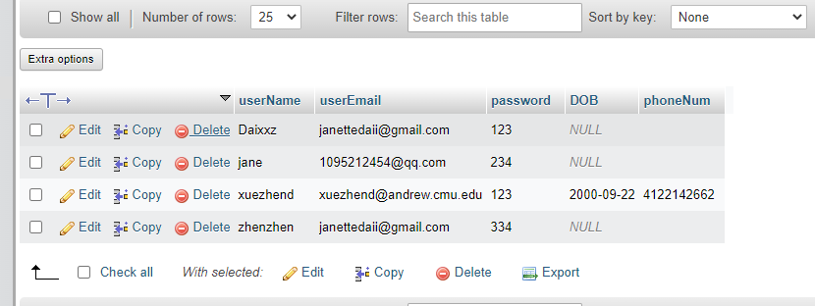

1. **Newsinfo**

Newsinfo would store the newsId, newsTitle, newsMessage, newsPic, addingtime and # of endorse and number of oppose. It should be noticed that the user cannot add to the newsinfo chart, since not everyone could post a news to the website!

The structure of news info is as below:

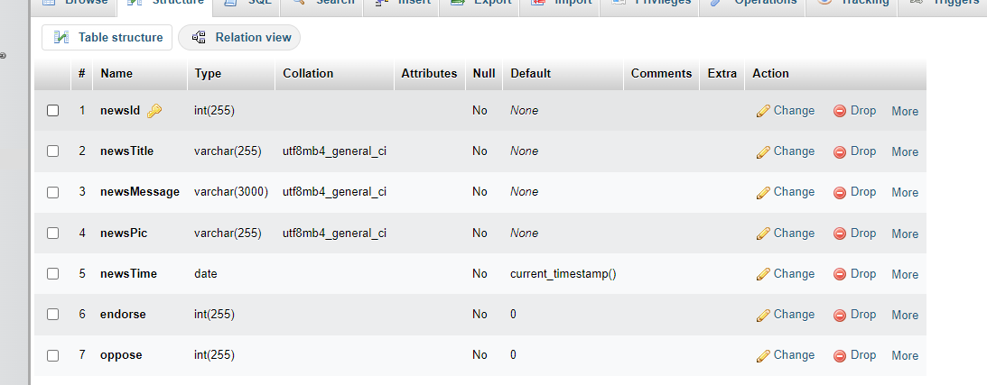

The primary key is newsId, and for better looking, in the newsMessage, every paragraph could add<p>,</P>

The example of the news is as below:

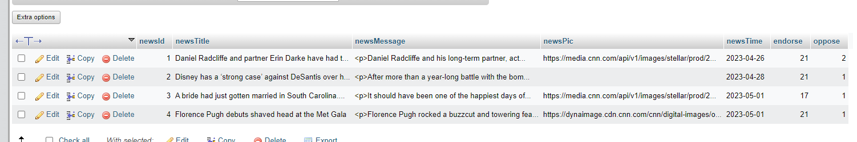

The example of the data would be like:

1. newsTitle: Daniel Radcliffe and partner Erin Darke have had their first child

newsMessage: <p>Daniel Radcliffe and his long-term partner, actress Erin Darke, have had their first child.</p>

newsPic: <https://media.cnn.com/api/v1/images/stellar/prod/230326114710-daniel-radcliffe-erin-darke-090822.jpg?c=16x9&q=h_720,w_1280,c_fill/f_webp>

1. newsTitle: Disney has a ‘strong case’ against DeSantis over his ‘retaliatory campaign,’ First Amendment experts say

newsMessage:

<p>After more than a year-long battle with the bombastic Florida governor, the entertainment behemoth filed a blistering lawsuit in federal court, not mincing words as it alleged that it had been the victim of a “targeted campaign of government retaliation” for having the gall to speak out against the so-called “Don’t Say Gay” bill.</p>

<p>“Disney regrets that it has come to this,” the company said in its lawsuit, arguing that it found itself in the “regrettable position” because it “expressed a viewpoint the governor and his allies did not like.” Disney added, “In America, the government cannot punish you for speaking your mind.”</p>

<p>The lawsuit, the culmination of ever-growing hostilities between the Magic Kingdom and Sunshine State, was filed moments after a DeSantis-appointed board moved to recover power it had lost over Disney’s special taxing district. Earlier this year, Disney quietly outmaneuvered the board and struck a decades-long deal to ensure it retained authority over the land around its sprawling Orlando-area theme parks.</p>

newsPic: null

1. Taginfo

Taginfo is to store the information of tags, including tagId, newsId, username, tagMessage,tagTime. The structure of the taginfo is as below:

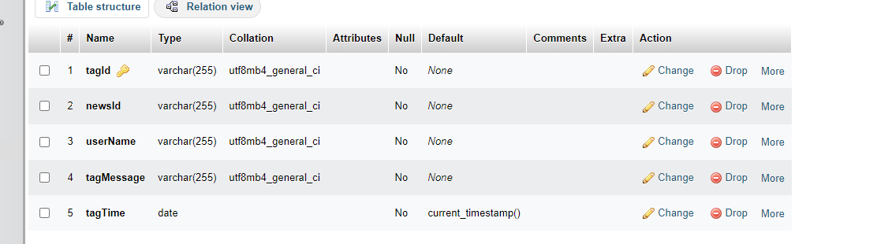

One example of taginfo is:

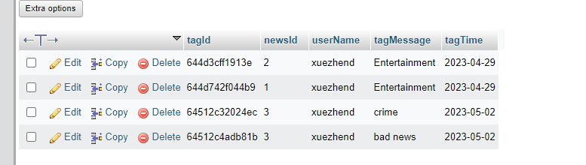

1. Commentinfo

This table is for storing the content of comment submitted by users. The structure is :

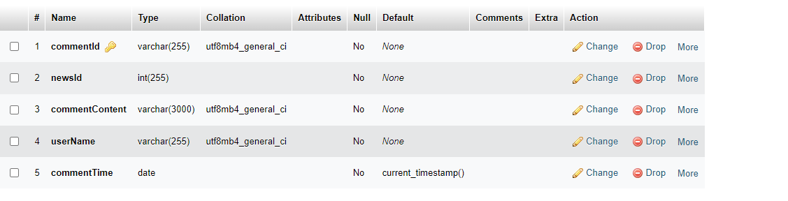

The primary key is commentId, is randomly generated by code.

The example of the table is:

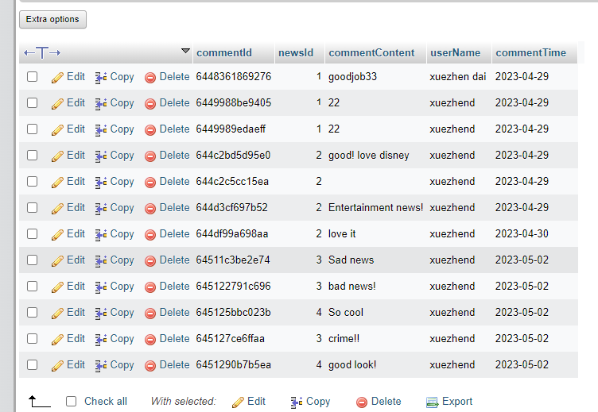

1. Userlike

This table is created for storing the favorates/liking action made by users. The primary key is likeId, the structure is shown as below:

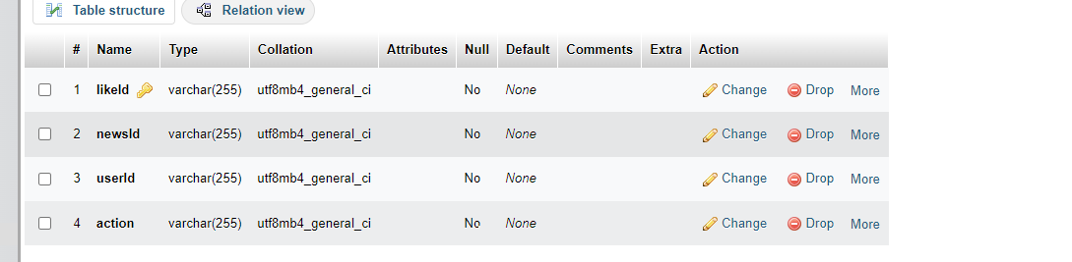

And the example is shown as below:

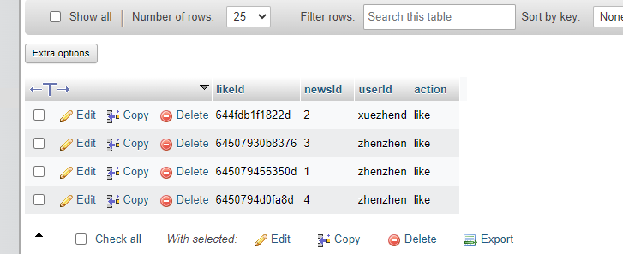

1. Suggestionnews

The last table is generated from python file suggestion.py, the structure is as shown:

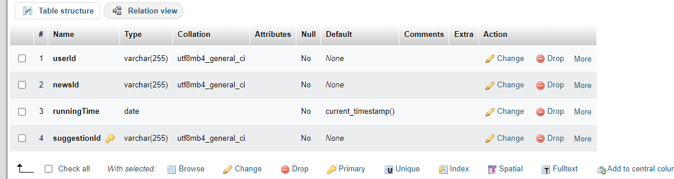

One example of the suggestion is shown as below:

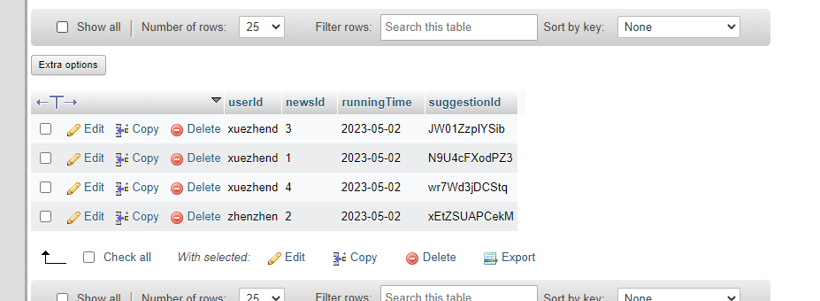

When running this program, there need to have enough action in the userlike.