# Self-Driving Car Engineer – Capstone Project

1. **Introduction**

In this project, we developed software to drive Carla, the Udacity autonomous car. The autonomous car is in essence a robot. The project's goal is to provide the robotic vehicle with the ability to plan a route and drive the course. During the drive, the car will drive smoothly while detecting traffic lights, react accordingly and drive within the lanes.

1. **Team Members**

|  |  |
| --- | --- |
| **Member Name** | **Email** |
| Amir Abu Jandal | [jandal487@gmail.com](mailto:jandal487@gmail.com) |
| Prabhakaran Shankar | [karansprabhu@gmail.com](mailto:karansprabhu@gmail.com) |
| Leon.Yu | [luteresa@163.com](mailto:luteresa@163.com) |
| Arul Raj | arullkr@gmail.com |

1. **System Architecture Diagram**

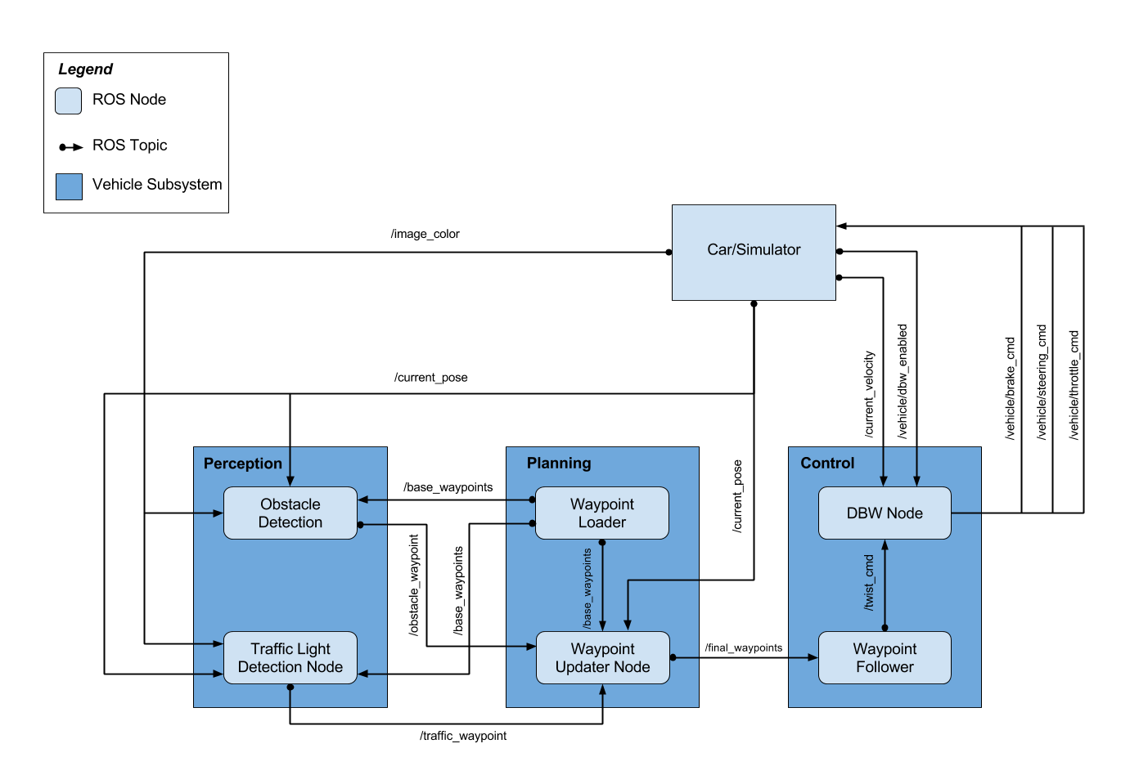

1. **Required code implementations**

We have implemented our code in the following files:

1. /CarND-Capstone/ros/src/waypoint_updater/waypoint_updater.py
2. /CarND-Capstone/ros/src/ twist_controller/dbw_node.py
3. /CarND-Capstone/ros/src/ twist_controller/twist_controller.py
4. /CarND-Capstone/ros/src/tl_detector/tl_detector.py
5. /CarND-Capstone/ros/src/tl_detector/light_classification/tl_classifier.py
6. **Projects Rubrics**

Did the car navigate the track successfully? Yes.