Master MOSiG - M1

Report

Signal Fundamentals
Computer Exercises N. 1

Authors
Jander Botelho do Nascimento
Raquel Araújo de Oliveira

Grenoble, 13 October 2010

Index
Master MOSiG - M1 1
Report 1
Authors 1
Brute-force algorithm 3
Question 1 3
Greedy algorithm 3
Question 2 3
Question 3 3
Experimental comparison 3
Question 4 3
Question 5 7
Question 6 7
Question 7 7

Brute-force algorithm

Question 1
In the brute-force its necessary to make a combination of each element,for instance:
Considering the set {1,2,3}, we can create the following subsets {{1,2,3},{1,3,2},{2,1,3},{2,3,2},{3,1,2},{3,2,1}}
According to the combinatorial statements we may say that the size of possible subsets is the number of elements(n) factorial, or n!.
In the Knapsack problem, we may apply the same rule, creating a tree of the possible solutions. The ideal solution is the combination in which we have the most expensive items, respecting the constraint of the knapsack weight. So the complexity in the worst case would be O(n!)

Greedy algorithm

Question 2
The worst case in greedy is O(n).

Question 3
Greedy not always gives the best solution, such as in the trial/instance_10_20_16 (Maximum weight is 21), in this case if we apply the greedy algorithm we will have:
item 1 has profit 3 and weigth 2 profit/weigth 1.500000
item 2 has profit 11 and weigth 9 profit/weigth 1.222222
item 3 has profit 6 and weigth 5 profit/weigth 1.200000
item 4 has profit 3 and weigth 4 profit/weigth 0.750000
Total: weight:20 price:23
Otherwise if we apply the brute-force algorithm, we will have:
item 1 has profit 11 and weigth 9 profit/weigth 1.222222
item 2 has profit 13 and weigth 12 profit/weigth 1.083333
Total: weight:21 price:24
As we can see, in this situation the greedy did not made the best choice;

Experimental comparison

Question 4
Several tests were made varying the max number of elements in 7,10 and 11. Each round collected the informations about the price, in which every bag carry, and the time that the algorithm took to give a solution;
With 7 elements:
In the time chart[1] is possible to see that with more than 6 elements the brute-force algorithms takes exponential time to give a result.
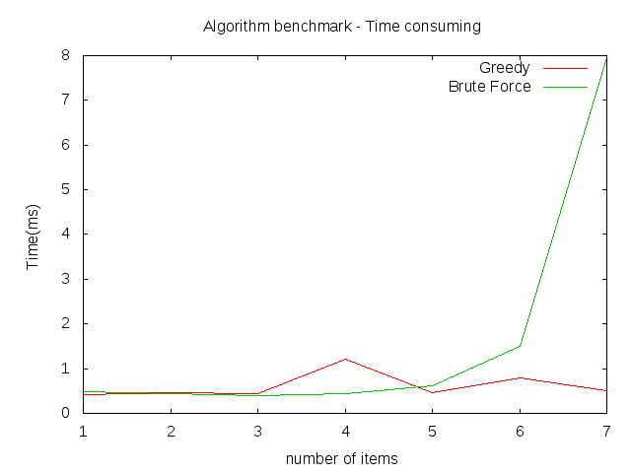
Although, if we analyze the price chart[2] we can see that the brute-force result has always the same price as the greedy algorithm or a higher price, which is the goal of the knapsack problem.
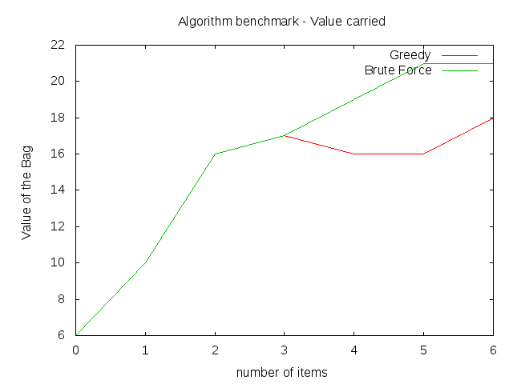
With 10 elements:
Time wise, as we can check in the chart[3], the brute-force takes about 7.4 seconds to give a solution while the greedy still gives a solution in less than 1 (one) second, that's why the red line is not visible (chart was scale to fit the brute-force result).
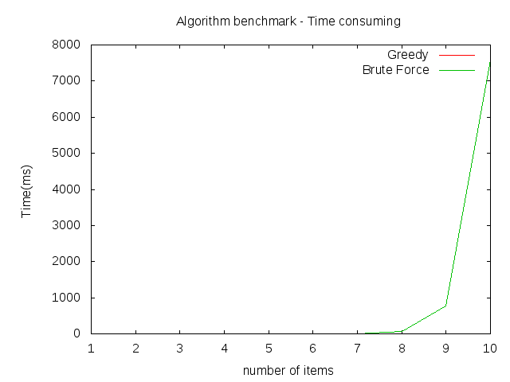
In the chart[4], the price of the bag created with the brute-force algorithm is still higher than the one created with greedy algorithm.
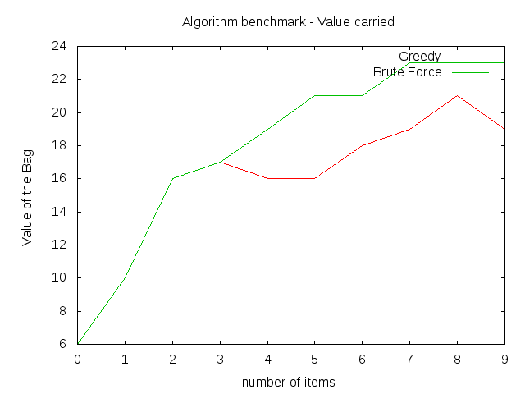
With 11 elements:
The chart[5] shows that the time for brute-force give a solution keeps growing, while the greedy keeps stable. But the brute-force[6] still gives us the best solution, a bag with the higher price;

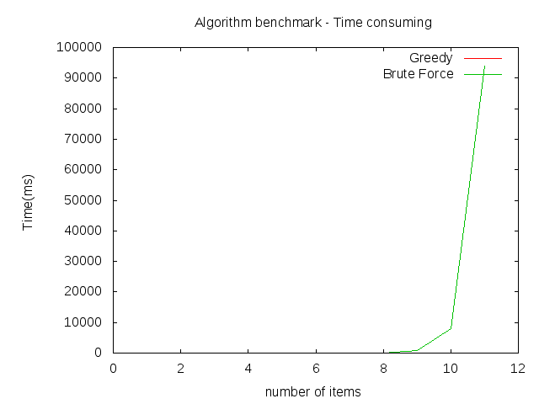
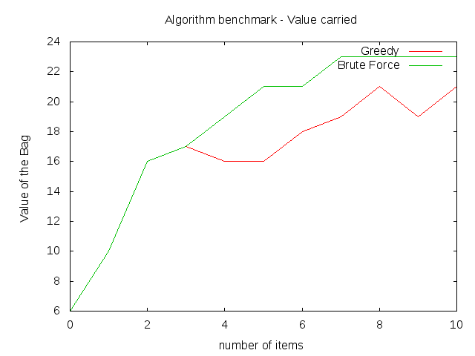

Question 5

Question 6
For the greedy algorithm its possible to reply in 28 seconds with 12000 elements, the brute-force gives the answer in 10 seconds for 10 elements, with 11 elements takes longer than 30 seconds.

Question 7

