Master MOSiG - M1

Report

Algorithm and program design
Knapsack problem

Author
Jander Botelho do Nascimento

Grenoble, 20 October 2010

Index
Master MOSiG - M1 1
Report 1
Author 1
Brute-force algorithm 3
Question 1 3
Greedy algorithm 3
Question 2 3
Question 3 3
Experimental comparison 4
Question 4 4
Question 5 8
Question 6 8
Question 7 8
Tools and Architecture 9
Architecture 9
Makefile 9
generate_analysis.sh 9
test_acurracy.sh 10

Brute-force algorithm

Question 1
In the brute-force its necessary to make a combination of each element, trying all possible subsets, for instance:
Considering the set {1,2,3}, we can create the following subsets {{1,2,3},{1,3,2},{2,1,3},{2,3,2},{3,1,2},{3,2,1}}, so the brute-force algorithm should test all these solution and check which one of them is the best.
According to the combinatorial statements we may say that the size of possible subsets is the number of elements(n) factorial, or n!.
In the Knapsack problem, we may apply the same rule, creating a tree of the possible solutions. The ideal solution is the combination in which we have the most expensive items, respecting the constraint of the knapsack weight. So the complexity in the worst case would be O(n!)

Greedy algorithm

Question 2
As the most complex operation in Greedy is the sorting, and the sort method chosen was the bubble sort, which has the complexity O(n²), so the Greedy complexity in worst case is O(n²).

Question 3
Greedy not always gives the best solution, such as in the trial/instance_10_20_16 (Maximum weight is 21), in this case if we apply the greedy algorithm we will have:
item 1 has profit 3 and weigth 2 profit/weigth 1.500000
item 2 has profit 11 and weigth 9 profit/weigth 1.222222
item 3 has profit 6 and weigth 5 profit/weigth 1.200000
item 4 has profit 3 and weigth 4 profit/weigth 0.750000
Total: weight:20 price:23
Otherwise if we apply the brute-force algorithm, we will have:
item 1 has profit 11 and weigth 9 profit/weigth 1.222222
item 2 has profit 13 and weigth 12 profit/weigth 1.083333
Total: weight:21 price:24
As we can see, in this situation the greedy was not best choice. This is because greedy chooses the highest price per weight, but the problem with this approach is that more frequently there still space left in the bag.

Experimental comparison

Question 4
Several tests were made varying the max number of elements in 7,10 and 11. Each round collecting informations about the price, in which every bag carries, and the time that the algorithm took to give a solution.
From 1 to 7 elements
In the time chart[1] is possible to see that with more than 6 elements the brute-force algorithms takes exponential time to give a result.
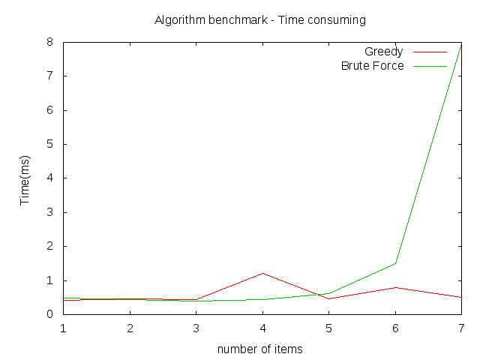Illustration 1
Although, if we analyze the price chart[2] we can see that the brute-force result has always the highest price(which is the goal of the knapsack problem) or at least same price as the greedy algorithm.
From 1 to 10 elements
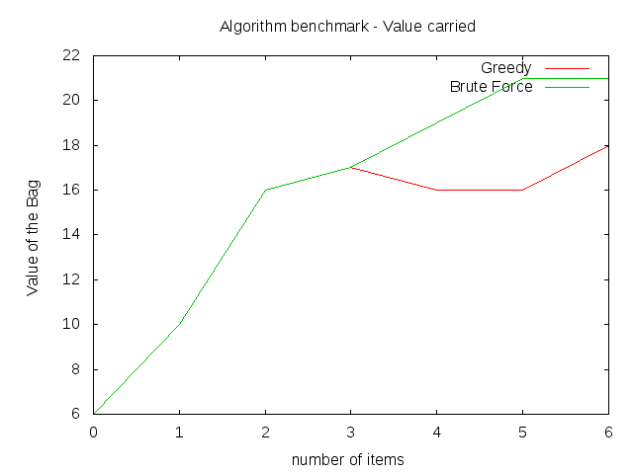Illustration 2
Time wise, as we can check in the chart[3], the brute-force takes about 7.4 seconds to give a solution while the greedy still gives a solution in less than 1 (one) second, that's why the red line is not visible (chart was scale to fit the brute-force result).
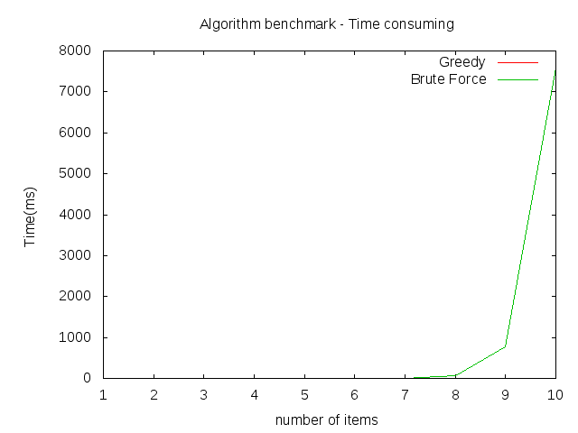Illustration 3
In the chart[4], the price of the bag created with the brute-force algorithm is still higher than the one created with greedy algorithm.
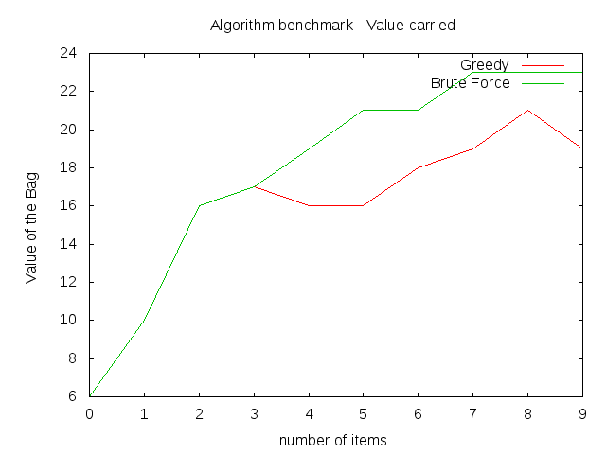Illustration 4
From 1 to 11 elements
The chart[5] shows that the time for brute-force give a solution keeps growing, while the greedy keeps stable(it's not possible to see Greedy line in this chart because it's too small compared with brute-force). But the brute-force[6] still gives us the best solution, a bag with the higher price;

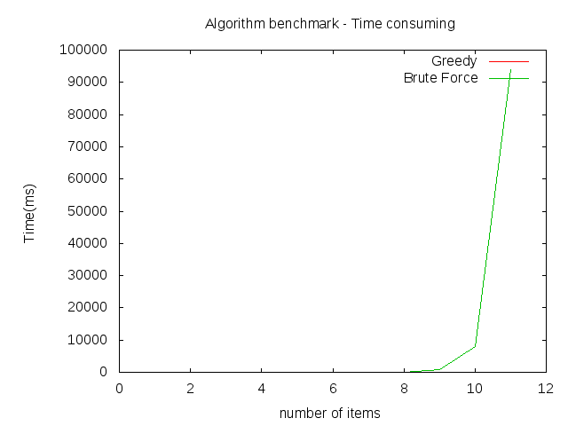Illustration 5
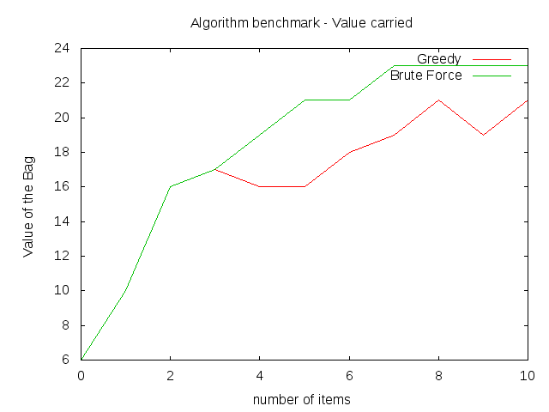Illustration 6

Question 5
Greedy do not outperform brute-force in terms of optimal solution(bag price).
In terms of execution time, with 12 elements the brute-force took too much time, an execution time that may be unacceptable compared with Greedy algorithm.

Question 6
For the greedy algorithm its possible to reply in 28 seconds with 12000 elements, the brute-force gives the answer in 10 seconds for 10 elements, with 11 elements takes longer than 30 seconds.

Question 7
Since the computational time taken by brute-force, this algorithm is pretty limited. And takes an exponential time to give an answer. So i strongly do not advice the using of this algorithm.

Tools and Architecture

Architecture
Description: this is the dependence between the two algorithms, which share baselib.c code, which contains utility functions.
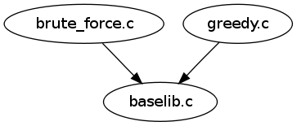

Makefile
Description: This file is used by make application to generate the following executables:
- generator: which create instances for knapsack problem
- read_instance: program that is capable to read structures created by generator
- greedy: program that implements greedy algorithm, that takes as argument instances generated by generator program
- brute_force: program that implements brute-force algorithm, that takes as argument instances generated by generator program
How to run?
- change to the application directory(in which Makefile file exists)
- than execute: make
Dependencies:
- make package. To install run sudo apt-get install make --assume-yes --force-yes

generate_analysis.sh
Description: Execute both algorithms (greedy and brute_force) varying instance size (defined in the script). This script also create a chart representing the data collected (if the dependence is available). The chart is based in files which contains data about the algorithms execution, like time and price of bags. The file name pattern is algorithm_[price|time]_[instance size].dat.
How to run?
- change to the application directory(in which Makefile file exists)
- then run ./generate_analysis.sh

Dependencies:
- gnuplot package, creates charts about the data collected. To install run sudo apt-get install gnuplot --assume-yes --force-yes

test_acurracy.sh
Description: Test all instances stored in trial directory and generate an output file with the name algorithm_acurracy.dat. This file may be used to generate a chart comparing both algorithms running with 100 instances of size 10.
How to run?
- change to the application directory(in which Makefile file exists)
- then run ./test_acurracy.sh

Dependencies:
- None

