Master MOSiG - M1

Report

Signal Fundamentals
Computer Exercises N. 2

Authors
Jander Botelho do Nascimento
Raquel Araújo de Oliveira

Grenoble, 13 October 2010

Index
Master MOSiG - M1 1
Report 1
Authors 1
Linear systems and Convolution 3

Linear systems and Convolution

- Input signal generation
  - On which condition (on y[0]) is this system linear? Prove that this system is linear (under this condition)

  - Complete the corresponding Java code creating these input signals.

public static Signal generateX1(int nbSamples) {
Signal x1 = new Signal();
x1.settName("x1[n] = sin(2 Pi n / 100)");

// Write your code here
double y;
for(int i=0;i<nbSamples-1;i++){
y=Math.sin((2.0 * Math.PI * i) / 100.0);
x1.addElement((double) i, y);
}

return x1;
}

/**
* Generates and returns the signal
* x2[n] = 4*exp(-(n-150)^2/300) - exp(-(n-150)^2/2500)
* @param nbSamples number of samples of the signal.
* @return x2[n] = 4*exp(-(n-150)^2/300) - exp(-(n-150)^2/2500)
*/
public static Signal generateX2(int nbSamples) {
Signal x2 = new Signal();
x2.settName("x2[n] = 4*exp(-(n-150)^2/300) - exp(-(n-150)^2/2500)");

// Write your code here
double part1, part2, y;
for(int i=0;i<nbSamples-1;i++){
part1=i-150.0;
part1=part1 * part1;
part1=part1/300.0;
part1=part1*(-1);
part1=Math.exp(part1);
part1=4*part1;

part2=i-150.0;
part2=part2 * part2;
part2=part2 / 2500.0;
part2=part2*(-1);
part2=Math.exp(part2);

y=part1-part2;
x2.addElement((double) i, y);
}

return x2;
}

/**
* Generates and returns the signal
* x3[n] = 1 for 240 &lt; n &gt; 300
* -2 for 299 &lt; n &gt; 380
* 0 otherwise
* @param nbSamples
* @return x3
*/
public static Signal generateX3(int nbSamples) {
Signal x3 = new Signal();
x3.settName("x3");

// Write your code here
double y;
for(int i=0;i<nbSamples-1;i++){
if (240<i && i<300)
y=1;
else if(299<i && i<380)
y=-2;
else
y=0;
x3.addElement((double) i, y);
}

return x3;
}

  - Test and sum these 3 signals by generating 500 samples signals. (Menu 1: Generate x1, x2, x3, gaussian noise and sums) and save each signal.

.
|-- generated_signal.dat
|-- x1.dat
|-- x2.dat
|-- x3.dat
`-- x4.dat (gaussian noisy)

  - Complete the corresponding Java code.

public Signal singlePolLowPassFilter() {
Signal result = new Signal();
result.settName("Filtered signal");
// Write your code here
result.addElement(0, 0);
for(int n=1;n<getNbSamples();n++){

double yOfNMinusOne=result.getValueOfIndex(n-1);
double xOfN=this.getValueOfIndex(n);
result.addElement(n, 0.05*xOfN+0.95*yOfNMinusOne);

}
//end of my code

return result;
}

  - Pass each signal x1, x2, and x3 through the linear system. What do you observe?

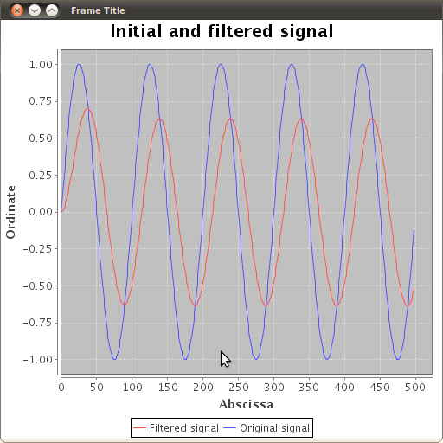 | 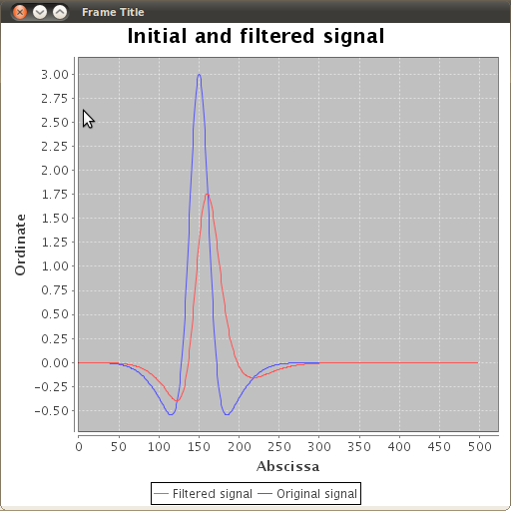 | 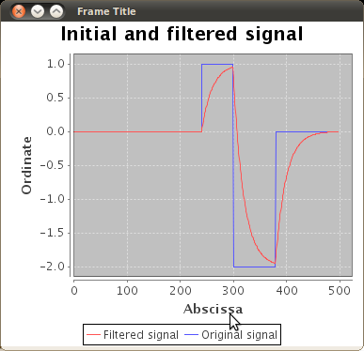

It's possible to see that the filter smooths all signal edged. Reducing the noisy of the signals.

  - Pass the sum x = x1 + x2 + x3 through the linear system. 1-Sum the output signals y= S(x1) + S(x2) + S(x3) = y1 + y2 + y3 and compare it to x. What do you observe? Why?

y | x
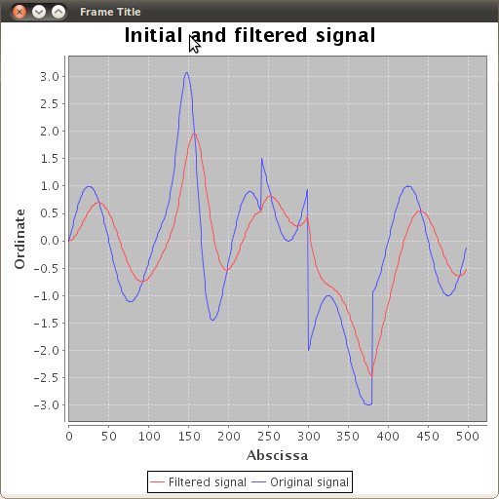 | 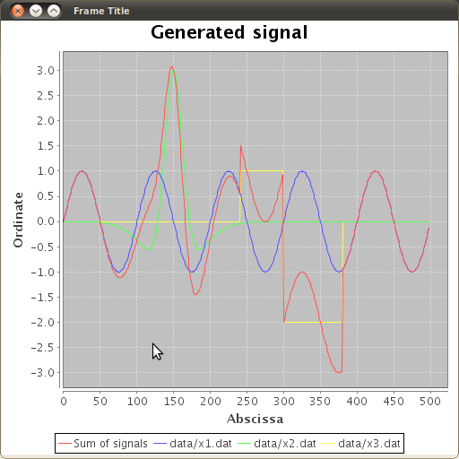

They are simillar in their shape. [CHECK]

  - Generate a signal xNoise = x1 + x2 + x3 + x4 and compare it with x.

  - Pass xNoise through the linear system. What do you observe?

  - (Go further) Explain why.

- 1D Convolution
  - Which condition on K ensures you the same number of operations between the 2 implementations?

  - Complete the corresponding Java code.

  - Create 2 signal files and check the result of truncated linear convolution and circular convolution.

  - What are the diferences between both results ? Explain these diferences with the equations 1 and 2.

  - What do you observe?

