Index

Index 1
Basic Signal Processing 1
Digital Noise Processing 1
Signal Decomposition 2

Authors
Jander Botelho do Nascimento
Raquel Araújo de Oliveira

Basic Signal Processing

1.1-In the directory named data, create a fi
le named prices.dat containing
the predicted stock market price of the exercise number 6 (Financial
Experts) of the exercises sheet.
Display it with the application.

Our informations would be : (1,996
)(2,868
)(3,855
)(4,956
)(5,867
)(6,933
)(7,866
)(8,887
)(9,936
)(10,901)(11,818
)(12,956)

The result in the screen would be:

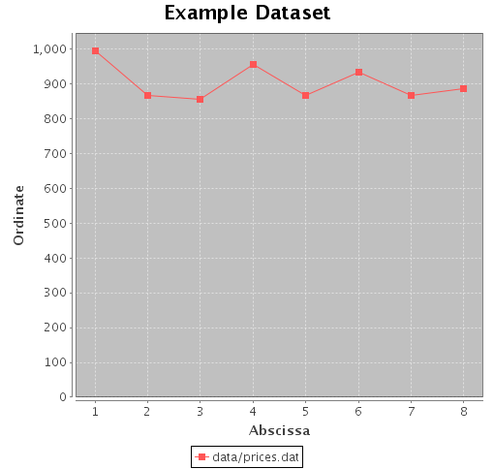

1.2-By right-clicking on the
figure and choosing Properties, change
¤ the title of the graphic
¤ the abscissa and ordinate labels
¤ the scale to display the signal properly
¤ the color to personalize your
figure.
Save your graphic as a picture by right-clicking on the
figure and choosing Save as.

The result in the screen would be:
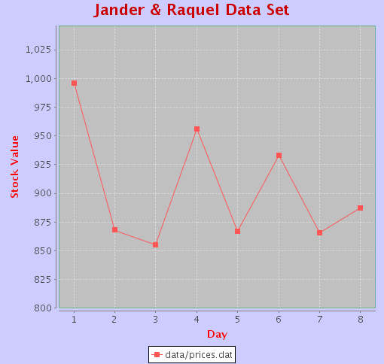

1.3-In the fi
le Signal.java, complete the methods public double
getMean() and public double getStandardDev().
Note: these methods are instance methods: to access the data of the
considered signal, use this.getValueOfIndex(int index);

1.4-What are the mean and the standard deviation of the expert's predic-
tions?

Answer;

1.5-What are the accuracy and the precision of the expert's predictions?

Answer;

1.6-Prove that for a given i, xi will be counted in hj if and only if (see papersheet)

Answer;

1.7-Complete the function public Signal getHitogram(double
intervalLength) of the
le Signal.java.

Answer;

1.8-Display the histogram the the predicted stock market price with an
interval length of 10.
Answer;

Digital Noise Processing

2.1-Complete the following function returning a signal containing
nbElements random numbers between min and max.

Answer;

2.2-Compute uniforms random signal and their mean and standard devia-
tion for the following values
¤ minVal: 0.0
¤ maxVal: 1.0
¤ nbElements: 10, 100, 1000 and 10000
and illustrate that the more samples you generate, the closer you should
get to the theoretical values.

Answer;

2.3-What is the pdf of a uniform random signal? Illustrate that the more
samples you generate, the closer the histogram gets to the pdf.

Answer;

2.4-What are the theoretical mean and standard deviation of a signal ob-
tained by added two random numbers generated independently between
0:0 and 1:0 to form each sample?

Answer;

2.5-What are the theoretical mean and standard deviation of a signal ob-
tained by adding twelve random numbers generated independently be-
tween 0:0 and 1:0 to form each sample?

Answer;

2.6-Deduce from the previous question an algorithm to generate a Gaussian
noise signal of mean (sigma)= 0 and standard deviation (sigma)= 1.

Answer;

2.7-Complete the corresponding code of the function public static
Signal createGaussianNoiseSeries(int nbElements) in the
le
Signal.java.

Answer;

2.8-Illustrate that the more samples you generate and the smaller the length
of histogram intervals are, the closer you get to a Gaussian by displaying
your signals histograms and a Gaussian curve.

Answer;

Question To go further
Write an algorithm to generate a Gaussian noise signal with a given
mean and a given standard deviation.

Answer;

Signal Decomposition

3.1-Complete these methods: public Ar rayLi s t<Gene ralSignal> evenOddDecomposition ( ), public Ar rayLi s t<Gene ralSignal> int e r l a c edDe c ompo s i t i on ( ).

Answer;

3.2-Create a
le containing a small signal (10 samples), either by hand or
by generating a random signal (see previous computer exercise).
Test and illustrate the decomposition of this signal.

Answer;

