+++IF false+++
Image within falsy block
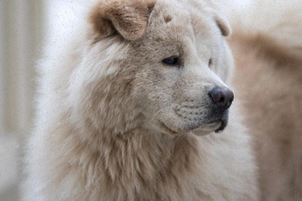
+++END-IF+++
+++IF false+++
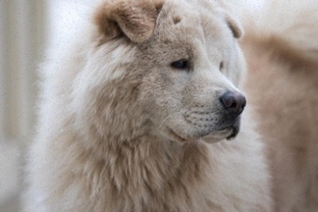
Anchored image within falsy block
+++END-IF+++
+++IF true+++
Image within truthy block

+++END-IF+++
+++IF true+++

Anchored image within truthy block
+++END-IF+++

