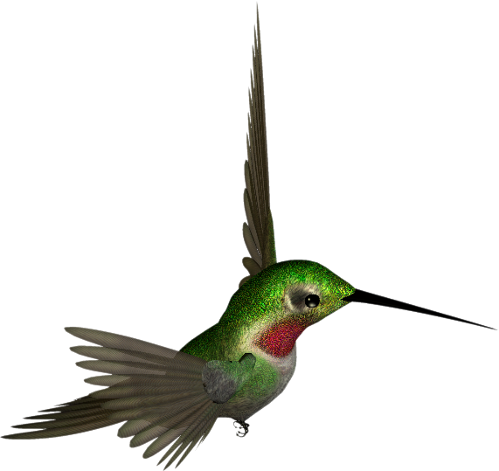
Lets tightly wrap this one. Lets tightly wrap this one. Lets tightly wrap this one. Lets tightly wrap this one. Lets tightly wrap this one. Lets tightly wrap this one. Lets tightly wrap this one. Lets tightly wrap this one. Lets tightly wrap this one. Lets tightly wrap this one. Lets tightly wrap this one. Lets tightly wrap this one. Lets tightly wrap this one. Lets tightly wrap this one. Lets tightly wrap this one. Lets tightly wrap this one. Lets tightly wrap this one. Lets tightly wrap this one. Lets tightly wrap this one. Lets tightly wrap this one. Lets tightly wrap this one. Lets tightly wrap this one. Lets tightly wrap this one. Lets tightly wrap this one. Lets tightly wrap this one. Lets tightly wrap this one. Lets tightly wrap this one. Lets tightly wrap this one. Lets tightly wrap this one. Lets tightly wrap this one. Lets tightly wrap this one. Lets tightly wrap this one. Lets tightly wrap this one. Lets tightly wrap this one. Lets tightly wrap this one. Lets tightly wrap this one. Lets tightly wrap this one. Lets tightly wrap this one. Lets tightly wrap this one. Lets tightly wrap this one. Lets tightly wrap this one. Lets tightly wrap this one. Lets tightly wrap this one. Lets tightly wrap this one. Lets tightly wrap this one.

