Vladyslava Andrushchenko

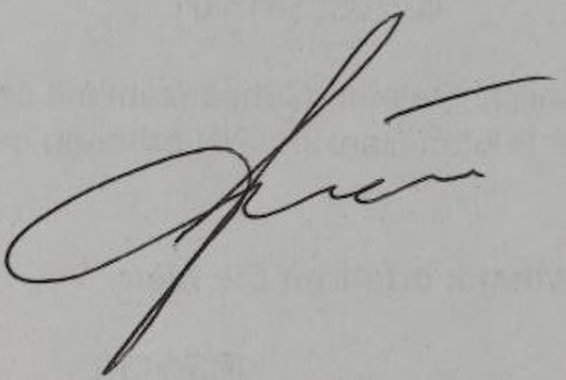

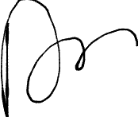

x

https://vitest.dev/guide/coverage

