Outline

Pubertal Development
- Review literature on pubertal development in boys and girls and links to outcomes in adolescence, early adulthood, and mid-life.
  - Pubertal timing (i.e., the onset of puberty) demonstrates significant individual variability, with far reaching consequences for developmental processes.
  - In particular, early maturing girls have higher risk for mood disorders and externalizing behaviors such as delinquency, substance use, early sexual activity.
  - Both early- and late-maturing boys demonstrate elevated risk for depression and other internalizing behaviors
  - Comparatively, relatively little is known about the long-term impact of pubertal processes beyond adolescence and early adulthood but:
    - Some evidence suggests that links between pubertal timing and adverse outcomes are minimal by the fourth decade of life (Boden, 2011; Senia, 2018)
    - Other evidence suggests that risk conferred by early or off-time pubertal development persists into adulthood in certain domains (e.g., depression, sleep; Hoyt, 2020)
  - Understanding these links between pubertal processes and behavioral outcomes depends on measurement
The Measurement of Pubertal Timing
- What measures are available to measure pubertal timing?
  - Menarche (single indicator), self-report (e.g., PDS, peer relative timing measures), hormone measurements, physical exams
    - Can vary in terms of their objectivity (vs. subjectivity), whether they’re concurrent or retrospective, or whether they’re cross-sectional or longitudinal
  - Different measures have different strengths
    - Adolescents aren’t great at identifying early pubertal signs which can lead to regression through the stages (Tanner Stage 3 → Tanner Stage 2)
    - Some items in the PDS aren’t as reliable (e.g., skin changes; Shirtcliff, 2009)
  - Timing might be best assessed after puberty. Explain why.

- Retrospective pubertal measures
  - There are several measures available to assess retrospectively reported pubertal timing including retrospective PDS measures and a timing measure (Beltz & Berenbaum, 2013).
    - Psychometrically validated/assessed Cronbach’s alpha, ICC, correlations with recalled age for menarche & spermarche, but not with prospective measurements or a separate dataset
  - Retrospective timing measures are a powerful tool.
    - Work with these retrospective measurements has revealed important insights into the persistence of mood disorders, substance use, and behavioral problems
  - But concerns about the use of these measures persist:
    - Reliability: high internal consistency at the time of assessment (see Beltz & Berenbaum, 2013), but what about test-retest reliability or reporting over time?
    - Validity: what is the role of recall bias can’t look at validity because there’s no objective reports of pubertal development during adolescence

What’s Known about the Reliability and Validity of Retrospective Reporting?
- Review what sexual initiation and substance use studies tell us about reliability of retrospective reporting as a benchmark. Some key issues include:
  - Length of recall
  - Sex differences
  - Off-time/Regression to the mean
- Review menarche/timing studies (i.e., what gaps does our study fill?)
  - Marie & Jacobsen (2017): High reproducibility of menarche with long length between initial and retrospective report.
    - But both time points were retrospective
  - Gilger et al (1991): substantial test-retest reliability, MZ intraclass correlations exceeded DZ intraclass correlations, magnitude of relations followed theoretical expectations of traits with genetic influences
  - If many retrospective reports are taken at 18, then those might good reports
    - But only measured in adulthood
    - And small sample size
  - General limitations of these studies:
    - Both time points were retrospective
    - Both time points were in adolescence
    - Only menarche → no boys were assessed

The Current Study
- Compare prospective reports of status to a validated measure of retrospective pubertal timing using a large cohort of youth followed prospectively into adulthood
  - Aim 1: Examine the correspondence between prospective and retrospective reports of timing in boys and girls.
    - Compare these findings to sexual initiation
  - Aim 2: Examine whether prospective and retrospective reports of timing are differentially associated with outcomes.
  - Aim 3: Examine factors (moderate the accuracy of outcomes) associated with better or worse recall of outcomes (e.g., age, length of recall…)

Methods
Participants
Measures
Analytic Plan
Results

Aim 1: Examine the correspondence between prospective and retrospective reports of timing in boys and girls.
- Report means and zero order correlations for indicator (sexual initation, menarche, girls’ timing, boys’ timing) in text
- Figure 1a & 1b: Average sexual initiation and menarche by early, on-time, and late categories
- Figure 2c & 2d: Average sexual girls’ and boys’ timing by early, on-time, and late categories
- Figure 3. Correspondence between prospective and retrospective reports of timing.

Figure 1b. EXAMPLE menarche by early, on-time, and late categories

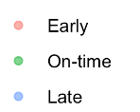
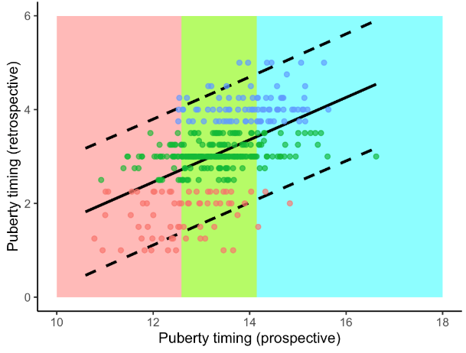
Retrospectively Reported Menarche

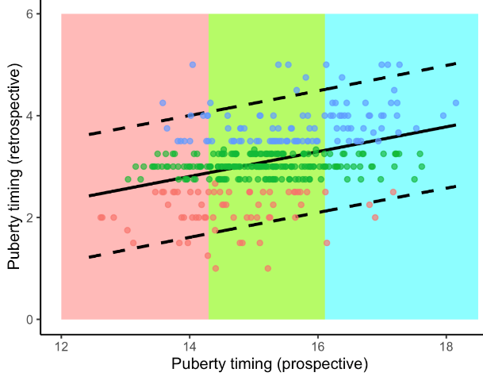
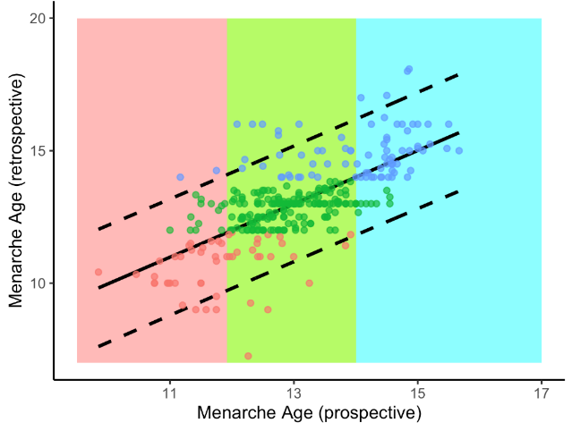

Figure 3. EXAMPLE Correspondence between prospective and retrospective reports of timing.

Aim 2: Examine whether prospective and retrospective reports of timing are differentially associated with outcomes.
- Figure 4. Depict outcomes using area plots (e.g., Beltz, 2014)

Aim 3: Examine factors (moderate the accuracy of outcomes) associated with better or worse recall of outcomes (e.g., age, length of recall…)
- Report in text

Discussion

