Connecting the dots

Score Reading – making connections between the written music notation and how your ears/eyes interpret what it should sound like.

PART 1 - Examine the following score excerpt by Haydn:

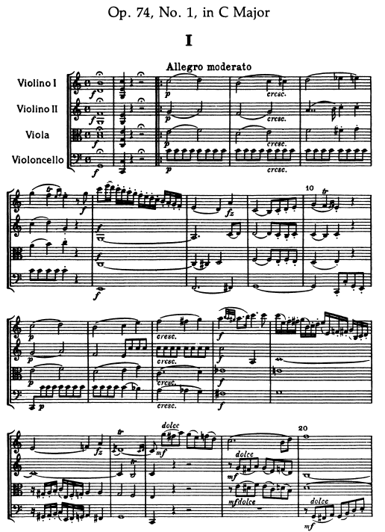

Click on each of the links below and select which audio recording most accurately represents the notated score? (Follow the score as you are listening)

[Listen only to the first 20 bars or so of the recordings]

1. https://www.youtube.com/watch?v=2DGQyz35xQg

2. https://www.youtube.com/watch?v=aeYjiG0AywQ

3. https://www.youtube.com/watch?v=wRZVRkxrwBI

ANSWER

PART 2 - Answer specific questions relating to the Elements of Music and/or Compositional Devices / Musical Techniques, or musical symbols.

Refer to the score on the previous page:

- Describe the time signature used in the excerpt.
- What clef does the Viola use and name the note played in bar 7?
- Define the tempo marking Allegro Moderato?
- What chord is created in bar 1?
- List and define all musical symbol/s that appear in bar 1.
- List and define all of the articulations that appear in bar 9.
- Describe and name the two musical ornaments seen in the 1st Violin part in bar 10.
- Circle a 16th rest / semiquaver rest.
- Explain the notation used in the Violoncello part in bars 4-5.
- Name the interval created between the viola and the 2nd violin in bar 3 (beat 1 and 2).

PART 3 – Look at the following score excerpt. Without listening to a recording of it, visually interpret how it might sound.

Using appropriate / relevant music terminology, write sentences, paragraphs, dot points to explain how the music will / should sound.

Refer to some or all of the Elements of Music and Compositional Devices/ Musical Techniques to assist your answer.

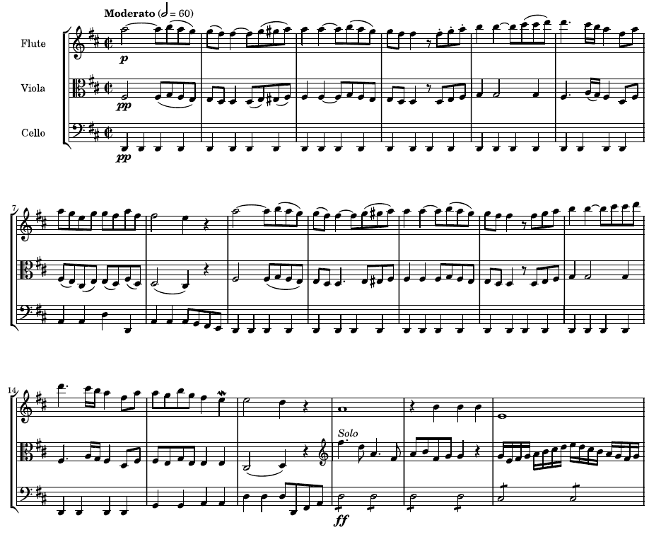

PART 4 – Click on the link below to now listen to the score. (listen only for the amount of time represented by the excerpt in Part 3)

https://www.youtube.com/watch?v=N9Un3Nq3PtU

Reflect upon how accurate you were in describing the music by placing a tick against the appropriate indicator. Write your own descriptors to suit the music you have been listening to. (three have been provided to get you started)

Descriptors | Indicators
Specific statements relating to the excerpt | Accurate | Partially accurate | Not accurate
The music sounded like what I thought it would
I described the timbre accurately
I accurately commented upon the texture

Highlight ONE area of study that you need to further concentrate on to assist in your skill building with score reading and “Connecting the Dots.”

___________________________________________________________________________________________________________________________________________________________________________________________________________________________

Highlight ONE are that you feel you are doing well at in this area of study.

___________________________________________________________________________________________________________________________________________________________________________________________________________________________

http://ks.imslp.net/files/imglnks/usimg/d/da/IMSLP471151-PMLP44350-Devienne_Trios_Score_with_Cover_Page.pdf

