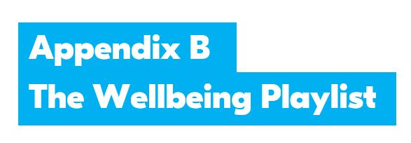

Lesson 3 Perfecting the ultimate playlist

Wellbeing Prompt Sheet

Sometimes I feel:

For instance when:

This makes me feel like:

But I know this won’t be useful so instead I take a deep breath and do this instead:

I might play this song:

because it makes me feel:

