Supplementary Figures
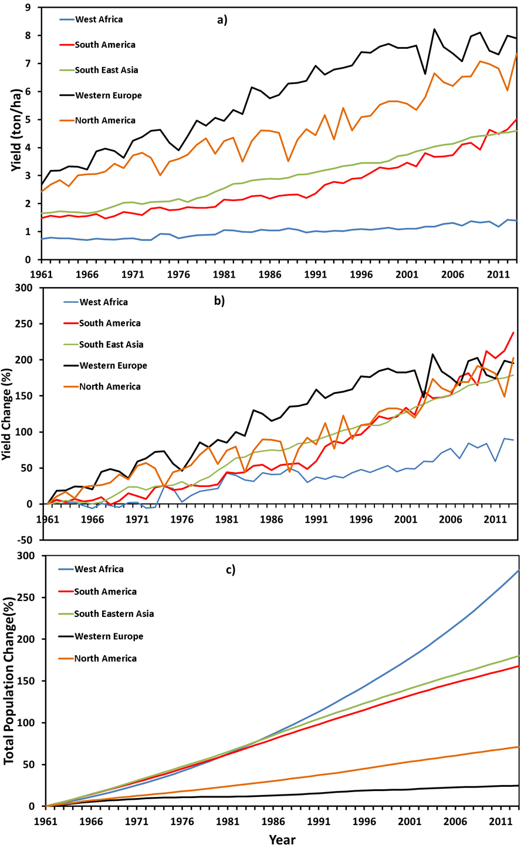
Figure S1: Cereals yield (a, b) and population(c) trend comparison. Source: FAOSTAT, 2017

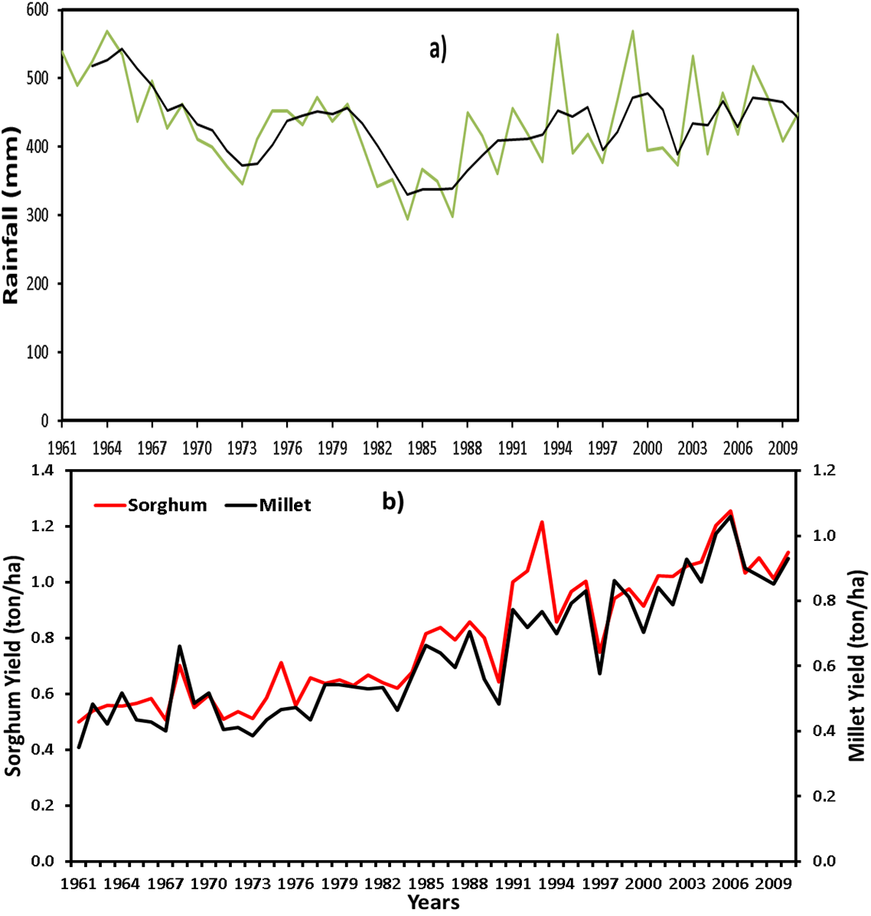
Figure S2. Decreasing rainfall (a) and increasing yields (b) at Dori in Burkina Faso

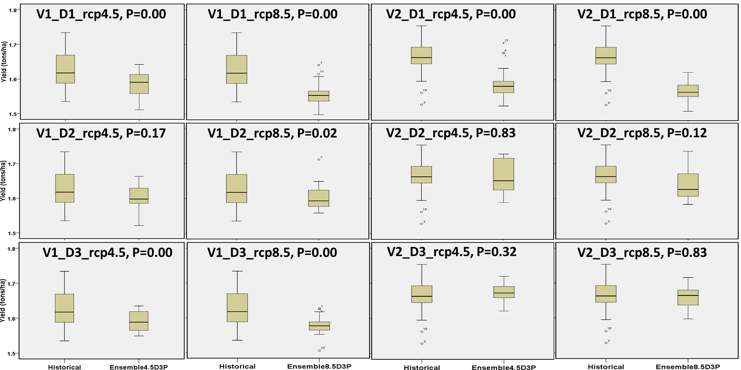
Figure S3: NTarla sorghum yield ensemble (9 GCM models) under the rcp4.5 and 8.5 for future period, 2021/25-2050 relative to the baseline periods, 1981/85-2010.
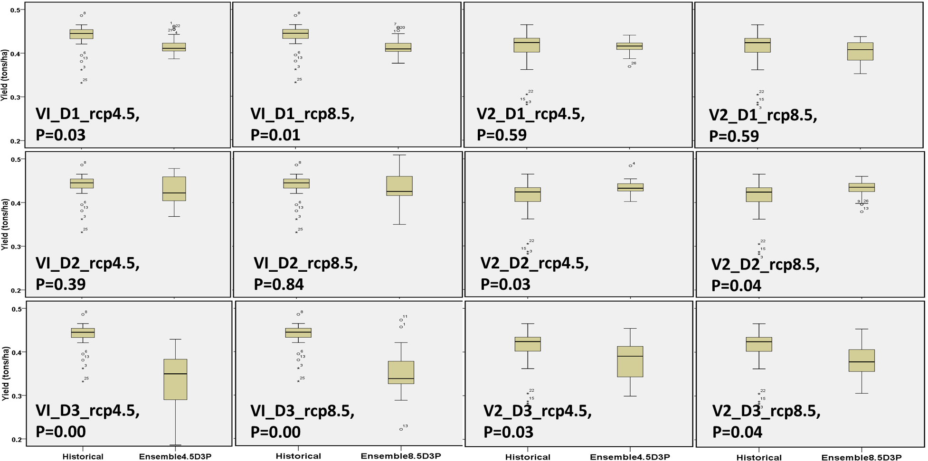Figure S4: Tillabery millet yield ensemble (9 GCM models) under the rcp4.5 and 8.5 for future period, 2021/25-2050 relative to the baseline period, 1981/85-2010.

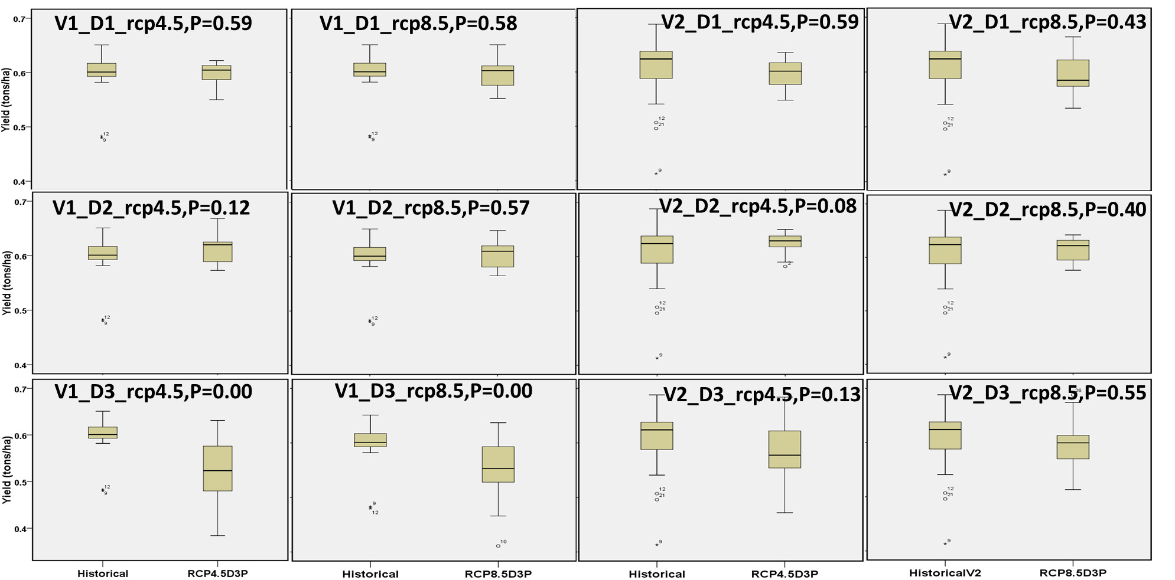
Figure S5: Dori millet yield ensemble (9 GCM models) under the rcp4.5 and 8.5 for future period, 2021/25-2050 relative to the baseline period, 1981/85-2010.

Supplementary Tables.

Table S1: Southern Guinea Savanna (Makurdi) average simulated maize and sorghum grain yield change for the future period (2025-2050) relative to the current period (1985-2010)
Scenarios | Yield(tons/ha)  MaizeV1 | Y∆(%) | Yield(tons/ha)  MaizeV2 | Y∆(%) | Yield(tons/ha)  SorghumV1 | Y∆(%) | Yield(tons/ha)  SorghumV2 | Y∆(%)
Histv1D1p | 1.281 | 0 | 1.278 | 0 | 1.565 | 0 | 1.602 | 0
Rcp4.5V1D1P | 1.307 | 2.1 | 1.329 | 4.0 | 1.572 | 0.4ª | 1.605 | 0.2ª
RCP4.5V1D2P | 1.313 | 2.5 | 1.340 | 4.9 | 1.630 | 4.1 | 1.668 | 4.2
RCP4.5V1D3P | 1.329 | 3.7 | 1.344 | 5.1 | 1.647 | 5.2 | 1.693 | 5.7
RCP8.5V1D1P | 1.317 | 3.3 | 1.335 | 4.4 | 1.562 | -0.2ª | 1.604 | 0.2ª
RCP8.5V1D2P | 1.320 | 3.0 | 1.347 | 5.4 | 1.605 | 2.6 | 1.663 | 3.8
RCP8.5V1D3P | 1.323 | 3.3 | 1.337 | 4.6 | 1.623 | 3.7 | 1.681 | 5.0
RCP8.5V1D1M | 2.017 | 57.5 | 2.033 | 59.0 | 2.478 | 58.3 | 2.511 | 56.8
RCP8.5V1D2M | 2.015 | 57.3 | 2.050 | 60.4 | 2.550 | 62.9 | 2.621 | 63.7
RCP8.5V1D3M | 2.029 | 58.4 | 2.049 | 60.3 | 2.575 | 64.6 | 2.648 | 65.3
RCP8.5V1D1NP | 2.791 | 117.9 | 2.832 | 121.6 | 3.522 | 125.0 | 3.481 | 117.4
RCP8.5V1D2NP | 2.796 | 118.3 | 2.839 | 122.1 | 3.609 | 130.6 | 3.613 | 125.6
RCP8.5V1D3NP | 2.804 | 118.9 | 2.834 | 121.7 | 3.690 | 135.8 | 3.685 | 130.1
RCP8.5V1D1OP | 3.613 | 182.1 | 3.645 | 185.2 | 4.815 | 207.7 | 4.554 | 184.4
RCP8.5V1D2OP | 3.590 | 180.3 | 3.660 | 186.4 | 4.892 | 212.6 | 4.735 | 195.7
RCP8.5V1D3OP | 3.601 | 181.2 | 3.615 | 182.9 | 5.012 | 220.3 | 4.833 | 201.8
Note: All are significant at 0.05 except those specified as ª
Table S2: Northern Guinea Savanna (Samaru illustrated) average simulated maize and sorghum grain yield change for the future period (2021-2050) relative to the current period (1981-2010)
Scenarios | Yield(tons/ha)  MaizeV1 | Y∆(%) | Yield(tons/ha)  MaizeV2 | Y∆(%) | Yield(tons/ha)  SorghumV1 | Y∆(%) | Yield(tons/ha)  SorghumV2 | Y∆(%)
Histv1D1p | 1.628 | 0 | 1.628 | 0 | 1.360 | 0 | 1.397 | 0
Rcp4.5V1D1P | 1.325 | -18.6 | 1.393 | -14.4 | 1.246 | -8.4 | 1.257 | -10.0
RCP4.5V1D2P | 1.341 | -17.6 | 1.348 | -17.2 | 1.278 | -6.0 | 1.276 | -8.6
RCP4.5V1D3P | 1.364 | -16.2 | 1.385 | -14.9 | 1.267 | -6.9 | 1.303 | -6.7
RCP8.5V1D1P | 1.302 | -20.0 | 1.303 | -19.9 | 1.208 | -11.2 | 1.239 | -11.3
RCP8.5V1D2P | 1.319 | -19.0 | 1.321 | -18.9 | 1.238 | -8.9 | 1.253 | -10.2
RCP8.5V1D3P | 1.360 | -16.5 | 1.368 | -15.9 | 1.257 | -7.6 | 1.287 | -7.8
RCP8.5V1D1M | 1.993 | 22.4 | 2.014 | 23.7 | 1.924 | 41.5 | 1.945 | 39.3
RCP8.5V1D2M | 2.026 | 24.5 | 2.032 | 24.8 | 1.974 | 45.1 | 1.972 | 41.2
RCP8.5V1D3M | 2.082 | 27.9 | 2.103 | 29.2 | 1.990 | 46.4 | 2.033 | 45.6
RCP8.5V1D1NP | 2.758 | 69.4 | 2.801 | 72.0 | 2.724 | 100.3 | 2.682 | 92.0
RCP8.5V1D2NP | 2.790 | 71.4 | 2.797 | 71.8 | 2.792 | 105.3 | 2.723 | 95.0
RCP8.5V1D3NP | 2.908 | 78.6 | 2.921 | 79.4 | 2.835 | 108.4 | 2.812 | 101.3
RCP8.5V1D1OP | 3.525 | 116.5 | 3.592 | 120.6 | 3.687 | 171.1 | 3.517 | 151.8
RCP8.5V1D2OP | 3.595 | 120.8 | 3.597 | 121.0 | 3.577 | 163.0 | 3.577 | 156.1
RCP8.5V1D3OP | 3.764 | 131.2 | 3.801 | 133.5 | 3.821 | 181.0 | 3.684 | 163.8
Note: All are significant at 0.05 level
Dori/  Scenarios | Yield(tons/ha)  V1 | Y∆(%) | Yield(tons/ha)  V2 | Y∆(%)
Histv1D1p | 0.601 | 0 | 0.604 | 0
Rcp4.5V1D1P | 0.597 | -0.7ab | 0.598 | -1.0ab
RCP4.5V1D2P | 0.614 | 2.2ab | 0.624 | 3.4
RCP4.5V1D3P | 0.524 | -12.9 | 0.582 | -3.6ab
RCP8.5V1D1P | 0.596 | -0.8ab | 0.594 | -1.6ab
RCP8.5V1D2P | 0.606 | 0.8ab | 0.614 | 1.6ab
RCP8.5V1D3P | 0.553 | -7.9 | 0.596 | -1.3ab
RCP8.5V1D1M | 0.922 | 53.4 | 0.871 | 44.2
RCP8.5V1D2M | 0.933 | 55.3 | 0.887 | 46.9
RCP8.5V1D3M | 0.687 | 14.4 | 0.793 | 31.3
RCP8.5V1D1NP | 1.259 | 109.5 | 1.219 | 101.9
RCP8.5V1D2NP | 1.275 | 112.1 | 1.246 | 106.3
RCP8.5V1D3NP | 0.721 | 20.0 | 0.968 | 60.2
RCP8.5V1D1OP | 1.601 | 166.4 | 1.524 | 152.4
RCP8.5V1D2OP | 1.607 | 167.3 | 1.610 | 166.6
RCP8.5V1D3OP | 0.746 | 24.1 | 1.109 | 83.6
Tahoua/  Scenarios | Yield(tons/ha)  V1 | Y∆(%) | Yield(tons/ha)  V2 | Y∆(%)
Histv1D1p | 0.412 | 0 | 0.402 | 0
Rcp4.5V1D1P | 0.411 | -0.1ab | 0.410 | 2.0ab
RCP4.5V1D2P | 0.417 | 1.2ab | 0.432 | 7.5
RCP4.5V1D3P | 0.333 | -19.2 | 0.379 | -5.8ab
RCP8.5V1D1P | 0.400 | -2.8ab | 0.409 | 1.7ab
RCP8.5V1D2P | 0.415 | 0.7ab | 0.420 | 4.5ab
RCP8.5V1D3P | 0.353 | -14.1 | 0.395 | -1.8ab
RCP8.5V1D1M | 0.612 | 48.7 | 0.602 | 49.7
RCP8.5V1D2M | 0.633 | 53.7 | 0.620 | 54.3
RCP8.5V1D3M | 0.603 | 46.5 | 0.480 | 19.4
RCP8.5V1D1NP | 0.832 | 102.2 | 0.831 | 106.7
RCP8.5V1D2NP | 0.855 | 107.9 | 0.846 | 110.5
RCP8.5V1D3NP | 0.739 | 79.6 | 0.495 | 23.1
RCP8.5V1D1OP | 1.048 | 154.8 | 1.017 | 153.1
RCP8.5V1D2OP | 1.062 | 158.1 | 1.069 | 165.9
RCP8.5V1D3OP | 0.824 | 100.3 | 0.495 | 23.1
Tablee S3: Sahelian zone (Dori and Tahoua illustrated) average simulated millet grain yield change for the future period (2021-2050) relative to the current period (1981-2010)
Note: ab indicate not Significant at 0.05

