
Albemarle County Public Schools
Composting Program – School Implementation Guide

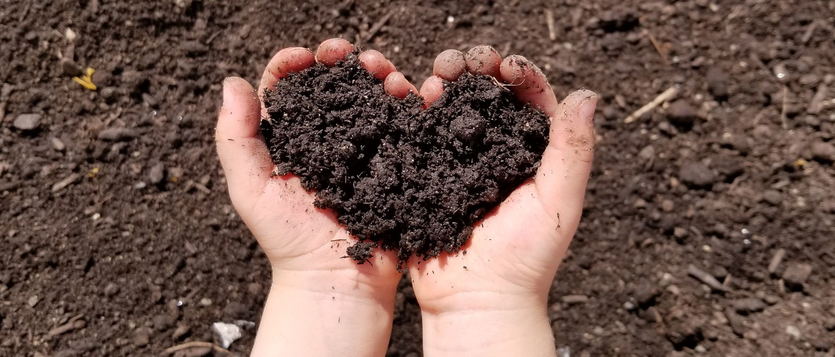
COMPOSTING IMPLEMENTATION
GUIDE

Image Source: Black Earth Composting Compost

PREPARED BY:
John Coles
Environmental Program Manager
Albemarle County Public Schools
401 McIntire Road, Charlottesville, VA 22901
434-975-9340 | 434-249-6720
jcoles@k12albemarle.org

Compost is made out of food scraps, brown leaves, and other organic matter that might look dead; however, all of these items, when combined properly, can generate soil that will nourish new life.
-Wendell Berry

Contents
Introduction 3
Division Support for Composting 3
Reasons to Compost 3
Getting Started 4
The Role of Teachers 4
The Role of Students 4
The Role of Building Services 4
The Role of Child Nutrition Services 5
The Role of the Community 5
How To Compost 5
What is Compostable 5
What is NOT Compostable 5
Finished Compost 6
FAQ 6
Lessons, Activities, & Classroom Resources 7
Additional Resources & Acknowledgements 7

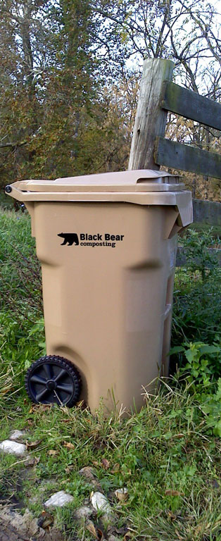
Introduction

Division Support for Composting
A wide array of support for composting exists within the Albemarle County Public Schools community. Boards and committees including members of the School Board, the Solid Waste Alternatives Advisory Committee, and the Advisory Committee for Environmental Sustainability, and the Parent Council have expressed support for composting in schools. Albemarle County’s Climate Action Plan states that composting shall be made available in all public schools.

Reasons to Compost
Composting has numerous benefits for humans and the natural environment.
  - Environmental Benefits of Composting Include:
- Minimizing the emissions of methane, a greenhouse gas emitted during the anerobic breakdown of organic matter.
- Sequestration of the greenhouse gas, carbon dioxide.
- Improved soil health when reapplied to a garden or natural area, including increased water infiltration and storage.
  - Human and Community Benefits Include:
- Educate students on composting, an environmentally friendly waste disposal method which benefits the environment.
- Reduce the school’s solid waste stream and divert waste from landfills.
- Recycle natural resources
- Create a beneficial product – finished compost – which can be used in school gardens and landscapes.

Image Source: Black Bear Composting Compost

Getting Started
Within the Albemarle County Public School community there is support and excitement surrounding composting. A composting program will affect all school personnel. Therefore, a successful program will involve clear communication, cooperative problem solving, and shared responsibility for program success among all stakeholders.
As each school begins to implement its composting program, different stakeholder groups will have unique desires, roles, and concerns which need to be addressed. The following sections address each of these groups and begin to define their needs and roles. Schools may find it beneficial to create a composting stakeholder or steering committee to elicit feedback from these various individuals and guide the program accordingly.

The Role of Teachers
Teachers will be instrumental in the successful adoption of the composting program in each school by introducing the composting program to students and integrating composting concepts into the curriculum. The aid of teachers, teacher’s assistants, and other instructional staff will be needed to monitor student food-sorting at containers in the cafeteria. Finally instructional staff should participate in composting themselves by sorting their own organic waste into the compost bin.

The Role of Students
Students are at the core of the composting program, as they ARE the composters. Their job is to sort their lunch waste daily in the cafeteria, placing all organic and compostable waste into the compost bin. Additionally, depending on the school’s model, some students may elect to be members of a compost team that helps with daily composting activities (e.g., aid peers with sorting of lunch waste) and acts as peer advocates for the compost program.

The Role of Building Services
  - Environmental Program Manager
The Environmental Program Manager oversees the composting program on a division-wide level. The Environmental Program Manager collaborates directly with schools wishing to begin cafeteria composting by coaching students, staff, volunteers, and custodians on composting best practices and by providing necessary supplies. Serving as the liaison between ACPS and the commercial composting vendor, any service requests should be routed through the Environmental Program Manager.
  - Custodial Staff
Custodial staff support the school’s cafeteria composting program by taking compostable waste from the cafeteria and kitchen to the curbside bin daily. Additionally, custodians will prepare the indoor compost bin with a fresh compostable liner for the following day. Custodians notify the Environmental Program Manager if additional composting supplies are needed or if there are any issues with the Commercial Composting Vendor’s Service.
  - Grounds & Maintenance Staff
Grounds and maintenance staff support the composting program by adding organic compostable waste that is generated in the course of their work such as vegetation clippings, leaves, and saw dust from dust collection systems to the exterior curbside carts.

The Role of Child Nutrition Services
Commercial Composting Service
Albemarle County Public Schools partners with a commercial composting service to facilitate the process of converting food waste into soil. This means that ACPS’s compostable waste is collected from the school and taken to a compost facility where food scraps are mixed with woody materials like grass clippings and hay, then placed into long piles. Piles are monitored, mixed, and watered and left to age for six months. Finally, the compost is screened to ensure that large particles are kept out of the finished compost. Schools and individuals can use finished compost in their gardens and lawns as a soil amendment that is beneficial to plants.

Child Nutrition Services, including school kitchen staff will compost any food scraps generated during the preparation of meals via separate back-of-house compost bins. Where possible, reusable or compostable serving ware will be used. Kitchen staff will communicate to teachers and student composting clubs exactly which types of serving ware can be composted.

The Role of the Community
Getting a composting program off the ground in a school involves a great deal of effort. Volunteers, including parents, parent organizations, non-profits, and other community groups can help with the success of the program by helping with lunchtime sorting, teaching about composting, and organizing the school’s program.

How To Compost

What is Compostable?
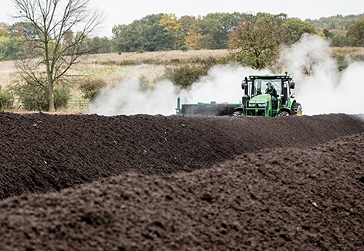
A whole slew of organic products – meaning a substance produced or derived from living organisms – are compostable; however, for the sake of ACPS’s cafeteria composting program the focus will center around food waste. If it is edible, it is compostable.
Additionally, nearly all of the serving ware that school lunches are served on are compostable. This includes trays, bowls, and dip cups. Work with kitchen staff to determine which items are compostable and which need to go in the trash. Napkins and paper towels are also compostable and should be composted. Each school has been provided with compostable can liners which will break down during the composting process – plastic trash liners will not and therefore should not be used. Additional liners can be requested from the Environmental Program Manager if needed.
What is Compostable?
Rule of thumb:
If it Grows it Goes
If in doubt, keep it out
Regarding compost, quality is more important than quantity. Non-compostable items simply won’t break down and will contaminate finished compost. Be diligent about sorting trash from compostable waste and use compostable liners – not trash bags. If you’re not sure whether something is compostable, keep it out of the compost bin.

What is NOT Compostable?
Whereas most organic substances are compostable, nearly all inorganic substances are not compostable. This includes plastics, glass, metal, and Styrofoam. Additionally, anything that may be potentially hazardous to the environment such as medical waste or chemicals should not go into the compost bin and should be disposed of through proper channels. If there is any doubt whether something is compostable, keep it out of the compost bin.

Finished Compost
Each participating school is entitled to one cubic yard of finished compost per school year. Contact the Environmental Program Manager with details to request compost. Compost can be used in school gardens or landscaping to amend soil and support new life. It can be brought into the classroom as an educational resource. However, the finished compost is used, take a moment to celebrate everyone’s hard work!

FAQ
Q: Will compost bins attract pests and wildlife?
A: Food scraps and other compostable waste have been directed into the school’s dumpsters for years without causing major adverse issues with pests or wildlife. Rolling carts are stored outside and collected multiple times per week. In the unlikely event that there are pest or wildlife problems contact the Environmental Program Manager so that a solution can be found.
Q: Will compost bins have a bad odor?
A: Compost bins are emptied multiple times per week and are collected and cleaned every summer by the commercial composting vendor. While it is possible that composting bins may emit a small amount of odor, it should be minimal.
Q: What if there is too much compostable waste to fit into the bin.
A: If this becomes a regular issue (great job!), notify the Environmental Program Manager so that additional bins and/or service can be added to the school.
Q: Will Contaminated Loads be Rejected, wasting all of that hard work?
A: Accidents happen, and a few pieces of non-compostable material will not cause a load to be rejected. There is an open line of communication between ACPS and the composting vendor. The Environmental Program Manager is notified immediately if the compost is too contaminated and will work with the school to correct the issue.
Q: How should participant push-back be addressed?
A: Unfortunately, not everyone will wish to participate in the school’s composting program. It is important to work with the various stakeholder groups to address concerns with the composting program and to adjust accordingly.
Q: Why doesn’t my school have cafeteria compost collection?
A: Compost collection is an optional – but strongly encouraged – activity that schools can utilize to reduce their waste stream and greenhouse gas emissions. If you are interested in beginning cafeteria composting at your school, seek support from your school administration and other interested stakeholders to get a program going.

Lessons, Activities, & Classroom Resources
There are fantastic opportunities to incorporate composting into the curriculum. Below are a few suggestions, however numerous educational opportunities exist.
- Create a micro-composter in a bottle (1-6), PepsiCo Recycling
- Plan a Waste-Free Lunch (1-6), King County, Vermont
- The Food Waste Warrior Toolkit (K-12), World Wildlife Fund
- De’compost’ition – (9-12), Cornell Waste Management Institute

Acknowledgements
Content Sourced from:
- School Composting, A Manual for Connecticut Schools
- Black Bear Composting – Crozet VA

