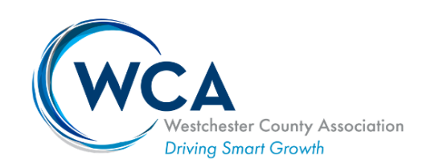
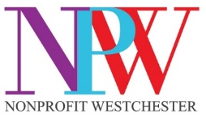

FOR IMMEDIATE RELEASE

Media Contact:
Jessica Apicella
Buzz Creators, Inc.
(914) 358-5080
jessica@buzz-creators.com

WESTCHESTER COUNTY ASSOCIATION & NONPROFIT WESTCHESTER
TO HOST VIRTUAL CONVERSATION WITH U.S. SENATOR KIRSTEN GILLIBRAND

Interactive Event Will Focus On Pressing Climate and Infrastructure Issues

White Plains, N.Y. (November 23, 2021) – The Westchester County Association (WCA), and Nonprofit Westchester (NPW), are hosting a free virtual event, An Open Conversation with US Senator Kirsten Gillibrand, on Thursday, December 9, 2021 at 1:30 – 3:00 p.m. EST. This event will include an interactive dialogue, discussing the most pressing issues impacting businesses and the Hudson Valley community.

“With the passage of major infrastructure legislation and continuing debate over the President’s BUILD BACK BETTER agenda, this is a particularly timely opportunity to hear from Senator Kirsten Gillibrand about what she is working on to deliver for our businesses and residents,” said Michael Romita, President & CEO of Westchester County Association. “We are thrilled to have her join us to talk about current community issues and how the Hudson Valley will be impacted. Nonprofits play an important role in our business community, so we are glad to come together with Nonprofit Westchester to facilitate this insightful discussion.”

The discussion will focus on the infrastructure law and its implications for the Hudson Valley as well as the status of additional economic impact and social legislation. Additionally, Senator Gillibrand will address the aftermath of the COP26 Climate Summit and specifically what it means for New York.

“Nonprofit Westchester is looking forward to partnering with the Westchester County Association on what we know will be an informative and interactive conversation with Senator Kirsten Gillibrand,” stated Jan Fisher, Executive Director of Nonprofit Westchester. “Senator Gillibrand has long championed issues that the nonprofit sector has focused on, including improving educational opportunities from pre-k to college or vocational training for all people, workforce development and increasing access to good, affordable healthcare. What makes this forum so important is the focus on intersecting issues between the business and nonprofit sectors, and a commitment to seeking solutions collaboratively.”

An Open Conversation with US Senator Kirsten Gillibrand will take place via Zoom. The event is free to attend. Registration is required, please register HERE.
Questions will only be taken in advance of the event. Please submit questions to info@westchester.org no later than December 6, 2021.

About Westchester County Association
The Westchester County Association is the preeminent professional leadership organization serving Westchester County and the region. The WCA is committed to smart growth, economic vitality, and to providing a strong and clear voice for the collaborative interests of business and nonprofits. Its key objectives are to promote positive economic development in the region, foster business development, and provide its members with access to key public and private sector individuals, agencies, and organizations. For more information about the Westchester County Association, visit www.westchester.org.

About Nonprofit Westchester
Nonprofit Westchester (NPW) is Westchester’s only membership organization dedicated solely to advancing and advocating for the needs and interests of the county's nonprofit sector, the people and communities they serve, and the nonprofit workforce. Representing more than 200 nonprofit organizations and business members, the mission of NPW is to strengthen the visibility, capacity and impact of the nonprofit sector in Westchester. For more information, visit www.npwestchester.org.

# # #

