

Calendar Draft 2025-26
Survey Results

September 23 - October 9, 2024



To what degree do you support the draft?
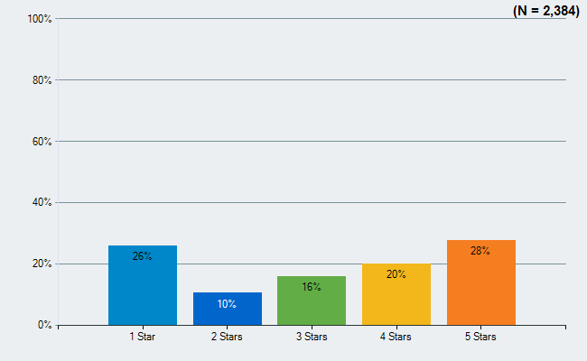

General comments about the draft:
- Consider a year-round schedule
- Consider a week for Thanksgiving
- Consider other religions/faiths when selecting days off
- Try to make fewer 4-day weekends, or overlap them with federal holidays
  - They are difficult for child care
  - They can be disruptive to student routines, which requires time to reset
- Consider implementing early start/end dates for the school year with more notice
- Consider moving the teacher work day from December 19th to January 5th

Comments about the earlier end date:
- School does not end before Memorial Day, and families may not return for the three school days after Memorial Day
- The start of summer activities for kids may not coincide with the end of school
- Some summer jobs (e.g. lifeguarding) may not start/end in alignment with an earlier end date

In past years, ACPS has traditionally started the third week of August. In the revised version, we have an earlier start date. To what degree do you support starting and ending the school year earlier?
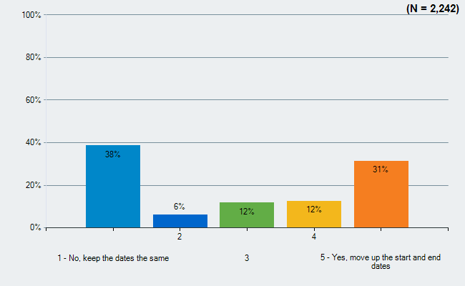

Comments in favor of an earlier start date:
- More alignment with surrounding localities (specifically CCS and CATEC)
- Allows the semester break to be before winter break
Comments opposed to an earlier start date:
- It is hotter in mid-August than it is in June, so moving the calendar forward ensures students will be in school, on buses, walking to school, at recess, etc. while it is hotter than if the calendar remained unchanged
- Tough for transportation staff who drive buses with no air conditioning
- End of may is typical college graduation, and families may have to choose between high school and college graduations (overlaps UVA graduation)
- Could constrain VHSL sports since practices will not start until 8/1

Traditionally, the school division puts Spring Break on the first full week of April. To what degree would you support moving the spring break earlier?
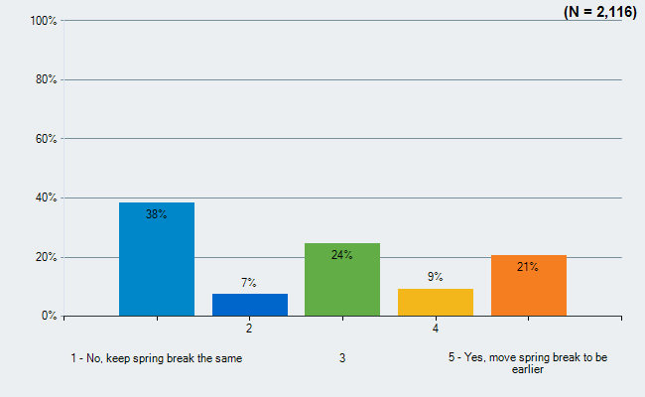

Comments about spring break:
- Generally, comments preferred a later spring break to have a chance at better weather for the break
- A later spring break provides days off during the longest stretch of continuous school days
- Does not align with UVA
Demographics of Respondents:

I am:
 | Count | %
Albemarle County Community Member | 50 | 2%
ACPS Employee | 547 | 21%
ACPS Parent | 1,427 | 56%
ACPS Parent & Employee | 272 | 11%
ACPS Student | 253 | 10%
Total Responses | 2,549

Ethnicity/Race
 | Count | %
Asian | 130 | 5%
Black/African American | 197 | 8%
Hispanic/Latino | 125 | 5%
Native American/Alaska Native | 25 | 1%
Native Hawaiian/Other Pacific Islander | 13 | 1%
White | 2,032 | 85%
Total Unique Responses | 2,390
Note: Because multiple answers per participant are possible, the total percentage may exceed 100%.

Gender
 | Count | %
Female | 1,941 | 80%
Male | 460 | 19%
Non-binary | 28 | 1%
Total Responses | 2,429

In my household:
 | Count | %
We primarily speak English | 2,279 | 92%
We primarily speak another language | 61 | 2%
We speak both English and another language | 124 | 5%
Total Responses | 2,464

