Out date: 5-Oct-2023, 09:35AM Mountain Standard Time
Due date: 11-Oct-2023, 11:59PM Mountain Standard Time
- This lab is worth 100 points.
- Please submit this document with all the questions answered along with a copy of your Orange pipeline before the due date in WyoCourses. File should be named as lab2.1_lastname.docx / lab2.1_lastname.ows.

Objective: To build a modeling pipeline in Orange and apply multi-linear regression modeling to predict a quantitative target variable.

Data:
Horizontal drilling which provides additional exposure of the reservoir to the wellbore (lateral length) is one of the primary drivers that made economic production of oil and gas from the tight shale reservoirs in the US a success, in conjunction with stimulation using hydraulic fracturing.

Objective of the exercise is to understand effect of lateral length of a horizontal well on shale gas production in some of the US shale plays using multiple linear regression analysis. While lateral length would be one of the primary predictors, other variables considered are vertical section length of the horizontal well, proppant volume and fluid volume pumped for stimulating the horizontal section of the well using hydraulic fracturing and type of shale plays.

Data source: https://doi.org/10.15786/22394989 [WyoScholar Digital Repository]
Originally downloaded from National Oil and Gas Gateway (http://www.noggateway.org/explore). From participating states that contribute to this data source, Arkansas and Colorado were identified as states of interest for the project owing to the level of shale gas drilling and production activity in these states over the period 2008-2018 and data availability on Fluids and Proppants.

Variables of interest:
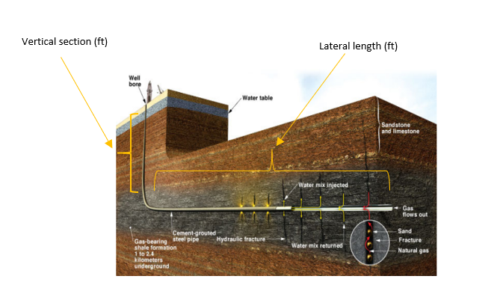
Figure 1: Horizontal well schematic (from The Academy of Medicine, 2017)

Referring to the Figure-1 above, the following were identified as variables of interest after reviewing the dataset:

Response (Target) variable: Max_Gas, Maximum Gas Production (Million Standard Cubic Feet, MSCF)
Since shale gas wells have their peak production in the first 2-3 years after the well is drilled, stimulated and put on production, maximum annual gas production is selected as the best response variable to predict using the predictor variables identified below

Predictor variables:
Lat_Len, Lateral length of the horizontal section (feet)
Measured Depth, Total Depth of the well (feet)
Bottom and Top Perforation depth (feet)
Wellhead Latidude and Longitude (decimal degrees), surface location of the well
Fluid, Total amount of fracturing fluid (typically water) pumped to create the hydraulic fractures (Barrels)
Proppant, Total amount of proppant (typically sand) pumped along with the fracturing fluid as a slurry to keep the hydraulically created fractures open (Pounds)
ShalePlay (a dummy variable, 0- Fayetteville, Arkansas Shale gas play and 1- Mancos, Colorado Shale gas play)
Drilling Orientation (a dummy variable)

Data: For this lab, please download final.xlsx to your local folder.
Note: This is the final processed dataset from the raw files in the data source link using Python

Lab Instructions
- Open Orange, and add File widget to the canvas and load the final.xlsx dataset.
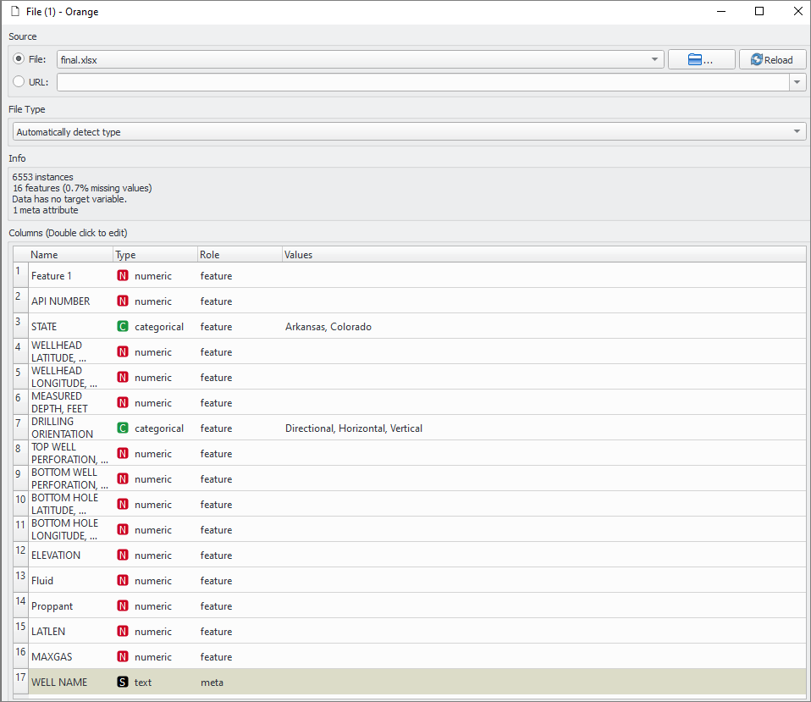

- Inspect the File widget and complete the following table. (10 points)
Total instances
Dimensionality of the data set

- Add Feature Statistics and Data Table widgets to the File widget. Inspect the features using these two widgets. (10 points)

List down key observations about feature inconsistencies and possible actions to clean out the dataset

- Add Select Rows widget to the File widget and apply the following filters.
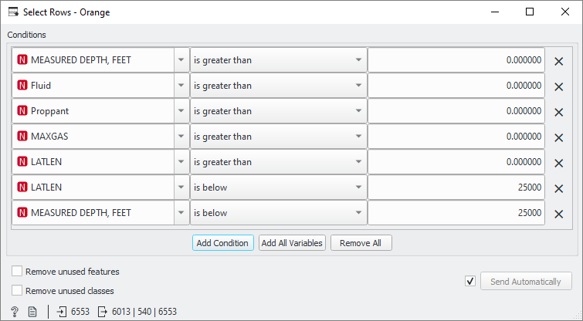

- Add Data Table, Feature Statistics, Distribution, Scatter Plot & Correlations and Scatter Plot widgets to complete the table below: (30 points)
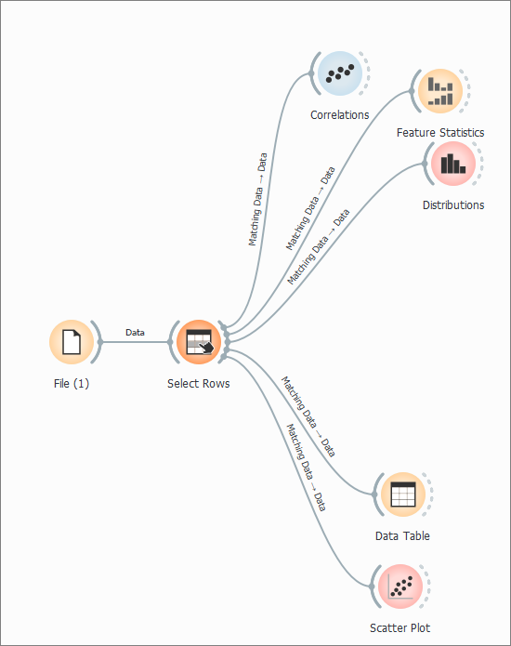
Min and Max of key predictor variables
Distribution of the predictor variables:
Min, Max and distribution of the target variable, Max_Gas
% of wells from the two states (shale plays) and drilling orientation
Any rows missing target values?
From the Scatter Plot, what are the predictors that you believe would have the highest impact on predicting Max_Gas?

How would you describe the relationships for these predictors with the target?
Do you notice outliers in the data?
From the correlations widget, what do you think about the correlation between predictors?

- Add and open Select Columns widget and confirm selection as below:
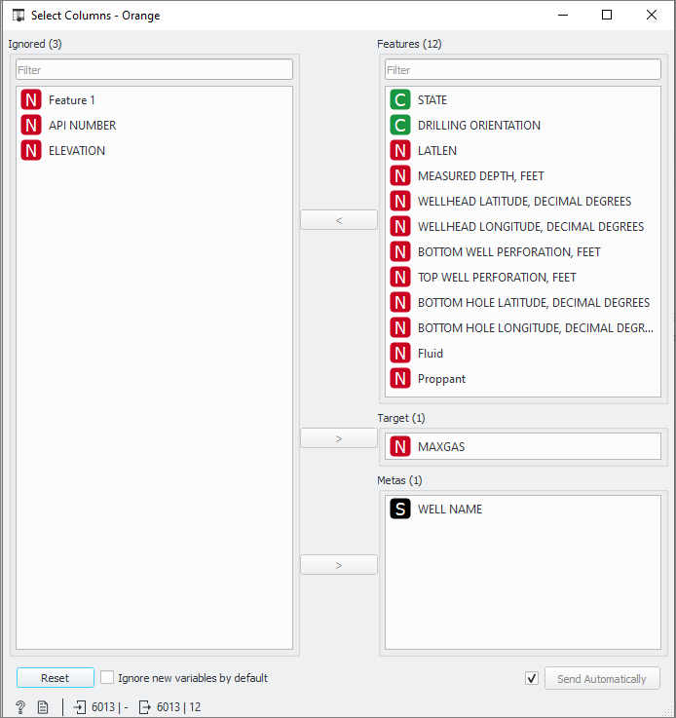

- Add the Data Sampler widgets to the Select Columns widget as shown below:
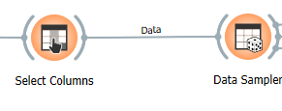
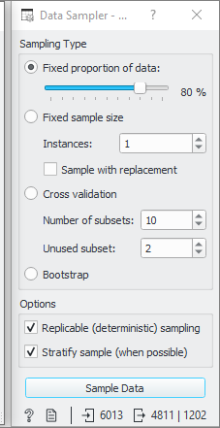
- Add the Linear Regression, Test and Score widgets and connect the Data Sampler widget to Test and Score widget as shown below. Also, add a Data Table widget to the Linear Regression widget.
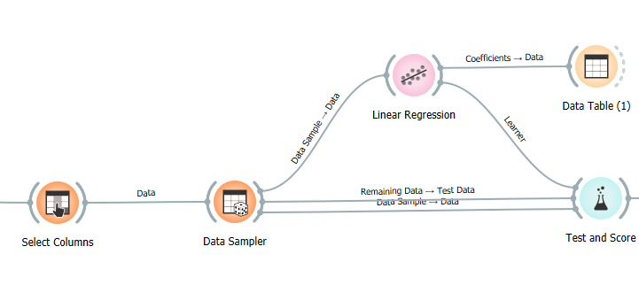

- Default preprocessing is applied by the Linear Regression widget in the following order:
- Remove instances with unknown target values.
- Dummy code categorical variables (with one-hot-encoding)
- Remove empty(null) columns.
- Impute missing values with mean values.
If we need to modify any of the above, we can add a Preprocess widget to the Linear Regression widget as shown below:
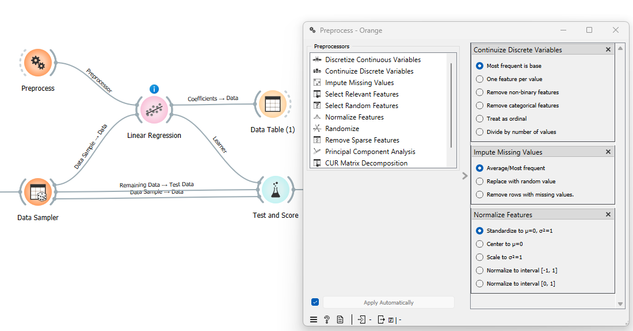
- Open and inspect the Linear Regression widget:
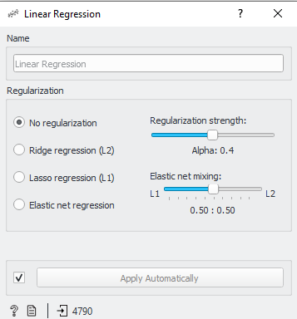

- Open Data Table widget connected to the Linear Regression widget and inspect the parameter coefficients. (10 points)
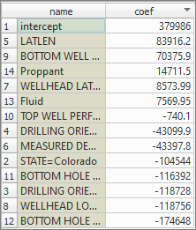
What can you say about the relationships between the different predictors and the response variable (Max_Gas)?

- Open Test and Score widget and complete the table below: (15 points)
What are the evaluation metrics you see?
Model | RMSE |  | MAE | R2
Linear Regression (cross validation , 10 folds
Linear Regression (Test on test data)

How would you interpret this model based on R2 and cross validation?

- Add Predictions and Scatter Plot widgets to the Test and Score widget as shown below:
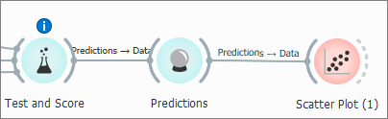
- Open the Scatter Plot widget connected to Predictions widget. Select Max_Gas as X-axis and Linear Regression as Y-axis. (10 points)
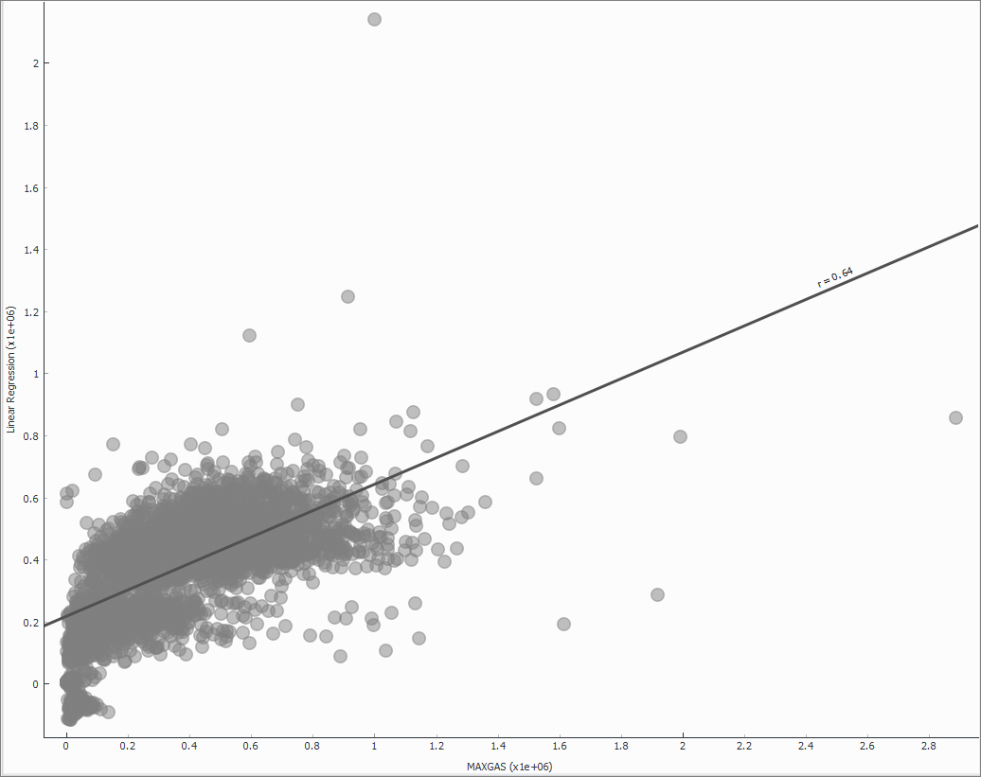
What do you think about the prediction quality?

- As part of model diagnostics in linear regression, it is standard practice to visualize the residual (error) plot and look for patterns to understand model validity. Residual variable is constructed as shown below using the Feature Constructor widget added to the Predictions widget as shown below:
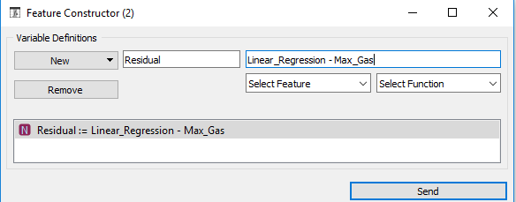
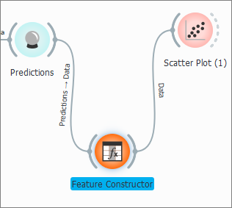

- Open Scatter Plot widget and select Linear Regression (Predicted Max_Gas from the regression model) and Residual. Plot would look as below:
(15 points)

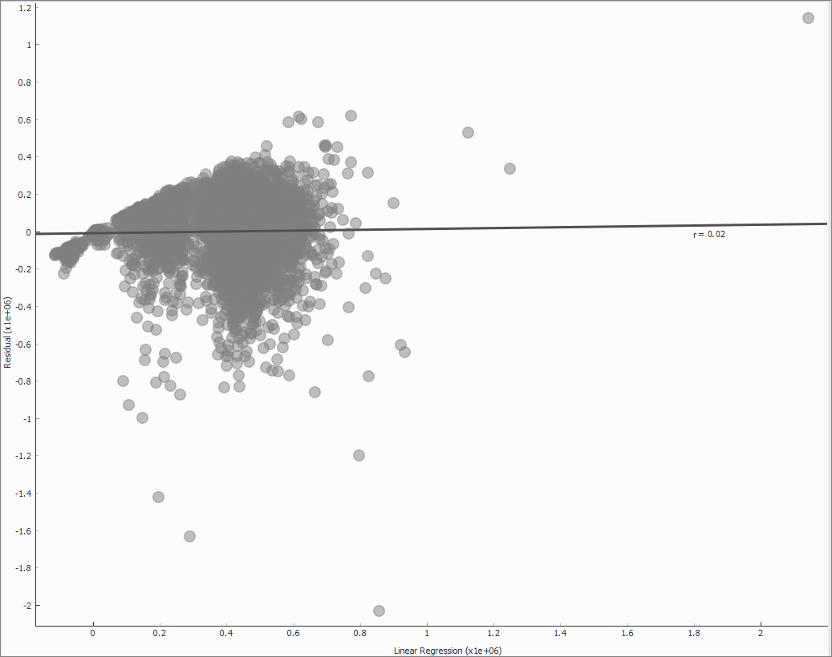
Do you see a pattern?
What does this indicate?
What can you do to address this issue?

