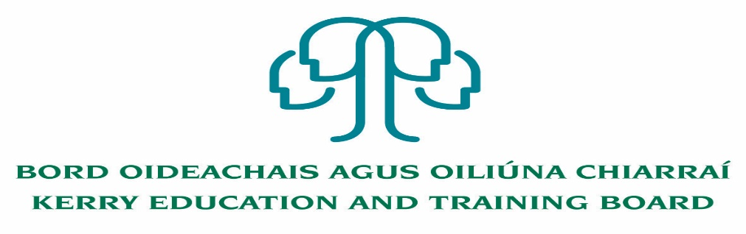

Kerry Education and Training Board (Kerry ETB) is a statutory education and training authority for County Kerry, established in accordance with the provisions of the Education and Training Boards Act 2013.

Kerry ETB is a provider of Primary, Post Primary and Further Education and Training services in Co. Kerry. The ETB has c. 1300 employees, an annual budget of c. €82 million, c.37 Centres of Education and Training with the organisations Head Office located in Tralee, Co. Kerry.

Teaching Posts

Applications are invited for the following Specific Purpose teaching post (s), under the aegis of Kerry Education & Training Board which may arise in the school year 2023/2024 (all appointments are to Kerry ETB – centre of first assignment is indicated here for the assistance of applicants). All vacancies are subject to the Directors of Redeployment agreeing to the posts being filled, following completion of the 2023 Scheme. A panel may be formed from these competitions from which appointments may be made in 2023/2024.

Causeway Comprehensive School
CWS 23.24.42 Guidance Counsellor (Maternity leave Cover) 22

Castleisland Community College
CIS 23.24.43 Business (Experience of teaching Accounting is an advantage) 17
(Maternity Leave Cover)
CIS 23.24.44 Physics (Experience of teaching Science to JC is an advantage) 17
(Maternity Leave Cover)

A Teacher Education qualification is a requirement.

Candidates proposed for appointment with Kerry Education & Training Board must be registered in accordance with Section 31 of the Teaching Council Act, 2001.

Applicants are requested to submit Confirmation of Teaching Council Registration outlining subjects qualified to teach and proof of current registration with their application form.

---------------------------------------------------------------------------------------------------------------------------------

Please complete application form which can be downloaded from our website www.kerryetb.ie/opportunities and return by email only to jobs@kerryetb.ie. No C.V.’s, only official application form will be accepted.

Applications by email only must be received not later than 12 noon Wednesday 21st June 2023.

Please complete application form, including reference form, for the post(s) you are applying for.

Colm Mc Evoy
Chief Executive Officer

Kerry Education & Training Board services Gaeltacht areas.
Cuirfear fáilte roimh chomhfhreagras i nGaeilge.
Garda Vetting of successful candidates will take place prior to offer of employment.
Canvassing will automatically disqualify.
Short-listing will take place on the basis of the information provided in the application form. Depending on the qualifications and experience of applicants, short-listing thresholds may be higher than the minimum standards set out.

Kerry Education & Training Board is an equal opportunities employer.
“Creating a Learning Society in Kerry”

