Job:

Hi Delta FlexGas® - Type WH

Dual Fuel Water Heaters
Models 302CD-902CD

Engineer:

Contractor:
Prepared By: Date:
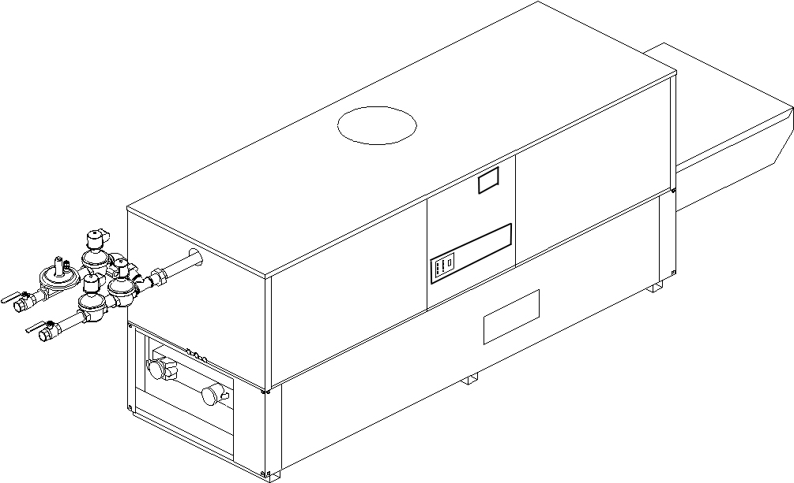
Model: Indoor/Outdoor: MBTUH Input:
- 100% Factory Fire Tested
- Thermal Efficiency: Up to 85%
- Versa IC® Controller with LCD Display
- Maximum Setpoint: 150°F
- Maximum Outlet Temperature: 200°F
- Minimum Non-Condensing Inlet Temperature: 105°F
- Thermal Shock Proof Heat Exchanger
- Limited Twenty-Year Thermal Shock Warranty
- Limited Ten-Year Cupro-Nickel Heat Exchanger Warranty
- Limited Five-Year Copper Heat Exchanger Warranty
- Full Safety Diagnostics with Fault History
- PolyTuf Powder Coated Cabinet
Patent Nos. 6,904,873 & 7,044,124; other patents pending
- No Combustible Floor Shield Required
- Fan-Assisted
- Patented Burner Security Blanket
Proudly Assembled in the USA


- Ultra-Low NOx – SCAQMD 1146.2 Certified
- Cascade up to 4 Heaters – No External Sequencer Required

Heat Exchanger
- Headers
Brass – Standard
A-2 Glass-Lined Cast Iron
- ASME Inspected and HLW Stamped
160 PSIG Working Pressure
- National Board Approved
- Fin Tubing
Copper (Std.) 85%
Cupro-Nickel 83.1%
- ASME Steel Tube Sheet
- Silicone High-Temp. O-Rings
- ASME Pressure Relief Valve
125 PSIG – Standard
PSIG – Optional
- Temperature and Pressure Gauge
- Water Connections
Left – Standard
A-6 Right Hand

Controls
- 120V, 60Hz, 1∅ Power Supply
- 120/24V 60Hz Transformer
- Versa IC® Integrated Control
- 100% Shut-Off/Lockout
- Hot Surface Ignition
- Ignition Module
3-Try – Standard
C-6 Single-Try
- Remote Flame Sensor
- Fixed High Limit, Manual Reset 240°F
- On/Off Power Switch
- Flow Switch
- Blocked Vent Pressure Switch
- Combustion Air Proving Switch
- Programmable Pump Time Delays
- Heater
- Recirculation
- Enable/Disable

Controls – cont.
- LCD Display; Status, Fault and Diagnostics
- Cold Water Protection Function
Optional CWR Variable-Speed Pump
(See Cat. 5000.73)
- Modbus RTU BMS Port (Up to 115K Baud,
B-85 – BMS Gateway – BACnet MS/TP, BACnet IP, N2 Metasys or Modbus TCP
B-86 – BMS Gateway – LonWorks

Gas Train
- Manual Gas Shut-Off Valve(s)
- Gas Pressure Regulator
- Safety Shut-off Valve
- Firing Control Valve
- Firing Mode: 2-Stage (WH3)
- Natural/Propane Gas
- Gas Connection
Left - Standard
Z-1 Right
- Design Certified - ANSI Z21.10.3/CSA 4.3

Construction
- Indoor/Outdoor Construction
- Enclosed Front Controls
- Powder Coat Finish
- CSA Low Lead Certified (≤ .25% Lead)

Venting
Vent Category I/III Cupro-Nickel
Vent Category II/IV Copper
- Vent Location
Top – Standard
D-14 Rear
- Vent Termination Cap
D-11 Outdoor
D-15 Indoor, Horizontal
Indoor, Vertical (by others)
- Combustion Air
D-17 In-Line Filter Kit (TruSeal only)
D-16 Air Intake Elbow

Venting – cont.
- Extractor – Optional
By others
Not required

Burner
- Ultra-Low NOx: Less Than 20 PPM

Options
C-6 Ignition Module, Manual Rest
D-21 TruSeal® Direct Vent
F-10 Low Water Cut-Off, Remote Probe
I-1 High Limit Control, Auto Reset
P- Pump Bronze
HP, 120V, 1∅, 60Hz
Water Hardness GPG
Mounted Loose
Front Rear
P- Cold Water Run (See 1000.19)
S-1 Low Gas Pressure Switch, Manual
S-2 High Gas Pressure Switch, Manual
X-1 SureRack® Kit
X-2 SureRack Add-on
For Metric information, see Catalog
Additional Options or Accessories
For Metric information, see Catalog

Multi-Boiler Temperature Controllers
TempTracker Mod+ Hybrid
B-36, 2-4 Heaters
B-37, 5-10 Heaters
B-38, 11-16 Heaters
B-39 EMS 4-20mA Remote Setpoint Interface Module
B-62 BACnet MS/TP Interface





Hi Delta Flex Gas – Type WH
Models 302CD-902CD Model

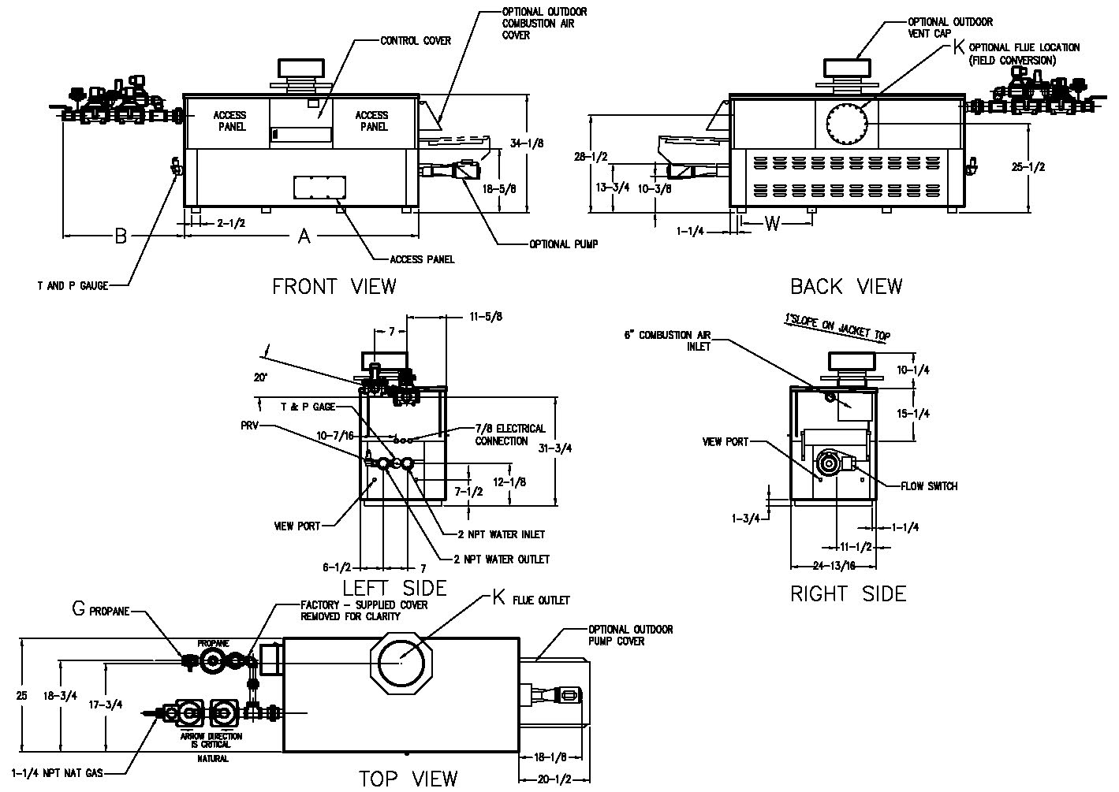
3-3/4
NOTE: Pump location varies based on model and application.
 | SPECIFICATIONS |  |  |  |  |  |  |  | Approx.  Shipping  Wt. (lbs.)
Model | MBTUH |  |  | A  Width | G  NPT | K | W | Amp.  Draw* | Approx.  Shipping  Wt. (lbs.)
Model | Input | Output  85% | Output  83.1%
302CD | 300 | 255 | 249 | 36 | 3/4 | 6 | 14-3/4 | 6 | 380
402CD | 399 | 339 | 332 | 43 | 3/4 | 6 | 18-1/2 | 6 | 445
502CD | 500 | 425 | 416 | 50 | 1-1/4 | 6 | 22 | 6 | 545
652CD | 650 | 553 | 540 | 60-1/2 | 1-1/4 | 8 | 27-1/4 | 6 | 590
752CD | 750 | 638 | 623 | 67-1/2 | 1-1/4 | 8 | 30-3/4 | 6 | 675
902CD | 900 | 765 | 748 | 78 | 1-1/4 | 8 | 36 | 7 | 740
* Without pump
NOTES: 1. Dimensions are in inches.
2. Rates shown are for natural or propane gas, and elevations up to 4,500 feet. For installation above 4,500 feet, please contact manufacturer.
3. Required natural gas pressure is 7 – 10.5” WC. Required propane gas pressure is 11 - 13” WC.

Hi Delta Flex Gas – Type WH
Models 302CD-902CD Model
SHL includes 50 ft of tubing each way (100 total)
** Must use optional cupro-nickel tubes. For hardness exceeding 25 GPG, must use water softener
Basis for minimum flow is 40 GPM or 30°F ∆T, 90 GPM for maximum flow

Model | 83.1% System Flow and Head Loss
Model | 3-4 Grains Per Gallon |  |  |  |  | 5-15 Grains Per Gallon |  |  |  |  | 16-25** Grains Per Gallon
Model | ΔT  (°F) | GPM | ΔP  (FT WC) | MTS  (IN) | SHL  (FT WC) | ΔT  (°F) | GPM | ΔP  (FT WC) | MTS  (IN) | SHL  (FT WC) | ΔT  (°F) | GPM | ΔP  (FT WC) | MTS  (IN) | SHL  (FT WC)
302CD | 13 | 40 | 2.0 | 2 | 5.1 | 10 | 50 | 3.0 | 2 | 7.7 | 6 | 90 | 9.8 | 2 | 23.7
402CD | 17 | 40 | 2.0 | 2 | 5.1 | 13 | 52 | 3.4 | 2 | 8.4 | 7 | 90 | 10.0 | 2 | 23.8
502CD | 21 | 40 | 2.1 | 2 | 5.2 | 16 | 52 | 3.5 | 2 | 8.6 | 9 | 90 | 10.4 | 2 | 24.2
652CD | 27 | 40 | 2.2 | 2 | 5.3 | 21 | 52 | 3.7 | 2 | 8.7 | 12 | 90 | 10.8 | 2 | 24.7
752CD | 28 | 45 | 3.0 | 2 | 6.8 | 23 | 55 | 4.4 | 2 | 9.9 | 14 | 90 | 11.3 | 2 | 25.1
902CD | 28 | 54 | 4.3 | 2 | 9.7 | 21 | 73 | 7.8 | 2 | 17.2 | 17 | 90 | 11.7 | 2 | 25.5

SHL includes 50 ft of tubing each way (100 total)
** Must use optional cupro-nickel tubes. For hardness exceeding 25 GPG, must use water softener
Basis for minimum flow is 40 GPM or 30°F ∆T, 90 GPM for maximum flow
Model | 85% System Flow and Head Loss
Model | 3-4 Grains Per Gallon |  |  |  |  | 5-15 Grains Per Gallon |  |  |  |  | 16-25** Grains Per Gallon
Model | ΔT  (°F) | GPM | ΔP  (FT WC) | MTS  (IN) | SHL  (FT WC) | ΔT  (°F) | GPM | ΔP  (FT WC) | MTS  (IN) | SHL  (FT WC) | ΔT  (°F) | GPM | ΔP  (FT WC) | MTS  (IN) | SHL  (FT WC)
302CD | 13 | 40 | 2.0 | 2 | 5.1 | 10 | 50 | 3.0 | 2 | 7.7 | 6 | 90 | 9.8 | 2 | 23.7
402CD | 17 | 40 | 2.0 | 2 | 5.1 | 13 | 52 | 3.4 | 2 | 8.4 | 8 | 90 | 10.0 | 2 | 23.8
502CD | 21 | 40 | 2.1 | 2 | 5.2 | 17 | 52 | 3.5 | 2 | 8.6 | 10 | 90 | 10.4 | 2 | 24.2
652CD | 28 | 40 | 2.2 | 2 | 5.3 | 21 | 52 | 3.7 | 2 | 8.7 | 12 | 90 | 10.8 | 2 | 24.7
752Cd | 29 | 45 | 3.0 | 2 | 6.8 | 23 | 55 | 4.4 | 2 | 9.9 | 14 | 90 | 11.3 | 2 | 25.1
902CD | 29 | 54 | 4.3 | 2 | 9.7 | 21 | 73 | 7.8 | 2 | 17.2 | 17 | 90 | 11.7 | 2 | 25.5

Model | 83.1 % Recovery Rates
Model | 20° | 30° | 40° | 50° | 60° | 70° | 80° | 90° | 100°
302CD | 1511 | 1007 | 755 | 604 | 504 | 432 | 378 | 336 | 302
402CD | 2010 | 1340 | 1005 | 804 | 670 | 574 | 502 | 447 | 402
502CD | 2518 | 1679 | 1259 | 1007 | 839 | 709 | 630 | 560 | 504
652CD | 3274 | 2182 | 1637 | 1309 | 1091 | 935 | 818 | 727 | 655
752CD | 3777 | 2518 | 1889 | 1511 | 1259 | 1079 | 944 | 839 | 755
902CD | 4533 | 3022 | 2266 | 1813 | 1511 | 1295 | 1133 | 1007 | 907

Model | 85 % Recovery Rates
Model | 20° | 30° | 40° | 50° | 60° | 70° | 80° | 90° | 100°
302CD | 1545 | 1030 | 773 | 618 | 515 | 442 | 386 | 343 | 309
402CD | 2055 | 1370 | 1028 | 822 | 685 | 587 | 514 | 457 | 411
502CD | 2576 | 1717 | 1288 | 1030 | 859 | 736 | 644 | 572 | 515
652CD | 3348 | 2232 | 1674 | 1339 | 1116 | 957 | 837 | 744 | 670
752CD | 3864 | 2576 | 1932 | 1545 | 1288 | 1104 | 966 | 859 | 773
902CD | 4636 | 3091 | 2318 | 1855 | 1545 | 1325 | 1159 | 1030 | 927
Raypak, Inc. 2151 Eastman Avenue, Oxnard, CA 93030 (805) 278-5300 Fax (800) 872-9725 www.raypak.com

