Governing Documents Enhancements and Clarifications Subcommittee (GDECS)
Webex/ Teleconference
April 14, 2023
9:00 a.m. – 10:00 a.m. EPT

Administration (9:00-9:05)
Welcome, announcements, and review of Anti-trust, Code of Conduct, and Public Meetings/Media Participation Guidelines– Janell Fabiano

Working Items (9:05-10:55)
1. PJM presenters will review proposed Tariff and OA revisions.
2. Janell Fabiano will review the timeline, voting instructions, and next steps for the GDECS items

Future Agenda Items (10:55 – 11:00)
None

Future Meeting Dates and Materials |  |  | Materials Due  to Secretary | Materials Published
Date | Time | Location |  | Materials Published

Author: Janell Fabiano

Antitrust:
You may not discuss any topics that violate, or that might appear to violate, the antitrust laws including but not limited to agreements between or among competitors regarding prices, bid and offer practices, availability of service, product design, terms of sale, division of markets, allocation of customers or any other activity that might unreasonably restrain competition. If any of these items are discussed the chair will re-direct the conversation. If the conversation still persists, parties will be asked to leave the meeting or the meeting will be adjourned.

Code of Conduct:
As a mandatory condition of attendance at today's meeting, attendees agree to adhere to the PJM Code of Conduct as detailed in PJM Manual M-34 section 4.5, including, but not limited to, participants' responsibilities and rules regarding the dissemination of meeting discussion and materials.

Public Meetings/Media Participation:
Unless otherwise noted, PJM stakeholder meetings are open to the public and to members of the media. Members of the media are asked to announce their attendance at all PJM stakeholder meetings at the beginning of the meeting or at the point they join a meeting already in progress. Members of the Media are reminded that speakers at PJM meetings cannot be quoted without explicit permission from the speaker. PJM Members are reminded that "detailed transcriptional meeting notes" and white board notes from "brainstorming sessions" shall not be disseminated. Stakeholders are also not allowed to create audio, video or online recordings of PJM meetings. PJM may create audio, video or online recordings of stakeholder meetings for internal and training purposes, and your participation at such meetings indicates your consent to the same.
Participant Identification in Webex:
When logging into the Webex desktop client, please enter your real first and last name as well as a valid email address. Be sure to select the “call me” option.
PJM support staff continuously monitors Webex connections during stakeholder meetings. Anonymous users or those using false usernames or emails will be dropped from the teleconference.

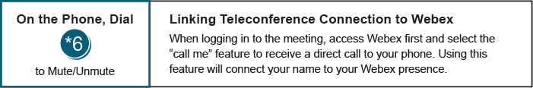

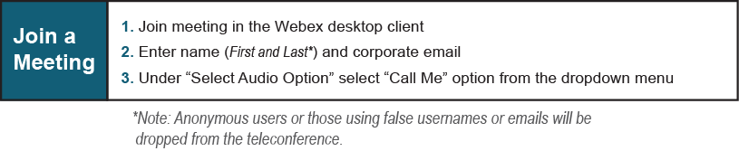

Provide feedback on the progress of this group: Facilitator Feedback Form
Visit learn.pjm.com, an easy-to-understand resource about the power industry and PJM’s role.

