Copy/Importing From A Past Event
1. In Administration, open the Sales Organization folder and select Event.
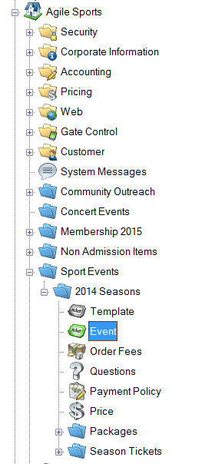
2. Search for the previous event that you wish to copy. Right-click on the event and select Copy/Import.
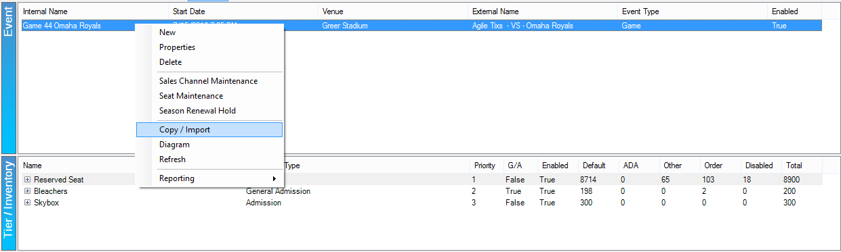
3. The Copy/Import window will appear.
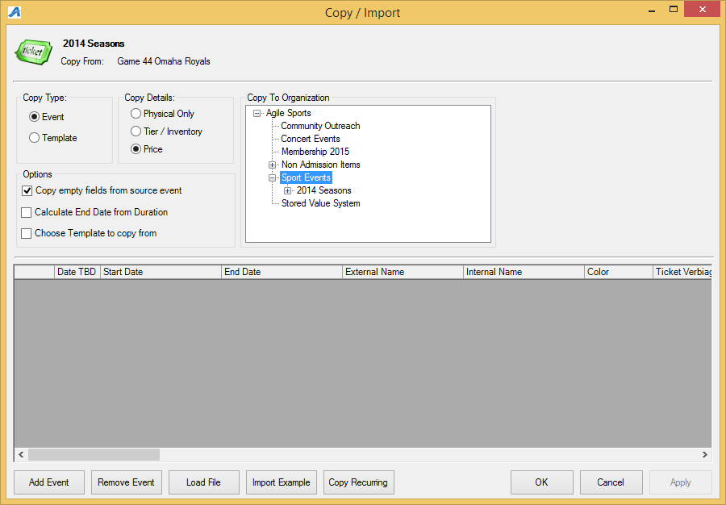
- Under the Copy Type, select Event.
- In Copy Details, choose what you would like to copy from the original event. Choose Physical Only if you only want to copy the event information. Choose Tier/Inventory if you want to copy the event information with the same tier inventory. Choose Price if you want to copy everything including the prices that were originally built with the past event.
- In Copy to Organization, select the Sales Organization folder to which this event needs to be copied.
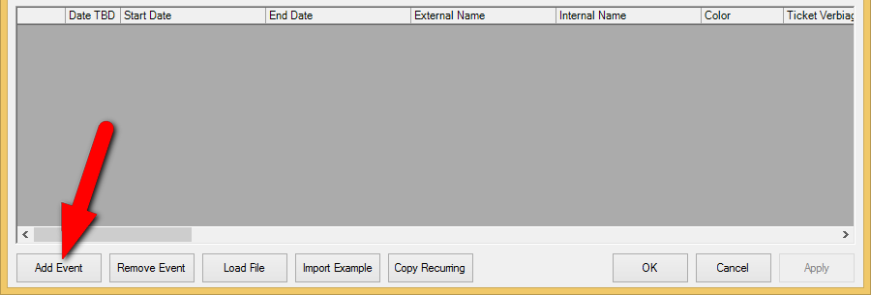
4. For a single event that you are copying, click Add Event in the bottom left-hand corner.
5. A database field will appear. In the Start Date, enter the date and time of the event. In the End Date, enter the ending time of this event (i.e. Event XYZ is on September 1, 2020 at 7PM and the runtime of that show will have the event end on September 1, 2020 at 9:30PM for a total run time of 2 hours and 30 minutes).
6. Type in the External and Internal name for this year's show. NOTE: If the event name is the same as it was last year, then leave the External Name and Internal Name blank as it will copy everything from last year.
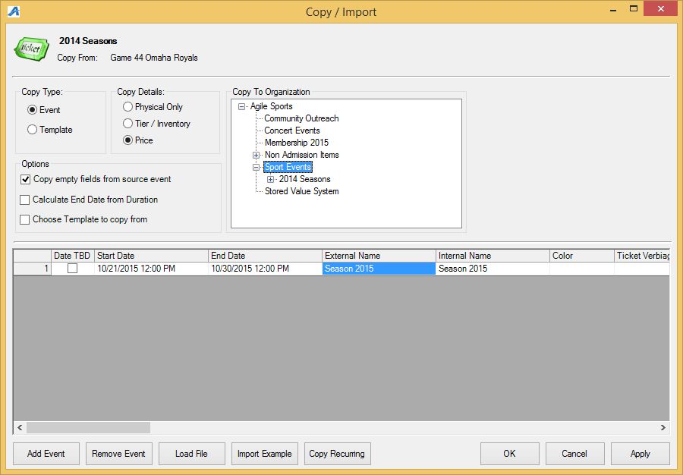
7. If you have more than one showing of this event, repeat steps 4 through 6 to add additional events.
8. Once you have all the event dates, click Apply to copy the events to the Blue Sales Folder.
9. Go to the Blue Sales Folder to update, edit text, descriptions and images for that event.
10. Once you have completed your edits, place the event(s) on sale.
____________________________________________________________

Recurring Dates
11. In Administration, open the Sales Organization folder and select Event
12. Search for the previous event that you wish to copy. Right-click on the Event and select Copy/Import.
13. First:
- Under the Copy Type, select Event.
- In Copy Details, choose what you would like to copy from the original event. Choose Physical Only if you only want to copy the event information. Choose Tier/Inventory if you want to copy the event information with the same tier inventory. Choose Price is you want to copy everything, including the prices that were originally built with the past event.
- In Copy to Organization, select the Sales Organization folder to which this event needs to be copied.
- Make sure that the box next to Copy Empty Fields From Source Event is checked.
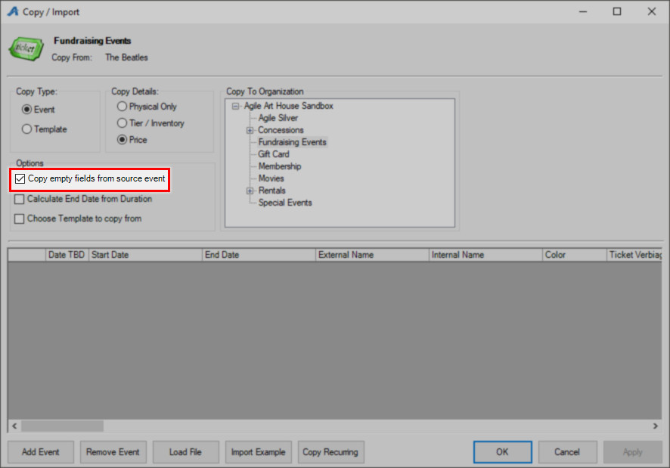
14. Click the Copy Recurring button to add recurring dates using this event.
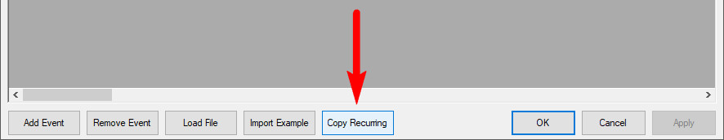
15. Enter the Date and Time that your events will start.
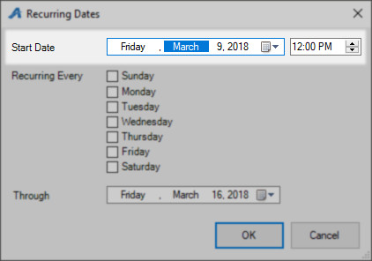
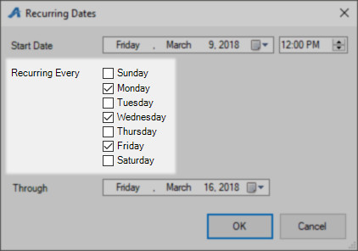
16. Check the box next to the days that this will be recurring.

17. In the Through date box, enter in the last day that your event will repeat.
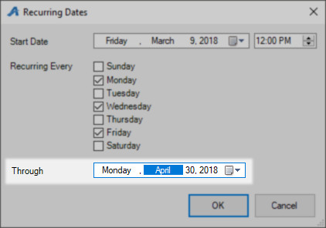

18. Click OK.

19. Your events will be generated.
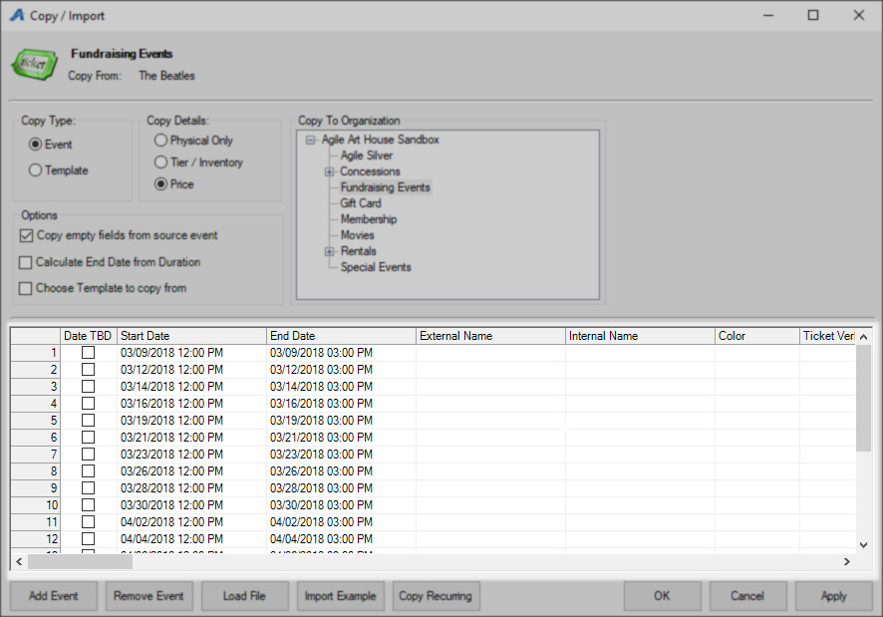
20. Click Apply to save and OK to close the window.
NOTE: These events will need to be placed on sale once you have copied them. To Learn how to place multiple events or shows on sale, Click HERE.

