


CRICOS Annual Registration Charge (CARC) Collection Process
  - Please take time to read through this brochure as it contains important information regarding the CARC collection process.
Please note: this brochure has been updated as per the Cost Recovery Implementation Statement (CRIS) for the Commonwealth Register of Institutions and Courses for Overseas Students (CRICOS) and includes the annual indexation figures (as of 2023).

Background
The CRICOS Annual Registration Charge (CARC) is the cost recovery charge, payable by all Commonwealth Register of Institutions and Course for Overseas Students (CRICOS) registered and suspended providers each year.
The CARC is comprised of the following components:

Annual Charge | Providers | Allocation | Element Amount
Part A Base – CRICOS Systems | All | Equally to all providers | $203
Part A Base – ESOS Regulation and Support | All | Equally to all providers | $293
Part A Pro Rata – CRICOS Systems | All | Pro-rata based on number of CARC Enrolments | $5*
Part B School Regulation – Education and Engagement | Schools | Equally to all school sector providers | $131
Part C School Regulation – Oversight and Management | Schools | Equally to all school sector providers with at least 1 CARC Enrolment | $785

* The CARC’s Part A Pro Rata component is determined according to the number of international students that studied at your organisation in the relevant calendar year, and by the duration of study as determined by the Proposed Course Start and Proposed Course End Dates on the student’s Confirmation of Enrolment (CoE).

Who will pay regulatory charges?
Education providers listed on CRICOS who provide or seek to provide education services to overseas students are subject to these regulatory charges.
This includes schools, vocational education and training providers, higher education providers, English Language Intensive Courses for Overseas Students (ELICOS) and Foundation Program providers.

What do I need to do?
Ask yourself the following questions:
- Do the enrolment records in PRISMS reflect our actual enrolments for the year?
- Would I be confident using our enrolment data if the CARC were calculated today?
If you are not sure of these answers or know the response is no, you will need to take action to review your data.

When do I review data?
The Department of Education strongly encourages providers to review their PRISMS enrolment data regularly as best practice. The timing and frequency with which data reviews are possible may depend on the type of organisation and the way in which attendance is monitored.
- Some organisations (such as schools) may reconcile PRISMS enrolment records with actual student numbers throughout the year.
It may be appropriate for other organisations (such as universities) to conduct a reconciliation when all assessment is complete at the end of each semester.

The critical point to remember is that the actual student number and their CoE records within PRISMS should accurately reflect the study outcomes of international students who are or were studying with you at the end of the year.
Undertaking the review of data throughout the year may ensure that there are no surprises when the CARC is being determined.
Please note: the accuracy of the CARC calculated for your organisation is dependent on the accuracy of your enrolment data in PRISMS. Incorrect data will produce a wrong CARC calculation.
Accurate enrolment data in PRISMS is essential for an accurate CARC calculation.

How do I review data?
The enrolment data on which your CARC calculation is based is available in PRISMS, via the ‘CARC Enrolment by Student by Course Export’, under the reports section. The export provides a list of overseas students that undertook or are still studying in a given course at your organisation in the relevant year.
The export presents the data in the summarised format of one line of data per student, per course. If you wish to view further details of the individual CoE records on which the export is based, this information is available via the ‘CARC Raw CoE Data’ export within PRISMS.
Follow these steps to view the data that will be the basis for determining your CARC:
- Logon to PRISMS and select the Reports tab.
- Open the ‘CRICOS Annual Registration Charges Exports and Reports’ folder, then select the ‘CARC Enrolment by Student by Course Export’ option.
- Provide the required information, the click Generate Report.
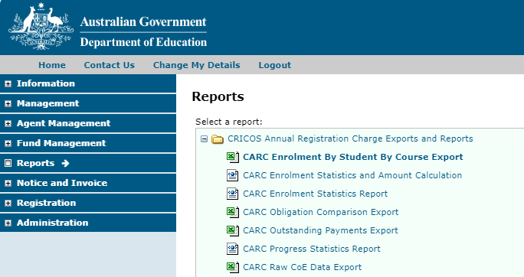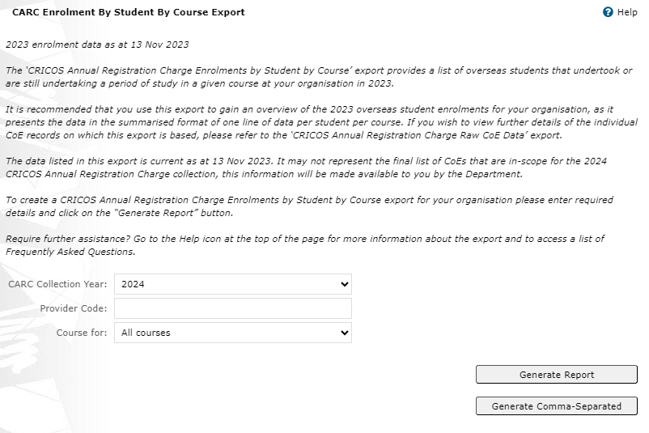
0
- Review the list of students that studied or are still studying in each course at your organisation during the relevant enrolment year. The list of students should be equal to the number of students that actually studied at your organisation throughout the year.

What if the data does not match?
Where providers feel that the data on PRISMS does not accurately reflect their enrolments, they may need to reconcile their in-house system to PRISMS, to ensure enrolment numbers in both systems are the same. The enrolment data must be an accurate reflection of students who undertook study at an organisation.
If you do not agree with the list presented in the export, it could be for one or more of the following reasons:
Issue | Reason | Resolution
The list doesn’t show a student that studied in a particular course. |  | A CoE was not created/approved for the student, or the CoE expired and never went to the studying status. | Create a CoE with backdated studying dates or update the expired CoE to studying or finished.
The list contains a student that never studied with the provider. |  | A CoE was created and not reported on. |  |  |  | Report on the relevant CoE.
The list indicates a student studied for a shorter period than they actually did. As per your records, the actual study period was longer. |  | The entire study period a student undertakes with your organisation should be represented by one or more CoEs. If the student studied longer than the CoEs indicate, check the original records in PRISMS. The study dates on the existing record(s) should cover the same period the student actually studied with your organisation. |  |  |  | Create a new CoE to cover the missing period of study.
The list indicates a student studied longer than the actual duration they studied. As per your records, the actual study period was shorter. |  | In most situations, when a student deviates from their originally intended period of study, you need to report them. If you find that a student is listed as having studied for a longer period on PRISMS, you will need to update the relevant CoE to report the reason for the shortened period of study. |  |  |  | Report on the relevant CoE to indicate why there was a change to the originally intended period of study.

