Keystone Biology- Cell Growth and Reproduction
- Binary Fission

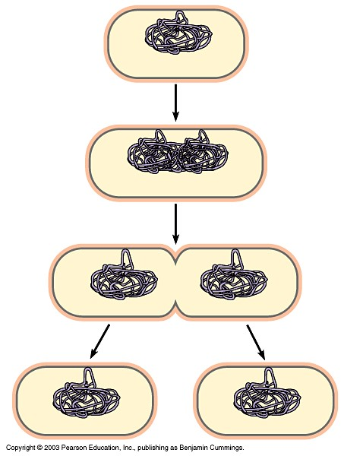

- Mitosis
  - Define:

  - Label and Explain:

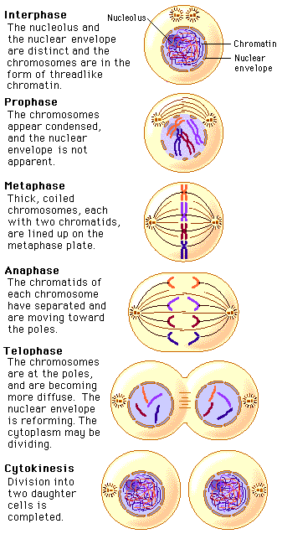

- Meiosis
  - Define:

  - Label and Explain:
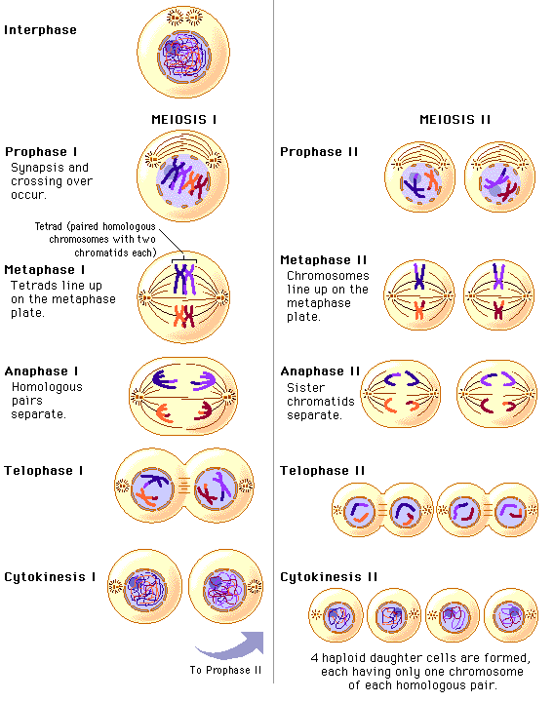

- Genetic Variation
  - Crossing Over
    - Crossing over occurs ________________________ I when two chromosomes pair up and ___________________________________.

    - Crossing over ____________________________________ the parents and their offspring.
  - Genetic Variation
    - Genetic variation can also occur when____________________________ ___________________________________________________________

    - Since each offspring receives a __________________________________
___________________________________________________________

