QUESTIONS
- Pearl Company paid dividend 30 TL per share last year. The stocks currently sell 500 TL per share. It is estimated 8% growth per year. What is the cost of equity?

Solution: D₁ = D₀ * (1+g) = 30 * (1+0,08) = 32,4
R_{e} = (D₁ / P₀) + g = 32,4 / 500 + 0,08 = 14,48 %

- Calculate the aftertax cost of debt under each of the following conditions:
Yield | Corporate Tax Rate
a. 8.0% | 18%
b. 12.0% | 34%
c. 10.6% | 15%

Solution: K_{d} = Yield (1 – T)
Yield (1 – T) Yield (1 – T)
a. 8.0% (1 – .18) 6.56%
b. 12.0% (1 – .34) 7.92%
c. 10.6% (1 – .15) 9.01%

- The treasurer of Riley Coal Co. is asked to compute the cost of fixed income securities for her corporation. Even before making the calculations, she assumes the aftertax cost of debt is at least 3 percent less than that for preferred stock. Based on the following facts, is she correct?
Debt can be issued at a yield of 11.0 percent, and the corporate tax rate is 21 percent. Preferred stock will be priced at $60 and pay a dividend of $6.40. The flotation cost on the preferred stock is $6.
Solution: Riley Coal Inc.
Aftertax cost of debt:
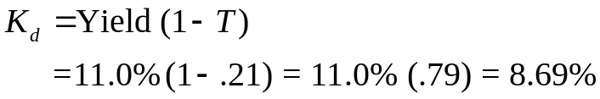

Aftertax cost of preferred stock:
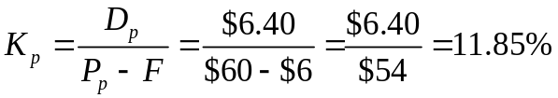
Yes, the treasurer is correct. The difference is 3.16% (8.69% versus 11.85%).
- Given the following information, calculate the weighted average cost of capital for Digital Processing Inc. Line up the calculations in the order shown in the Table.

Percent of capital structure:

Preferred stock 20%
Common equity 40
Debt 40

Additional information:

Corporate tax rate 25%
Dividend, preferred $8.50
Dividend, expected common $2.50
Dividend, preferred $105.00
Growth rate 7%
Bond yield 9.5
Flotation cost, preferred $3.60
Price, common $75.00

Solution: Digital Processing Inc.
K_{d} = Yield (1 – T)
= 9.5% (1 – .24)
= 9.5% (.76)
= 6.27

K_{p} = D_{p}/(P_{p} – F)
= $8.50/($105 – 3.60) = $8.50/$101.40 = 8.38%

K_{e} = (D₁/P₀) + g
= ($2.50/$75) + 7% = 3.33% + 7% = 10.33%

 |  | Cost (aftertax) | Weights | Weighted Cost
 | Debt (K_{d})  Preferred stock (K_{p})  Common equity (K_{e}) (retained earnings)  Weighted average cost of capital (K_{a}) | 7.22%  8.38  10.33 | 40%  20  40 | 2.89%  1.68  4.13  8.70%
5. Speedy Delivery Systems can buy a piece of equipment that is anticipated to provide an 11 percent return and can be financed at 6 percent with debt. Later in the year, the firm turns down an opportunity to buy a new machine that would yield a 9 percent return but would cost 15 percent to finance through common equity. Assume debt and common equity each represent 50 percent of the firm’s capital structure.
a. Compute the weighted average cost of capital.
b. Which project(s) should be accepted?
6. Telecom Systems can issue debt yielding 9 percent. The company is in a 30 percent bracket. What is its aftertax cost of debt?
- Medco Corporation can sell preferred stock for $90 with an estimated flotation cost of $2. It is anticipated the preferred stock will pay $8 per share in dividends.
a. Compute the cost of preferred stock for Medco Corp.
b. Do we need to make a tax adjustment for the issuing firm?
- Global Technology’s capital structure is as follows:
Debt 35%
Preferred stock 15
Common equity 50
The aftertax cost of debt is 6.5 percent; the cost of preferred stock is 10 percent; and the cost of common equity (in the form of retained earnings) is 13.5 percent. Calculate Global Technology’s weighted average cost of capital.
Input areas
Growth rate | 7%
Last dividend | $1.76
Stock price | $52.99

According to the input areas, what is the cost of common equity?
- Murray Motor Company wants you to calculate its cost of common stock. During the next 12 months, the company expects to pay dividends (D₁) of $2.50 per share, and the current price of its common stock is $50 per share. The expected growth rate is 8 percent.
a. Compute the cost of retained earnings (K_{e}).
b. If a $3 flotation cost is involved, compute the cost of new common stock (K_{n}).

