Editor-in-Chief,
International Journal of Public Health Research,
Department of Community Health,
Universiti Kebangsaan Malaysia Medical Centre,
Jalan Yaacob Latif, Bandar Tun Razak,
56000, Kuala Lumpur, Malaysia.

Sir,

SUBMISSION FOR MANUSCRIPT.

With regard the above matter, I’m as the corresponding author on behalf of the listed author is going to submit our manuscript for review and publish in this journal. Below are the details;

Title:
THE ASSOCIATION OF KNOWLEDGE, ATTITUDE AND PRACTICE WITH 24 HOURS URINARY SODIUM EXCRETION AMONG MALAY ETHNIC IN MALAYSIA.

Author:

Author’s Name |  |  | Affiliation |  |  | Signature
- Diana Mahat | Department of Community Health,  Faculty of Medicine,  UKM Medical Centre,  Jalan Yaacob Latif, Bandar Tun Razak,  56000, Kuala Lumpur, Malaysia | 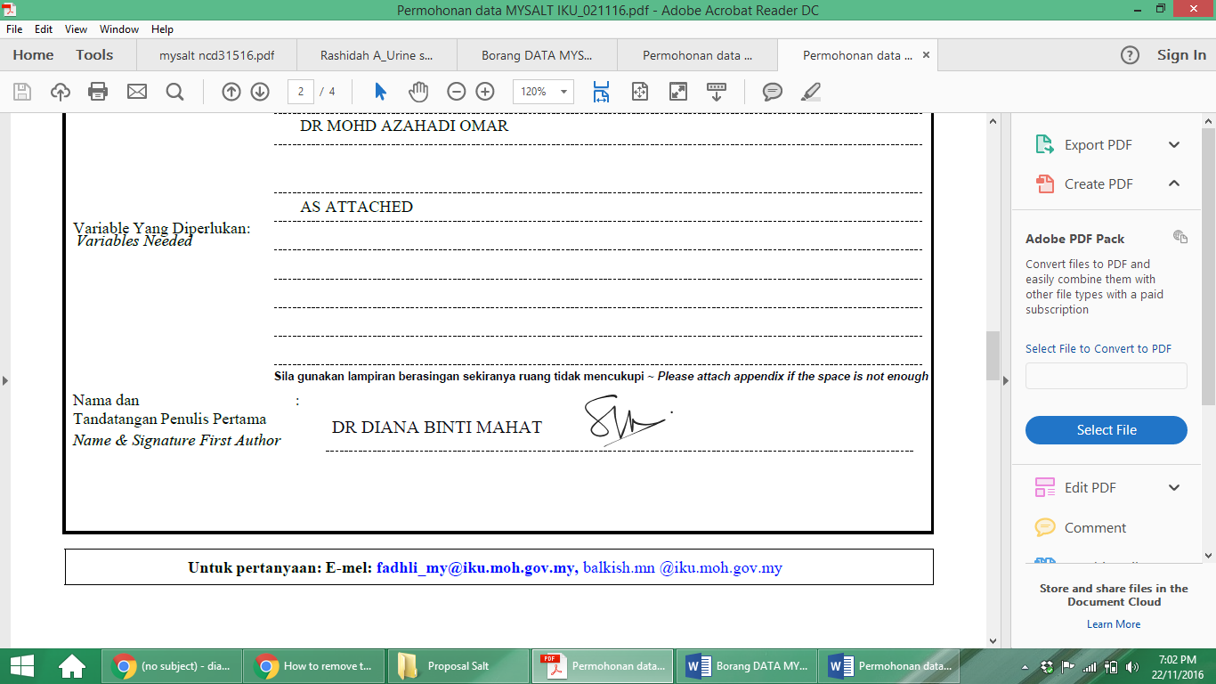
- Zaleha Md Isa |  |  | 
- Azmi Mohd Tamil |  |  | 
- Mohd Ihsani  Mahmood |  |  | 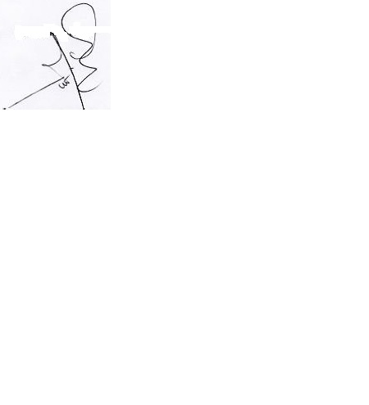
- Fatimah Othman | Centre for Nutrition Epidemiology Research,  Institute for Public Health,  Ministry of Health,  Jalan Bangsar,  50590 Kuala Lumpur, Malaysia | 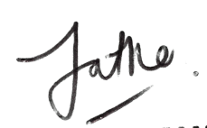
- Rashidah Ambak |  |  | 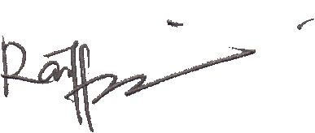
The objective of this study is to determine the associations between knowledge, attitude and practice on sodium intake among Malays ethnicity in Malaysia. This study also will identify major food groups which contribute to the dietary sodium intake among them. This information is necessary in order to provide a baseline for monitoring purpose and also for the development of new strategies and promotional activities at the national level that enables effective public education initiatives development.

Please acknowledge that all authors have read and approved the content of the manuscript and there is no conflict of interest among the authors.

Thank you for your consideration.

Yours sincerely,
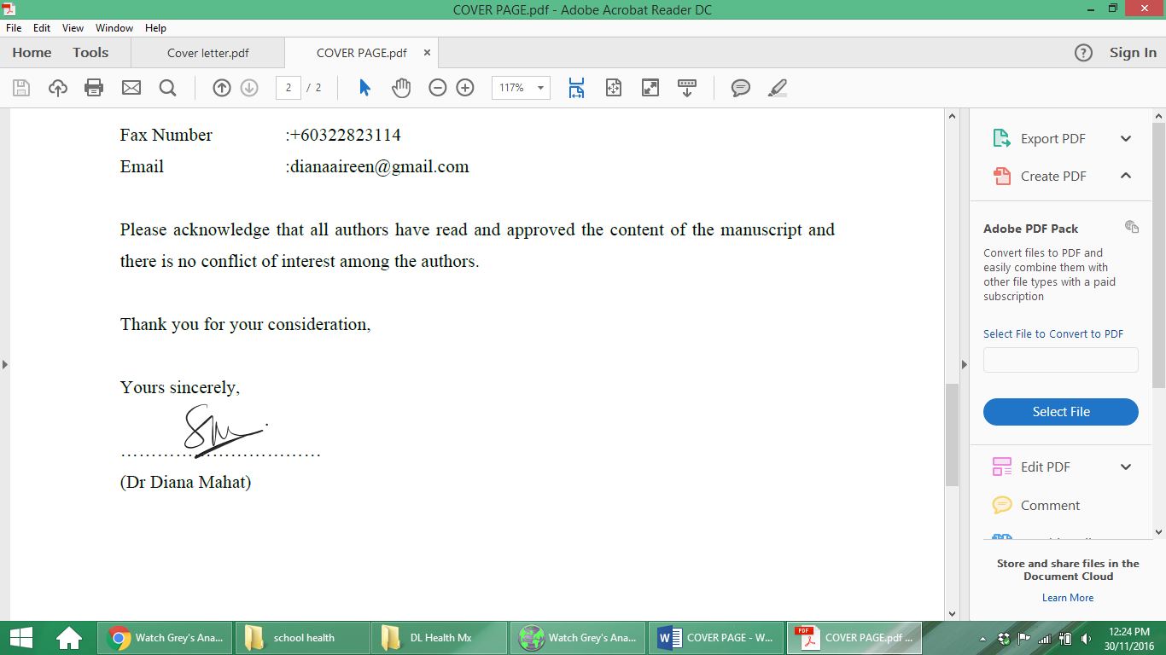
(Dr Diana Mahat)

