Safe Snow Removal
Winter has already arrived in some parts of the United States—and will arrive soon in many other regions—so it’s never too early to train your workers on safe snow removal. Ensuring they know how to clear their driveways safely will cut down on absenteeism and injuries during the winter months. So whether they use snowblowers or shovels, give them an effective review of how to stay safe when removing snow.
Snowblowers are very popular because they make snow removal so much easier, but they are powerful machines that must be treated with respect. Train your workers to take the following precautions:
•If snow is forecast, check the area to be cleared to ensure that it is free of debris that might get picked up and hurled by the blower. Never use a snowblower on a gravel driveway for that very reason.
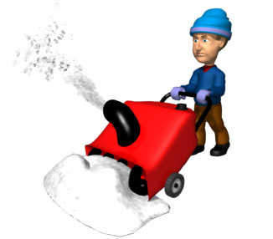
•Read the manufacturer’s manual before using the blower.
•Dress appropriately with warm clothing, sturdy boots, and hearing protection, but no loose scarves or other items that could get caught in the blower.
•Protect yourself from carbon monoxide poisoning by starting and running gasoline-powered snowblowers outside.
•Before you start, make sure no one is in the dangerous discharge area.
•Never leave a machine running when it is unattended.
Sometimes snowblowers can get clogged. Here’s what workers should do when a clog occurs:
•NEVER put your hand in the intake or discharge chute!
•Turn the engine off, wait at least 5 seconds for the blades to stop rotating.
•Use a long stick or broom handle (NEVER your hand) to clear the clog.
•Keep all shields in place. DO NOT REMOVE the safety devices on the machine.

If your workers opt for the more traditional method of shoveling snow, remind them that shoveling is an extremely strenuous activity, especially if there’s a lot of snow or if the snow is wet and heavy. Give them these precautions to follow:
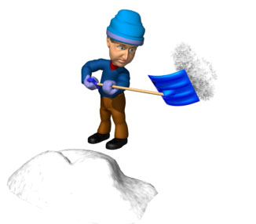
•Check with your doctor before you shovel.
•Pick the right shovel for you. A smaller blade will require you to lift less snow, putting less strain on your body.
•Plastic shovels weigh less than metal.
•Use a shovel with an ergonomic handle.
•Pick up smaller loads of snow.
•Push snow rather than lift it when possible.
•Try to clear snow early and often—take frequent breaks.
It also makes sense to give workers a quick refresher on safe lifting. Urge them to protect their backs from injury by lifting correctly.
•Lift with your legs, not with your back.
•Bend your knees and keep your back as straight as possible.
•Never bend at the waist.
•Step in the direction that you are throwing snow.
Most importantly—encourage your workers to listen to their bodies. And stop if they feel pain!
Why It Matters...
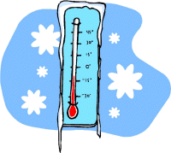
•Snow shoveling causes an average of nearly 100 deaths and 11,500 emergency department visits each year in the United States.
•The most frequently injured area of the body is the lower back (34%).
•Heart problems make up 7% of the injuries—but 100% of the deaths.
•The most common cause of injuries was acute musculoskeletal exertion (54%).
•Slips or falls (20%) are the second most common cause of injuries.

