

Sandwell MBC: Standard Operating Procedures
1. Process overview

Process Name | Lift Breakdowns
Process Reference | AM_Rep_07
Service Area | Asset Management and Maintenance and Housing Services
Process Summary | The process for Lift Breakdowns
Senior Responsible Officer | Tony Thompson - Fire Safety, Facilities & Premise Manager
Frequency | Adhoc
Inputs | Notification of breakdown
Outputs | Completion of lift repair
Links to other Processes | N/A
Systems Used | MySandwell/Service, Job Manager, DRS, Open Housing
Templates / Tools

INdex

- Operational PROCESS MAP
- Operational PROCESS DETAILed description
- Appendices

2. OPERATIONAL PROCESS MAP

For a larger view of the process flow please click the link Lift Breakdown process - Sandwell Intranet

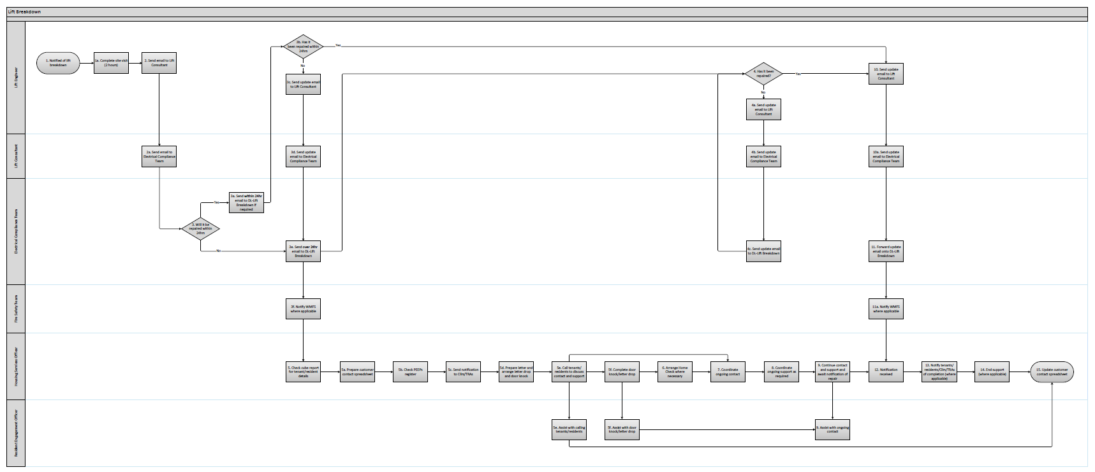

3. OPERATIONAL PROCESS DETAILED DESCRIPTION

Step No. | Process Step | Detailed Description | Timeline | Team and named contact | System Required | Outputs and Templates
1 | Notification of Lift breakdown | Report of lift breakdown received from customer. | Adhoc | Lift Engineering Services (LES) | Telephone, email, MySandwell/Service
1a. | Complete site visit | LES complete a site visit to determine the issue | Day of notification | Lift Engineering Services (LES)
2 | Send email to Lift Consultant | LES email to advise they have received notification of a lift breakdown and when the inspection/repair has been scheduled for. | Day of notification | Lift Engineering Services (LES)
2a. | Send email to Electrical Compliance Team | Cundall emails to advise they have received notification of a lift breakdown and when the inspection/repair has been scheduled for. | Day of notification | Lift Consultant (Cundall)
3 | Will it be repaired within 24hrs? | Email received from LES will determine the length of time the lift will be out of service. | Day of notification | Electrical Compliance Team | Outlook
3a | Send within 24hr email to DL-Lift Breakdown if required | The Electrical Compliance Team use their discretion to email the DL – Lift Breakdown if required due to lift being fixed within 24hrs. | Day of notification | Electrical Compliance Team | Outlook
3b | Has it been repaired within 24hrs? | LES to liaise with engineers. | Within 24hrs | Lift Engineering Services (LES)
3c | Send update email to Electrical Compliance Team | LES email the Lift Consultant with an update on the repair. | Within 24hrs | Lift Engineering Services (LES)
3d | Send email to Electrical Compliance Team | Cundall emails to advise they have received notification of a lift breakdown and when the inspection/repair has been scheduled for. | Day of notification | Lift Consultant (Cundall)
3e | Send over 24hr email to DL-Lift Breakdown | The Electrical Compliance Team email the DL – Lift Breakdown to notify them of the breakdown and any details relating to the repair. | Day of notification | Electrical Compliance Team | Outlook
3f | Notify WMFS where necessary | The Fire Safety Team notify WMFS via the portal that the lift is out of service. | Day of notification | Fire Safety Team | WMFS portal
4 | Has it been repaired? | LES to liaise with engineers. | Within 24hrs | Lift Engineering Services (LES)
4a | Send update email to Lift Consultant | LES email the List Consultant with an update on the repair. | As required | Lift Engineering Services (LES)
4b | Send update email to Electrical Compliance Team | Cundall emails the Electrical Compliance Team with an update on the repair. | Day of notification | Lift Consultant (Cundall)
4c | Send update email to DL-Lift Breakdown | The Electrical Compliance Team email the DL – Lift Breakdown to notify them of the update. | Day of notification | Electrical Compliance Team | Outlook
5 | Check cube report for resident details | A cube report is available for the Housing Services Officers to be able to view the contact details and vulnerabilities of tenants and residents in the affected block. | Day of notification | Housing Services Officer | Excel | Cube report
5a | Prepare customer contact spreadsheet | The Housing Services Officer accesses the customer contact spreadsheet and starts to populate the customer contact details from the cube report. | Day of notification | Housing Services Officer | Excel | Customer contact spreadsheet
5b | Check PEEPs register | The Housing Services Officer contacts the Fire Safety Team to check if any tenants/residents have a personal evacuation plan. Details of which should be recorded on the customer contact spreadsheet. | Day of notification | Housing Services Officer | Excel | PEEP’s register, Customer contact spreadsheet
5c | Send notification to Cllrs/TRAs | The Housing Services Officer sends notification of the breakdown email to Cllrs and TRAs. | Day of notification | Housing Services Officer | Outlook | Lift out of order emails
5d | Prepare letter and arrange letter drop and door knock | The Housing Services Officer prepares the customer contact letter with the relevant information and arranges a letter drop/door knock. | Day of notification | Housing Services Officer | Word | Customer contact letter
5e | Call tenants/residents to discuss contact and support  Assist with calling tenants/residents | The Housing Services Officer calls the tenants/residents with the assistance of the Resident Engagement Officer to advise them of the lift breakdown, discuss contact preferences and any support needs they may have that will be affected by the breakdown.  All questions from the customer contact checklist should be asked and details recorded on the customer contact spreadsheet. | Day of notification | Housing Services Officer, Resident Engagement Officer | Word, Excel | Customer contact checklist, Customer contact spreadsheet
5f | Complete door knock/letter drop  Assist with door knock/letter drop | A letter drop and door knock will be complete by the Housing Services Officer and Resident Engagement Officer to ensure contact has been made with all tenants/residents.  All questions from the customer contact checklist should be asked and details recorded on the customer contact spreadsheet. | Within 24hrs of notification | Housing Services Officer, Resident Engagement Officer | Word, Excel | Customer contact checklist, Customer contact spreadsheet
6 | Arrange Home Check where necessary | Where it has been identified that there are support needs the Housing Services Officer should arrange to complete a home check. | Suitable time for the tenant | Housing Services Officer | JM, DRS | Home check form
7 | Coordinate ongoing contact | Any contact preferences and frequencies that have been identified and recorded on the customer contact spreadsheet should be diarised. | Time of identification | Housing Services Officer | Excel, Outlook | Customer contact spreadsheet
8 | Coordinate ongoing support as required | Where support needs have been identified the Housing Services Officer makes relevant referrals/arrangements.  If a Floating Support referral is required clearly identify that it relates to a Lift Breakdown on the referral form and in the subject of the email.  The customer contact spreadsheet should be updated accordingly. | Time of identification | Housing Services Officer | Excel, Outlook | Customer contact spreadsheet, Floating Support referral form
9 | Continue contact and support and await notification of repair  Assist with ongoing contact | The Housing Services Officer ensures that contact and support is ongoing throughout the duration of the lift breakdown. | As required | Housing Services Officers, Resident Engagement Officer | Excel | Customer contact spreadsheet
10 | Send update email to Lift Consultant | LES email the Lift Consultant to advise the repair has been complete. | Time of completion | Lift Engineering Services (LES)
10a | Send update email to Electrical Compliance Team | Cundall emails the Electrical Compliance Team to advise the repair has been complete. | Day of notification | Lift Consultant (Cundall)
11 | Forward update email onto DL-Lift Breakdown | The Electrical Compliance Team email the DL – Lift Breakdown to notify them that the repair is complete. | Day of notification | Electrical Compliance Team | Outlook
11a | Notify WMFS where necessary | The Fire Safety Team notify WMFS via the portal that the lift has been repaired. | Day of notification | Fire Safety Team | WMFS portal
12 | Notification received | The Housing Services Officer receives notification of the repair. | Day of notification | Housing Services Officer
13 | Notify tenants/residents/Cllrs/TRAs of completion (where applicable) | The Housing Services Officer notifies tenants/residents Cllrs and TRAs that the lift has been repaired. | Day of completion | Housing Services Officer
14 | End support (where applicable) | The Housing Services Officer liaises with the tenant/resident and any relevant teams to end support. | Day of notification | Housing Services Officer
15 | Update customer contact spreadsheet | The Housing Services Officer updates the customer contact spreadsheet confirming contact and support that has been ended. | Day of notification | Housing Services Officer | Excel | Customer contact spreadsheet

- APPENDICES

Appendix 1 | Customer contact letter
Appendix 2 | Customer contact update letter
Appendix 3 | Lift out of order email
Appendix 4 | Customer contact checklist
Appendix 5 | Customer contact spreadsheet
Appendix 6 | Distribution List

Appendix 1



Address
S
S
S
S
S

Our Ref:
Your Ref:
Date:

Dear Tenant/Resident,

Re: Lift breakdown

As you may be aware the lift in block name is currently out of order.

Our lift contractor, Lift Engineering Services (LES), have been instructed to complete the necessary repair.

In the meantime, officers from Sandwell Council will contact you to discuss any support you may need while the lift is not in operation.

Should you require any further information please scan the QR code below or contact your Housing Services Officer insert name on insert number.

Yours sincerely,


Mr Tony Thompson
Fire Safety, Facilities & Premise Manager

Appendix 2

Address
S
S
S
S
S

Our Ref:
Your Ref:
Date:

Dear Tenant/Resident,

Re: Lift breakdown

Following notification that the lift in block name is currently out of order, we would like to advise you of the following update

Insert details

Should you require any further information please scan the QR code below or contact your Housing Services Officer insert name on insert number.
Yours sincerely,

Mr Tony Thompson
Fire Safety, Facilities & Premise Manager

Appendix 3

Good morning/afternoon,

The lift in insert block is currently out of order.
Lift Engineering Services (LES), have been instructed to complete the necessary repair and it is expected that the repair will be completed by insert date.
The reason for the delayed repair is insert reason.
We will continue to notify you if there are any issues with the repair that will cause further delays.

Kind regards

Appendix 4
Customer contact checklist
Name
Address

Contact telephone
Email address
Date contacted
Officer name

Do you have any medical needs that would make it difficult for you to leave or return to your flat whilst the lift is broken?
Are there any tasks that you feel you need support with?
How frequently do you feel you need this support?
Do you live with anyone that can assist you?
Do you have any carers or relatives that can assist you?
Do you receive support from any other agencies?
Would you consider support from another agency?
How would you like to receive lift updates?
How often would you like to receive the updates?

Appendix 5

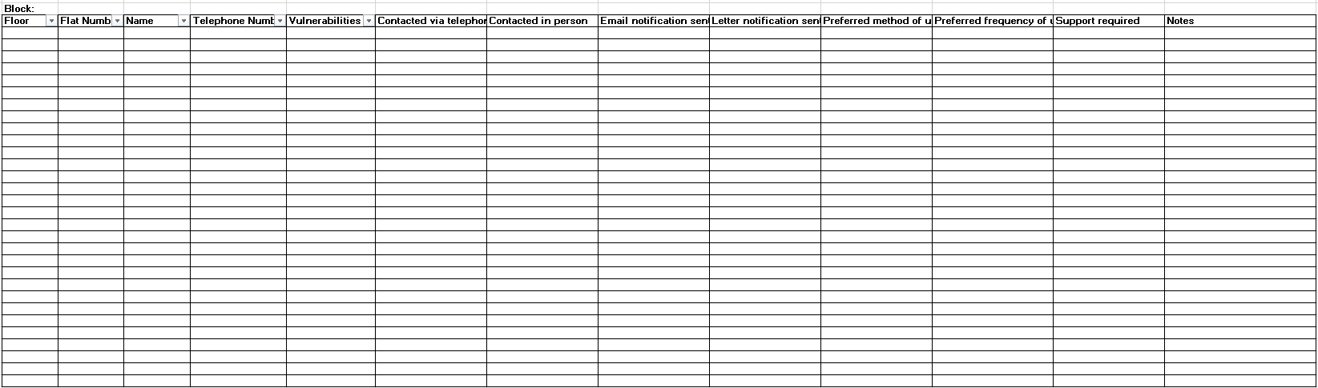

Appendix 6

Distribution list DL-Lift Breakdown
Recipient | Email address
John Nash | John_Nash@sandwell.gov.uk
Phil Deery | Phil_Deery@sandwell.gov.uk
Tony Thompson | Tony_Thompson@sandwell.gov.uk
Lee Mlilo | Lee_Mlilo@sandwell.gov.uk
Abdulmonim Khan | Abdulmonim_Khan@sandwell.gov.uk
Bryan Low | Bryan_Low@sandwell.gov.uk
Estate Services | Estate_Services@sandwell.gov.uk
CCTV | CCTV_Team@sandwell.gov.uk
Voids | voids_maintenance@sandwell.gov.uk
Repairs | Ryan_Davies@sandwell.gov.uk  John_Hall@sandwell.gov.uk  Ian_Sorrell@sandwell.gov.uk  Isabel_Cole@sandwell.gov.uk  Alex_Isherwood@sandwell.gov.uk  Ruth_Dolan@sandwell.gov.uk  Michelle_Dawes@sandwell.gov.uk
Repairs – out of hours | Simon_Moseley@sandwell.gov.uk  Deborah_Blackham@sandwell.gov.uk  Laraine_Rowley@sandwell.gov.uk  Richard_Thomas@sandwell.gov.uk  Claire_Harrison@sandwell.gov.uk  Angela _Pinney@sandwell.gov.uk
Housing Hub | Housing Hub@sandwell.gov.uk
Contact Centre | Customer_Services@sandwell.gov.uk
Local teams | Wednesbury_Support@sandwell.gov.uk  WestBromwich_Support@sandwell.gov.uk  Rowley_Support@sandwell.gov.uk  Oldbury_Support@sandwell.gov.uk  Tipton_Support@sandwell.gov.uk  Smethwick_Support@sandwell.gov.uk
Community Alarms | community_alarms@sandwell.gov.uk

9. PROCESS DEVELOPMENT HISTORY
Version | Modified By | Date | Reason | Approved By | Amendment Details
V1 | Tony Tompson | 25.03.2024 | Creation | Sarah Ager | N/A
Key Stakeholders

Name | Position / Role | Details of consultation / review | Date
Sarah Ager | Assistant Director – Asset Management and Improvement | Agreed and SOP sign off complete | 25.03.2024
Jim Brennan | Head of Tenancy and Estate Management | Input and review of process | 25.03.2024
Tom Jones | Head of building safety compliance | Input and review of process | 25.03.2024
Dean Wright & Jan Macmillan | SCIPS | Review of process | 29.02.2024
Sue Smith | Hamstead Village TRA | Review of process | 29.02.2024
John Nash | Electrical Compliance Manager | Input and review of process | 25.03.2024

Documentation Consulted
Title | Author | Date Reviewed

Process Sponsor Sign Off
Name | Position | Version Reviewed | Date
Sarah Ager | Assistant Director – Asset Management and Improvement | Lift Breakdown SOPv1 | 25.03.2024

Key Issues and Business Decisions Pending
Issue or Business Decision | Owner | Contact for Resolution | Date of Resolution

