  What should I already know?
  - How old I am.
  - That my parents and grandparents are older than me.
  - I may have siblings that are younger than me
  - Schools were different in the past but some things were similar
  - Hospitals were different in the past but some things were similar
  What will I find out by the end of the unit?
  - Know a decade is 10 years
  - Times were slightly different when my parents/carers were little
  - Times were very different when my grandparents were little
  - Know some of the similarities and differences between their lives and those of adults around them
  - There was a time before my grandparents
  - were born.
  - Life was very different then
  - People wore different clothes, travelled in different ways, played with different toys, went on different holidays and school was very different too.
  - Shops were different and supermarkets did not exist
  - Technology has changed how people pay
   | Vocabulary
  after | later in time than, or behind in order
  before | at an earlier time; in the past
  century | equal to one hundred years
  chronology | the order of events in time
  differences | the condition of being different from or not like
  during | throughout the entire time of
  new | having recently arrived, been produced, or come into being
  now | at this time or in these times
  old | having existed for many years; not new.
  older | having lived for many years
  past | having happened or gone by at an earlier time
  present | existing at this time; current
  sibling | a sister or a brother
  similarity | likeness
  slightly | a small amount; a little
  technology | devices which are the result of scientific knowledge being used for practical purposes.
  then | soon after; next
  usually | most common or expected
  younger | earlier stage of life
Historical Skills and Enquiry
- Create a timeline showing key family events, and then use words such as before, after, past, present, then and now to describe their chronology.
- Describe what life was like when your parents/carers were little and what the similarities and differences are.
- Describe what life was like when your grandparents were little and what the similarities and differences are.
- Describe how Alderley Edge has changed over the last century
- Describe how technology has changed over the last decades - interview your parents/carers and grandparents and ask them what they do now that they couldn’t do before
- Research some things that happened before your parents/ carers were born and place these on your timeline.
- Research some things that happened before your grandparents were born and place these on your timeline.

 | 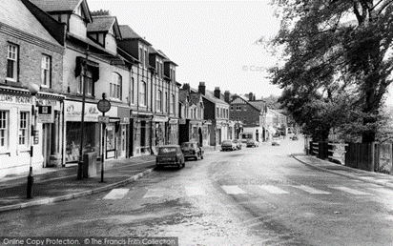

Wartime Life | When your grandparents were little | When your parents/carers were little | Your childhood
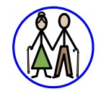

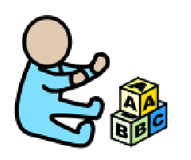

Key Concepts
Daily life  (Past times) | Know the similarities and differences between times in the past and compare to their own experiences
Links with other subjects
PSHE – relationships, growing and changing
Geography – hot and cold climates, contrasting locality (seaside)
Reading – finding information, extracting meaning, compare and contrast
Maths – time, ordering and sequencing

