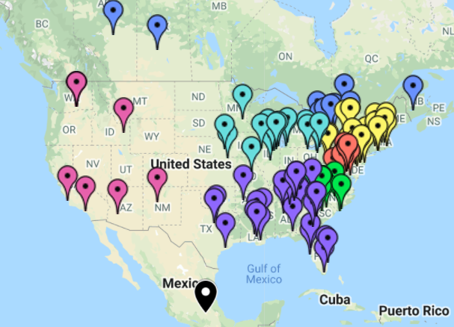 Currently over 100 Chapters across the US, Canada, and Mexico.  What is NAYGN  NAYGN is a non-profit organization which provides opportunities for a young generation of nuclear enthusiasts to develop strong leadership and professional skills, create life-long connections, engage and inform the public, and inspire today’s nuclear technology professionals to meet the challenges of the 21st century. NAYGN was established in 1999 and now consists of 100+ chapters across North America. The four cornerstones are: professional development, public relations, community outreach and membership/networking.  Benefits of NAYGN  - Inform and educate the general population about nuclear science and technology;  - Provide a forum for the professional development of its membership.
  Who We Are
  NAYGN Board of Directors
  - President – Matthew Mairinger
  - Vice President – Christy Fletcher
  - Past President – Amanda Lang
  - Professional Development Officer – Ce’Nedra Darragh
  - Public Information Officer –
  Katie Mitchell
  - Communications Officer –
  Ivey Wilson
  - US Operating Officer – Lindsy Davis
  - Canadian Operating Officer –
  Matthew Przbylowski
  - Treasurer – Brian Holman
  - DE&I – Sarah Davis
  - Technology Officer – Michael Smyth
  Follow us
  
  @NA_YGN TheNAYGN
  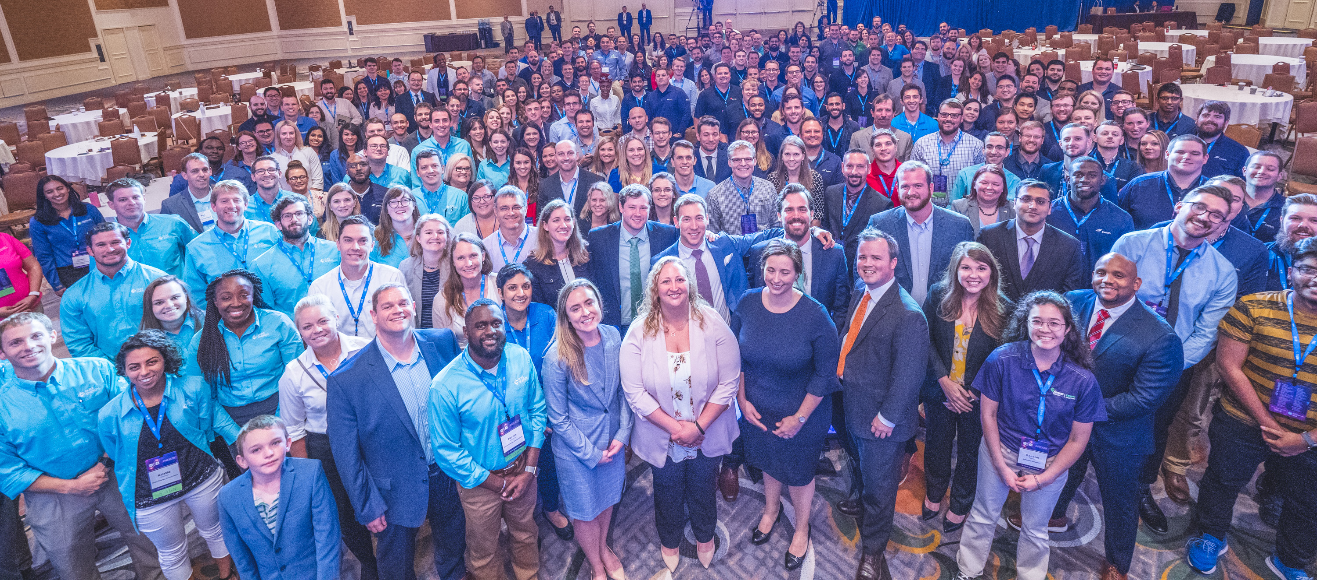
  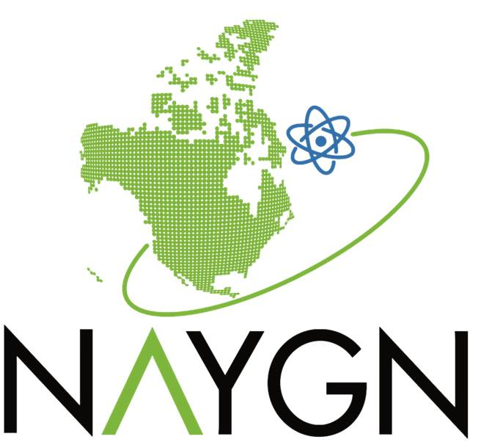 | 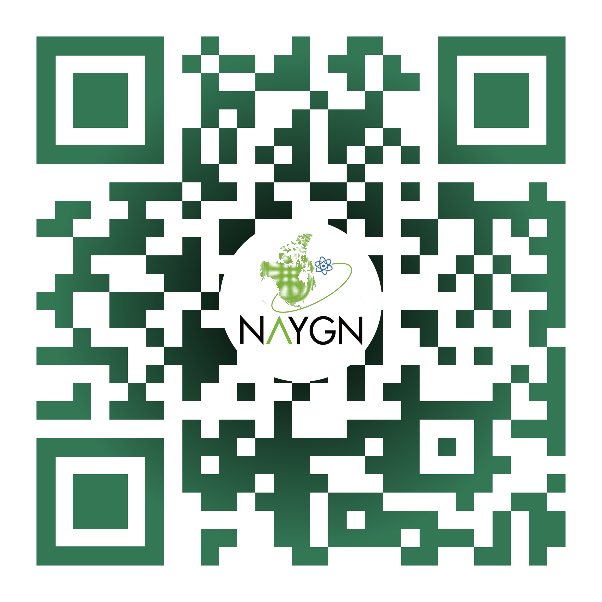
  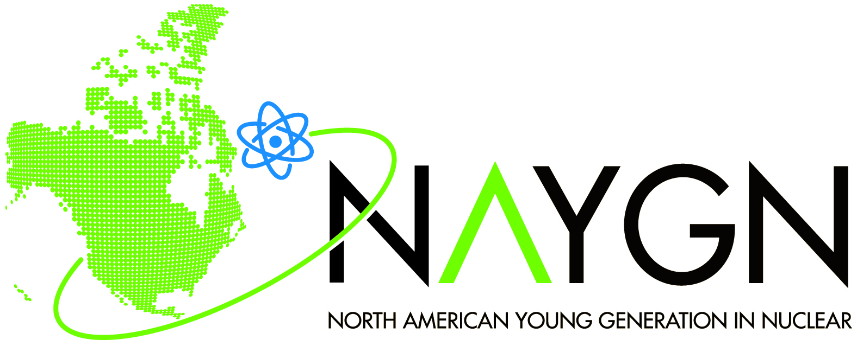
  North American Young Generation in Nuclear (NAYGN)
  How to Start A New LOCAL CHAPTER
  Step-by-Step Guide from an Idea to Your Opportunity
How can I find out more?  With so many chapters out there already there’s a good chance you already have an NAYGN chapter near you! Visit https://naygn.org/chapters/chapter-list/ to see a list of the chapters across North America as well as who is the chapter contact and who is the lead for that region.  “I love what NAYGN is doing but there are no chapters around me, what can I do?” Anonymous Adam  I found a chapter near me!  Awesome, life just got a whole lot easier for you friend. Some keen individual already saw the potential and made a chapter. Reach out to the chapter lead listed to find out how to get involved and register for free at www.naygn.org/register under the applicable chapter. | How do I start a chapter?  Deep breaths here and we can get through this together. If you (or someone at your company/college/etc.) are interested in starting your very own Local NAYGN Chapter here is your step-by-step guide. There is no minimum requirement to start a chapter.  1. Visit http://naygn.org/start-a-chapter/ for great resources about starting a chapter.  2. Contact Canada@naygn.org if in Canada or USA@naygn.org if in America as well as vp@naygn.org providing the chapter name, lead contact details for the chapter, company name (if applicable) and location of the chapter.  3. Your chapter will be added to the list of existing chapters, the chapter lead will be added to the NAYGN local chapter lead email distribution list, and your chapter will be added to the NAYGN metrics page.  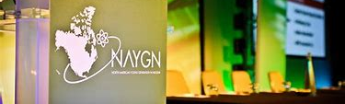 | How do I get my new chapter off the ground?  1. Funding – there are no membership fees for NAYGN members so funding for the chapter comes from: fundraising at events or sponsorship. Email Treasurer@naygn.org for sample sponsorship letters.  2. Organization structure –Do you want a rigid structure (chapter lead, vice lead, treasurer, communications chair, PD chair, PR chair, outreach chair, membership chair) or an informal structure? Will terms last 1, 2 or 3 years? How will voting take place going forward?  3. Membership list – to get started you will have to build a membership distribution list. This can be via email or through a Facebook or other medium. A kickoff event is a great way to build your network.  4. Events – Events can be: lunch and learns, facility tours, speaking seminars, community volunteer events, sporting games, etc. The NAYGN mission is broad and flexible!

