Name __________________________________________ Date ________________
http://www.sense-lang.org/typing/tutor/keyboarding.php
Fill in the keyboard:
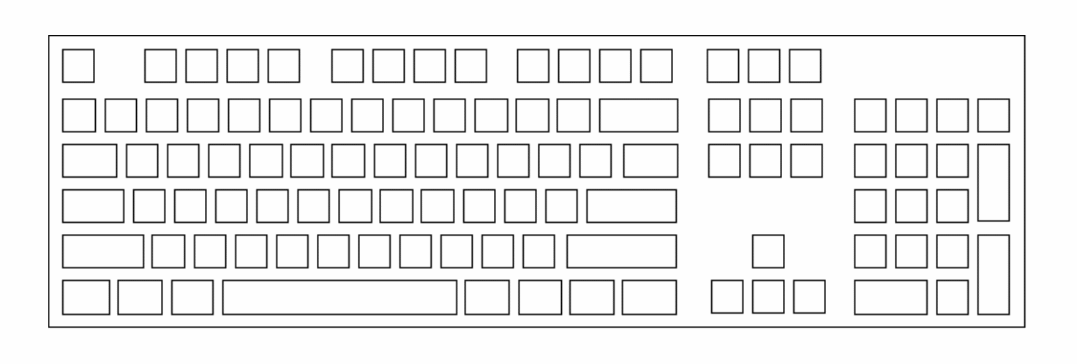
What are the four tips they present:
1) ____________________________________________________________________________
______________________________________________________________________________

2) ____________________________________________________________________________
______________________________________________________________________________

3) ____________________________________________________________________________
______________________________________________________________________________

4) ____________________________________________________________________________
______________________________________________________________________________

