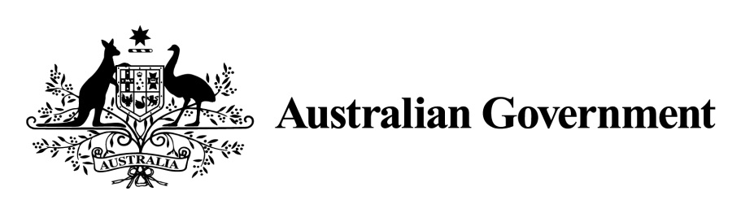

National Land Transport Act 2014

VARIATION OF THE ROADS TO RECOVERY LIST 2019

Instrument No. 2019/3
I, OLIVER HOLM, General Manager, South East Infrastructure Investment, Department of Infrastructure, Transport, Cities and Regional Development, under Sections 88(2) and (3) of the National Land Transport Act 2014 (the Act), vary the Roads to Recovery List 2019 which was made by the Minister on 31 October 2018, and amended by Instrument No. 2019/2 made on 1 July 2019 as follows:

- Name of variation

This variation instrument is the Roads to Recovery List 2019 Variation Instrument No. 2019/3.

- Variation

(a) In Schedule 1 of the List:
Omit the amount specified in Column 2 of Schedule 1 for the funding recipient ‘Armidale Regional Council’ and replace the omitted amount with $7,148,503.

Omit the amount specified in Column 2 of Schedule 1 for the funding recipient ‘Inverell Shire Council’ and replace the omitted amount with $7,010,275.

(b) In Schedule 2 of the List:
Omit the amount specified in the List for Western Australia in Column 2 of Schedule 2 and replace the omitted amount with the amount $25,588,063.

- Commencement

This instrument commences on 31 July 2019.

Dated: 29 July 2019

OLIVER HOLM
General Manager
South East Infrastructure Investment
Infrastructure Investment Division
Department of Infrastructure, Transport, Cities and Regional Development

Schedule 1 to Instrument 2019/3

Item | Column 1 - Funding recipients | Column 2 – Funding amounts
2 | Armidale Regional Council | $7,148,503
59 | Inverell Shire Council | $7,010,275

Schedule 2 to Instrument 2019/3

Item | Column 1 – States and areas of States | Column 2 – Funding amounts
1 | Western Australia | $25,588,063

